Federal Highway Administration Project 3:
  - Project Three Written Report

Student: Ryder Anderson
Department of Civil & Environmental Engineering, University of Nebraska-Lincoln
CIVE 202: Civil Engineering Analysis II
Client: Federal Highway Administration
Professor: Dr. Kaycie Lane
March 29, 2026

Contents
Table of Figures 3
Executive Summary 4
Analysis 5
NHTS Data 5
Time-Series Analysis (NGSIM Data) 9
IDM results 11
Methods 12
Data Import and Review 12
NHTS Variables 12
Bar Chart Construction 13
Histogram Construction 13
Boxplot Construction 13
NGSIM Variables 13
Intelligent Driver Model (IDM) Simulation 14
Model Comparison 14
AI Usage 14
References 14

Table of Figures
Figure 1 Count of Vehicles by Vehicle Type 5
Figure 2 Distribution of Vehicle Age 6
Figure 3 Boxplot of Vehicle Age by Household Location 7
Figure 4 Customized Vehicle Type Bar Chart 8
Figure 5 Leader and Follower Position vs Time 9
Figure 6 Leader and follower speed vs time 10
Figure 7 Acceleration Comparison Using IDM 11
Figure 8 Position Comparison Using IDM 12
Figure 9 IDM parameters, symbols, descriptions, and typical values 14
Figure 10 IDM acceleration and desired minimum gap equations 14

Executive Summary
The report is based on data from the National Household Travel Survey (NHTS) and the Next Generation Simulation (NGSIM) datasets provided by the client. The client had asked us to create a clear and simple visualization in Python using matplotlib and seaborn. The graphs the client required us to use were a bar chart, a histogram, a boxplot, and two time-series plots. The client also requests an intelligent driver model (IDM) to simulate vehicle-following behavior. Our team reviewed both the NHTS and NGSIM datasets to determine which information would be most useful for illustrating transportation trends and driving behavior. From the NHTS data, we chose vehicle age, vehicle_type, fuel_type, vehicle_per_household. These variables helped us show the types of vehicles in the dataset, vehicle age distribution, and vehicle age across household locations. From the NGSIm data, we chose the variables trajectory_number, Time (s), leader_acceleration(m/s^2), follower_speed (m/s), follower_position (m), leader_speed (m/s), and follower_acceleration (m/s^2). These variables were then used to create the required time-series plots and to complete the IDM simulation so we can compare real and simulated follower behavior over time.

Analysis

NHTS Data
Figure 1: shows the bar chart of vehicle type. The bar chart shows that the most common vehicle in the dataset is Automobile/car/stationwagon with over 6000 recorded. The second largest category is SUV, with over 4,500 recorded. Then pickup trucks with over 2,250 recorded. The remaining vehicles have a much lower count, which shows us that the main transportation through the area is by passenger vehicles, which is very important to consider when designing a roadway and traffic flow. Since pickup trucks make up a large portion of the data, it will affect the design a lot when it comes to the pavement's loading and geometric design considerations.
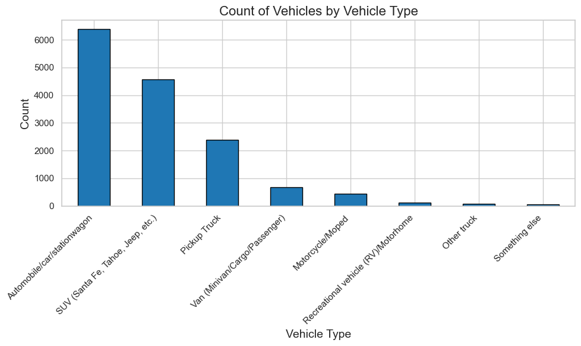
Figure 1 Count of Vehicles by Vehicle Type
Figure 2: is the histogram of the distribution of Vehicle Age. This plot shows how the data is skewed toward newer vehicles, with the highest frequency being 1-year-old vehicles. The median age is 8 years old, and the average vehicle age is about 10.7 years. Even though the data heavily leans towards the newer side at the tail end of the data at 40 years. This matters a lot toward our data, as we need the roads to accommodate older vehicles, as they can affect safety, emissions, and how quickly newer vehicle technologies are adopted.

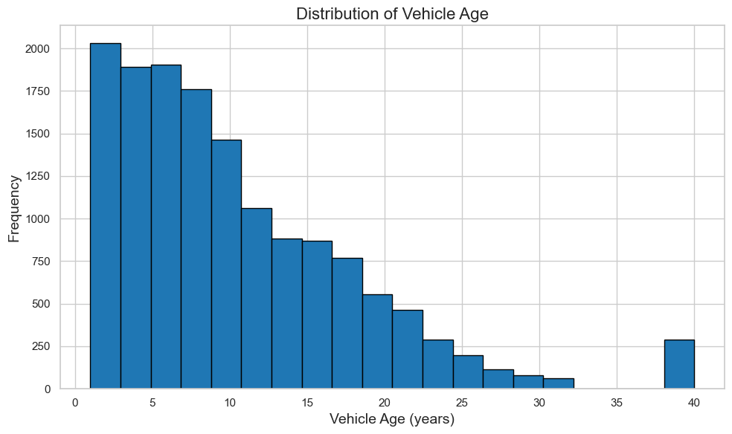
Figure 2 Distribution of Vehicle Age

Figure 3: is the boxplot of Vehicle Age by Household Location. This graph compares the vehicle age between Urban and Rural households. From the dataset, rural has a higher median vehicle age at around 9 years, while the urban group has an average median vehicle age at around 8 years old. The average vehicle age is also higher in rural households at about 11.7 years old, compared to urban households, which is about 9.5 years old.

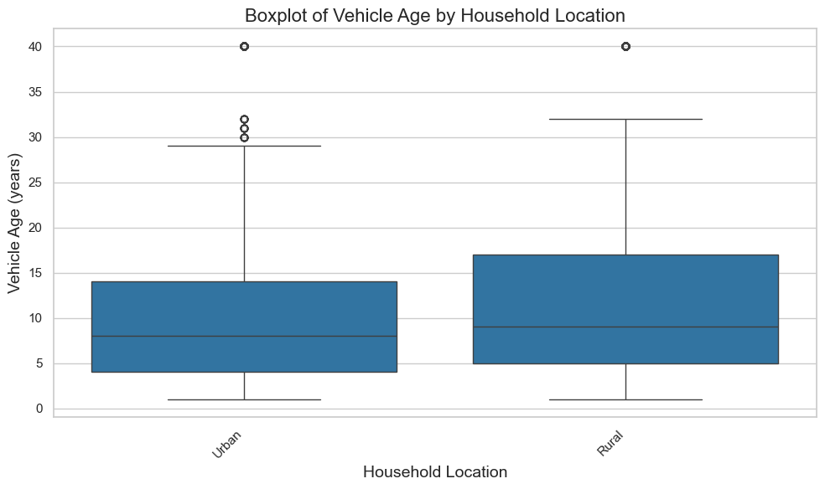
Figure 3 Boxplot of Vehicle Age by Household Location

Figure 4: is a customized vehicle type bar chart. The graph uses the same vehicle type data as Figure 1, but it changes the bar color, title size, and axis formatting. The main purpose of this figure was to show that the plot can be adjusted beyond the default Python settings while still presenting the same results clearly.
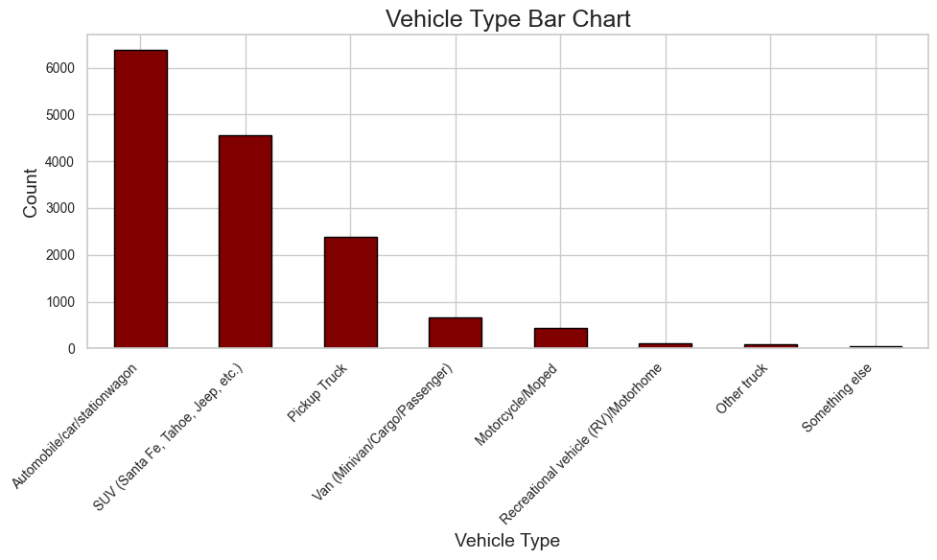
Figure 4 Customized Vehicle Type Bar Chart

Time-Series Analysis (NGSIM Data)
For the NGSIM portion of the project, the team selected trajectory number 2 for the time-series plots and the IDM simulation. This trajectory contains 398 rows of data and covers a time range from 0.1 to 39.8 seconds.
Figure 5: shows the leader position and follower position vs time for trajectory 2. Both lines increase steadily over time, showing how both vehicles continue moving forward through trajectory 2. The follower remains behind the leader for the entire time, which is expected in leader-follower pairs. The spacing, however, does change between the two vehicles from the follower is not able to completely guess exactly what the leader does.
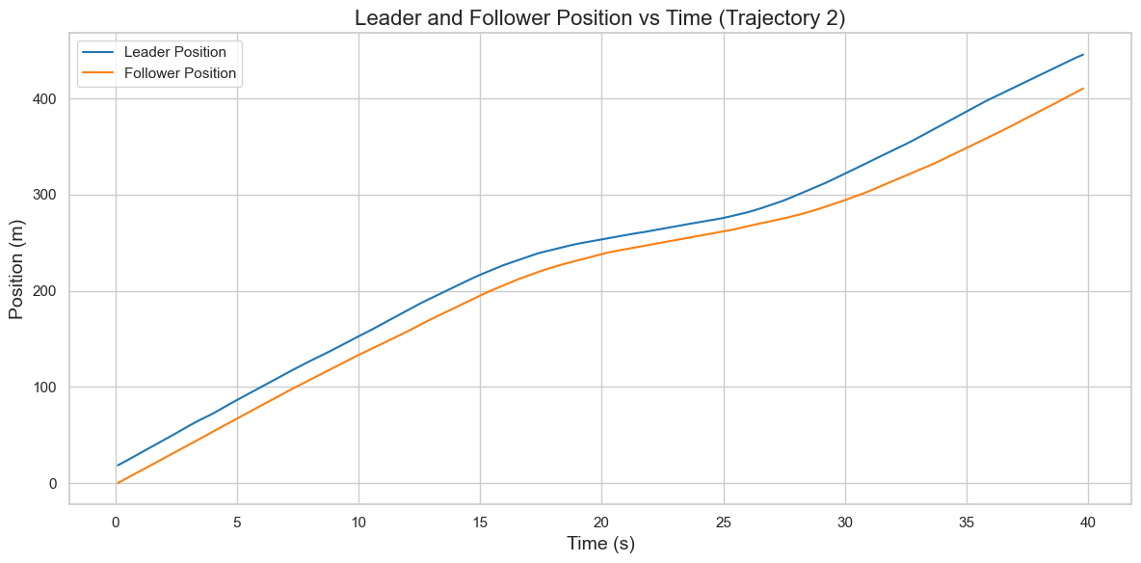
Figure 5 Leader and Follower Position vs Time

Figure 6: shows Leader and Follower Speed vs Time for trajectory 2. The two speeds on the curves are relatively close to each other, which shows that the follower is responding to the movement of the leader very well. The average leader speed is about 10.7 m/s, while the average follower speed is about 10.3 m/s. The leader speed has a range from 3.8 to 14.5 m/s, and the follower speed ranges from 4.3 to 14m/s. These results show that the follower and leader are both moving at a very similar speed, with the follower just having to make slight adjustments over time.
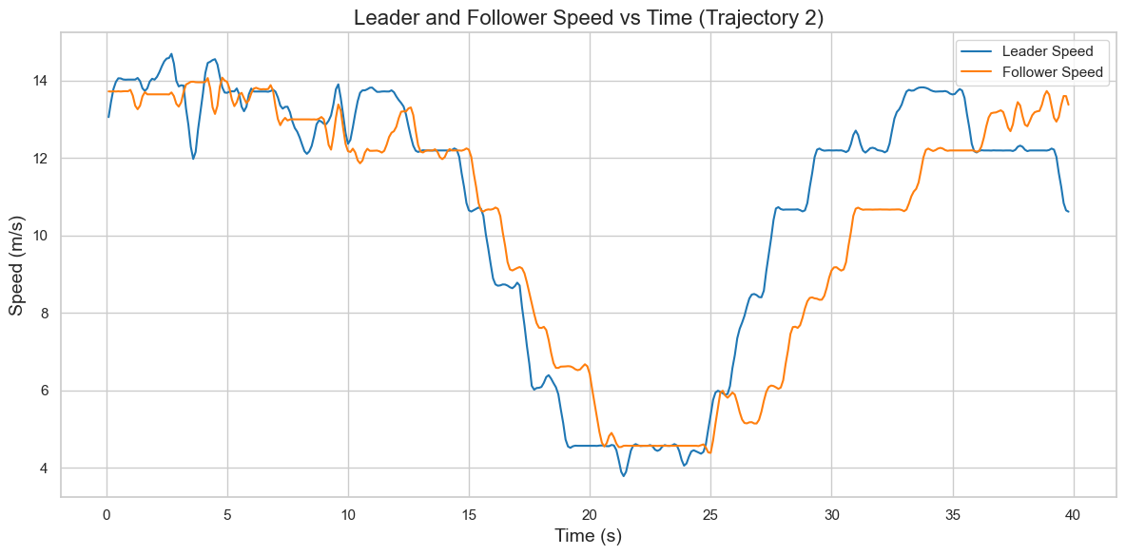
Figure 6 Leader and follower speed vs time

IDM results
The IDM simulation was run using trajectory number 2 from NGSIM data. The simulated follower vehicles started from the same initial place and speed as the real follower vehicle, and the model used the leader trajectory as the input.
Figure 7: is the acceleration comparison plot. This graph compares the leader acceleration, real follower acceleration, and simulated follower acceleration over time. The leader acceleration ranges from -5.95 to 5.95 (m/s^2), and the real followers' acceleration ranges from about -5 to 5 (m/s^2). While the simulated follower acceleration is much smoother at about -2 to 1 (m/s^2), as it knows the trajectory of the leader acceleration. Real drivers tend to make more sudden throttle and braking adjustments, while the IDM model produces a smoother response.
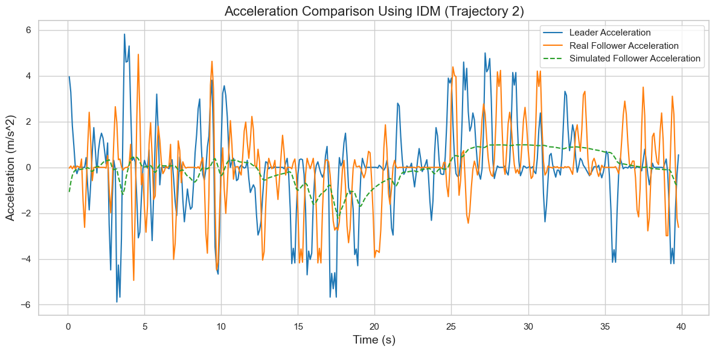
Figure 7 Acceleration Comparison Using IDM

Figure 8: is a position comparison plot. This graph compares the real follower position, simulated follower position, and leader position over time. The simulated follower generally follows the same trend line as the real follower position but tends to stay closer to the leader position. At the end of the simulation, the simulated follower position was closer to the leader position but not by much, showing how the simulation isn’t 100% accurate but does tend to follow relatively the same trendlines.
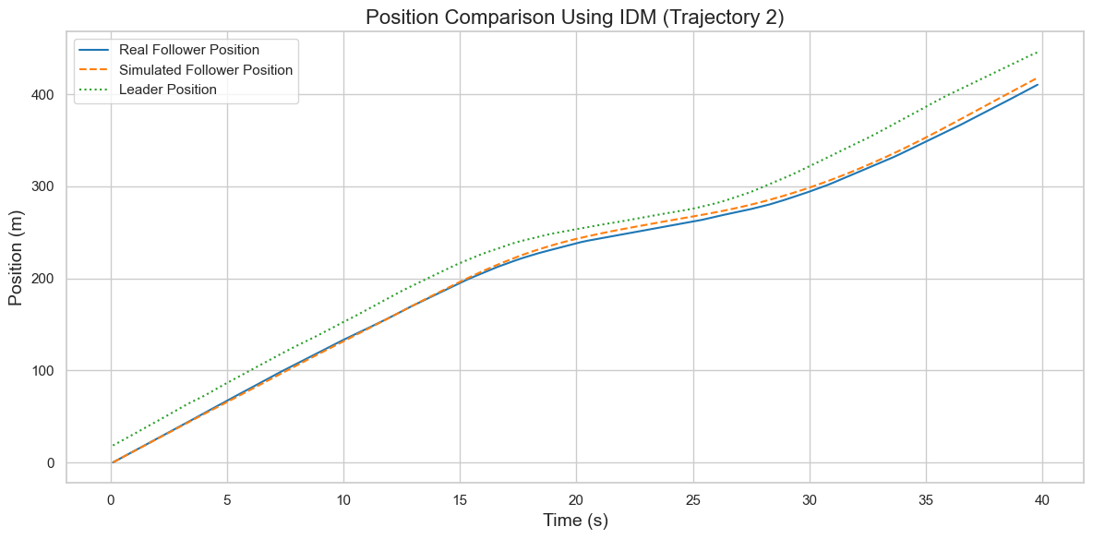
Figure 8 Position Comparison Using IDM

Methods

Data Import and Review
The project analysis was completed in Python using pandas, matplotlib, and seaborn. The two datasets used in this project were the National Household Travel Survey (NHTS) dataset, which describes household and vehicle characteristics, and the Next Generation Simulation (NGSIM) dataset. Each CSV file was imported into Python as a pandas DataFrame. After importing the column names, data types, and missing values were reviewed to make sure all the data necessary to complete the project was included. For each figure, rows with missing data were excluded before plotting to include only necessary data, and all plots were given titles, axis labels, and legends.

NHTS Variables
The NHTS portion of the project selected three variables because they demonstrate transportation patterns useful for planning. The first selected variable was vehicle_type, which was used to summarize the composition of the vehicle fleet. This was selected because it helps show what type of car is most common amongst households taking this road, such as SUVs, pickup trucks, vans, and motorcycles. This can help us understand what the overall design and needs to meet are for this road. The second selected variable was vehicle_age, which is used to describe the distribution of vehicle ages in the given data. The third selected set of variables was the vehicles_per_household, which was grouped by household_location. These variables were selected to compare how vehicle ownership differs between urban and rural areas.

Bar Chart Construction
The bar chart was constructed from the NHTS dataset using the vehicle_type column. The observations were counted on a frequency table and were plotted with the x-axis being the categories and the y-axis being the count. This plot was designed to show how often each vehicle type appears.

Histogram Construction
The histogram was constructed using the NHTS vehicle_age variable. Treating vehicle age as a numeric value, the team created a histogram with evenly spaced bins to show the distribution of vehicle ages for the dataset. The team chose to do a histogram because it is exceptionally well-suited to show spread, concentration, and outliers of a continuous or a discrete number, such as vehicle age.

Boxplot Construction
The boxplot was created using household_location as the grouping variable and vehicles_per_household. The team had used multiple box plots for the rural and urban categories. The boxplot shows the median, the quartile ranges, and the outliers are displayed automatically by the boxplot. This type of graph was used as it shows the bigger picture needed for the distribution of vehicle ownership. This makes it easier to see whether one group tends to own more vehicles and if one has a variety of vehicles.

NGSIM Variables
For the NGSIM portion of the project, the variables Time, leader_speed(m/s), follower_speed(m/s), leader_acc(m/s^2), follower_acc(m/s^2), leader_position(m), follower_position(m), and trajectory_number were used. These were selected because they show the relationship between a leader vehicle and a follower vehicle. The team used speed and acceleration to show how a driver responds over time, so we could see the gap behavior. The trajectory number was used so one specific leader-follower pair could be selected and tracked throughout the analysis. The team had also made another plot using the leader position and follower position plotted against time. Making a new variable called gap distance.

Intelligent Driver Model (IDM) Simulation
The final method used in the project was the Intelligent Driver Model (IDM) simulation. For this part, one NGSIM trajectory was selected, and the leader's motion was used as the model input. Then the follower's starting position was taken from the same trajectory. Then, at each time step, the IDM was used to calculate the simulated follower acceleration based on the spacing between the vehicle and the follower speed, and the speed difference between the leader and the follower.
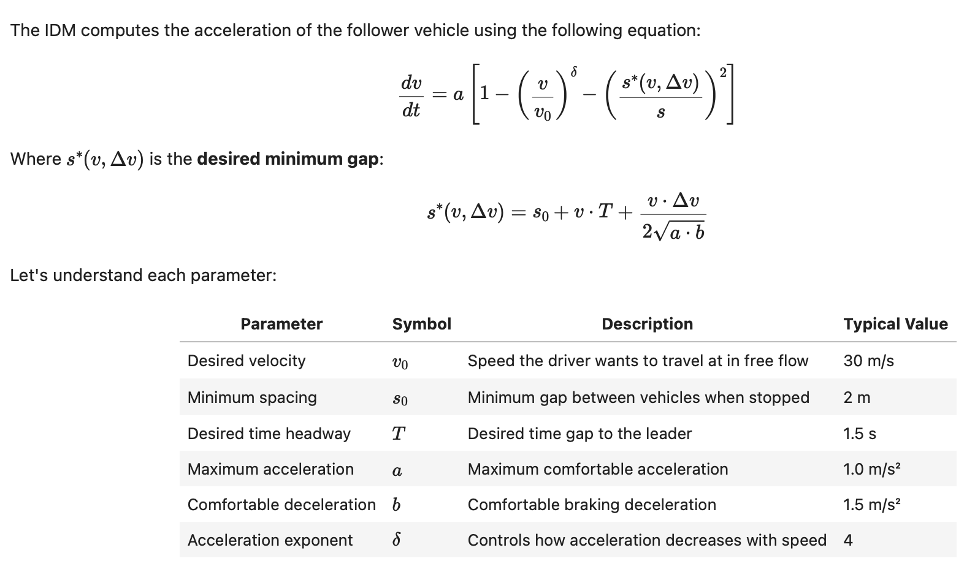
Figure 9 IDM parameters, symbols, descriptions, and typical values

Figure 10 IDM acceleration and desired minimum gap equations

Model Comparison
To compare the model to the actual data, a final plot was made showing the leader acceleration, observed follower acceleration, and simulated follower acceleration. Plotting the data made it possible for us to be able to compare the real follower behavior vs the IDM.

AI Usage
AI was used in the making of this project. The AI tools used were Grammarly, ChatGPT, and Visual Studio. Grammarly was used to correct typos and run-on sentences it also rewrote some sentences. ChatGPT was used to summarize the project and to give a layout of what should go where. Visual Studio was used to help make the code to fix errors and reduce the fatigue of typing everything out.

References
OpenAI. (2026). ChatGPT (March 30 version) [Large language model]. https://chat.openai.com/
Federal Highway Administration. (2023). Next Generation Simulation (NGSIM). U.S.
Department of Transportation. https://ops.fhwa.dot.gov/trafficanalysistools/ngsim.htm
Federal Highway Administration. (2022). National Household Travel Survey (NHTS).
U.S. Department of Transportation. https://nhts.ornl.gov/
Grammarly. (2026). Grammarly [Writing assistance software]. https://www.grammarly.com/
Microsoft Corporation. (n.d.). Visual Studio Code [Computer software]. https://code.visualstudio.com/
(2020). Traffic-Simulation.de. https://traffic-simulation.de/info/info_IDM.html

‌

