Automation of Steel Beam Calculations
Jacob Kosmicki, Ryder Anderson, Harrison Drake
Dr. Lane
Course: CIVE 202
5/8/2026
Client: Kiewit Corporation (Internal)

Contents
Table of Figures 3
Technical Executive Summary 4
Non-Technical Executive Summary 4
Analysis 5
Scenario 1:W8x21 5
Scenario 2: W10x33 6
Scenario 3: W6x15 6
Plot Results 6
Methods 8
Function Design 9
Data loading 10
Scenario Selection 11
Plot Construction 11
Instructions 11
Bias and Decision making 12
Why separate functions for each limit state? 12
Why use steelpy instead of hardcoding section properties? 12
Why compute both LRFD and ASD? 13
Why these three scenarios? 13
Bias in the design approach: 13
Ai Usage 13
References 13

Table of Figures
Figure 1 LRFD Tension Member Comparison 7
Figure 2 ASD Tension Member Comparison 8

Technical Executive Summary
The following report is written over our chosen Project 5 topic, which is the automation of W-shaped tension member design calculations for Kiewit Corporation. The structural team at Kiewit Corporation typically and frequently uses the American Institute of Steel Construction (hereinafter referred to as AISC) manual. The engineers at Kiewit have created their own versions of an Excel spreadsheet to handle the calculations needed for their job, but the company as a whole has not created a standardized spreadsheet. These spreadsheets are not widely shared and do not function the same. Due to these factors, the Structural PE Program Manager has requested a proof-of-concept Python code sheet that can automate the tension member design procedure from AISC Example D.1. The program checks tensile yielding on the gross section, tensile rupture on the net section, and the recommended slenderness limit. Then three different W-shaped scenarios were run through the code, and the results were plotted. This was done to compare the different scenarios and show the code working further.

Non-Technical Executive Summary
To address the issue for Kiewit Corporation, this project developed a Python-based computer program. It was used to unify the process of calculating steel members in W-shape by creating an automatic design tool that eliminates the need for multiple Excel files created by different engineers. This tool can be used by the engineer to enter data regarding the steel member information, connection data, and loading data. As a result, the output would be design results and comparative graphs.

Three different cases of the steel member were evaluated to demonstrate how the algorithm operates across various member dimensions and connection-point conditions. As the results show, the higher the dimension of the steel, the higher the available strength. However, using smaller dimension or shorter connections may result in reducing the available capacity. In summary, this program provides Kiewit Corporation with a proof of concept for automation of the steel calculation process.

Analysis
First, to start the analysis in the code, the functions were verified against the known results from AISC Example D.1. The example from the manual used a W8x21 W-shape beam with ASTM A992 steel (Fy = 50 ksi, Fu = 65 ksi), four bolt holes with 3/4-inch bolts, a connection length of 9 inches, and a member length of 25 feet. The section properties were loaded using steelpy instead of hard-coding them into the code.
After running the code, the verification results matched the AISC manual final results.

Scenario 1:W8x21
The first scenario uses the same WW8x21 section from Example D.1. The dead load used was 30 kips, and the live load used was 90 kips. These two variables give a required LRFD strength of 180 kips and a required ASD strength of 120 kips. Both of these variables exceed the available strengths for yielding and rupture. Tensile rupture governs the design with an LRFD available strength of 210.6 kips, apart from 277.2 kips for yielding.

Scenario 2: W10x33
The second scenario uses a larger W10x33 section with a corresponding longer connection length of 12 inches. The dead load is 50 kips, and the live load is 120 kips. The larger gross area increases the yielding capacity of the modulus, and the longer connection raises the shear lag factor U, which, in turn increases the rupture capacity as well. This scenario showcases when a larger section provides significantly more capacity than the required strength. The section properties were also pulled from steelpy with the WT5x16.5 centroid distance used for the shear lag calculation.

Scenario 3: W6x15
The final scenario uses a smaller W6x15 section with a shorter connection length of 6 inches. The dead load used in the scenario is 20 kips, with the live load being 50 kips. The smaller gross area subsequently reduces the yielding capacity, and the shorter connection reduces U, which then subsequently reduces the rupture capacity further. This scenario showcases where the tensile rupture governs the scenario due to the connection geometry. The WT3x7.5 centroid distance was used for the shear lag factor.

Plot Results
The LRFD comparison plot shows the available yielding strength, available rupture strength, and required strength side by side. Across the three scenarios, the yielding strength is higher than the rupture strength. This confirms that tensile rupture governs each specific case. The W10x33 has the highest available strengths of the three, while the W6x15 has the lowest. The ASD comparison plot shows the same trend. Both the plots were made within the Jupyter notebook.
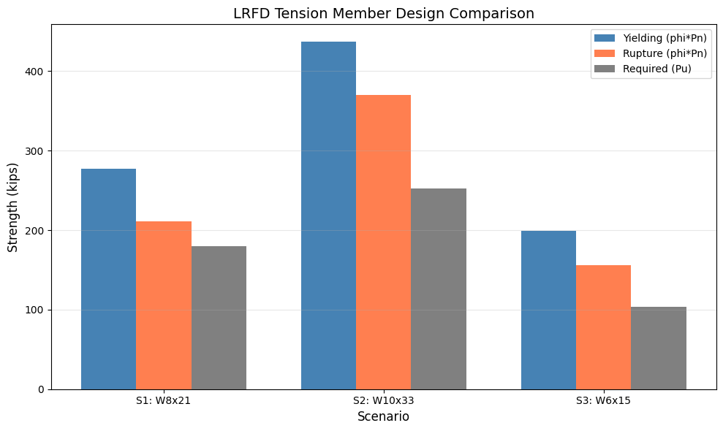
Figure 1 LRFD Tension Member Comparison

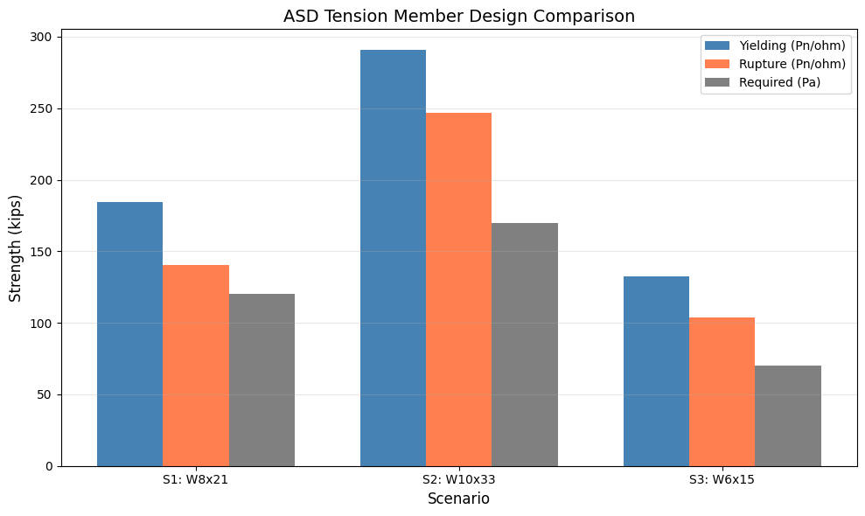
Figure 2 ASD Tension Member Comparison

Methods
The main data source used for developing this project was the AISC Steel Design Examples V15.1), specifically Example D.1 for a W-shaped tension member. The AISC Steel Construction Manual (15th Edition) was also referenced for specification equations. Section properties were loaded from the steelpy package (v1.1.1); due to this loading external sources, it is an external source as well as a newly installed package loaded into Python.

Function Design
A total of six Python functions were created to automate the member designs. Two “helper” functions were made to pull section properties from the steelpy database. The get_w_porps function receives a W-shape name as a string within Python and returns a database of all section properties, such as area or flange width, for example.
The get_wt_xbar function takes a WT-shape name and returns the centroid distance. These two functions replace having to hardcode these values in the code by hand. The tensile_yielding function checks tensile yielding on the gross section. It takes the yield strength and gross area as inputs, then calculates the nominal strength using the equation Pn = Fy x Ag. It then applies the LRFD resistance factor of 0.90 and the safety factor of 1.67 to return the nominal strength and available strength.
The tensile_rupture function calculates the tensile rupture for the net section. This function receives a total of nine inputs: the ultimate strength (Fu), gross area (Ag), number of bolt holes, bolt hole diameter (dh), flange thickness (tf), flange width (bf), depth (d), connection length, and the WT-shape centroid distance (x_bar). From these inputs, the function calculates the net area. It then determines the shear lag factor of U. The effective net area is found, as well as the nominal rupture strength. Finally, as with the last function, it applies the LRFD factor of 0.75 and the ASD factor of 2.00, then returns the nominal strength, both available strengths, net area, effective net area, and the shear lag factor used.

The effective net area is computed as An times U per Equation D3-1, and the nominal rupture strength is Fu times Ae per Equation D2-2. The function applies the LRFD factor of 0.75 and ASD factor of 2.00 and returns the nominal strength, both available strengths, net area, effective net area, and the shear lag factor used.
The slenderness_check function takes the member length in feet and the radius of gyration and verifies that L/r does not exceed 300 per AISC Specification Section D1. It returns the ratio and a True/False result.
The tension_member_design wrapper function combines all three checks into one. It takes fifteen inputs: the section name, Fy, Fu, Ag, bf, tf, d, ry, x_bar, number of holes, hole diameter, connection length, member length, dead load, and live load. It first calculates the required LRFD strength and ASD strength, then runs the yielding, rupture, and slenderness functions. This determines which limit state governs by comparing the LRFD available strengths.

Data loading
The steelpy package was used as the external data source. A total of 289 W-shape sections and 289 WT-shape sections were loaded from the steelpy database using pandas DataFrames. The W-shape DataFrame was cleaned by selecting only the columns relevant to tension member design, these are: section name, weight, area, depth, flange width, flange thickness, web thickness, and radius of gyration. For easier use, the columns were renamed, and any dashed values were replaced with NaN. The WT-shape DataFrame was filtered to just the section name and centroid distance.

Scenario Selection
Three different scenarios were run through the functions. As a reiteration of the above, the first scenario was selected as the baseline to verify the code's functionality against Example D.1. The second scenario was selected to show where the section has more capacity. The third scenario was chosen to showcase where rupture governs more than the other three examples. The section properties for each scenario were pulled from the steelpy database instead of hardcoding the numbers.

Plot Construction
All plots were constructed in a Jupyter notebook as the last projects. Matplotlib was chosen to create and plot the charts. The results from the three scenarios were plotted on a grouped bar chart; one chart compares the LRFD strengths, while the other compares the ASD values. Each scenario is labeled on the x-axis and color-coded with a legend for easy comparison. The y-axis is labeled in kips.

Instructions
Any current or future Kiewit employee can use the code by following the corresponding steps. First remove the # symbols in front of the pip install steelpy to install steelpy package into the terminal. Then run the code cell to load matplotlib, numpy, pandas, and steelpy. The employee can run any W-shape tension member design by calling the tension_member_design function with the section name, material properties, section geometry, connection details, member length, and loads. The section properties can be pulled from steelpy using the get_w_props and get_wt_xbar helper functions so the engineer does not need to look up values in the manual by hand, thus expediting the process. The function then prints a summary of the yielding, rupture, and slenderness results and returns a table that can be used in the future.
To run a new scenario the employee only needs to change the inputs in the function call. For example, to check a W12x50 with different loads, the engineer would call get_w_props("W12X50") to pull the section properties and then pass those properties along with the connection details and loads into the tension_member_design function. No changes to the underlying code are needed. This is the standardization that Kiewit requested to replace the inconsistent Excel spreadsheets across the office.
Reference the annotated code document for the Python code required for each step.

Bias and Decision making
Why separate functions for each limit state?
The yielding, rupture, and slenderness checks were written as individual functions because each check follows a distinct procedure in the AISC specification. Keeping them separate makes it easier for a future Kiewit engineer to update one check without affecting the others. It also makes debugging easier since each function can be tested on its own.
Why use steelpy instead of hardcoding section properties?
The original approach had all section properties typed in by hand from the AISC tables. This is error prone and defeats the purpose of automation. By pulling properties directly from the steelpy database, we eliminate manual lookup errors and make it easy to run the design for any W-shape without editing the code. This is the kind of standardization Kiewit requested.
Why compute both LRFD and ASD?
The AISC manual presents both design methods side by side. Computing both allows the engineer to use whichever method their project requires. This matches the format of Example D.1 in the AISC Design Examples.
Why these three scenarios?
The three scenarios were chosen to show how the governing limit state shifts. Scenario 1 is the baseline from Example D.1 where rupture governs. Scenario 2 uses a larger section with a longer connection to show how increasing the connection length raises U and can shift the governing state. Scenario 3 uses a smaller section with a shorter connection where rupture governs more heavily. This range demonstrates the sensitivity of the design to connection details.
Bias in the design approach:
The automated functions assume standard bolt hole sizes and ASTM A992 steel. If a designer used a different steel grade or non-standard holes, the results would change. The shear lag factor U calculation also depends on the connection geometry which the user must input correctly. The tool automates the math but the engineering judgment on connection layout is still the designer's responsibility.

Ai Usage
AI was used in the making of the project with Visual Studio, Claude, and Grammarly. Visual Studio was used to speed up and to understand the code, while Grammarly was used to help fix typos and run-on sentences. Claude was used to help structure the Python functions, integrate the steelpy package, and verify the calculation procedure against the AISC manual.

References
Anthropic. (2026). Claude (Claude Opus 4.6) [Large language model]. https://claude.ai
American Institute of Steel Construction. (2019). Steel Construction Manual Design Examples, Version 15.1. AISC.
American Institute of Steel Construction. (2017). Steel Construction Manual, 15th Edition. AISC.
steelpy v1.1.1 (2024). AISC Shapes Database for Python. https://pypi.org/project/steelpy/
Grammarly Inc. (2026). Grammarly (Version 2026) [Writing assistance software]. https://www.grammarly.com/
Microsoft. (2026). Visual Studio (Version 2026) [Integrated development environment]. https://visualstudio.microsoft.com/ (visualstudio.microsoft.com in Bing)

