This Very Website

The first project in here is of course this website itself. I am a lazy person, so even crafting
this little website is considered a significant ordeal for me. I used to be relatively capable with
HTML, CSS and JS, but that was almost 2 years ago. So I've had to revisit some videos and re-learn
most of this stuff. Oh well. As I'm typing this, the website is not live, nor is it even ready to be
considered in anyway a functioning site. This projects page has nothing but a couple of headers, and
the home page is filled with just a bunch of useless stuff from me trying to refarmiliarise myself
with HTML.

As I am typing this second paragraph, the webiste doesn't look too bad, now that I've rekindled my CSS knowledge a little more.

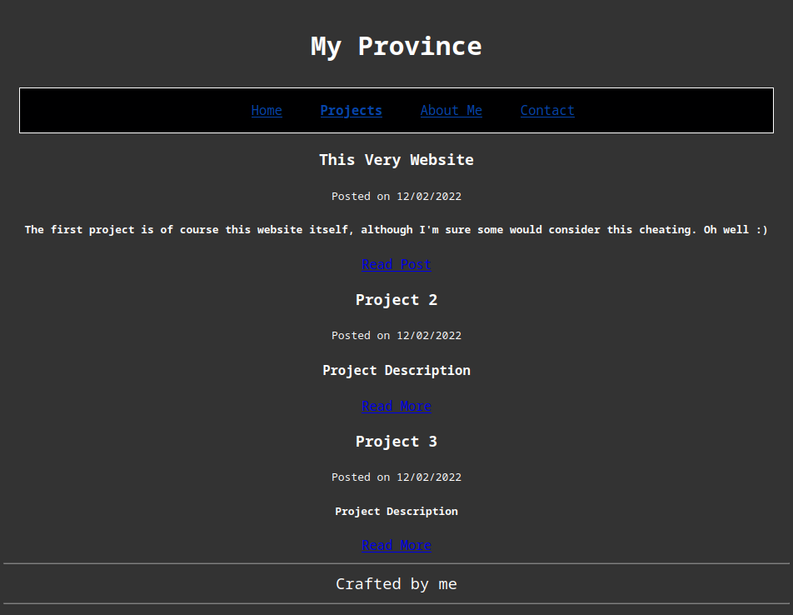

In this little ‘blog post’, yes I suppose that’s what you would classify this as, I would like to outline the purpose of this website and the kinds of things you can expect to see on here.

Soon I will be purchasing a 3D printer, and so I intend to post a lot of my prints on this website, partially to show them off, but also to motivate me to make even more of them. I will add another section for this, which by the time you are reading this will already be there. The most important part of the site will be this projects page, where you will be able to read about my various electronics and possibly programming projects here (if I bother to program anything in my free time). As I said before, I’m pretty lazy, but I actually really enjoy making little electronics projects, when I have interesting enough ideas that is. Programming on the other hand is unlikely since I’ve never written a substantial amount of code for anything outside of college. It simply isn’t my passion I suppose, although I do enjoy it, just not enough to push me to do it more often. But who knows, maybe I’ll finish that home assisstant program I was working on many months ago. Now that I’ve discovered the wonderful Raspberry Pi Zero 2 w, I have the perfect system to run the program on, and with that 3D printer coming soon, I’ll even have an enclosure. How exciting.

My aspirations for the future have me as a cryptographer of some sorts. In about 7 months I’ll be off to study Mathematics at university, and in my eyes there are really only 3 possible paths for me from there. I could spec into applied mathematics, become some sort of physicist or maybe even try to shoe-horn myself into an engineering career. Problem: I don’t like physics. Or maybe I do, a little, but with how poor my teachers have been over the years (especially right now, my goodness), any enjoyment of the subject has left me. Besides, I don’t think I’ve ever gone out of my way to look into physics in my own time the way I do with maths and computer science, but I digress. Another option is statistics, which could lead to a nice, well paid career in data science. Problem: I’m not a fan of statistics. Statistics in my opinion, isn’t too difficult, but what it is, is mind numbingly boring. Final option, Pure Mathematics (the best part) with a heavy focus on number theory in order to steer me into cryptography. That’s the (very loose) plan right now I suppose.

Anyway the reason I went on that huge tangent is to mention that I need to look into stuff related to cryptography and cyber security in general. This pertains to the topic of this here website in two ways: I may post about such topics, and I need to get a more private email service so I can setup a functioning contact page, as well as making my technological presence more secure too, without having to become a complete social outcast in the process (probably impossible, considering how many services out there either sell your data or are just outright spyware). Back to the email, I doubt anyone will bother to contact me, but no website is complete without a nice contact section.

If you look at the top of this page you will see ‘Posted on 12/02/22’, but it is infact now 13/02/22, and as such, in the interest of healthy sleeping habits, I will be ending this first post soon, but before I do, I need to mention the final purpose of this website, the about me page: a lovely excuse to write things, which I may or may not do. Fancy.

Thank you for reading, here’s to many more mediocre posts!

