Ministry of Education and Science of Ukraine
National Technical University of Ukraine
“Kyiv Polytechnic Institute named after Igor Sikorsky”
Educational and Scientific Institute of Atomic and Thermal Energy
Department of Digital Technologies in Energy

Visualization of graphical and geometric information
Graphics Work Report
Operations on texture coordinates

Student: Yarmoshenko Roman
Group: TR-52mp
Variant: 20

Kyiv – 2025
1. Task
The purpose of this laboratory work is to render a parametric surface in WebGL using indexed triangles and to apply modern per-pixel lighting based on normal mapping. The surface must support interactive control of granularity in the U and V directions and must be rendered with three different textures: a diffuse texture, a specular texture, and a normal texture. The diffuse texture modulates only the diffuse lighting component, the specular texture modulates only the specular component, and the normal texture provides a per-pixel normal in tangent space.
In addition, a tangent space basis (TBN) must be constructed for each vertex. The tangent vector has to be orthogonalized via Gram–Schmidt while giving priority to the vertex normal (i.e., the normal is treated as the stable direction and the tangent is adjusted to be perpendicular to it).
As an extra interactive feature, the texture coordinates must be transformed at runtime: the user can move the pivot point of rotation in UV space and rotate the texture around that pivot using keyboard controls. All transformations must be visible directly on the rendered surface.
The final result should demonstrate correct shading, stable normal mapping (without artifacts caused by a non-orthonormal basis), and responsive interaction in real time.

2. Theory
2.1 Parametric surface tessellation and indexed triangles
A parametric surface is described by a mapping S(u,v) that converts two parameters into a 3D point. To render such a surface on the GPU, the continuous domain of (u,v) is discretized into a grid. Each grid node becomes a vertex in a vertex buffer, and each grid cell is split into two triangles. Using an index buffer (ELEMENT_ARRAY_BUFFER) allows reusing the same vertex in multiple triangles, which reduces memory usage and makes it easy to change granularity by regenerating only arrays of vertices and indices.
If the grid has U lines and V samples, then each quad cell (i,j) references four vertices: i0 = (i,j), i1 = (i,j+1), i2 = (i+1,j), i3 = (i+1,j+1). Two triangles are typically formed as (i0, i1, i2) and (i1, i3, i2). Invalid vertices (for example, points where the equation cannot be solved) must be skipped, otherwise the triangles would be broken.
2.2 Lighting model: Ambient + Diffuse + Specular
The illumination of a point on the surface is computed as the sum of three components: ambient, diffuse, and specular. Ambient approximates indirect light and is constant for the surface. Diffuse is based on Lambert’s law and depends on the cosine of the angle between the surface normal N and the light direction L: max(dot(N,L),0). Specular models glossy highlights. A common approximation uses the Blinn–Phong model with a half-vector H = normalize(L+V), where V is the view direction. The specular term is pow(max(dot(N,H),0), shininess).
In this work, the diffuse texture modulates only the diffuse coefficient (kd), and the specular texture modulates only the specular coefficient (ks). This separation gives better artistic control: a material can be matte but still have colored diffuse details, or it can have localized shiny parts controlled by the specular map.

2.3 Normal mapping and tangent space basis (TBN)
Normal mapping is a technique that changes the normal used in lighting per pixel, without increasing geometry complexity. A normal texture stores a direction vector, usually in tangent space, encoded into RGB components. To use this normal in lighting, it must be transformed from tangent space to the space where lighting is evaluated (view space in this project).
For the transformation we build a local orthonormal basis at each vertex: T (tangent), B (bitangent), and N (normal). The tangent points in the direction of increasing U on the surface, and the bitangent points in the direction of increasing V. These vectors form a 3×3 matrix TBN. If n_ts is the normal sampled from the normal map (decoded to [-1..1]), then the view-space normal is N_vs = normalize(TBN * n_ts).
A crucial requirement is that T, B, and N are close to orthonormal. Otherwise the normal map becomes distorted, which produces visible artifacts such as incorrect highlights or sudden flips. In practice, the raw tangent computed from UV derivatives is orthogonalized against the normal using Gram–Schmidt.
2.4 Gram–Schmidt with priority to the normal
Gram–Schmidt orthogonalization is used to make the tangent perpendicular to the normal. The idea is to subtract from the tangent its projection on the normal: T' = T − N * dot(N, T). After that, T' is normalized. This step keeps N unchanged, so the normal is treated as the stable reference direction. Then B is reconstructed as cross(N, T') multiplied by a handedness sign. This handedness (often stored as a single scalar w) ensures consistent orientation of the tangent space even when UV mapping is mirrored.

3. Implementation details
3.1 Buffers, textures and uniforms
The surface is stored as five GPU buffers: positions (a_vertex), normals (a_normal), texture coordinates (a_texCoord), tangents (a_tangent), and an index buffer for triangles. The program creates one VBO per attribute and one IBO for indices. During rendering, each buffer is bound and connected to the corresponding attribute location using vertexAttribPointer.
Three textures are loaded from image files. The code binds them to texture units 0, 1, and 2 and assigns these units to the sampler uniforms u_diffuseTex, u_specularTex and u_normalTex. Because the fragment shader uses the same UV coordinates for all three textures, the maps stay aligned on the surface.
3.2 Surface generation and indices
The surface is generated for a given number of U lines and V samples (controlled by sliders). For each patch and each sign branch, the algorithm iterates over the (u,v) grid, solves the implicit equation, and stores the corresponding XYZ position. UV coordinates are computed by normalizing the parameter values into [0..1]. Then indices are emitted for every valid grid quad as two triangles. Invalid vertices are stored as NaN and any triangle that references at least one invalid vertex is skipped.
3.3 Vertex normals and tangents
Vertex normals are computed as a weighted average of adjacent face normals. For each vertex, all triangles sharing this vertex are collected. For each triangle, a face normal is computed by a cross product of its edges. The contribution of the face normal to the vertex is weighted by the corner angle at that vertex (facet angle weighted average). This reduces bias from very small or very large triangles and usually produces stable smooth shading.
Tangents are computed from the triangle geometry and its UV mapping. For each triangle, the position differences and UV differences form a small linear system that produces a tangent direction (U axis) and a bitangent direction (V axis). These per-face vectors are accumulated into per-vertex sums (tan1 and tan2). After accumulation, the tangent at each vertex is orthogonalized against the normal using Gram–Schmidt. Finally, the handedness w is computed to reconstruct a consistent bitangent in the shader.

3.4 Texture coordinate transformation (pivot + rotation)
To rotate the texture on the surface, the shader does not modify vertex positions; instead it modifies the UV coordinates used for sampling. Two uniforms are used: u_texPivot is the pivot point in UV space, and u_texAngle is the rotation angle in radians. In the fragment shader, the UV coordinate is shifted by subtracting the pivot, rotated by a 2D rotation matrix, and shifted back. The resulting UV is then used to sample diffuse/specular/normal textures.
The pivot and angle are controlled by keyboard events in JavaScript. Keys A/D move the pivot along U, W/S move it along V, Q/E rotate the texture, C resets the pivot to the center (0.5,0.5) and R resets the angle to 0.0. After each input, the values are clamped and uploaded to the GPU using uniform2fv and uniform1f.

4. User instructions
1) Open the HTML page in a browser that supports WebGL.
2) Use the trackball controls (mouse drag) to rotate the camera and inspect the surface.
3) Use the U and V sliders to change the surface granularity. After moving a slider, the mesh is regenerated and rendered again.
4) Use the keyboard controls to move the texture pivot and rotate the texture in real time:
A / D – move pivot left / right (U − / U +)
W / S – move pivot up / down (V + / V −)
Q / E – rotate texture counterclockwise / clockwise
C – reset pivot to the center (0.5, 0.5)
R – reset angle to 0.0
5) Verify the normal mapping by observing moving specular highlights when the light source rotates.
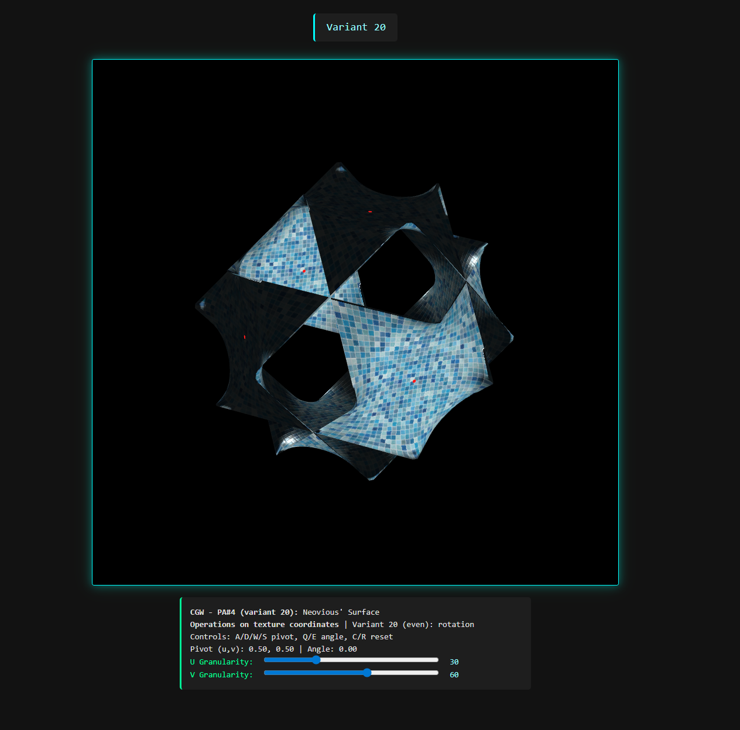
Picture 1 - Main window with the rendered surface and sliders.

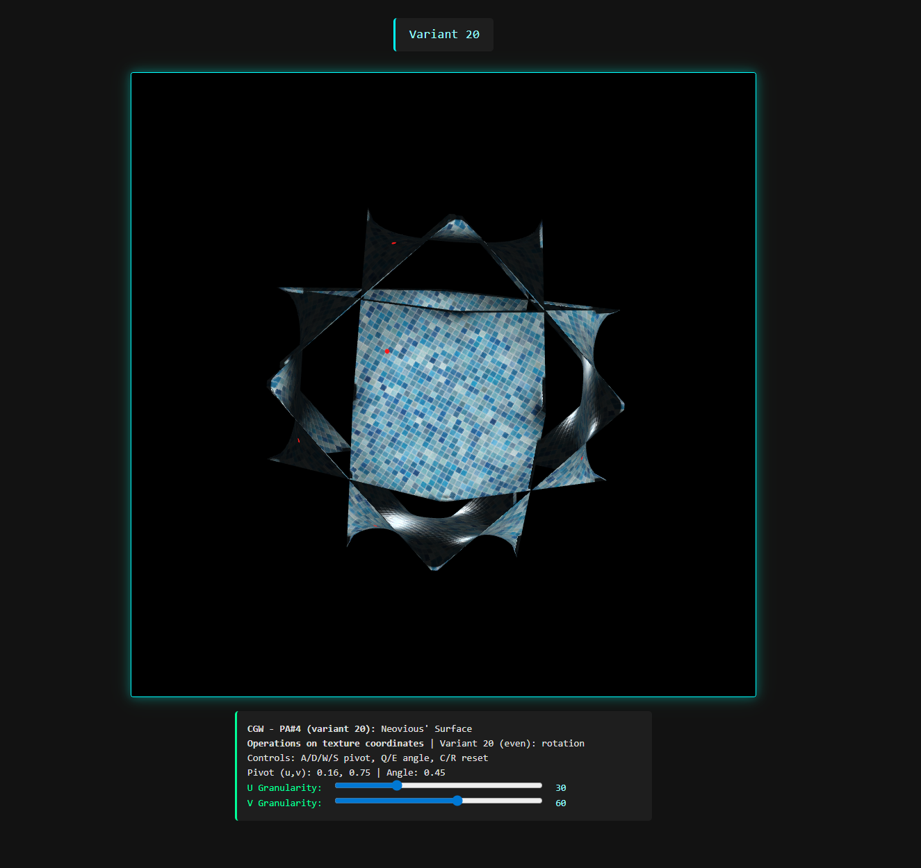Picture 2 - Texture pivot marker after moving and rotating pivot with keys (W/S/A/D & E/Q)
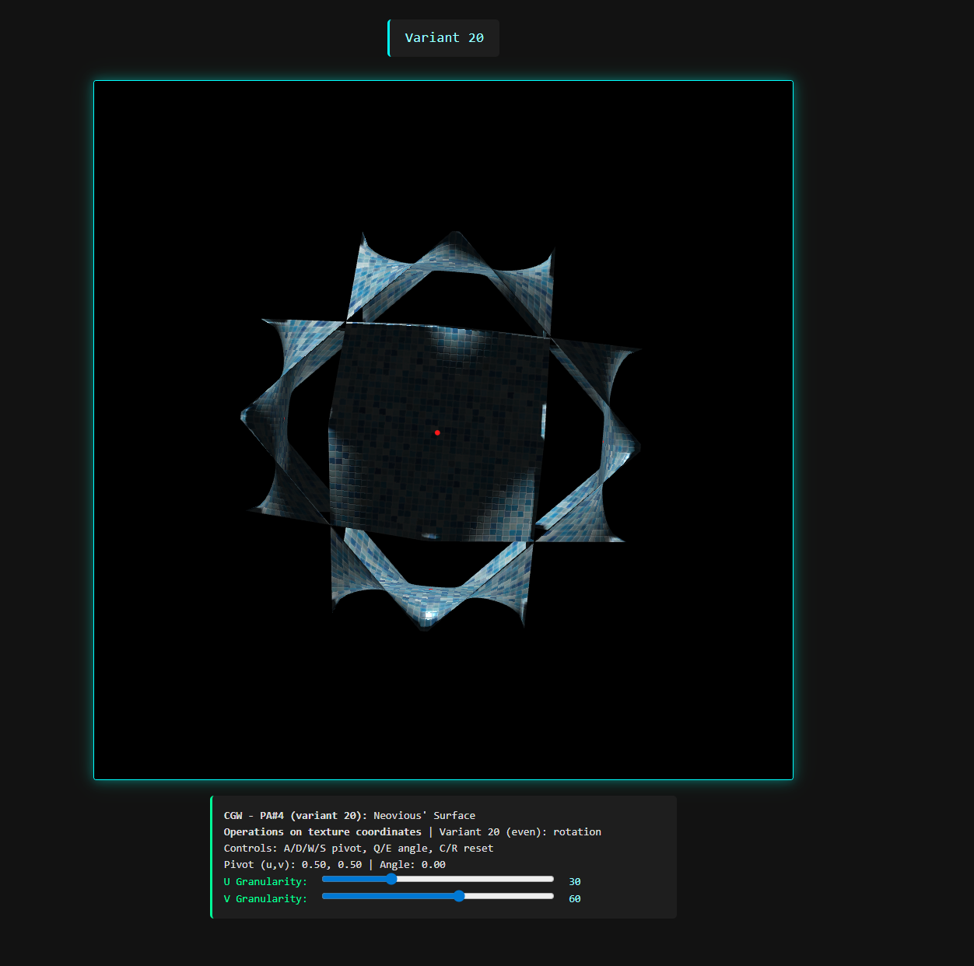
Picture 3 – Reset pivot point to [0.5, 0.5] and angle to 0.0 with keys (C/R)

5. Source code sample
5.1 Tangent computation (main.js)
// Per-face accumulation:
const tan1 = new Float32Array(numVertices * 3);
const tan2 = new Float32Array(numVertices * 3);

for (let f = 0; f < indices.length; f += 3) {
const i0 = indices[f], i1 = indices[f+1], i2 = indices[f+2];

// positions
const p0 = i0 * 3, p1 = i1 * 3, p2 = i2 * 3;
const x0 = vertices[p0], y0 = vertices[p0+1], z0 = vertices[p0+2];
const x1 = vertices[p1], y1 = vertices[p1+1], z1 = vertices[p1+2];
const x2 = vertices[p2], y2 = vertices[p2+1], z2 = vertices[p2+2];

// UVs
const w0 = i0 * 2, w1 = i1 * 2, w2 = i2 * 2;
const u0 = uvs[w0], v0 = uvs[w0+1];
const u1 = uvs[w1], v1 = uvs[w1+1];
const u2 = uvs[w2], v2 = uvs[w2+1];

const dx1 = x1-x0, dy1 = y1-y0, dz1 = z1-z0;
const dx2 = x2-x0, dy2 = y2-y0, dz2 = z2-z0;
const du1 = u1-u0, dv1 = v1-v0;
const du2 = u2-u0, dv2 = v2-v0;

const denom = du1 * dv2 - du2 * dv1;
if (Math.abs(denom) < 1e-8) continue;

const r = 1.0 / denom;

// T and B for this triangle
const tx = (dx1 * dv2 - dx2 * dv1) * r;
const ty = (dy1 * dv2 - dy2 * dv1) * r;
const tz = (dz1 * dv2 - dz2 * dv1) * r;

const bx = (dx2 * du1 - dx1 * du2) * r;
const by = (dy2 * du1 - dy1 * du2) * r;
const bz = (dz2 * du1 - dz1 * du2) * r;

// accumulate into vertices
tan1[p0] += tx; tan1[p0+1] += ty; tan1[p0+2] += tz;
tan1[p1] += tx; tan1[p1+1] += ty; tan1[p1+2] += tz;
tan1[p2] += tx; tan1[p2+1] += ty; tan1[p2+2] += tz;

tan2[p0] += bx; tan2[p0+1] += by; tan2[p0+2] += bz;
tan2[p1] += bx; tan2[p1+1] += by; tan2[p1+2] += bz;
tan2[p2] += bx; tan2[p2+1] += by; tan2[p2+2] += bz;
}

// Per-vertex finalize (Gram–Schmidt + handedness w)
for (let i = 0; i < numVertices; i++) {
const p = i * 3;

vec3 N = normalize(normals[p..p+2]);
vec3 T = tan1[p..p+2];

// prioritize N: T = T - N * dot(N,T)
T = normalize(T - N * dot(N, T));

float w = (dot(cross(N, T), tan2[p..p+2]) < 0.0) ? -1.0 : 1.0;

tangents[i*4+0] = T.x;
tangents[i*4+1] = T.y;
tangents[i*4+2] = T.z;
tangents[i*4+3] = w;
}

5.2 Normal mapping and UV rotation (shader.gpu)
// Fragment shader: rotate UV around pivot
uniform vec2 u_texPivot;
uniform float u_texAngle;

vec2 rotateUV(vec2 uv, vec2 pivot, float angle) {
float s = sin(angle);
float c = cos(angle);
uv -= pivot;
uv = vec2(uv.x * c - uv.y * s, uv.x * s + uv.y * c);
uv += pivot;
return uv;
}

void main() {
vec2 uv = rotateUV(v_uv, u_texPivot, u_texAngle);

// decode normal map (tangent space)
vec3 n_ts = texture2D(u_normalTex, uv).xyz * 2.0 - 1.0;

// build TBN in view space
mat3 TBN = mat3(normalize(v_T), normalize(v_B), normalize(v_N));
vec3 N = normalize(TBN * n_ts);

// sample kd and ks
vec3 kd = texture2D(u_diffuseTex, uv).rgb;
vec3 ks = texture2D(u_specularTex, uv).rgb;

// lighting: Ambient + Diffuse + Specular
float NdotL = max(dot(N, L), 0.0);
vec3 ambient = u_ambientColor * kd;
vec3 diffuse = (u_diffuseColor * kd) * NdotL;
vec3 specular = (u_specularColor * ks) * pow(max(dot(N, H), 0.0), u_shininess);

gl_FragColor = vec4(ambient + diffuse + specular, 1.0);
}

5.3 Keyboard controls for texture pivot and rotation (main.js)
// Global state
let texPivot = [0.5, 0.5];
let texAngle = 0.0;

window.addEventListener("keydown", (e) => {
switch (e.key.toLowerCase()) {
case "a": texPivot[0] -= 0.01; break;
case "d": texPivot[0] += 0.01; break;
case "w": texPivot[1] += 0.01; break;
case "s": texPivot[1] -= 0.01; break;
case "q": texAngle -= 0.03; break;
case "e": texAngle += 0.03; break;
case "c": texPivot = [0.5, 0.5]; break;
case "r": texAngle = 0.0; break;
default: return;
}
texPivot[0] = Math.min(1, Math.max(0, texPivot[0]));
texPivot[1] = Math.min(1, Math.max(0, texPivot[1]));
});

// Upload before drawing
gl.uniform2fv(shProgram.iTexPivot, texPivot);
gl.uniform1f(shProgram.iTexAngle, texAngle);

