Ministry of Education and Science of Ukraine
National Technical University of Ukraine
“Kyiv Polytechnic Institute named after Igor Sikorsky”
Educational and Scientific Institute of Atomic and Thermal Energy
Department of Digital Technologies in Energy

Methods of synthesis of virtual reality
Graphics Work Report
Spatial Audio

Student: Yarmoshenko Roman
Group: TR-52mp
Variant: 16

Kyiv – 2026

1. Task
The goal of this course work is to develop an interactive browser-based application that combines three-dimensional computer graphics with spatial audio technologies. The work is an extension of Practical Assignment #2 and is completed for Variant 16.
Full list of implementation requirements:
– Reuse the code from Practical Assignment #2, in which the Neovius surface is displayed in stereoscopic (red-cyan anaglyph) mode via WebGL with mouse trackball rotation support.
– Implement rotation of an audio source around the geometric centre of the surface using a tangential interface: the surface remains stationary while the sound source moves around it. The spatial position of the source is controlled by smartphone orientation angles transmitted via a WebSocket bridge.
– Play a favourite song in MP3 or OGG format with spatial positioning - the direction of the sound changes in real time according to the current position of the source.
– Visualise the position of the audio source as a sphere rendered in three-dimensional space over the wireframe surface model. While audio is playing the sphere pulses with an orange glow.
– Add a digital audio filter based on the BiquadFilterNode interface. According to Variant 16 a low-pass filter is used. Provide a checkbox element to enable/disable the filter and a slider to adjust the cutoff frequency.
The application must run entirely in the browser without server-side rendering. The only server-side component is a lightweight WebSocket bridge built on Node.js that relays device orientation data to the browser.
The deliverable is a set of static files (index.html, main.js, shader.gpu, server.js) together with standard utility helpers (m4.js, trackball-rotator.js). A sample MP3 file is also included in the repository.

2. Theory
2.1 Stereoscopic Rendering (Anaglyph)
Stereoscopic rendering simulates the binocular parallax of human vision to create a sense of depth. In the anaglyph technique the scene is rendered twice - for the left eye (red channel) and for the right eye (cyan = green + blue channels). A viewer wearing red-cyan glasses perceives each image with the corresponding eye, and the brain fuses the two images into a single three-dimensional picture.
An off-axis frustum model is used to avoid the “cardboard cut-out” artefact that arises with the simpler toe-in approach. For each eye the projection matrix is shifted so that both frusta share a common convergence plane at distance C. The eye separation E and field of view θ together determine the horizontal offset:
offset = (E / 2) · (near / C) · tan(θ / 2)
The resulting left and right projection matrices are passed into separate draw calls. WebGL colour masks (gl.colorMask) select the appropriate channel for each pass.
2.2 Neovius Implicit Surface
The Neovius surface is a triply periodic minimal surface defined implicitly by the equation:
3(cos u + cos v + cos w) + 4·cos u·cos v·cos w = 0
where u, v ∈ [−π/2, π/2] are two free parameters and w is found numerically via arccos. For each pair (u, v) two solutions (±w) exist, producing symmetric sheets of the surface. The surface is displayed as a wireframe (lines along u and v) over a filled triangular mesh.
2.3 Web Audio API and Spatial Sound
The Web Audio API provides an audio processing graph model. Nodes are connected in a directed acyclic graph from source to destination. The main nodes used in the project are:
– AudioBufferSourceNode - decodes and plays a loaded MP3/OGG file in a loop.
– PannerNode (HRTF model) - applies Head-Related Transfer Functions (HRTF) to simulate a point sound source at an arbitrary position (x, y, z) relative to the listener.
– BiquadFilterNode - performs biquadratic IIR filtering; configured as a low-pass filter for Variant 16.
The listener is fixed at the origin and oriented along −Z. When the sensor updates the source position, PannerNode.positionX/Y/Z values are updated in real time, providing a smooth change in perceived direction and distance.
2.4 Biquadratic Low-Pass Filter
The biquadratic filter implements a second-order IIR difference equation. When configured as a low-pass filter, frequencies below the cutoff frequency Fc pass without attenuation while higher frequencies are gradually attenuated. The transfer function in the z-domain is:
H(z) = (b₀ + b₁·z⁻¹ + b₂·z⁻²) / (1 + a₁·z⁻¹ + a₂·z⁻²)
Coefficients are derived from an analogue prototype using the bilinear transform with pre-warping at Fc. The Q factor controls the resonance peak at the cutoff frequency. In this application Fc is adjustable by the user from 80 Hz to 8000 Hz; Q is fixed at 1.2, giving the filter a warm, soft character.
2.5 Tangential Interface Based on Device Orientation
A tangential interface maps physical movement to virtual parameters. Here, the DeviceOrientationEvent on an iPhone provides azimuth and pitch angles. A lightweight WebSocket server on Node.js relays these angles as JSON messages to the browser. The browser converts the angles to a three-dimensional Cartesian position on a sphere of radius R = 1.8 units:
x = R · cos(pitch) · sin(azimuth)
y = R · sin(pitch)
z = R · cos(pitch) · cos(azimuth)

3. Implementation Details
3.1 Project Structure
The project is organised as a set of static files served directly from the file system or through a minimal HTTP/WebSocket server:
– index.html - markup, CSS, and script import tags; defines all UI panels.
– main.js - WebGL initialisation, stereo camera, audio graph, sensor logic.
– shader.gpu - four GLSL shaders declared as JavaScript string constants.
– server.js - Node.js WebSocket bridge that relays device orientation data.
– Utils/m4.js, Utils/trackball-rotator.js - matrix library and trackball rotator.
3.2 WebGL Rendering Pipeline
On startup, two separate shader programs are compiled: one for the Neovius surface and one for the sound-source sphere. The surface shader uses a simple MVP-transform vertex shader and a flat-colour fragment shader. The sphere shader displaces a unit sphere to the current source position (uSpherePos) and radius (uSphereRadius) in the vertex shader, allowing the sphere to follow the panner in scene space.
Each animation frame calls draw(), which instantiates a StereoCamera and applies the left-eye frustum (red channel) then the right-eye frustum (cyan channel). For each eye the view matrix is built by composing a fixed tilt rotation, a Z-offset that pushes the scene back 10 units, and an eye offset. The sphere pulses in brightness (orange glow) during audio playback - achieved by modulating the green component of uSphereColor with a sine wave keyed to Date.now().
3.3 Audio Graph and Low-Pass Filter
When the user loads an audio file it is decoded into an AudioBuffer. Three nodes are created: AudioBufferSourceNode, PannerNode (HRTF) and BiquadFilterNode (type “lowpass”, Q = 1.2). The graph topology is determined at play time by buildAudioGraph():
Filter OFF: source → panner → destination
Filter ON: source → panner → filter → destination
Toggling the checkbox calls toggleFilter(), which reconfigures the graph without stopping playback by disconnecting and reconnecting nodes. The cutoff-frequency slider directly sets filterNode.frequency.value through the AudioParam interface, applying the change smoothly within the audio stream.
3.4 Sensor Integration
When the user enters the bridge IP address and port and clicks “Connect”, a WebSocket connection is opened to ws://{ip}:{port}/. Each incoming JSON message is expected in the format { "azimuth": number, "pitch": number }. The handler calls anglesTo3D() to convert the angles to a 3-D position and then updatePannerPosition() to update all three AudioParam coordinates. The bridge server.js uses the npm package “ws” and broadcasts orientation data to all connected WebSocket clients.
3.5 User Interface Panels
The interface is divided into four colour-coded panels: Stereo Camera Parameters (green), Tangential Interface (orange), Spatial Audio (purple), and Low-Pass Filter (pink). Each panel uses a CSS grid with a 180-pixel label column, a flexible slider column, and a 60-pixel numeric-value column. All controls update their associated values in real time via the “input” event handler.

4. User Instructions
4.1 Launching the Application
1) Open a terminal and navigate to the project directory.
2) Run the command: node server.js - the WebSocket bridge will start on port 8765.
3) Open the file index.html in Google Chrome or Firefox (WebGL and Web Audio API support is required).
4) The WebGL canvas will display the Neovius surface in red-cyan anaglyph mode. The orange sphere is visible at its initial position.
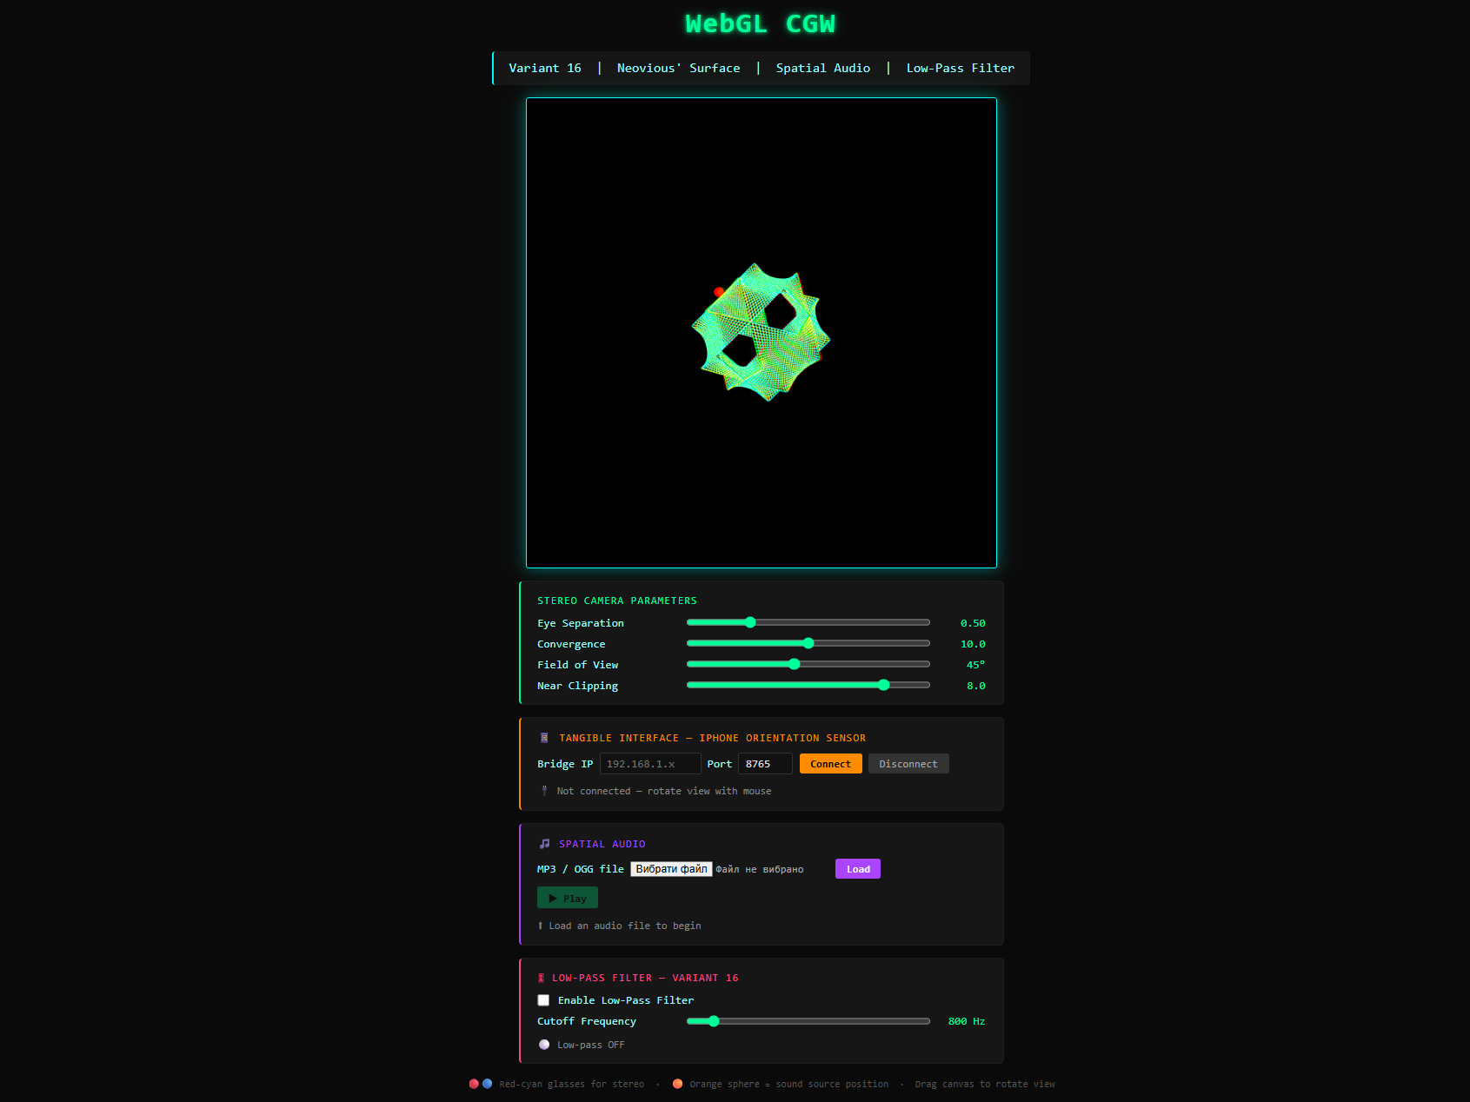
Screenshot 1 - Application view after launch: WebGL canvas with the Neovius surface in anaglyph mode and the orange sphere. Below - four control panels.

4.2 Loading and Playing Audio
1) In the “Spatial Audio” panel click the file-picker and select an MP3 or OGG file (a sample song is included in the project root).
2) Click “Load”. The status line changes to “Audio ready - press Play”.
3) Click “▶ Play”. The song starts playing in a loop and the sphere begins to pulse orange.
4) Click “Pause” to pause, “▶ Resume” to continue.
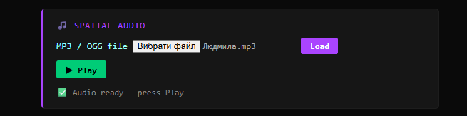
Screenshot 2 - Audio panel after file load: Play button is active, status shows “Audio ready”. The sphere glows on the canvas.

4.3 Connecting the Tangential Interface
1) Ensure the iPhone and the computer are on the same Wi-Fi network.
2) Find the local IP address of the computer (e.g. 192.168.1.42) and enter it in the “Bridge IP” field. Leave the port at 8765.
3) Click “Connect”. The status changes to “Connected → ws://…”.
4) Tilt or rotate the iPhone - the orange sphere moves accordingly and the perceived distance and direction of the sound change.
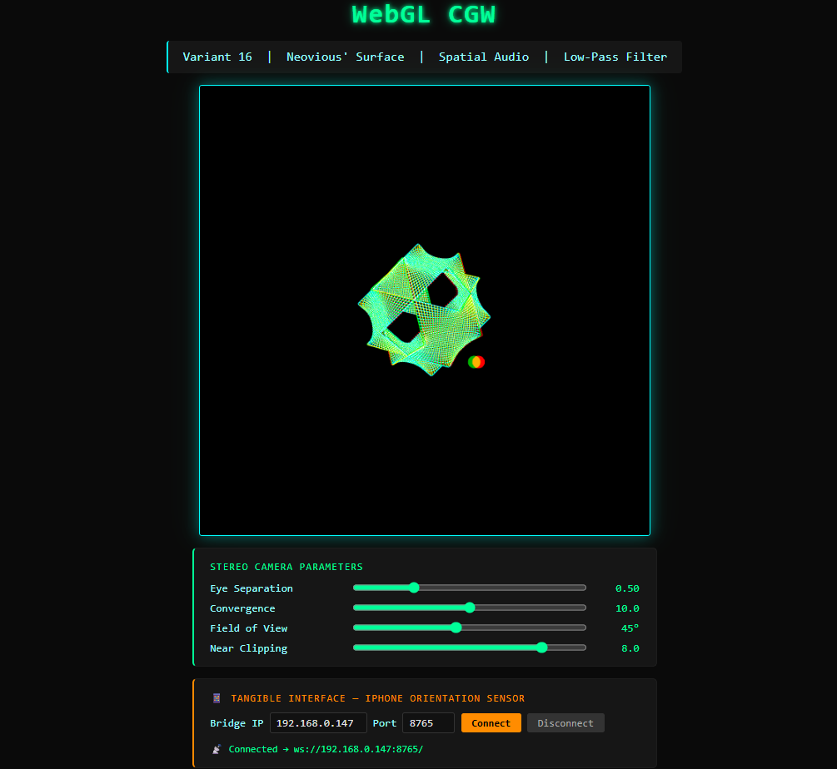
Screenshot 3 - Sensor panel after successful connection: green status “Connected”. Sphere displaced from its initial position according to device orientation.

4.4 Using the Low-Pass Filter
1) In the “Low-Pass Filter” panel check the “Enable Low-Pass Filter” checkbox.
2) Drag the “Cutoff Frequency” slider to the left - the sound becomes darker and more muffled. To the right - the frequency range widens.
3) Uncheck the box to bypass the filter and restore the full frequency response.
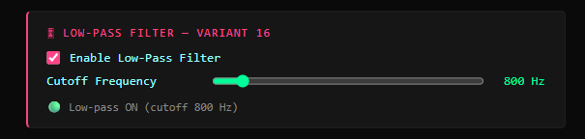
Screenshot 4 - Filter panel with checkbox enabled and slider at 800 Hz: status shows “Low-pass ON (cutoff 800 Hz)”.

5. Source Code Samples
5.1 Shaders (shader.gpu)
The surface vertex shader performs only MVP transformation:
// Surface vertex shader
const vertexShaderSource = `
attribute vec3 vertex;
uniform mat4 ModelViewProjectionMatrix;
void main() {
gl_Position = ModelViewProjectionMatrix
* vec4(vertex, 1.0);
}`;

The sphere vertex shader displaces a unit sphere in scene space:
// Sphere vertex shader
const sphereVertexShaderSource = `
attribute vec3 vertex;
uniform mat4 ModelViewProjectionMatrix;
uniform vec3 uSpherePos;
uniform float uSphereRadius;
void main() {
vec3 worldPos = vertex * uSphereRadius + uSpherePos;
gl_Position = ModelViewProjectionMatrix
* vec4(worldPos, 1.0);
}`;
5.2 Audio Graph Construction (main.js)
The function buildAudioGraph() rebuilds the graph according to the current filter state:
function buildAudioGraph() {
if (!audioSource || !panner || !filterNode) return;
try { audioSource.disconnect(); } catch (_) {}
try { panner.disconnect(); } catch (_) {}
try { filterNode.disconnect(); } catch (_) {}
audioSource.connect(panner);
if (filterEnabled) {
panner.connect(filterNode);
filterNode.connect(audioCtx.destination);
} else {
panner.connect(audioCtx.destination);
}
}
5.3 BiquadFilterNode Initialisation
The low-pass filter is initialised together with the PannerNode when an audio file is loaded:
// BiquadFilterNode - low-pass filter (Variant 16)
filterNode = audioCtx.createBiquadFilter();
filterNode.type = 'lowpass';
filterNode.frequency.value = parseFloat(
document.getElementById('filterFreq').value
); // initial value: 800 Hz
filterNode.Q.value = 1.2;
5.4 Converting Angles to 3-D Position
The function anglesTo3D() converts device orientation angles to a Cartesian position on a sphere:
const ORBIT_RADIUS = 1.8;
function anglesTo3D(azimuth, pitch) {
return {
x: ORBIT_RADIUS * Math.cos(pitch) * Math.sin(azimuth),
y: ORBIT_RADIUS * Math.sin(pitch),
z: ORBIT_RADIUS * Math.cos(pitch) * Math.cos(azimuth)
};
}
5.5 Stereo Camera with Asymmetric Frustum
The StereoCamera class computes projection matrices for the left and right eyes:
function StereoCamera(Convergence, EyeSeparation,
Aspect, FOVdeg, Near, Far) {
this.mFOV = FOVdeg * Math.PI / 180;
this.ApplyLeftFrustum = function () {
const top = this.mNear * Math.tan(this.mFOV / 2);
const a = this.mAspect * Math.tan(this.mFOV / 2)
* this.mConvergence;
const b = a - this.mEyeSep / 2;
const c = a + this.mEyeSep / 2;
return {
proj: makeFrustum(
-b * this.mNear / this.mConvergence,
c * this.mNear / this.mConvergence,
-top, top, this.mNear, this.mFar),
eyeOffset: +this.mEyeSep / 2
};
};
}

