CSC311 HW1

Decision Tree With Depth 50 and Criterion Gini (only first 3 layer shown)

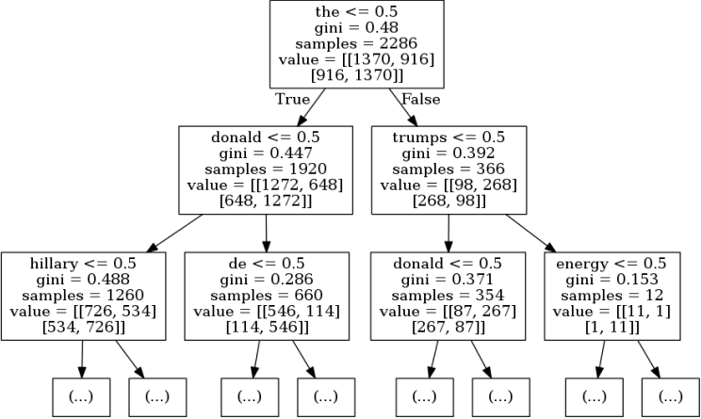
Prediction accuracy on test set: 0.7448979591836735

Sample Keywords:
information gain for the: 0.9042833975606189
information gain for donald: 0.834642716332616
information gain for trumps: 0.1929506731451265
information gain for hillary: 0.518867440494653
information gain for de: 0.881657886020225
information gain for energy: 0.9709392360332805
information gain for wtf: 0.00042251892876064265
information gain for riots: 0.6508499405789779
information gain for berserk: 0.00042251892876064265

K Nearest Neighbor Hyperparameter Performance
