Design and Evaluation of a SIEM-Based Security Monitoring System Using Simulated Attack Scenarios
Rylan D. Stalnaker
Western Governors University

Table of Contents
Summary 3-4
Review of Other Work 5-7
Changes to the Project Environment 8-10
Methodology 10-12
Project Goals and Objectives 12-13
Project Timeline 13-14
Unanticipated Scope Creep 14
Conclusion 14-18
References 19
Appendix A 20-22
Title of Appendix 20
Appendix B 23-24
Title of Appendix 23
Appendix C 25-29
Title of Appendix 25

Summary

Organizations of all sizes face an increase in cybersecurity attacks, and as technology systems advance, maintaining visibility into their networks and system activities has become much more difficult, making it harder to detect potential security threats promptly and reducing efficiency. Small organizations, especially, struggle with this problem because they rely more on the system logs from each endpoint, which become disorganized and difficult to sift through to identify suspicious behavior across their entire system architecture. This project explored implementing a centralized Security Information and Event Management (SIEM) solution to improve monitoring capabilities and support faster detection of security-relevant events and logs, thereby enhancing incident response plans and timing and increasing security postures within an organization.

To test and evaluate this approach, a controlled virtual lab environment was designed and implemented to simulate a small organizational network. The virtual environment contained a centralized Wazuh SIEM server running on an Ubuntu Server operating system (OS) and two monitored endpoint systems running Wazuh Agent on Windows and Linux OS in order to report data back to the SIEM server and show how a SIEM can record security logs from multiple devices and operating systems. All three systems were connected via a private network to help keep testing within safe parameters, prevent scope creep, and avoid impacting any external infrastructure.

Following deployment, baseline system activity was generated and recorded on the SIEM server to establish standard behavior patterns for the simulated organization. These baseline behavioral patterns consisted of routine tasks employees usually perform on their systems, such as logging in, creating and editing files, and rebooting or logging out. Controlled simulations of potentially suspicious or malicious activity, including repeated failed login attempts, system configuration changes, account-related modifications, changes to file permissions, changes to file contents, were then performed on the two endpoint systems. The Wazuh SIEM server successfully collected and displayed security-relevant events and alerts associated with these activities through the centralized dashboard.

The events and alerts generated by the SIEM were then analyzed, demonstrating that centralized log monitoring significantly improves the visibility into endpoint behavior and supports better identification of abnormal activity on an organization's network and infrastructure. Though the lab environment was limited in scale, the data and goals of the project still illustrate how SIEM deployment can strengthen security monitoring within an organizational setting, leading to faster incident response times and more robust incident response plans.

Overall, the project demonstrated that implementing a centralized SIEM solution enhances an organization's ability to observe, detect, and investigate suspicious or abnormal system activity. These results support the value of a centralized monitoring solution as a foundational component of an effective security operations strategy, especially in this era of technology.

Review of Other Work

Modern organizations face growing cybersecurity threats and challenges in detecting and responding to them fast enough. Some even compare cybersecurity to a cat-and-mouse game: defenders responding to attackers, attackers finding new ways to exploit vulnerabilities, and defenders having to increase security and respond again. Some research I was diving into emphasizes the importance of centralized monitoring, system behavioral analytics, and structured attack analysis to improve security visibility, posture, and response speed and effectiveness.

The first work by Ismail et al. (2025) highlights the growing role of Security Operations Centers (SOCs) in businesses and the improvements in using SIEM platforms to manage large volumes of security data from multiple endpoints and systems, while also providing insight into which data requires greater attention. The authors also state that open-source SIEM solutions such as Wazuh help organizations by providing a more cost-effective, scalable solution that offers monitoring capabilities similar to those of commercial SIEMs, while also enabling real-time event collection and data correlation for analysts (Ismail et al., 2025). The research conducted by the authors of this work helps demonstrate why Wazuh was an optimal choice for my project. Wazuh's flexibility and integration capabilities make it a viable and reliable option for a small lab environment, simulating a small organization, as well as for other real-world organizations seeking enterprise-level monitoring without the price point of proprietary or commercial monitoring tools. The study further details how SIEM systems improve incident response plans by taking raw system log data and transforming it into easily digestible information that can be built upon and used as security insights to improve the organization's security posture further. SIEM systems accomplish this by using processes such as event detection, filtering, categorization, and alert escalation based on severity scores, behavioral patterns, and some even use virus databases to look for known vulnerabilities. The lifecycle of event logging and analysis provided by SIEMs helps strengthen an organization's network, systems, and architecture security by enabling faster identification of abnormal activity (Ismail et al., 2025). This project focuses heavily on centralized log collection and analysis, emphasizing how it can benefit organizations, and its findings directly support the goals of this study.

Building on this idea, Hacks et al. (2023) emphasize the importance of conducting attack simulations and threat modeling when evaluating an organization's system security and posture. Their research delves into how SOC teams can use attack simulations to test and evaluate their defensive controls on their systems by seeing how an adversary might gain access to their network, move through their systems, and how the organization's defensive measures hold up against an attacker. From this, the SOC team can analyze the simulated attack and how their controls held up against it, then design better controls to defend against real-world threats. Another detail emphasized by the authors is that structured testing improves the quality and reliability of threat models, especially as system complexity increases (Hacks et al., 2022). This research supports the methods of this project by highlighting the value of simulating attack events as performed within the present project. By generating controlled suspicious or malicious activities within a safe lab environment, the project helps mirror real-world behaviors and actions made by attackers, thus further showing how SIEMs can detect and identify those behaviors on a network and flag them to the security team in order to improve their response time to these actions before real damage is caused to the organization.

Another study by Ranjan and Kumar (2022) explores the use of log analytics and machine learning to distinguish between legitimate users and malicious actors. Their findings show that analyzing user behavior using patterns in application logs can help security teams identify potential attackers before significant damage occurs to systems (Ranjan & Kumar, 2022). Ranjan and Kumar also state that these behavioral patterns can be used to improve the accuracy of threat and abnormal behavior detection, as well as strengthen proactive defense strategies, by leveraging differences between normal users' and attackers' patterns (Ranjan & Kumar, 2022).

All together these three studies demonstrate a clear consensus within their goals, and this project's goals, that is, centralized log monitoring, structured attack simulations, and behavioral pattern analysis, are all essential parts of any effective and strong SOC. This capstone project builds upon these foundations by implementing an open-source SIEM solution in a controlled virtual environment and evaluating its ability to detect suspicious activity by comparing normal user behavior with simulated attacker behavior.

Changes to the Project Environment

To support this project and implement centralized security monitoring with limited computer resources, several modifications and configurations were made to the project environment to ensure success. First, a virtual lab environment was designed and implemented to provide a safe, controlled testing environment while still simulating a small organizational network best to evaluate the effectiveness of a SIEM system within it. The environment was created using QEMU/KVM virtualization using the virt-manager package interface on an Ubuntu host system. Using this virtualization manager allowed multiple systems to operate simultaneously and provided network security by isolating the environment from the host's primary network.

The lab environment included three virtual machines connected via a virtual private network. The centerpiece of the environment was an Ubuntu Server machine used to install Wazuh. Wazuh served as the SIEM platform for the project, collecting and processing data and logs, and displaying them alongside security events generated by the two endpoint machines within the environment. The two endpoint systems were also deployed within the environment and represented typical organizational systems within the network: one was a Windows workstation, and the other was an Ubuntu workstation.

All of the virtual machines within the lab were connected to a dedicated Network Address Translation (NAT) virtual network named "siem-lab-net". Configuring the environment this way allowed systems to communicate within it while remaining isolated from external networks, improving its safety and security during the project. Network connectivity between the machines was verified by checking the virtual NIC settings and by performing a successful ping test between the server and endpoint systems. The ping test confirmed that log data could be transmitted reliably without risking data integrity, such as packet loss on the way from the endpoint systems to the server.

After validating that the network was secure, all systems were connected, and data could be sent between them, the Wazuh SIEM platform was installed on the central server using the official deployment method. To install Wazuh, you need the indexer, manager, and dashboard. The indexer acts as a data organizer and search bar; this tool allows Wazuh not only to look for specific data but also to determine where and how to organize it. The Wazuh manager acts as the controller, overseeing how Wazuh operates, what information is collected, and how the data is analyzed. The dashboard provides a centralized visual monitoring system for viewing all events, logs, and data. Once the SIEM services were operational, Wazuh agents were installed on both the Linux and the Windows endpoints. These agents help collect all security events, system events, and system logs from the workstation and send them to the Wazuh server for collection, analysis, and display on the dashboard. The endpoint agents were confirmed to be connected to the Wazuh server by checking the Wazuh dashboard, which showed that both systems were actively reporting events.

Once successful log ingestion was confirmed, routine user activities were simulated and performed on the Windows and Linux machines to generate baseline data for the SIEM server to build a pattern from. The baseline helped provide a pattern to then use as a reference for identifying suspicious and malicious activity during later testing phases of the project.

The final and complete environment provided full visibility into all endpoint activity. It enabled controlled simulation of normal user behavior and suspicious security events without impacting any production systems or the host machine. A centralized SIEM solution can be deployed and set up within a small organizational environment, as demonstrated by this implementation. It can improve monitoring and detection capabilities for small, cost-effective organizations.

Methodology

This project followed a design-and-evaluation methodology to best assess the effectiveness of a SIEM solution within a simulated small organizational environment. The main objective of this methodology was to design a system architecture with a centralized monitoring system, to generate both regular and suspicious system activity, and to assess how effectively the SIEM detected and reported potential security concerns.

The first phase of the methodology consisted of designing and building an isolated virtual lab environment that represented a small business network. The environment had one centralized monitoring server and two endpoint systems representing regular organizational workstations. All systems were connected via a private virtual network to ensure safe testing and prevent any harm or impact on external systems or networks.

After the initial phase, the Wazuh SIEM platform was installed on the central Ubuntu server, and agents were deployed to each Windows and Linux endpoint system to collect and forward security and system logs to the SIEM for analysis. Connectivity was verified by confirming that the monitoring system was receiving log data and was reporting each log appropriately with a severity score.

The third phase is where a baseline pattern of normal user behavior on the endpoint system was established. The expected behavior consisted of normal logins, creating and editing a file, interacting with the system as a user would, and then logging out. The purpose of this phase was to allow the SIEM to observe what is expected of the organization's network and system activity, then use those patterns to cross-reference new activity and later identify and detect abnormal behavior.

Once the baselines were run for the endpoints, the fourth phase consisted of controlled and simulated suspicious and possibly malicious behaviors on endpoint systems. The simulated activities were chosen to represent common security concerns, such as failed login attempts, which could indicate a brute-force attack; creating new users and adding them to the administrator groups to escalate privileges; and altering the firewall. It is policies, along with changes or modifications to file contents and/or user account permissions. The SIEM dashboard was monitored to determine whether suspicious behaviors were being detected and categorized correctly, thereby improving and streamlining the analysis of security events.

Finally, the alerts and associated log data were analyzed to evaluate the effectiveness of the SIEM solution and determine whether it indeed supported and achieved the project's goal. The events were reviewed to assess their relevance, accuracy, and whether they would provide value and utility to a company's incident investigation. Some of the events were then mapped to the MITRE ATT&CK framework to demonstrate better how the monitoring system can support real-world security analysis. Using the MITRE ATT&CK framework also helps show the attack vectors attackers have used or could use, and what they could lead to or exploit next, as defined by the framework. The results of this SIEM evaluation documented how centralized monitoring improves an organization's ability to identify abnormal behavior and respond to incidents faster.

Project Goals and Objectives

The main goal of this project was to design and implement a centralized SIEM system and evaluate it within a controlled virtual environment. The evaluation of the SIEM aims to demonstrate how centralized log monitoring can improve an organization's security posture by increasing internal visibility and enabling faster identification and response to potential threats to its systems and network infrastructure.

To accomplish this goal, several objectives were completed. The first objective was to design and build a virtual lab environment isolated from external networks and infrastructure, consisting of a centralized server and two endpoint systems due to limited resources. The reason this environment was chosen for this project is limited resources, but it still serves as a perfect representation of a small business network.

The next objective was to install and configure Wazuh on the centralized server. Once Wazuh was installed, the agents were deployed to the endpoints, and the dashboard confirmed that logs were being successfully sent from the endpoints to the SIEM server. The SIEM was functioning as expected, with endpoint logs being ingested and analyzed by the server.

The third objective was to create and simulate baseline system behaviors to provide a reference for comparing normal behavior with abnormal behavioral patterns in the network. The objective was also to simulate a malicious attack on endpoint systems. These malicious behaviors were meant to trigger security alerts in the SIEM for suspicious activity on systems by creating authentication errors followed by a successful login, changing configuration settings for files and groups, and adding administrative accounts. The SIEM was then evaluated to determine whether it could successfully detect and report potentially harmful behavior on endpoint systems.

The last objective for this project was to analyze the alerts generated by the Wazuh SIEM to assess how well it identified actions and score them by severity. By meeting all these objectives, the project has demonstrated the practical value of SIEM deployment in a business environment.

Project Timeline

The project was designed around available time rather than the usual timeline, which was built around the project's design. The shorter timeline than most was the deciding factor in how the design, implementation, testing, and evaluation phases of the project were executed. Work on the project began on February 12, 2026, and concluded on February 21, 2026. The overall period allotted to complete the project was 9 days, including time for testing, analysis, and documentation.

The first couple of days were focused on finalizing the project design and preparing the virtual lab environment. This phase consisted of building the virtualized environment, creating a virtual private network for it, and ensuring that all machines were correctly connected to the network and able to communicate with one another. Once the environment was built and the machines were stable, the Wazuh SIEM platform and endpoint agents were installed, and functionality was verified.

Once the SIEM solution and environment were successfully deployed, baseline activity was generated to create a pattern for cross-referencing data and determining whether it falls within normal parameters or is abnormal relative to the baseline. The last phase of the timeline was to analyze the results of the SIEM alerts, document the findings, and prepare the capstone report.

The predetermined timeline allowed the project to be built around it, enabling objectives to be completed within the available timeframe and still leaving adequate time for testing and refinement, as well as time for revisions to the capstone report if needed.

Unanticipated Scope Creep

When designing the project, careful attention was given to maintaining the proper scope to gather enough information for testing and analysis, and to determine whether the project achieved its goal within the allotted time. Due to limited resources and time, the primary focus was on designing and implementing an environment with little wiggle room to maintain control and prevent primary scope creep. In two of these designs, no significant deviations from the original scope occurred, though some minor adjustments were made during the implementation phase to keep the systems stable, reliably collect logs without packet loss, and test the machines for validation. These adjustments were typical for an implementation phase, so the project's scope and goal remained on track throughout. With the strict design and timeline, the project maintained a controlled scope and ensured completion within the timeline while still meeting all objectives.

Conclusion

Simulation Results and Findings

Following the establishment of baseline system behavioral patterns, multiple controlled simulations of suspicious behavior were executed on endpoint machines to test how well the Wazuh SIEM could detect and report these actions. The simulated actions were designed to create everyday security attack activities common in business environments, such as brute-force login attempts, changing configuration settings on endpoint machines, and tampering with sensitive files on endpoints. The goal of these actions was to determine whether the SIEM system could successfully and accurately identify and report suspicious behavior, drawing the attention of security analysts to investigate. Each simulated attack was performed on either the Windows or Linux endpoint, while the Wazuh dashboard was monitored for generated alerts. The SIEM successfully generated alerts for the majority of suspicious behaviors, demonstrating its value in a business environment by providing visibility into network architecture and systems.

Simulated Scenarios

To simulate an unauthorized access login event or a brute force login attempt, repeated failed login attempts were performed on the Windows endpoint. Once the system was given multiple incorrect login credentials within a short time period, a successful login was then executed, representing a brute-force attack followed by a successful login. The SIEM generated many authentication-related events showing failed login attempts. The SIEM helped show how multiple authentication failures can be monitored, reported, and investigated. The brute-force simulation helps demonstrate how security teams can identify targeted accounts and implement controls, such as account lockout after a specified number of failed login attempts, to prevent brute-force access to system accounts.

The following simulation scenario involved temporarily disabling and then re-enabling Windows Firewall on the Windows endpoint. The purpose of turning the firewall off and back on is to simulate how some attackers might try to turn off protective controls to avoid detection. The SIEM, however, did happen to record the events, allowing for further analysis. Without proper access controls, any account can disable or modify the firewall, significantly weakening the company's security posture. However, with the SIEM, the organization can quickly identify this behavior and respond before malware is infiltrated or data is exfiltrated.

The other simulated scenario involved modifying or adding user accounts and simulated privilege escalation tactics. Adding a new user and granting them administrative privileges creates a new account that the attacker can log into to execute all commands as an administrator and provides the attacker with persistence on the business's systems. However, Wazuh was able to create account-management-related events showing the modifications made. Without the SIEM the unexpected account and privilege changes may have gone unnoticed by the organization for a long time, however, with the SIEM the security team would be given timely alerts of the attacks when they ahppen in order to give them the chance to review account activity and implemtn other controls such as least-privilege policies in order to keep commands from being executed as an admin in the first place.

The final simulated scenario for this project involved changing system settings, adding files to sensitive locations on the Linux endpoint, and affecting the file integrity of classified files. File integrity and system modifications are particularly critical threats to a business. The SIEM recorded these events and generated alerts, enabling the logs to be investigated and remediated. Monitoring unexpected file changes in sensitive locations supports early investigation and response plans to prevent or stop further damage to the organization's systems.

Example Incident Analysis

To further demonstrate the effectiveness of the SIEM solution, one simulated security event was examined in detail to show how the SIEM supports incident identification and investigation.

During the testing phase, a simulated brute-force attack forced multiple failed login attempts on the Windows endpoint, followed by a successful login. The purpose of this behavior and simulation is to determine whether the SIEM would detect a potential unauthorized access attempt. After simulating the attack, the SIEM generated authentication-related alerts showing the repeated login failures. Reviewing the alert details showed that the events originated from the Windows endpoint, and the account being attacked was "Jane Doe" with rapid password guesses, a sign of possible brute-forcing. The dashboard enabled quick identification and analysis of data without requiring direct access to the endpoint system or its logs, and it further demonstrated the value of the SIEM by collecting logs in a centralized location, increasing visibility into endpoint systems, and enabling monitoring for malicious activity.

From a SOC analyst's perspective, a potential brute-force attack in a production environment would warrant an immediate response. Some response plans would include reviewing the affected account for compromise, checking whether the source of the attempts is legitimate or a potential threat, and implementing security controls such as temporary account lockout or a password reset, if needed, to prevent the unauthorized user from gaining access to the account.

This incident walkthrough shows how a security analyst could use the SIEM system to detect abnormal behavior on a system, investigate the logs, and remediate/implement improved security controls. Without a SIEM solution, the security analyst would not have a centralized location for log collection and might even need direct access to the affected workstation to read the system logs, further underscoring the value of a security monitoring system in any organization.

Summary of Detection Effectiveness

Overall, the Wazuh SIEM platform successfully detected and logged multiple categories of simulated attack behavior across both Windows and Linux endpoints. The SIEM provided the simulated organization with strong visibility into its systems, authentication activities, system configuration changes, account modifications, and file-related events.

Though the lab environment was limited in scale, the project's results still demonstrate the value and importance of a centralized log-monitoring server for modern security operations centers. Log collection and log correlation improve the organization's ability to detect and respond to malicious activity and to use behavioral patterns to create new security controls to prevent similar malicious activity. These findings support the value of SIEM deployment in business settings and the benefits it brings to the business's security posture and monitoring.

References

Hacks, S., Persson, L., & Hersén, N. (2022). Measuring and achieving test coverage of attack simulations extended version. Software and Systems Modeling, 22(1), 31-46. https://doi.org/10.1007/s10270-022-01042-9

Ismail, Kurnia, R., Widyatama, F., Wibawa, I. M., Brata, Z. A., Ukasyah, Nelistiani, G. A., & Kim, H. (2025). Enhancing security operations center: Wazuh security event response with retrieval-augmented-Generation-Driven copilot. Sensors, 25(3), 870. https://doi.org/10.3390/s25030870

Ranjan, R., & Kumar, S. S. (2022). User behaviour analysis using data analytics and machine learning to predict malicious user versus legitimate user. High-Confidence Computing, 2(1), 100034. https://doi.org/10.1016/j.hcc.2021.100034

Appendix A

Environment Verification

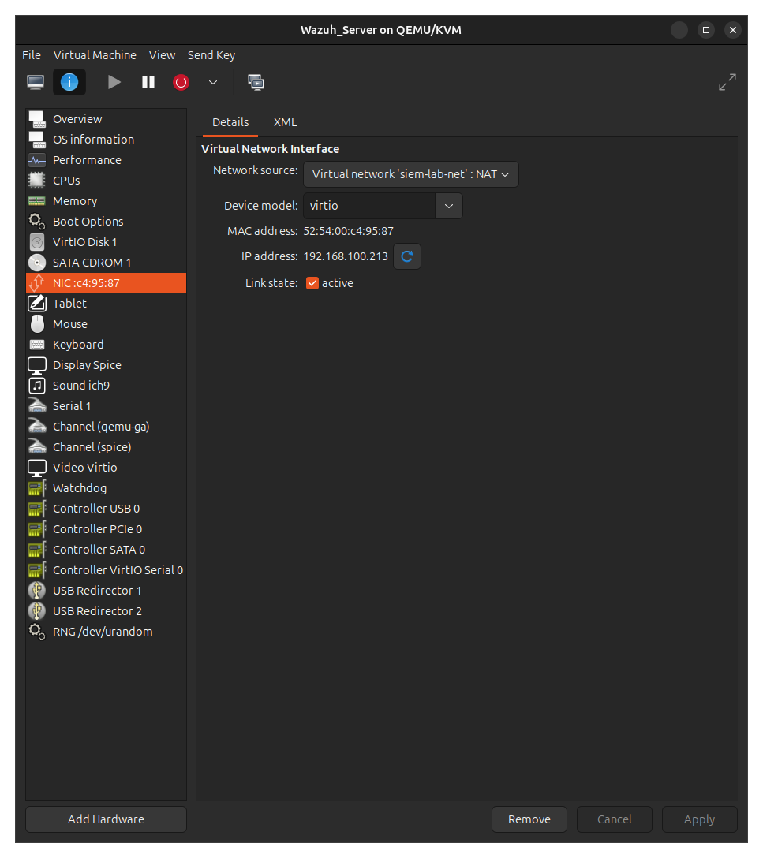Figure 1: Private Virtual Network Created and Linux Server Connected.
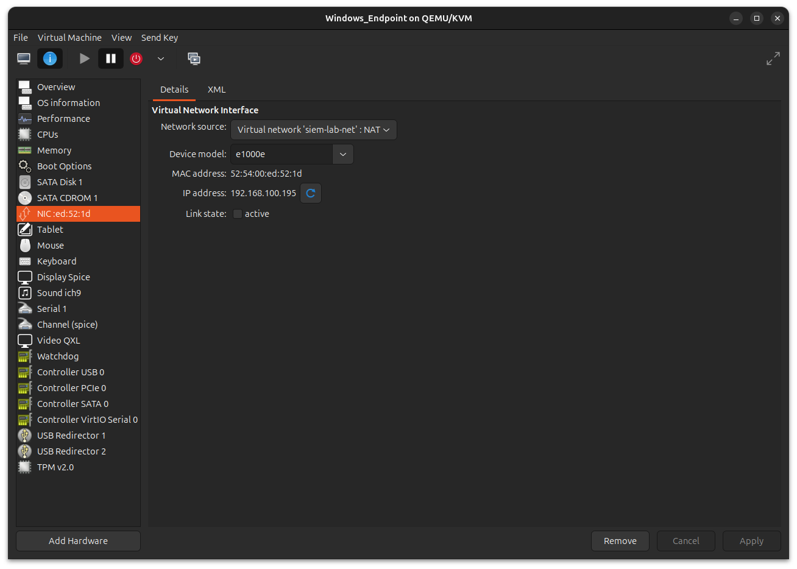Figure 2: Windows Endpoint is connected to Virtual Private Network.
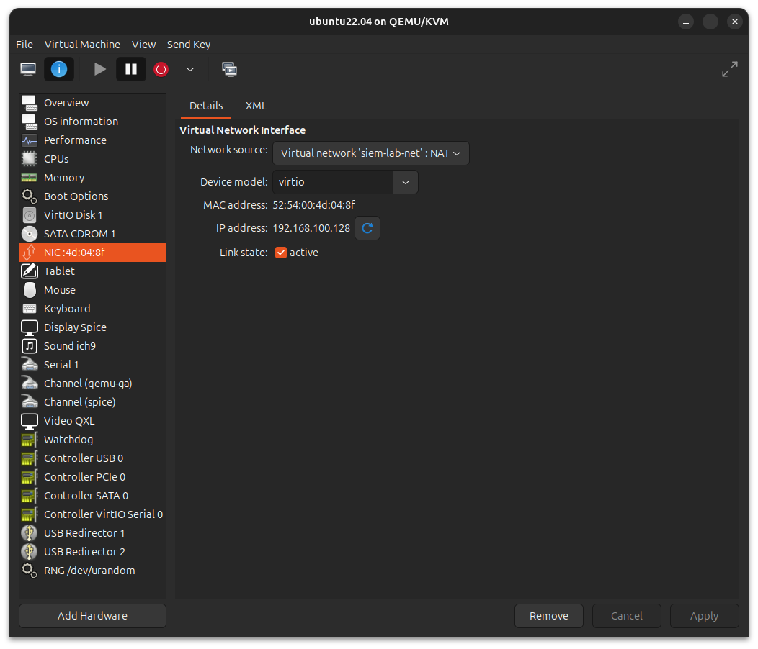Figure 3: Linux Endpoint is connected to Virtual Private Network.
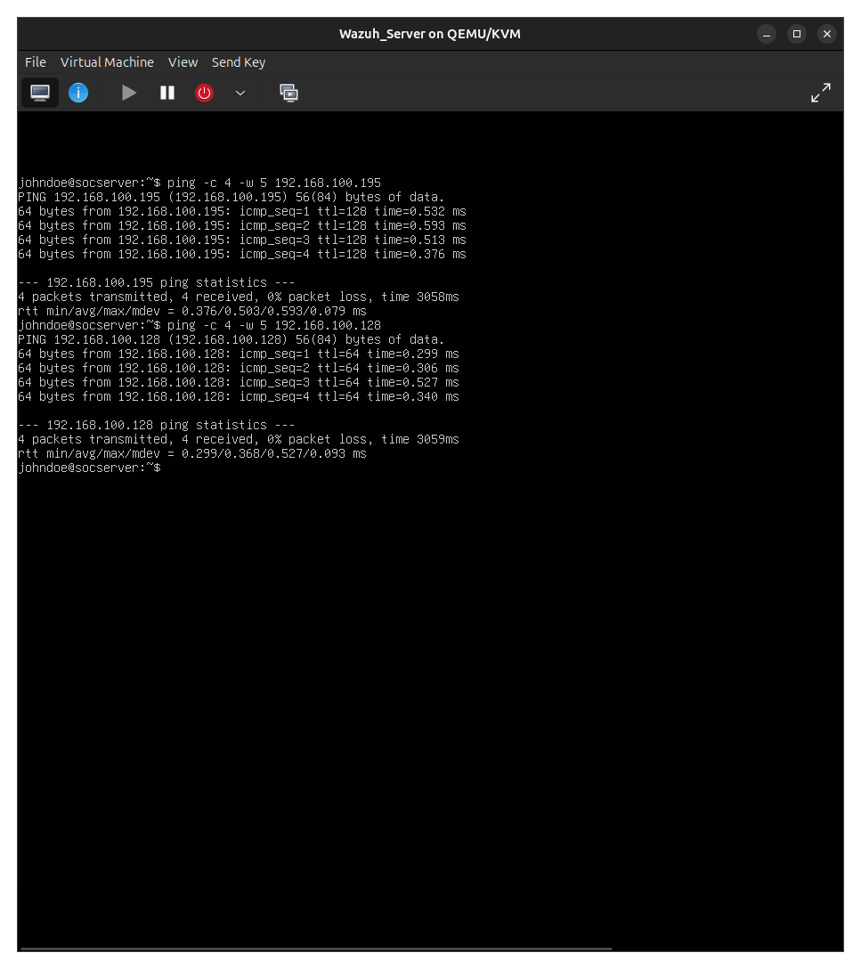Figure 4: Results from `ping` test showing connectivity between machines.

Appendix B

SIEM Deployment Evidence
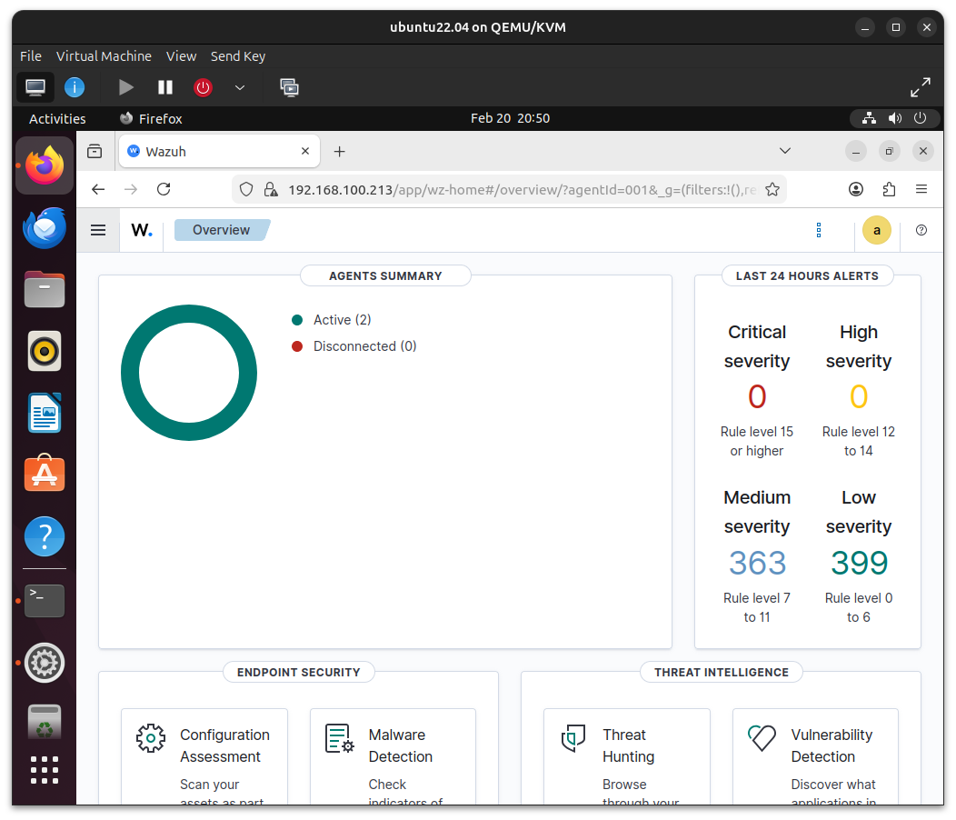Figure 5: Wazuh dashboard overview.
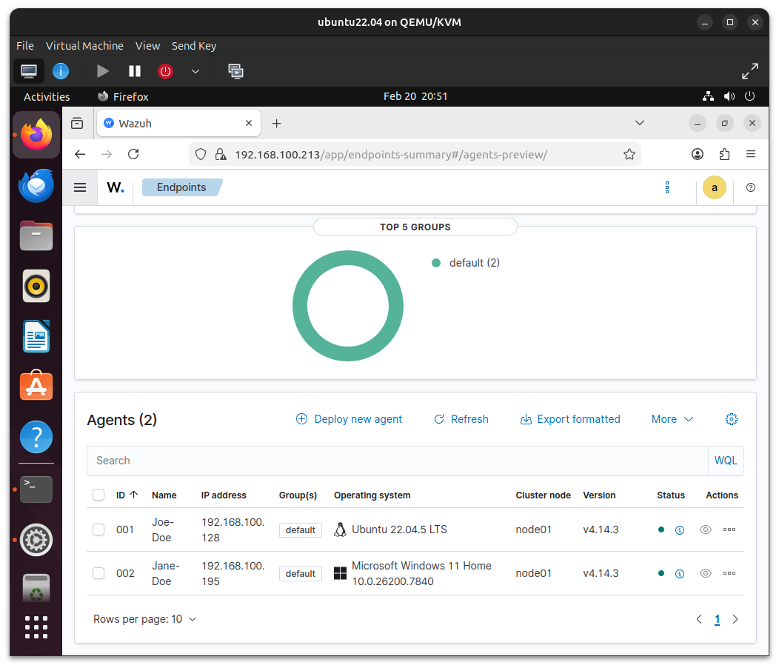Figure 6: Wazuh dashboard showing both Wazuh agents connected to the endpoints.
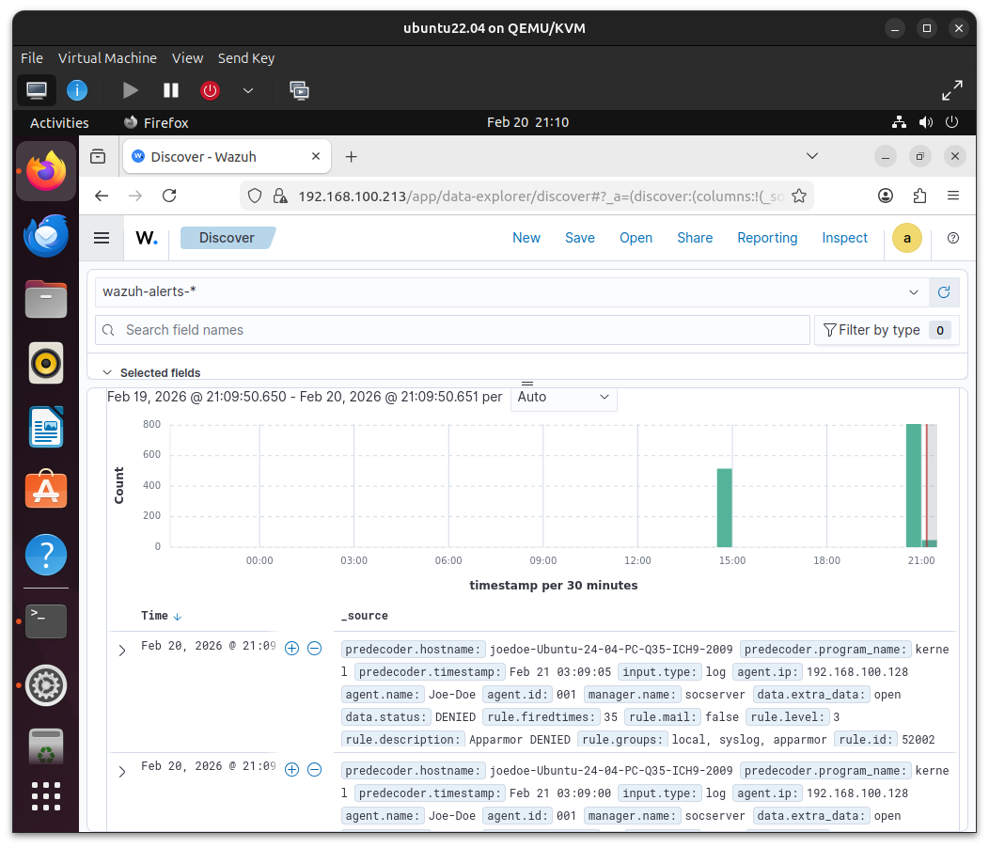Figure 7: Collection of baseline logs and behavioral patterns.

Appendix C

Simulated Attack Evidence
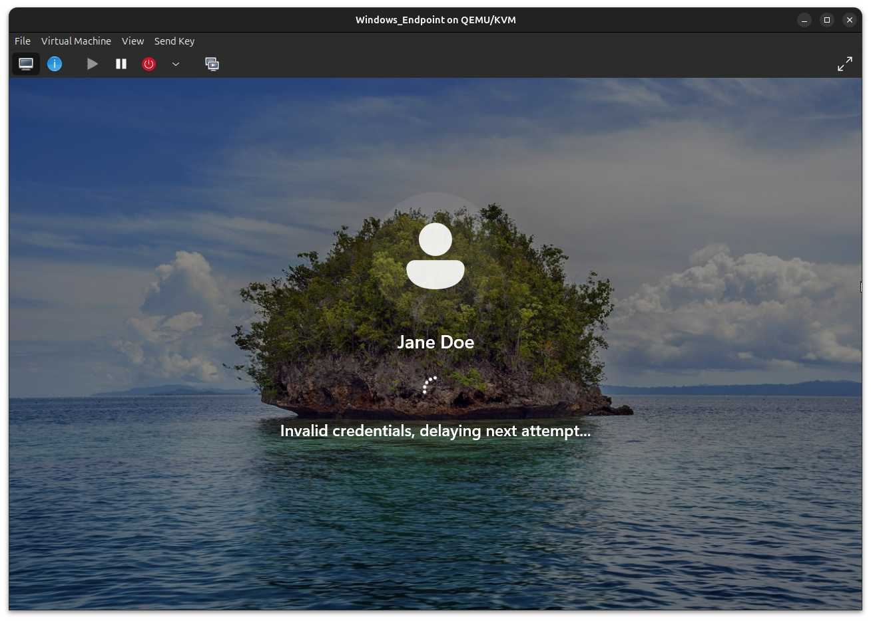Figure 8: Brute force simulation with intentional incorrect logins.
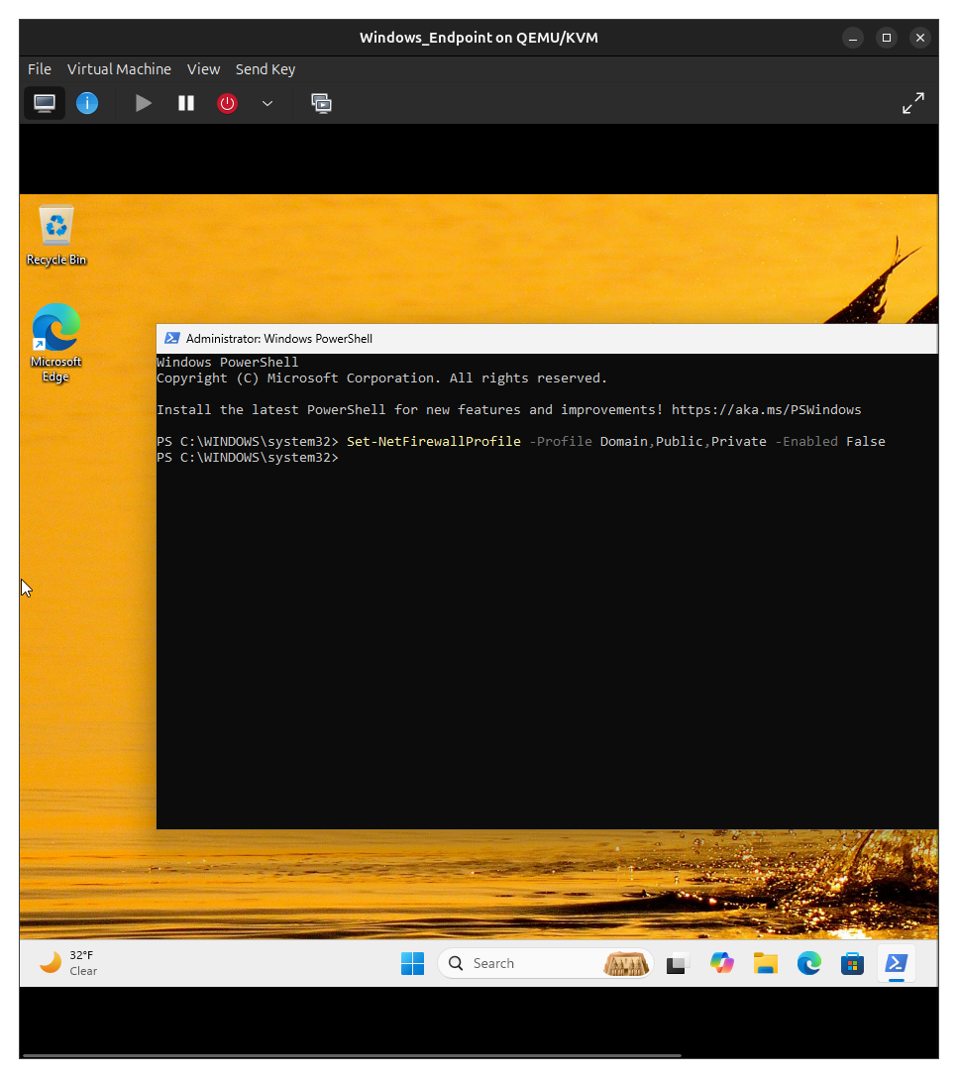Figure 9: Firewall configuration via PowerShell.
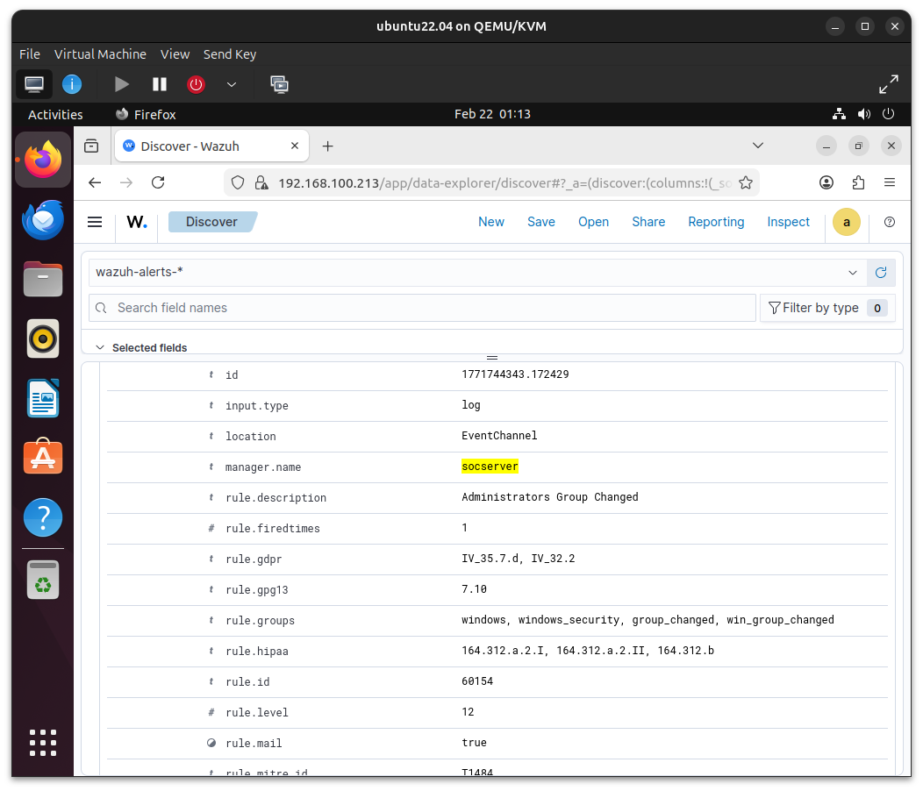Figure 10: Security event alert because of new user created and added to administrators group.

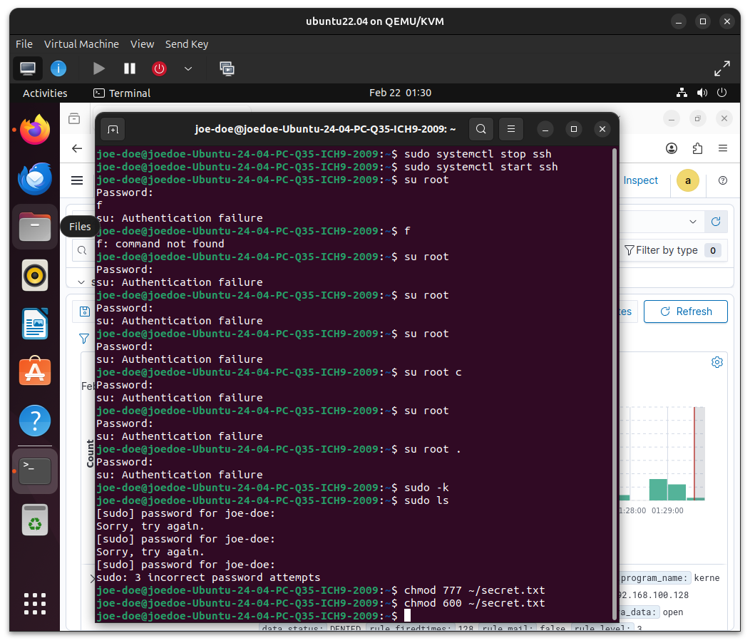Figure 11: Different attack methods on the Linux endpoint.

