**Title**

Travel Images App

**Short Description**

Discover and look at images of various cities from around the world.

**Full Descriptions**

Travel images is an android exclusive app, that allows free images viewing of various cities. Travel images is the best way to view images of new cities you may want to travel to. Using this app you can check out any city in pictures, absolutely free. The ever expanding library will allow you to see various aspects of the city you intend visit and will allow you to decide whether or not you want to visit. Travel images can be taken where ever you go and can be easily shown to friends and family to let them know where you will be going. Easy to use too, simply select the place you wish to go to and look at the images.

**Screenshots**

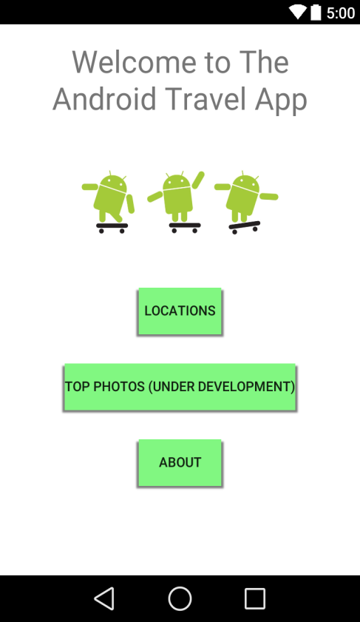 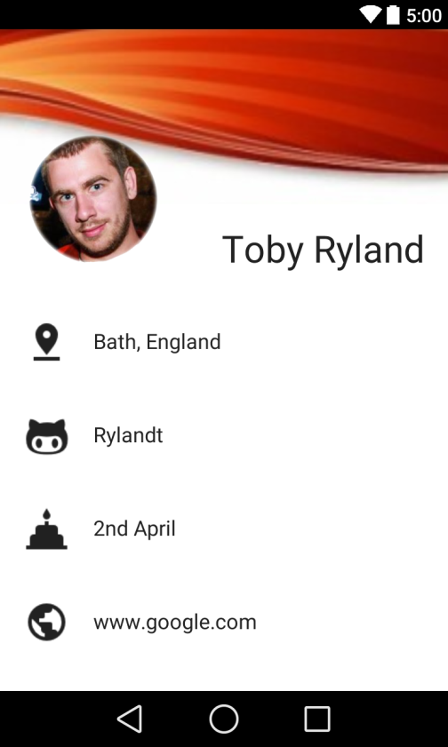

**2. What you Learned**

I learnt a great deal about layouts of XML using both relative layout, where everything will naturally be at the top and you need to add in context to tell the tag where it is mean to be. Linear layout is where everything will be below the other previous part of the app. Java is used on the backend of apps and works like other programing languages by having aspects such as arrays and variables. Android differs from others by its easy usage of connectivity to the internet. This allows android to access files very easily from online recourses. Using aspects like strings to work apps behind the scenes is another thing I’ve learnt. This has allowed the use of running apps

**3. What you're Proud of**

* I got an app working with some advanced features.
* I was able to use some of what I learnt to help other aspects of it.
* I was able to change things and use knowledge of other programming languages to help

**4. What you could've improved**

* I never got API working right with more time perhaps I might have been able to better incorporate it.
* Although not needed majorly it would have been nice to have top photos also complete.

**5. Features you would've added if you'd had more time**

* I also wanted to have an input form but, again this one didn’t materialise.
* I was trying to get an image to expand when clicked on, this never worked.

**6. Differences between building a desktop app, and your mobile app.**

With a desktop application, you are stuck to one place, where as a mobile app, is just that, mobile. With a mobile app, you can use things such as location data. This means that in your car you can use your mobile phone as a GPS were as, you could do something similar with a computer, it would be extremely difficult to operate and would be very clunky.

Also Mobile apps also need to have much bigger buttons and much less on screen, as a result of the small screen size, whereas desktop apps can be a lot busier as they will have a much bigger screen.

Mobile apps also run much more off not needing things like “back to main menu” as they contain a back button you can always use.