Q4(b) :
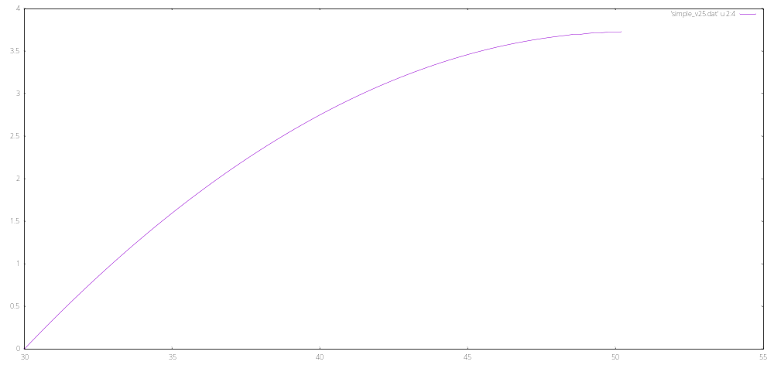
Plotting by gnuplot :

Q4(c) :
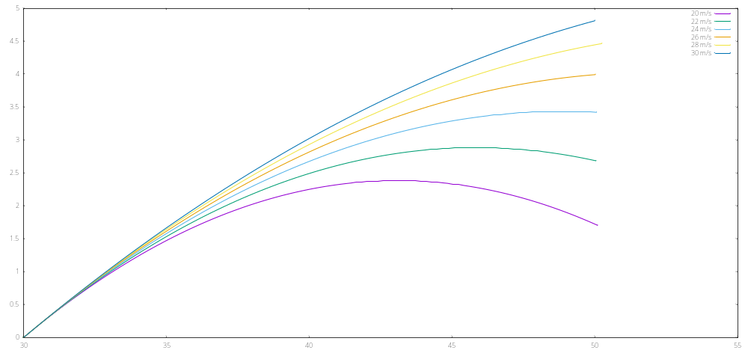
Plotting by gnuplot :

Only v = 20m/s is a good shot, all the remaining speed are over shots.

Q4(d) :
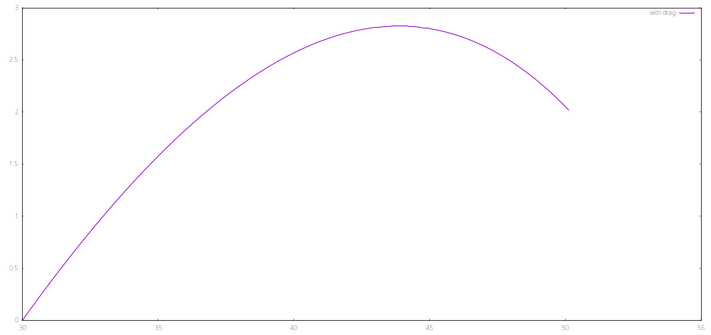
With drag force, now the shot is good. The goalkeeper have 1.12s before the ball crosses the goal line.

Q4(e) :
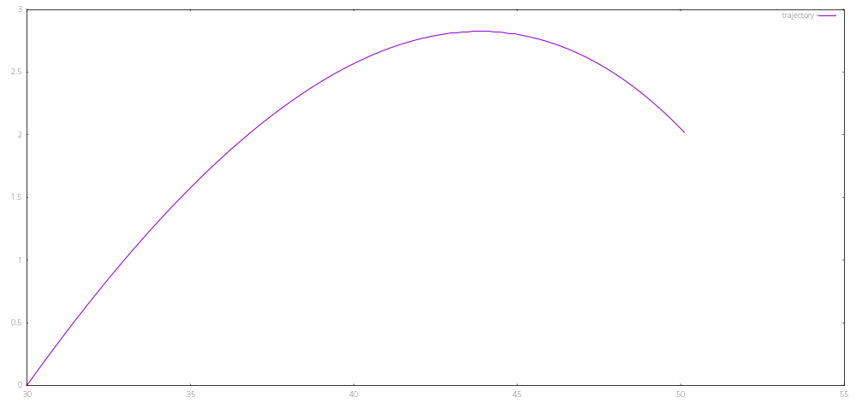
Plotting by gnuplot :

Q4(f) :
The ball has 0.02m from the vertical post.

