Q2(c) :
Max speed : 52.5641 m/s (Copy from C++ Program)
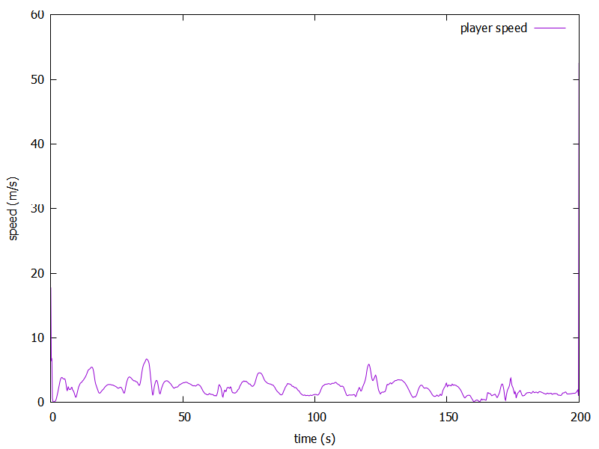
Plotting by gnuplot :

Q2(d) :
If using slice(), then the length of speed is ( Ndata-2 ) and acceleration is ( Ndata-4 ). However, symbols errors are always displayed when l used slice() and l don't know how to fix, so l use .shift() instead of slice().
In the case with .shift(), the lengths of speed and acceleration are the same ( = Ndata ), because .shift() always returns a same-size valarray and the element of the end is replaced by 0.

Q2(e) :
Dominant error comes from the measurement noise ( ± 0.2m ) in the input positions, which is a random observational error. For mitigation, we can smooth the positions before differentiating.
For precision, double is better for real-valued variables since it has 15 digits

Q2(f) :
We can fit an interpolation curve ( e.g. a cubic spline) through the measured positions.

