**ADM3305 – Assignment 3**

**Rylie Austin**

**8210704**

**Due: 2018-11-19**

**Professor: Antoine Sauré**

**Part A:**

The possible decision strategies the manger has are as follows:

Let ‘S’ denote “sent”, ‘N’ denote “not sent” , ‘L’ denote low level, ‘H’ denote high level.

* He can send catalogues only to customers categorized as low or ‘L’ 🡪 (L=S, H=N)
* He can send catalogues only to customers categorized as high or ‘H’ 🡪 (L=N, H=S)
* He can send catalogues to both kinds of customer 🡪 (L=S, H=S)
* He can send catalogues to neither kind of customer 🡪 (L=N, L=N)

**Part B:**

0.6

0.3

0.6

0.3

0.7

0.7

0.4

0.4

0.5

0.5

0.2

0.8

0.8

0.2

0.5

0.5

(L=S, H=N)

(L=N, H=S)

(L=N, H=N)

(L=S, H=S)

**Part C:**

To choose the best mailing strategy, a simulation model built in Python can be used.

First, 200 random numbers must be generated to simulate 10 replications of 5 years. The LCG method was used to generate these numbers as outlined in the following code:

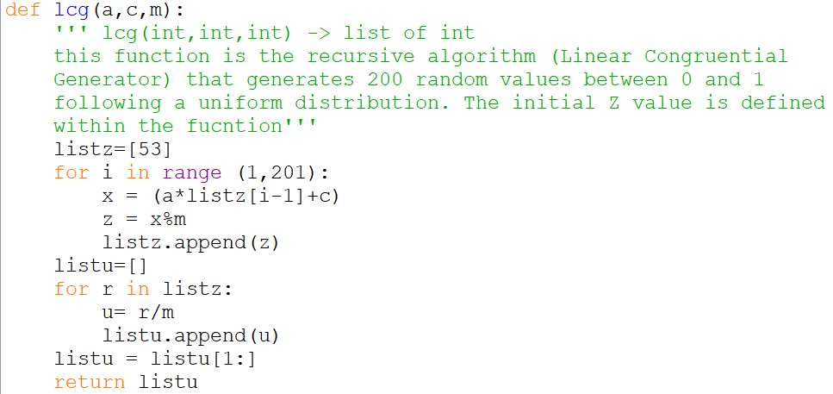

Next, the simulation model can be run based on the 200 random numbers generated above. This model needs to test each of the mailing strategies and provide the 95% confidence interval for expected quarterly profit. For each replication, the program generates a list of 20 ‘l’s and ‘h’s to represent the state that a customer is in in each phase(quarter) of the different strategies. It then generates a corresponding list of the net profit associated with each quarter given the state of the and the strategy it is simulating. Each replication list of quarterly profits for all strategies are averaged. Finally, the average and 95% CI for each strategy is calculated based on the 10 corresponding replication averages. Please see the docstrings and code in the model for more details:

Overall Model and list creation:

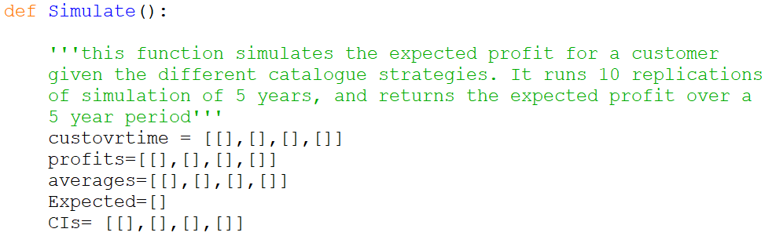

(L=S,H=N) module:

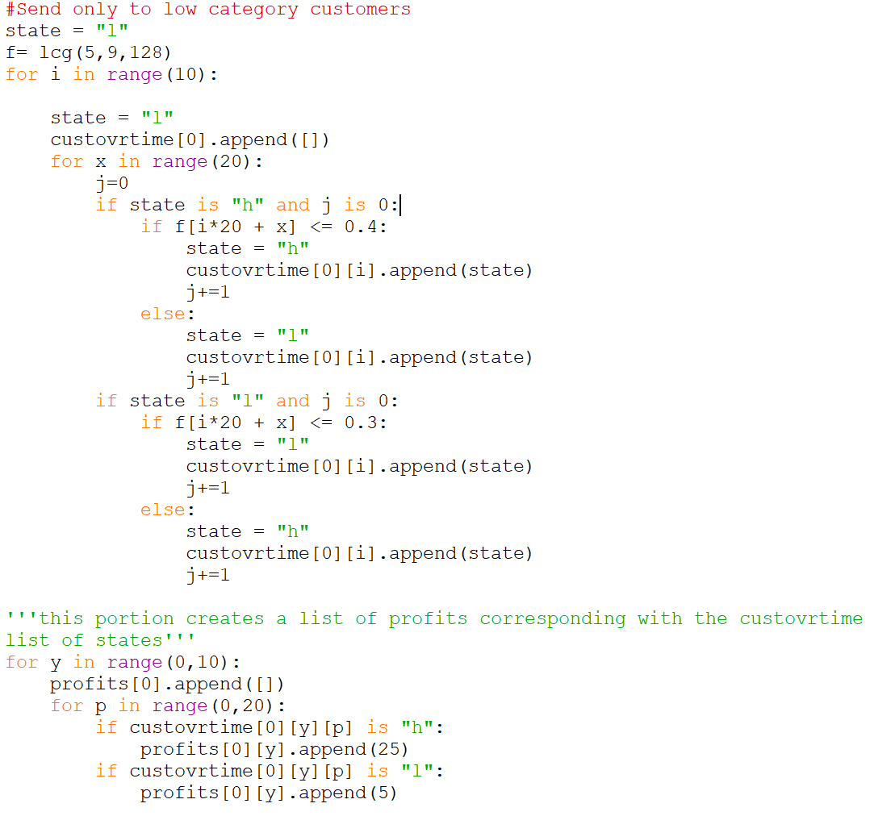

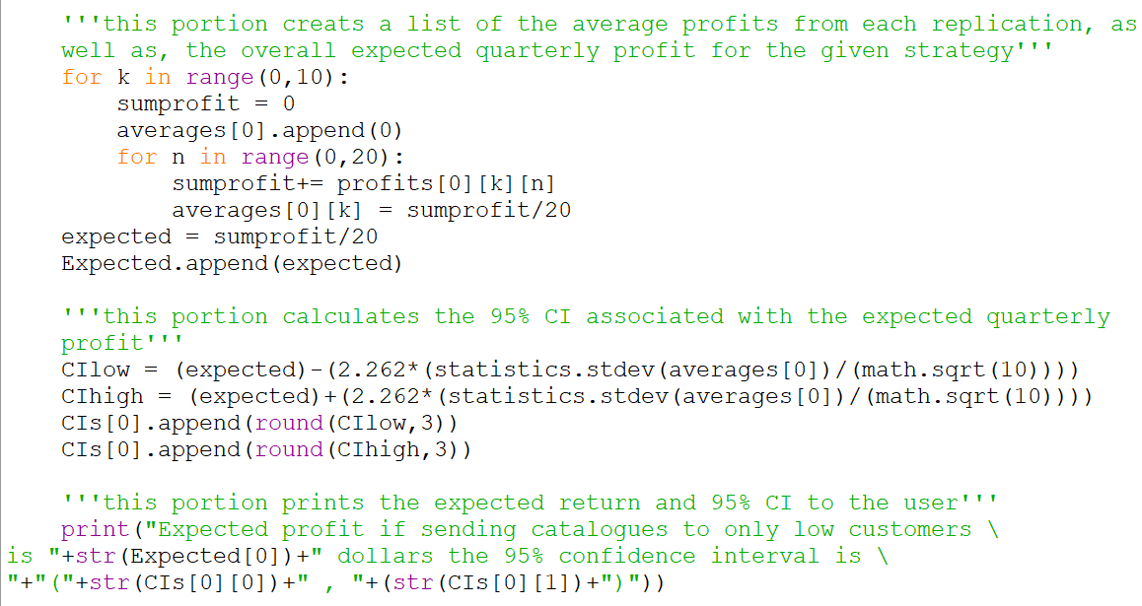

(L=N,H=S) module:

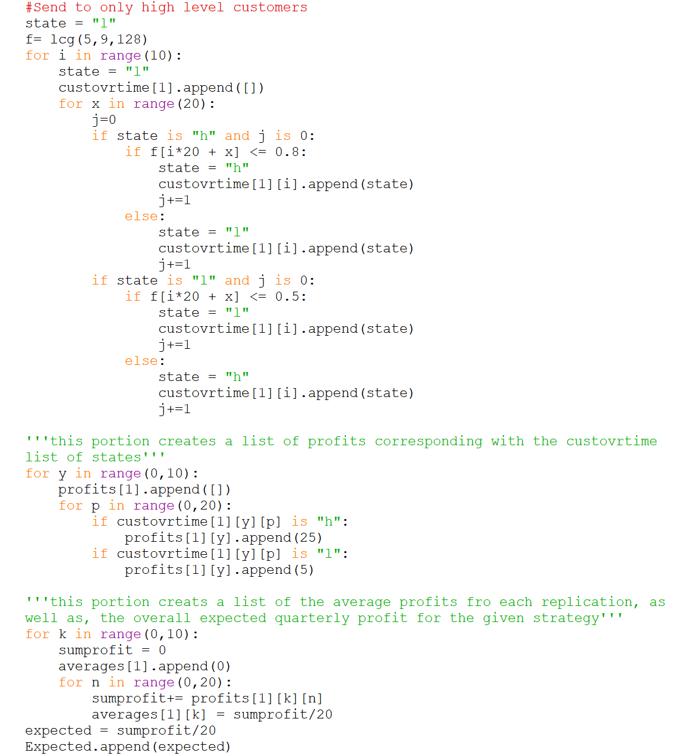

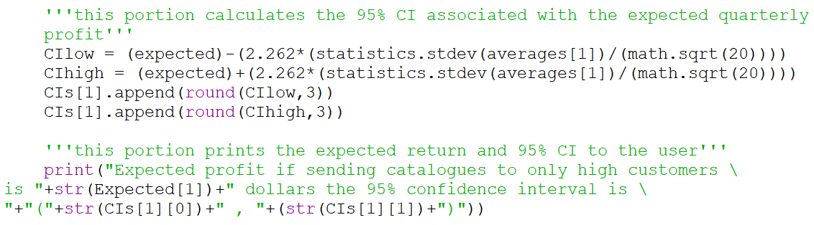

(L=N,H=N) module:

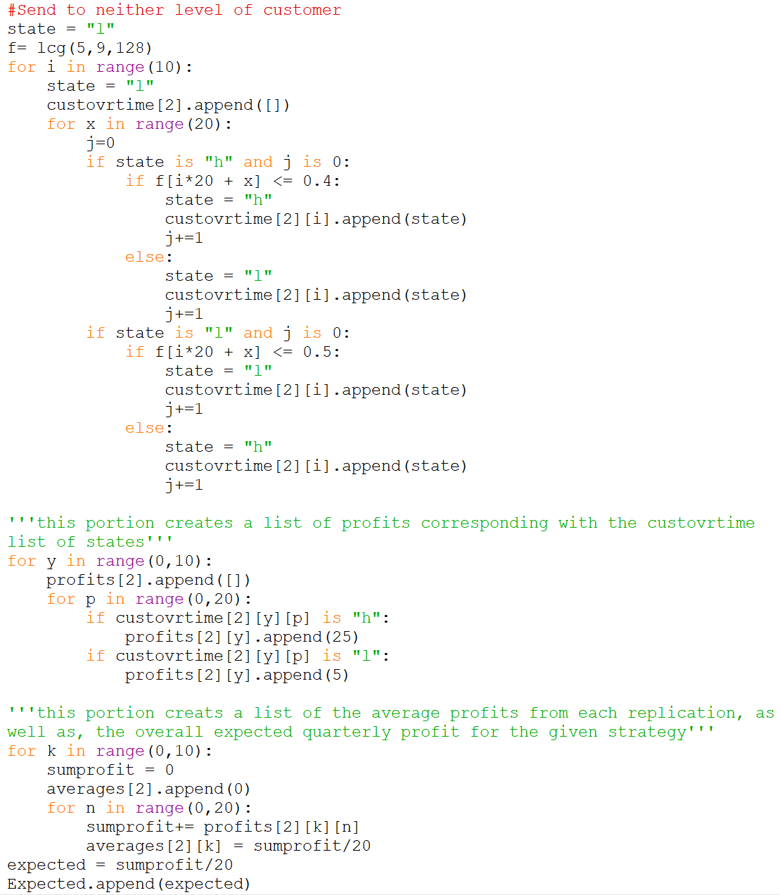

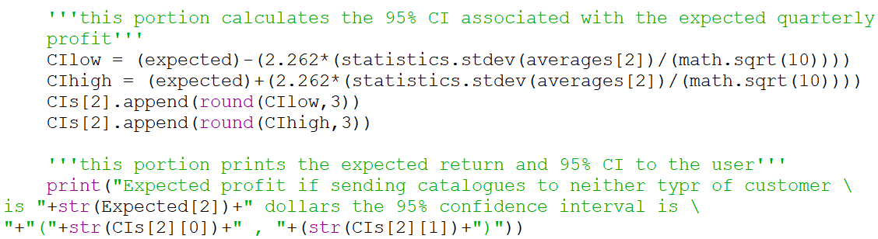

(L=S,H=S) module:

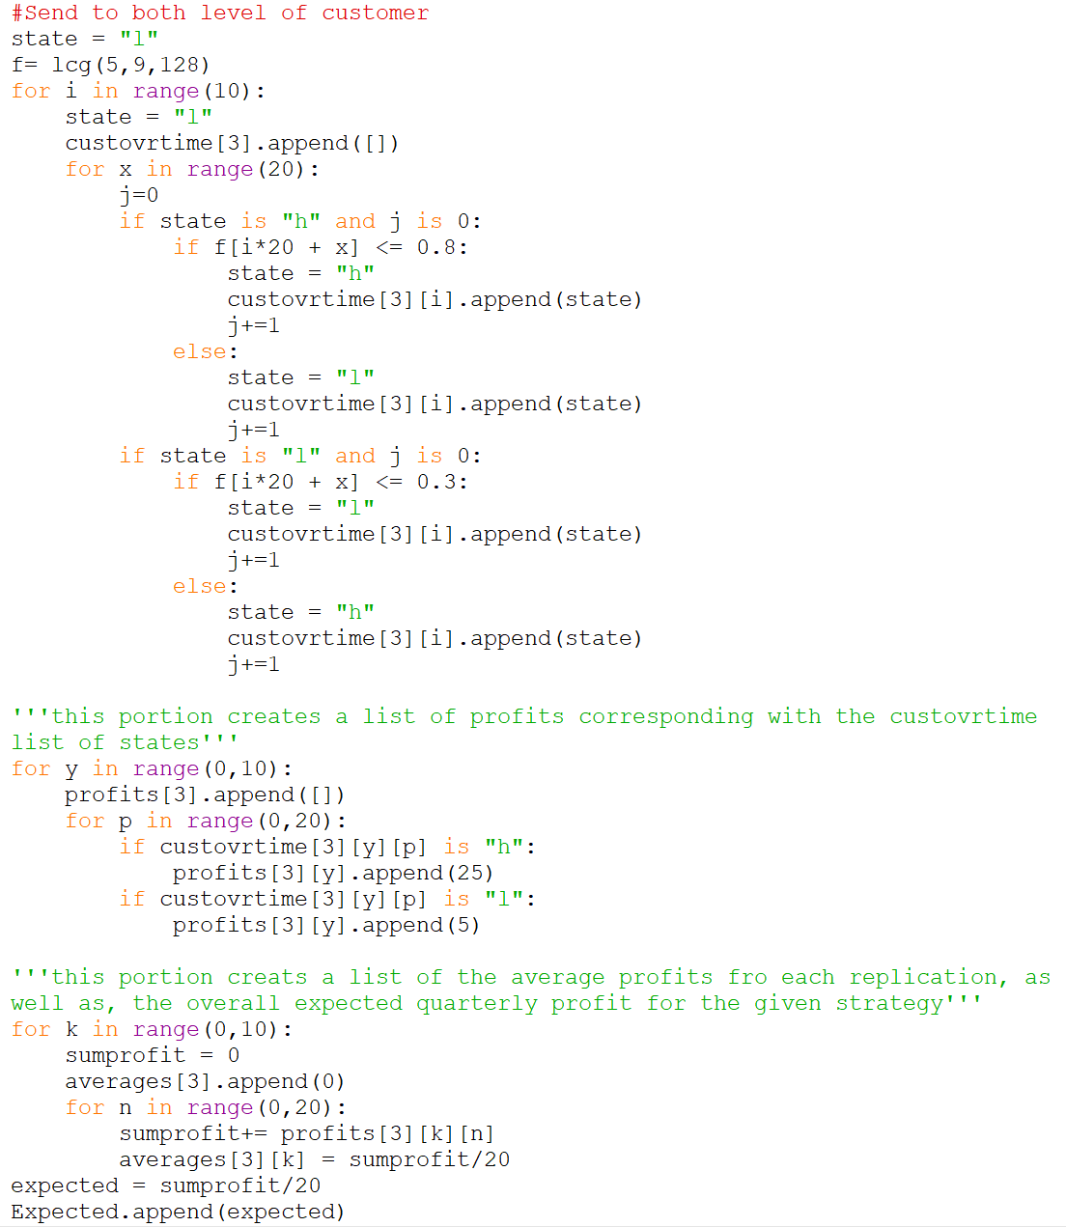

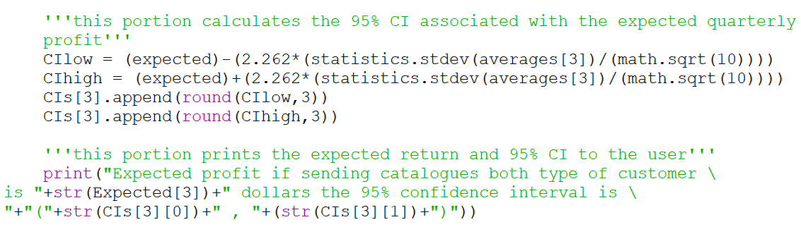

After running the program, the following output is provided:

As we can see, the highest expected net profit results from sending catalogues to both customers.This makes sense, because although the net profit per customer is lower when sending catalogues to both types, customers are more likely to convert from the ‘low’ to the ‘high’ category in the long run, resulting in more spending.

**Part D:**

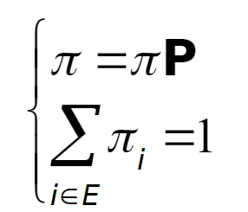To find the steady state vectors we will use the following properties:

Where - ‘***P***’ is the probability matrix

∴ (**P-I**)*π = 0 Where - ‘***I***’ is the identity matrix

- ‘*π’* is the steady state vector

(L=S,H=N)

1) Here we subtract the identity matrix from the probability matrix

L H

-0.7 0.7

0.6 -0.6

L H

0.3 0.7

0.6 0.4

1 0

0 1

=

-

2) Next we multiply the resulting matrix with our steady-state matrix to derive two linear equations

πL + πH = 1

0.7 πL - 0.6 πH = 0

L H

-0.7 0.7

0.6 -0.6

🡪

-0.7πL + 0.6πH = 0

0.7 πL - 0.6 πH = 0

= 0 🡪

πL  πH

*

3) Next we put the equations into matrix form and using the Gaussian method, convert the matrix into row echelon form

1 0 .53

0 1 .46

🡪

1 1 1

0.7 -0.6 0

Therefore, the steady state probabilities associated with sending catalogues to only low level customers are 53% Low and 46% High.

Expected Profit = .53(5)+.46(25) = $15.77

(L=N,H=S)

1) Here we subtract the identity matrix from the probability matrix

L H

-0.5 0.5

0.2 -0.2

L H

0.5 0.5

0.2 0.8

1 0

0 1

=

-

2) Next we multiply the resulting matrix with our steady-state matrix to derive two linear equations

L H

-0.5 0.5

0.2 -0.2

πL + πH = 1

0.5πL - 0.2πH = 0

🡪

*

-0.5πL + 0.2πH = 0

0.5πL - 0.2πH = 0

= 0 🡪

πL πH

3) Next we put the equations into matrix form and using the Gaussian method, convert the matrix into row echelon form

1 0 .29

0 1 .71

🡪

1 1 1

0.5 -0.2 0

Therefore, the steady state probabilities associated with sending catalogues to only high level customers are 29% Low and 71% High.

Expected Profit = .29(10)+.71(35) = $27.85

(L=N,H=N)

1) Here we subtract the identity matrix from the probability matrix

L H

-0.5 0.5

0.6 -0.6

L H

0.5 0.5

0.6 0.4

=

1 0

0 1

-

2) Next we multiply the resulting matrix with our steady-state matrix to derive two linear equations

L H

-0.5 0.5

0.6 -0.6

πL + πH = 1

0.5πL - 0.6πH = 0

🡪

*

-0.5πL + 0.6πH = 0

0.5πL - 0.6πH = 0

= 0 🡪

πL  πH

3) Next we put the equations into matrix form and using the Gaussian method, convert the matrix into row echelon form

1 0 .55

0 1 .45

🡪

1 1 1

0.5 -0.6 0

Therefore, the steady state probabilities associated with sending catalogues to neither level of customer are 55% Low and 45% High.

Expected Profit = .55(5)+.45(35) = $16.83

(L=S,H=S)

1) Here we subtract the identity matrix from the probability matrix

L H

0.3 0.7

0.2 0.8

L H

-0.7 0.7

0.2 -0.2

=

1 0

0 1

-

2) Next we multiply the resulting matrix with our steady-state matrix to derive two linear equations

L H

-0.7 0.7

0.2 -0.2

πL + πH = 1

0.5πL - 0.6πH = 0

🡪

*

-0.7πL + 0.2πH = 0

0.7πL - 0.2πH = 0

= 0 🡪

πL  πH

3) Next we put the equations into matrix form and using the Gaussian method, convert the matrix into row echelon form

1 0 .22

0 1 .78

🡪

1 1 1

0.7 -0.2 0

Therefore, the steady state probabilities associated with sending catalogues both levels of customers are 22% Low and 78% High.

Expected Profit = .22(10)+.78(25) = $28.34

So, overall we can see that the largest expected profit comes from sending catalogues to both types of customers with sending catalogues only to high level customers coming in at second. This is consistent with the results from the simulation in Part C. Therefore, it is recommended that the manager send catalogues to both levels of customer to realize the largest net profit.

**Personal Ethics Statement**

**Individual Assignment:**

By signing this Statement, I am attesting to the fact that I have reviewed the entirety of my attached work and that I have applied all the appropriate rules of quotation and referencing in use at the Telfer School of Management at the University of Ottawa, as well as adhered to the fraud policies outlined in the Academic Regulations in the University’s Undergraduate Studies Calendar. Academic Fraud Webpage

______________________________ 2018-11-10________________

Signature Date

 ______________________________ 8210704___________________

Last Name (print), First Name (print) Student Number