**ADM3305 – Assignment 4**

**Rylie Austin**

**8210704**

**Due: 2018-12-03**

**Professor: Antoine Sauré**

Question A

30

40

30

30

40

Number of Occupied Phone Lines

Up time: 8 hrs/day

Call Rate: λ = 30/hr

Service Rate: µ = 20/hr

20

Question B

The Python model on the next page simulates the evolution of the number of phone lines that are busy for 1000 one-day replications. It assumes that no phone lines are in use at the beginning of the day. The rate matrix is set and referred to as ‘ratrix’. The reason the transition rate from 3-3 is 30 is to allow for the simulation of the number of lost calls. While in state 3, calls come in at a rate at 30/hr and unless the system moves out of state three before a call is received, it is balked. Although the time of the two phenoma (receiving and serving) are not simulated separately in this model, it makes no difference in the long run. So we are able to simulate the number of calls balked by seeing if the state of the system remains the same in two or more successive counts on the state path. In the first portion of the model all arrays for the successive potion are defined. Next the sojourn time is generated randomly using the exponential distribution with parameter’ (1 / (cumulative outflow from the current state)), determined by the outflow from state n to state i divided by the total outflow from n. If a uniform random number is less than or equal to this value corresponding to each successive state tested, the state of the system is changed and recorded. The outputs from this portion include a list of sojourn times and the state path for each replication.

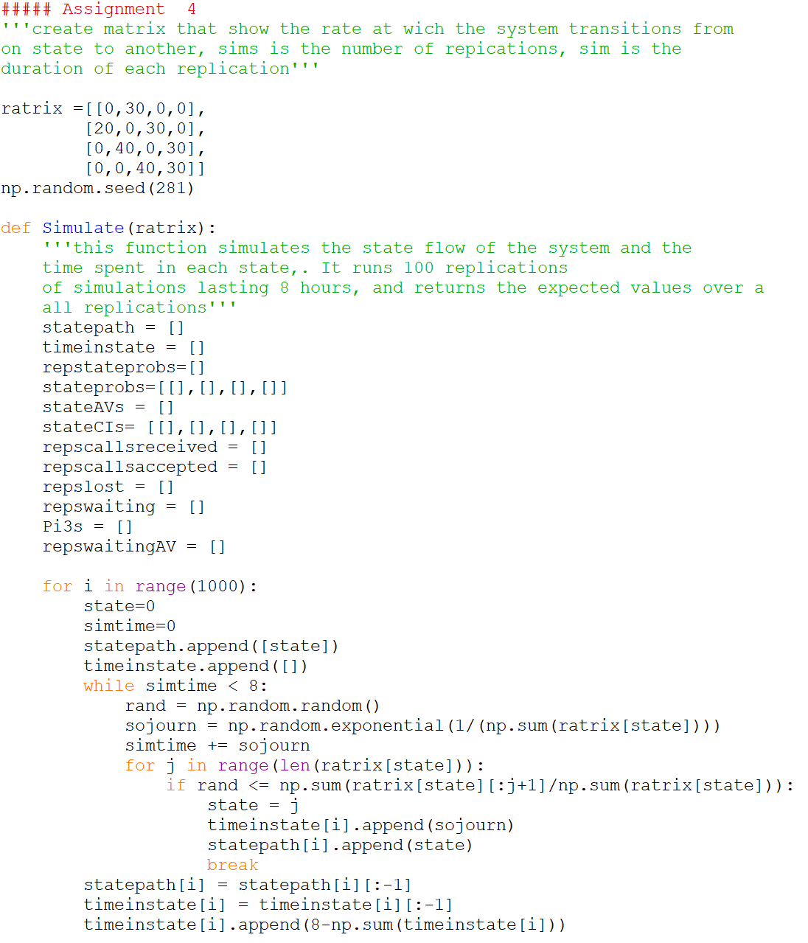

The next portion of the model calculates the probability of being in each state for each replication and then calculates the overall probabilities and confidence interval.

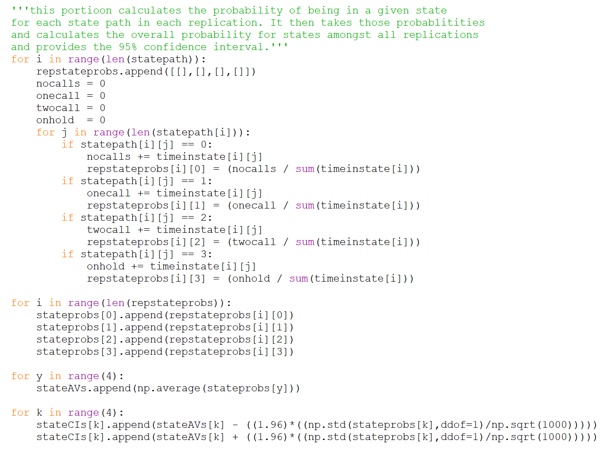

The next portion of the model calculates the number of calls received and accepted by the system in order to calculate the percentage of calls balked. Note that this is an approximation similar to simply using the percentage of time spent in state three (π3), but for the sake of simulation, this is one method that can be used.

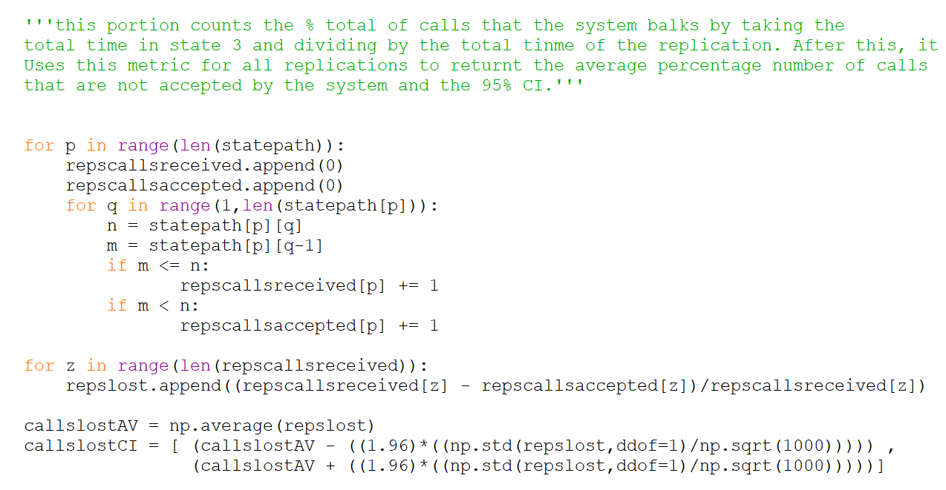

The next portion of the model calculates the wait times of each replication in minutes by adding the total sojourns of state three. It then uses these values to determine the overall average wait time and the associated confidence interval.

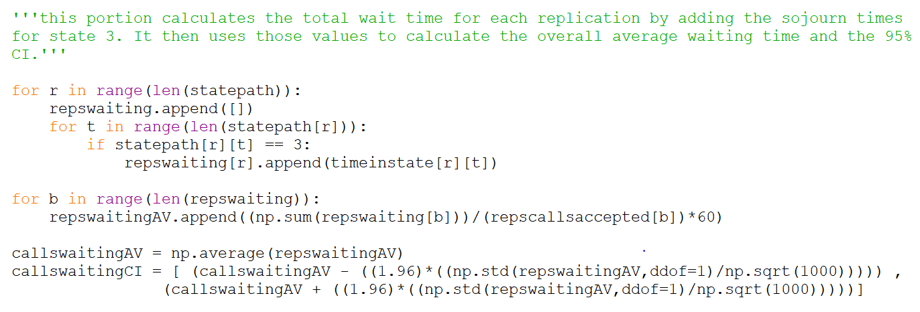

Question C

For percentage of calls not answered Python provides the following output:

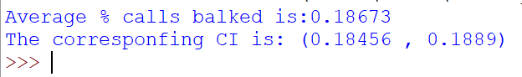

So, based on the simulation there is on average 18.7% calls balked with a corresponding 95% confidence interval of (18.5% , 18.9%)

For average holding time for calls that get through, Python provides the following output:



So, based on the simulation there is on average a 0.462 minute hold time with a corresponding 95% confidence interval of (0.457 , 0.467).

If the agents work twice as fast, the rate matrix is modified as follows:

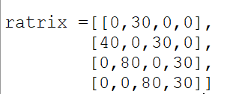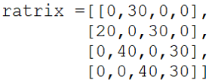

The impact on the values of interest are outlined below:



Now on average; 4.88% calls balked with a corresponding 95% confidence interval of (4.77% , 4.99%)



Now on average; 0.104 minute hold time with a corresponding 95% confidence interval of (0.102 , 0.105)

Question D



|  |  |
| --- | --- |
| π­­0 + π­­1 + π2 + π3 = 1  1)  30 π­­0 = 20 π­­1  State outflow set equal to state inflow  (balance equation)  50 π­­1 = 40 π­­2 + 30 π­­0  70 π­­2 = 40 π­­3 + 30 π­­1  40 π­­3 = 30 π­­2  2)  1.5*π­­0 = π­­1  Put all equations in terms of π­­0  1.125* π­­0 = π­­2  0.844* π­­0 = π­­3  3)  (1+1.5+1.125+0.844) π­­0 = 1  4.469 π­­0=1  π­­0 = .2238 => 22.38%  .  .  Derive steady state probabilities  .  π­­1=33.57%  π­­2=25.18%  π­­3=18.88%  As discussed in question B when simulating the number of lost calls, an approximation of this would be the percentage of time spent in state three. This is because the total number of call is the arrival rate, λ multiplied by the time of a replication, T multiplied by the steady state of state 3,all divided by T * λ. This makes sense because when we are in state three, the arrivals will be balked. Therefore:  # balked calls = (T* λ* π­­3)/ T* λ = π­­3 = 18.88%  Average # calls = (π­­3*T)/( T* λ(π­­0 + π­­1 + π2)) = .465 min | π­­0 + π­­1 + π2 + π3 = 1  1)  30 π­­0 = 40 π­­1  State outflow set equal to state inflow  (balance equation)  70 π­­1 = 80 π­­2 + 30 π­­0  110 π­­2 = 80 π­­3 + 30 π­­1  80π­­3 = 30π­­2  2)  0.75*π­­0 = π­­1  Put all equations in terms of π­­0  0.281* π­­0 = π­­2  0.105* π­­0 = π­­3  3)  (1+0.75+0.281+0.105) π­­0 = 1  2.136 π­­0=1  π­­0 = .468 => 46.80%  .  .  Derive steady state probabilities  .  π­­1=35.10%  π­­2=13.16%  π­­3=4.94%  As discussed in question B when simulating the number of lost calls, an approximation of this would be the percentage of time spent in state three. This is because the total number of calls is the arrival rate, λ multiplied by the time of a replication, T multiplied by the steady state of state 3, all divided by T * λ. This makes sense because when we are in state three, the arrivals will be balked. Therefore:  # balked calls = (T* λ* π­­3)/ T* λ = π­­3 = 4.94%  Average # calls = ( π­­3*T)/( T* λ(π­­0 + π­­1 + π2)) = .104 min |

As we can see, the results from the steady state analysis are very similar to the simulation results. The steady state results fall within the confidence intervals provided in the simulation output so we can conclude that that simulation is accurate in providing the desired metrics as an approximation.

**Personal Ethics Statement**

**Individual Assignment:**

By signing this Statement, I am attesting to the fact that I have reviewed the entirety of my attached work and that I have applied all the appropriate rules of quotation and referencing in use at the Telfer School of Management at the University of Ottawa, as well as adhered to the fraud policies outlined in the Academic Regulations in the University’s Undergraduate Studies Calendar. Academic Fraud Webpage

______________________________ 2018-12-01________________

Signature Date

 ______________________________ 8210704___________________

Last Name (print), First Name (print) Student Number