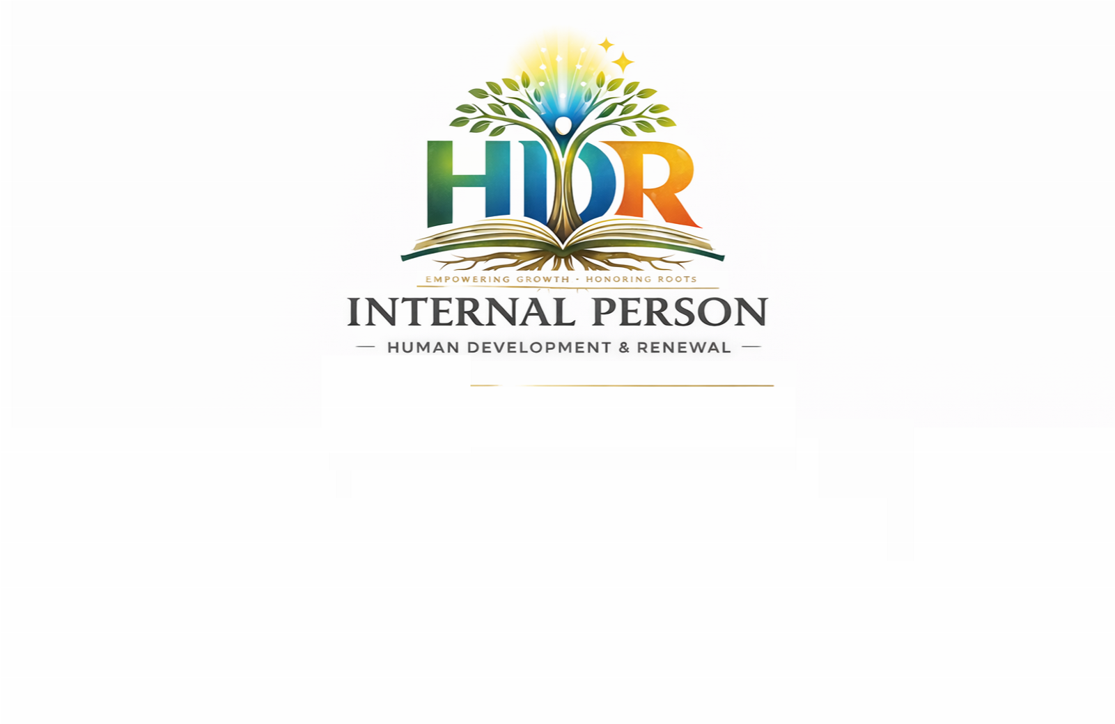
INTERNAL PERSON
Human Development & Renewal

Overview
Internal Person is a digital platform focused on empowering individuals to discover their inner strength, purpose, and voice. It creates a space for meaningful conversations, personal growth, and authentic connection.

Mission
To empower individuals to unlock their inner potential through connection, conversation, and self-awareness.

Vision
To become a global platform where people grow, inspire, and connect from within.

Core Values
Authenticity, Growth, Connection, Empowerment, Respect.

What We Offer
Live Discussions, Community Engagement, Interactive Sessions, Personal Growth Content.

Goal
To build a platform focused on value, growth, and real connection.

Contact
Company Name: InternalPerson (Pty) Ltd
Industry: Digital Media & Personal Development
Location: South Africa (pretoria)
Business Type: Private Company
Website: internalperson.site

Company director: Rymond Madisha
Contact: 072 251 0489
Email: madisharymond@gmail.com

