**PROJECT DESCRIPTIONS**

**1). Technologies used :**

* OS : Linux(you can use window but setup instruction different.)
* Server Software : Apache2
* Database : MySql

**2) Github Repo :**

<https://github.com/Ryn0K/phpinterntaskproject.git>

**3). Installation steps :**

* Place project files to your os specific location for server requirement to run the project.
* Donot forgot to change the dbconfig.ini for mysql configuration.
* Start the **apache2 and mysql** service.
* Import the **db.sql** file from **db/** directory in database.

**4). Database documentation**

**Table :** user

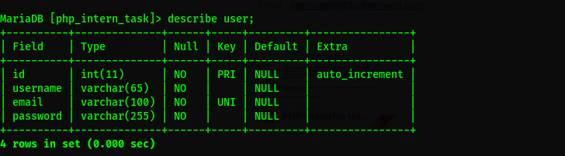

**5) Project snapshots.**

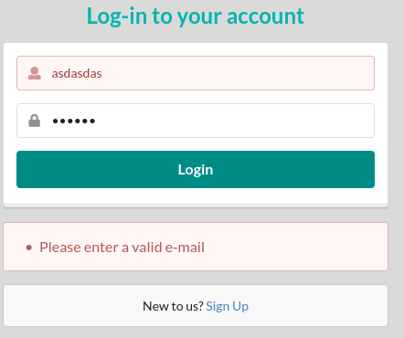**1. Login page :**

**2. User Registration pages.**

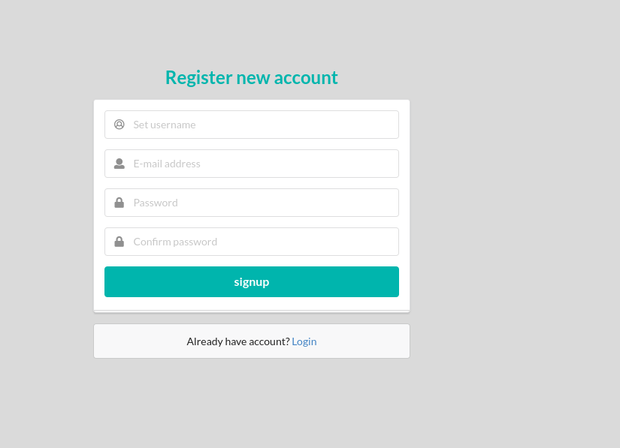

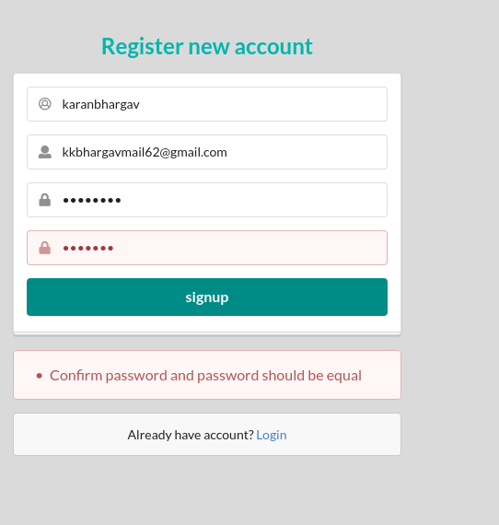

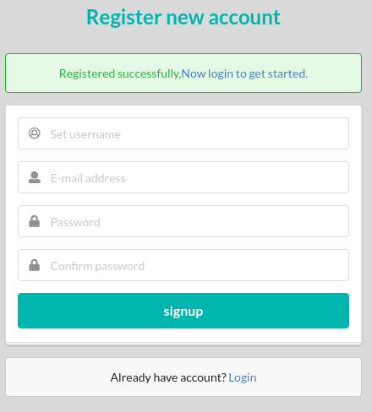

**3. Home page after successfull login.**

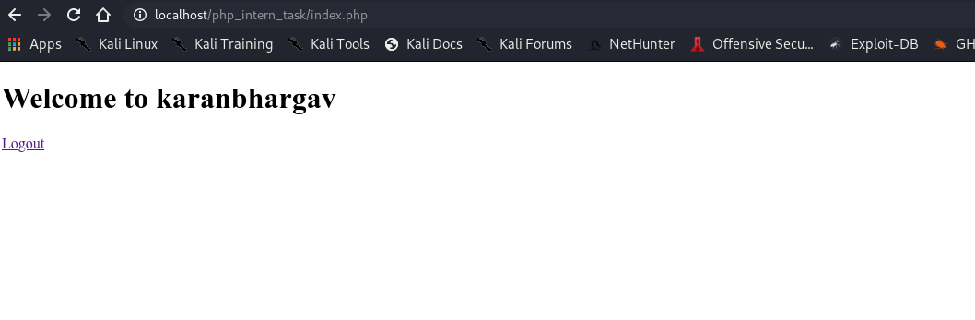**3.**