NAMA : WISNU RYAN GALUH NUGRAHA

NIM : 19030010

MOBILE COMPUTING

UML

1. Use Case Diagram

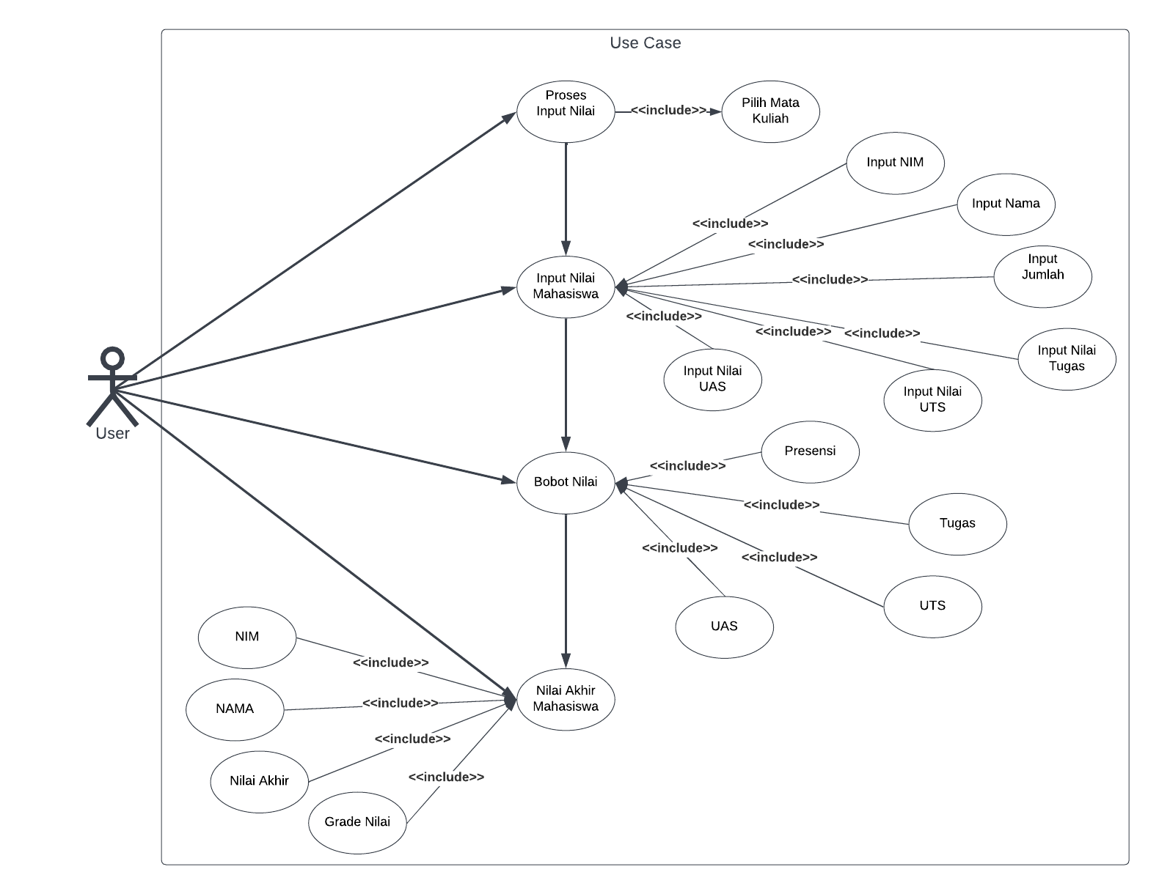

1. Class Diagram

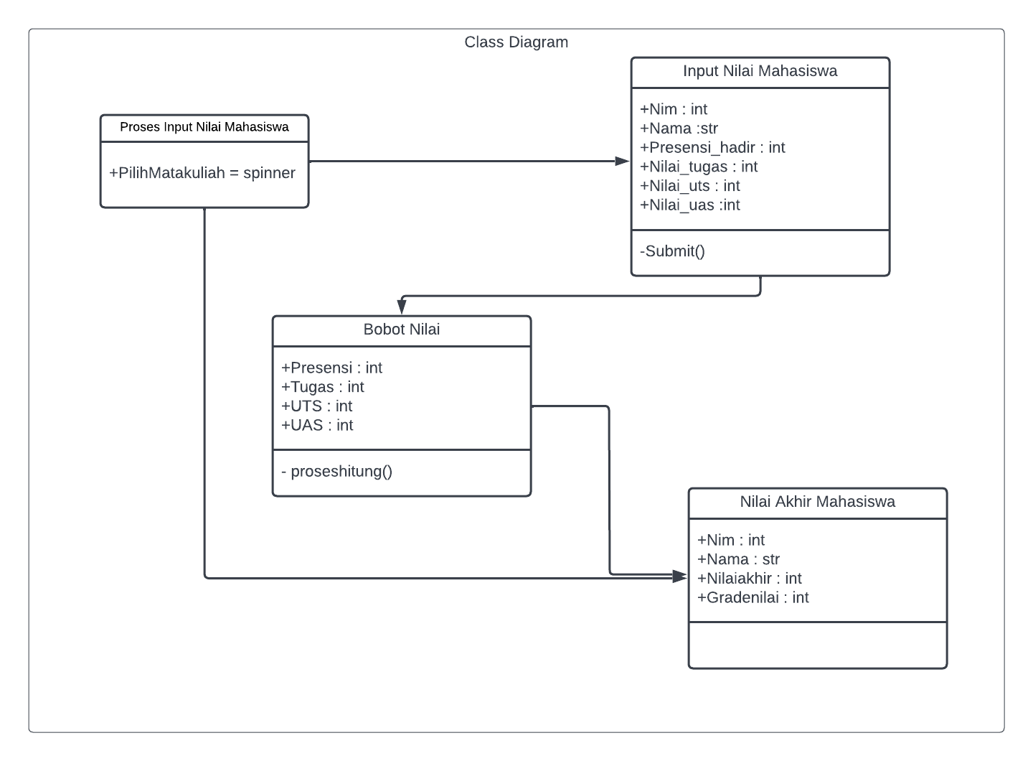

1. Activity Diagram

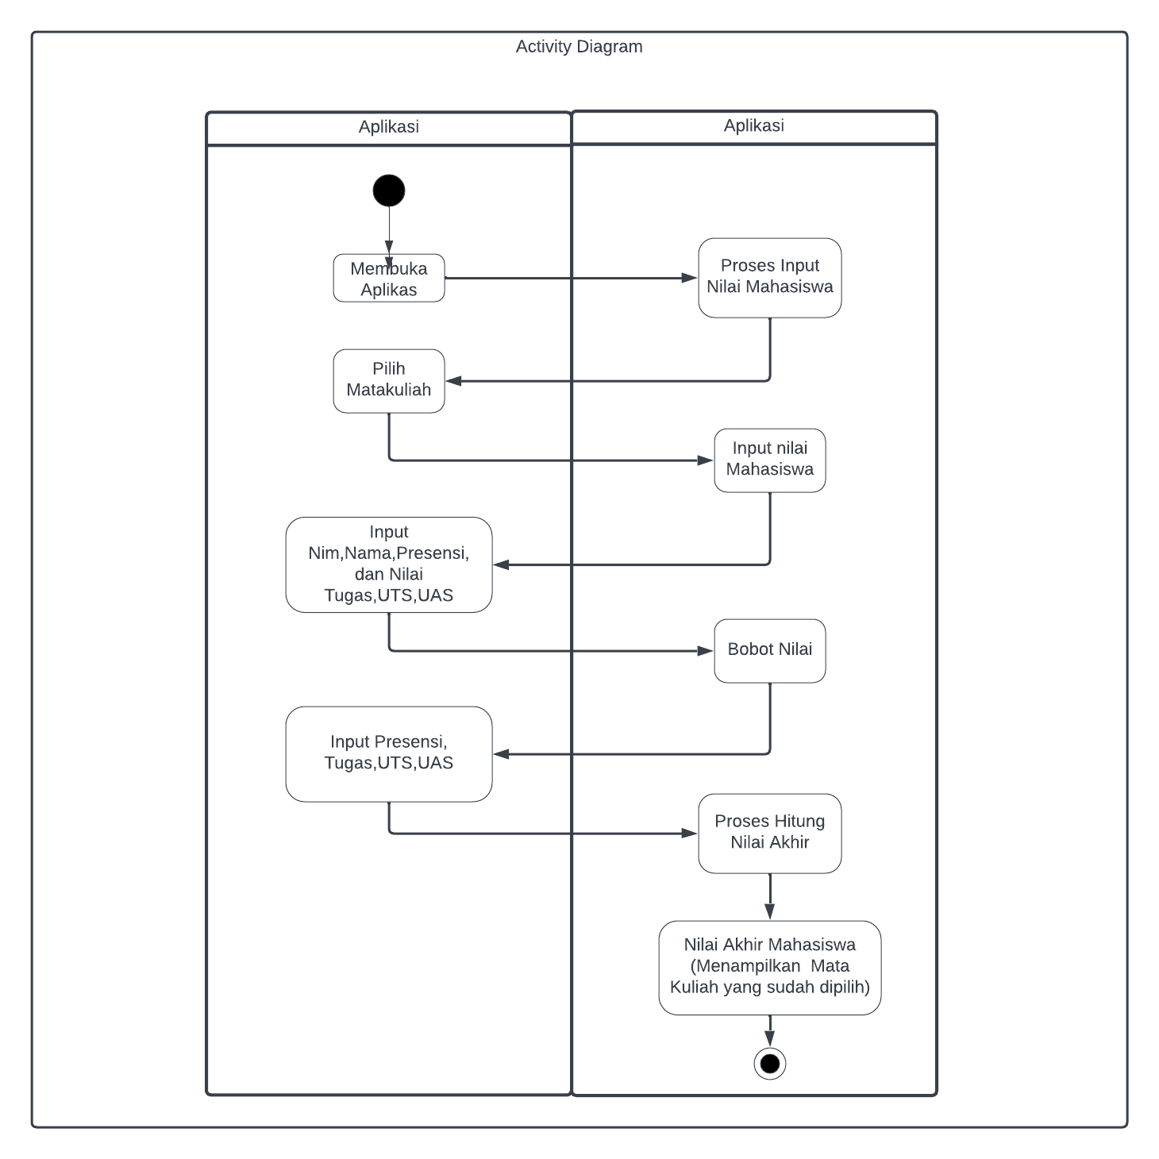

1. Sequence Diagram

