DP:0-1(nW)

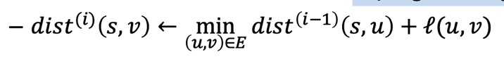

GraphDP: Floyd

GraphDP: All pair BF

GraphDP: Singlesource Shortest path(BF)

DP:Longest Pallindromic substring

DP: LCS(MN)

DP: Longest Incresing subseq(n^2)

D&C: Closest Pair(nlogn)

DP: Task selection(nlogn if sorted time)

DP: Runtime = Size of table \* time to fill every entry

D&C: Int multi

