Risk Register: (image created by AI to put table in a Portrait layout)
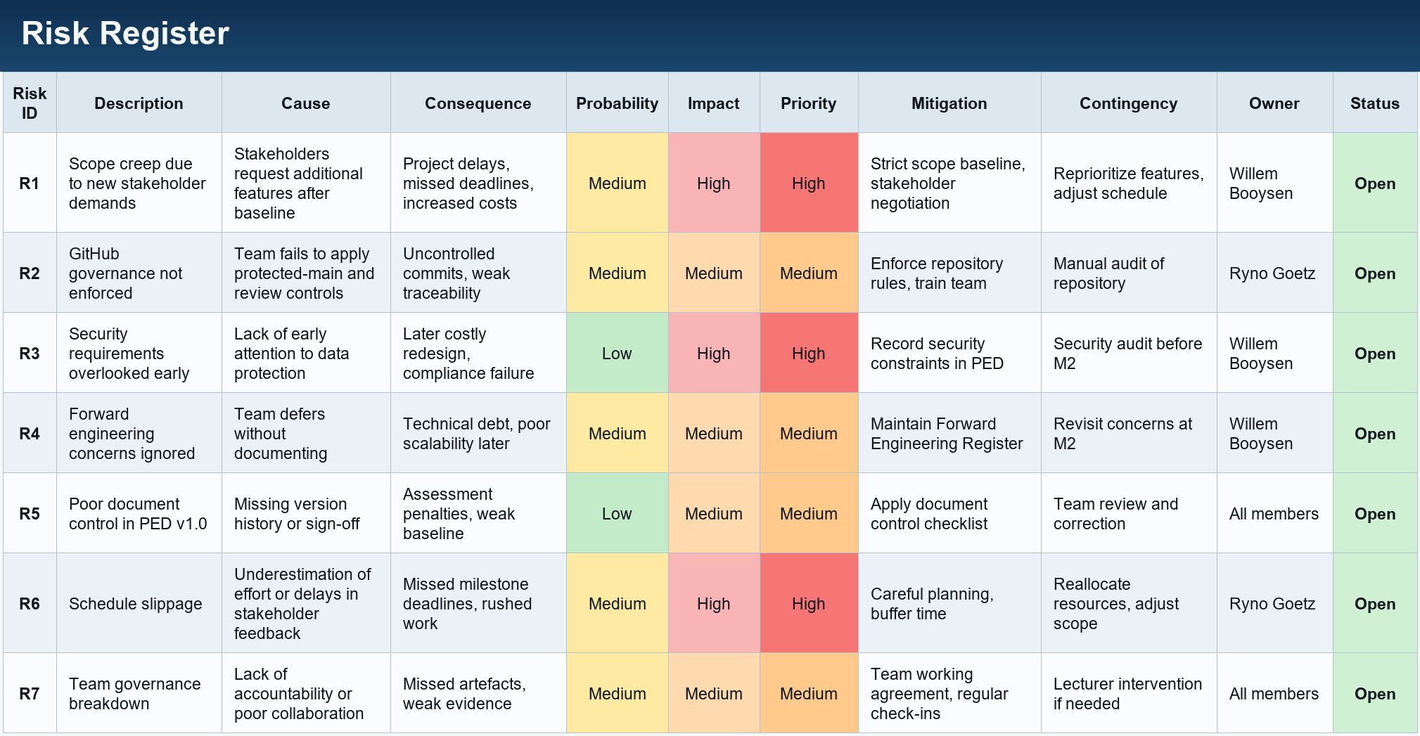

Highest concern risk:
The Highest concern risk would be R1. Scope creep for this project is the highest priority due to new stakeholder demands, as it poses the most immediate and fundamental threat to milestone delivery. While its probability is assessed as medium, the impact is high because uncontrolled expansion of scope directly undermines deadlines, inflates costs, and strains resources. Unlike other risks such as governance breakdown or document control issues, scope creep is a root risk that can trigger cascading effects, including schedule slippage and reduced quality. It is particularly critical because it arises immediately after the scope baseline is set, making early vigilance essential. Even with a strict baseline, stakeholder pressure can override team discipline, which makes mitigation challenging. For these reasons, scope creep is the highest concern and requires strong defence through stakeholder negotiation and disciplined scope management.
Forward Engineering Considerations: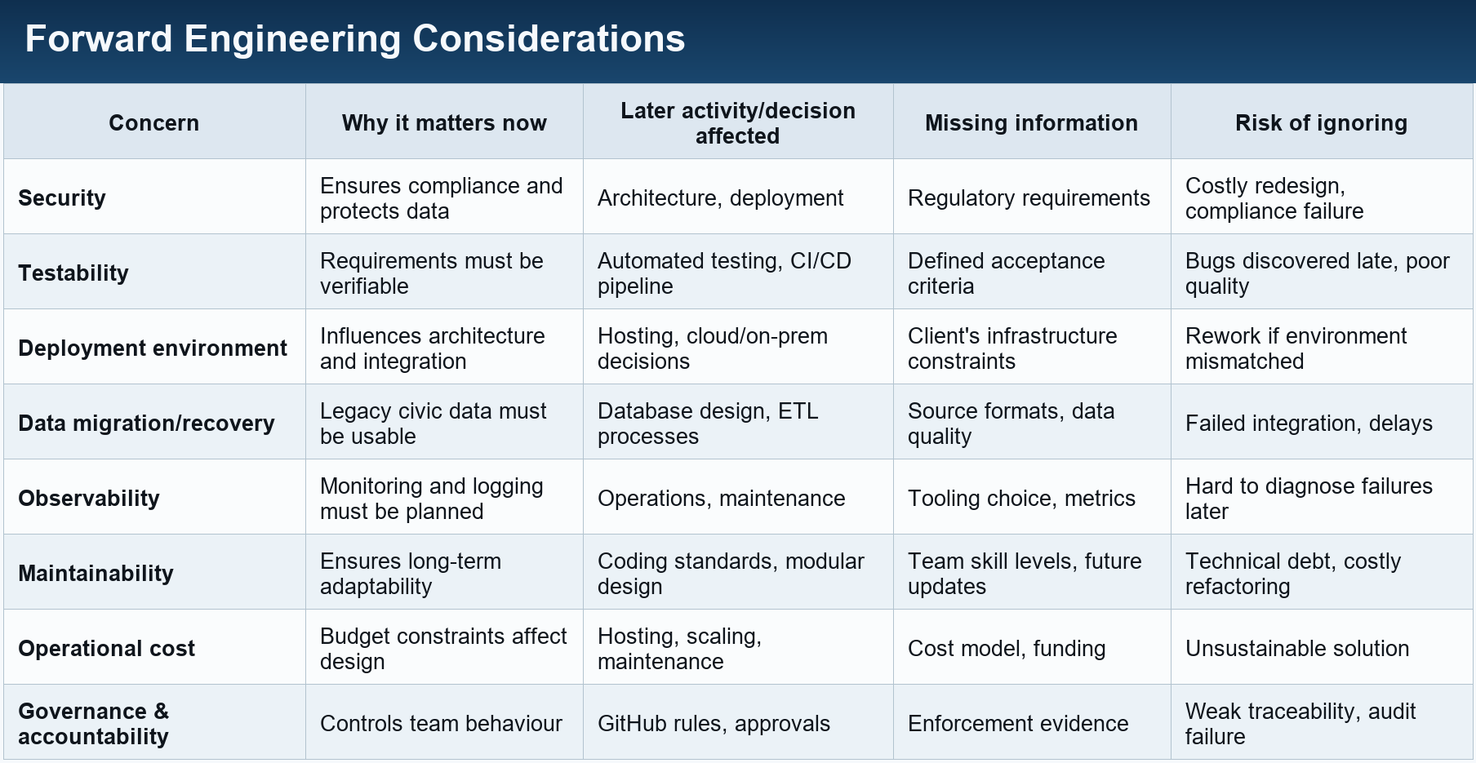

Engineering Decision Log:
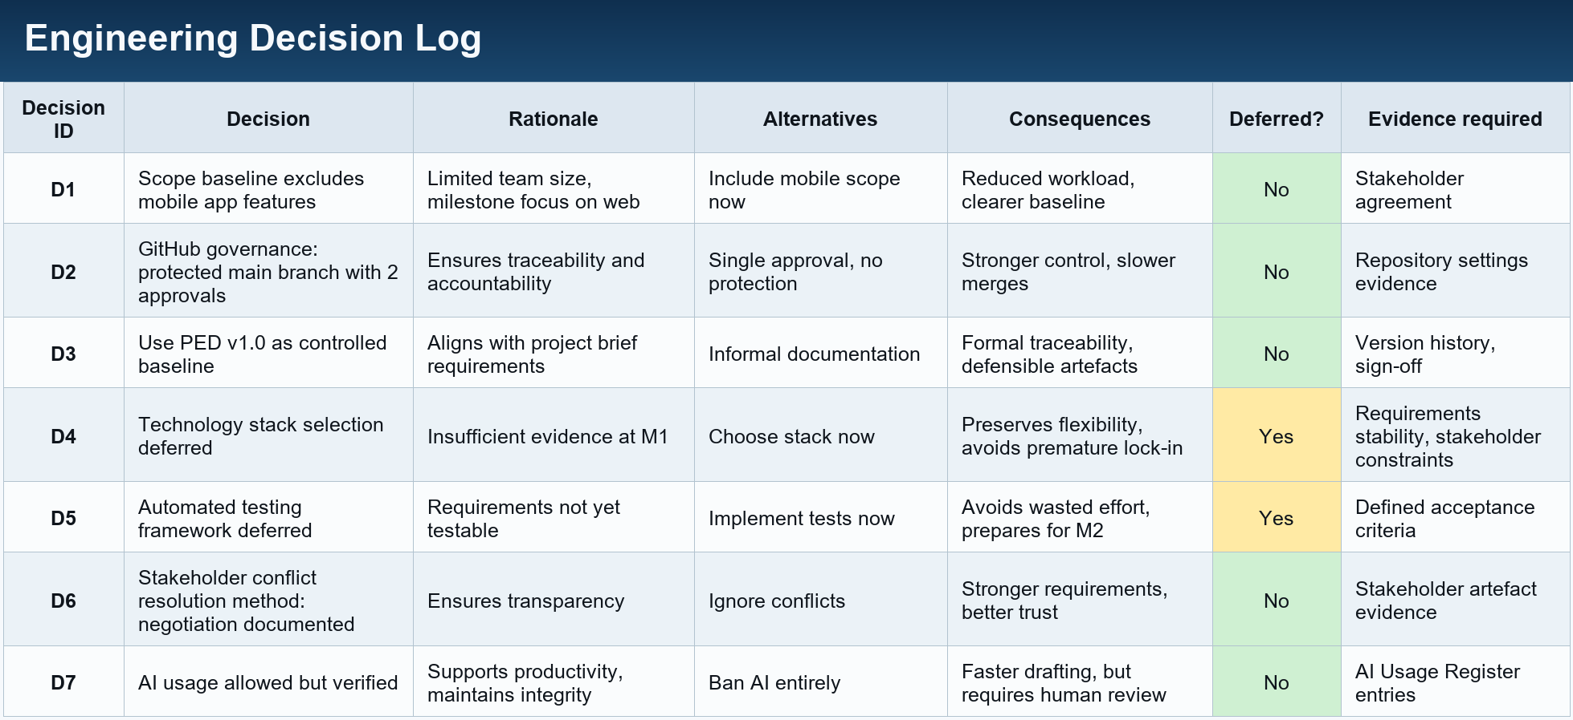

AI Usage Register:
Task | Prompt/Purpose | Contribution | Human Verification | Accepted/Corrected/Rejected | Responsible Member
Project planning documents | Assist with structuring and drafting project-management artefacts | Suggested initial wording, table structures and formatting | Checked against the milestone and master project briefs; corrected project-specific details | Accepted with corrections | Ryno Goetz
Table visualisation | Convert approved tables into clear standalone images | Assisted with layout and visual formatting | Compared every image with the original tables to confirm accuracy | Accepted after verification | Ryno Goetz
Language review | Improve clarity and consistency | Suggested wording and grammatical improvements | Manually reviewed before inclusion | Accepted with corrections | Ryno Goetz
Documentation | Improve wording and structure | Provided wording suggestions | Checked and edited manually | Accepted/Corrected | Steven
Requirements | Check requirement wording | Suggested clearer wording | Compared with project brief | Accepted/Corrected | Steven
RTM | Help organise traceability | Suggested table structure | Checked requirement IDs and links | Accepted/Corrected | Steven
Risk assessment | To help identify the highest concern risk | Suggested the highest risk | Used suggestion and reason to create a defence on why the suggestion is correct | Accepted/Corrected | Willem Booysen

