CivicConnect Assignment 3 Member Contribution Ryno Goetz
Question 1 Quality Strategy and Risk Based Verification
Module: Software Engineering 381
Prepared by: Ryno Goetz
Version and date: 1.0, 21 September 2026

Contents
Contents 2
Contribution overview 3
Contribution outputs 3
Question 1 Quality Strategy and Risk Based Verification 3
Quality assurance quality control verification and validation 3
Risk based verification 3
Complementary forms of verification evidence 4
Risk to Verification Evidence Map 5
Automation and quality gates 5
Critical judgement on a green pipeline 6
Research boundary 6
Question 4 Research to M3 Engineering Map 6
References 6
AI Usage Register 7

Question 1 Quality Strategy and Risk Based Verification
A defensible quality strategy connects stakeholder expectations and product risks to planned assurance activities, observable product evidence and explicit progression decisions. It therefore asks what can fail, who or what is harmed, how likely the failure is, what evidence would reveal it and what uncertainty remains. ISO/IEC 25010 supplies a quality model that can help teams express characteristics such as functional suitability, reliability, performance efficiency, security, maintainability and interaction capability as measurable objectives rather than vague claims (ISO and IEC, 2023).

Quality assurance quality control verification and validation
Quality assurance is process-oriented and preventive. It establishes the working conditions under which quality is likely to be built in, for example clear acceptance criteria, review rules, coding standards, test planning, traceability and controlled change. Quality control evaluates the resulting product or work product through inspection, measurement and testing. Verification asks whether the specified requirements and design were implemented correctly, while validation asks whether the resulting system is fit for stakeholder needs and its intended context. These activities overlap in practice: a review can verify a requirement, an automated test can control product quality, and stakeholder evaluation can validate whether technically correct behaviour solves the right problem.
The distinction matters because no single activity covers the whole quality problem. A team can follow a disciplined process yet misunderstand the need; it can pass implementation checks against an incomplete requirement; or it can satisfy a user scenario while concealing reliability or security weaknesses. ISO/IEC/IEEE 29119-2 treats testing as governed and managed processes across lifecycle models, supporting the view that evidence is planned, monitored and interpreted rather than appended at the end (ISO, IEC and IEEE, 2021).

Risk based verification
Risk-based testing selects, prioritises and manages test activities using risk analysis (ISTQB, 2024). Product risk combines the possibility of failure with its consequence. Business criticality adds context: failure in a rarely used administrative convenience may be tolerable, whereas a defect that exposes personal information, corrupts an audit trail or prevents recovery may justify deeper and more independent evidence even when its likelihood is uncertain.
A practical risk assessment can score likelihood and impact, then apply a criticality modifier for safety, security, legal, financial or mission consequences. The score is a prioritisation aid rather than an objective truth. The team should also record assumptions and confidence because little historical data can make a precise number misleading. Higher risk should normally increase the depth, diversity, timing and environment realism of verification: earlier reviews, more negative and boundary cases, independent review, integration with real dependencies, production-like load, and tighter exit criteria. Lower risk may justify sampling or lighter automation. Risk must be reassessed after design changes, defects, dependency updates or new operational evidence.

Complementary forms of verification evidence
Evidence form | Strong at exposing | Cannot prove on its own
Unit or component tests | Incorrect calculations, branching, state rules and boundary behaviour inside a small unit; fast localisation supports dense negative cases. | Correct collaboration, real database behaviour, deployment configuration, usability and end-to-end workflow.
Integration and API tests | Contract mismatches, serialisation, authentication or authorisation at interfaces, transaction boundaries, persistence mapping and dependency failure handling. | Browser-level experience, production scale, every external dependency condition and whether the requirement itself is right.
System and end-to-end tests | Broken user journeys, cross-component configuration, routing, session and workflow problems in a representative environment. | Exhaustive combinations, precise fault localisation, internal code quality or high-volume behaviour unless designed for it.
Static analysis and review | Suspicious code paths, unsafe constructs, style or maintainability issues, known patterns and defects visible without execution. | Runtime configuration, business-logic correctness, usable interaction, exploitability or absence of defects outside the rule set.
Performance and load evidence | Latency, throughput, saturation, capacity limits, resource leaks and failure behaviour under defined workloads. | Functional completeness, security, real future demand or production performance when the model and environment are unrepresentative.

The evidence forms are complementary because they trade speed and diagnostic precision against realism and scope. A risk should be mapped to the smallest evidence bundle that can expose the credible failure modes. More tests are useful only when their oracles, data, environment and coverage correspond to those risks.

Risk to Verification Evidence Map
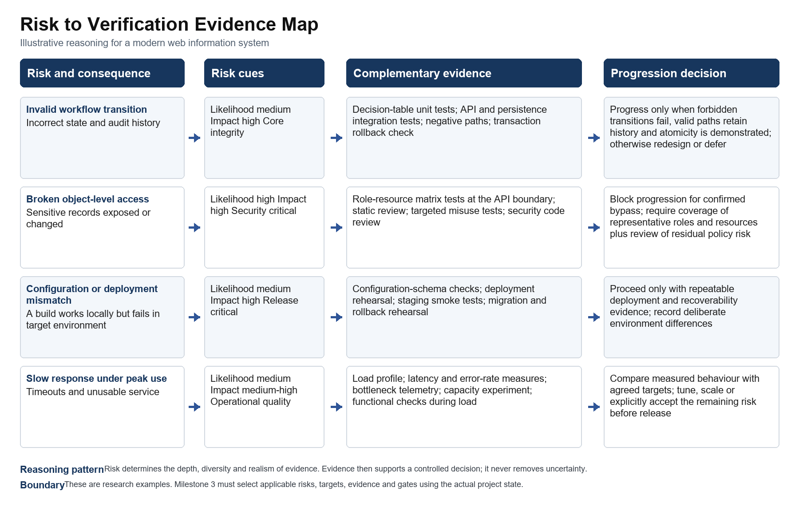
Figure 1 Original Risk to Verification Evidence Map
The map uses four illustrative risks to show the reasoning chain required by a quality strategy. It deliberately assigns evidence bundles rather than a single test type. For example, an access-control risk needs behavioural checks at the protected boundary plus design and code review; a deployment mismatch requires evidence from the deployment path and recovery process. The final column converts results into a progression decision and retains residual uncertainty.

Automation and quality gates
Automation makes selected checks repeatable, fast and visible. Candidate pipeline gates include compilation, static rules, unit and integration suites, dependency checks, test-result thresholds, migration validation and deploy-smoke checks. A useful gate has a stated risk purpose, an accountable owner, reliable execution, preserved evidence and an exception process. NIST's Secure Software Development Framework similarly treats automated tools as part of a broader set of practices that includes requirements, review, protected environments, provenance and vulnerability response (Scarfone, Souppaya and Dodson, 2022).
Poorly chosen gates create false confidence or delay work without reducing meaningful risk. Coverage percentages do not show that assertions are correct. Flaky checks encourage retries and normalise failure. A scanner can miss a novel or contextual defect, while a broad threshold can block low-risk findings and distract from a severe business-logic error. Gate criteria should therefore be reviewed when architecture, risk tolerance, dependencies or observed defects change.

Critical judgement on a green pipeline
All automated tests passing means only that the implemented checks produced their expected results in the environments and data used. It does not prove that every important requirement was represented, that the assertions detect the right failures, that stakeholder needs were validated, that permissions and business rules are complete, or that the target environment will behave like the test environment. It also says little about unknown vulnerabilities, usability, recovery, operational ownership or load beyond the tested profile. Release confidence should therefore come from converging evidence linked to risk, together with explicit acceptance of what remains unproven.

Research boundary
The approaches below are candidates supported by research. Milestone 3 must decide what applies by examining CivicConnect requirements, architecture, implementation, risks, constraints and available evidence. Words such as could, candidate and should be considered are used deliberately; this assignment does not claim that a control or tool has already been adopted.

Question 4 Research to M3 Engineering Map
The map transfers the strongest research findings into candidate evidence and open Milestone 3 decisions. The final column preserves the boundary: research expands the decision space, while M3 must use the actual CivicConnect product state to select, apply and verify controls.
Research finding | Engineering concern | Candidate approach or evidence | Trade off or limitation | Decision M3 must still make
Risk-based verification allocates depth and diversity of evidence according to likelihood, impact and criticality. | Unequal consequence of product failures | Risk register linked to unit, integration, system, performance and review evidence with explicit progression criteria. | Scores are uncertain and can become stale; more testing does not guarantee useful coverage. | Which CivicConnect risks justify deeper or independent evidence, and what thresholds support progression?
A green automated pipeline is evidence about implemented checks, not complete product quality. | False confidence from automation | Layered evidence, reviewed test oracles, environment-aware gates and controlled exceptions. | Manual evidence costs time; broad gates can be noisy or block low-risk work. | Which checks should become gates, which require human review, and how will exceptions be approved?

Contribution identifiers: A3-MAP-01 and A3-MAP-02. The final team brief integrates these rows with the four findings supplied by the other members.

References
International Organization for Standardization and International Electrotechnical Commission (2023) ISO/IEC 25010:2023 Systems and software engineering - Systems and software Quality Requirements and Evaluation - Product quality model. Geneva: ISO. Available at: https://www.iso.org/standard/78176.html (Accessed: 21 September 2026).
International Organization for Standardization, International Electrotechnical Commission and Institute of Electrical and Electronics Engineers (2021) ISO/IEC/IEEE 29119-2:2021 Software and systems engineering - Software testing - Part 2: Test processes. Geneva: ISO. Available at: https://www.iso.org/standard/79428.html (Accessed: 21 September 2026).
International Software Testing Qualifications Board (2024) Certified Tester Foundation Level Syllabus v4.0.1. Available at: https://istqb.org/wp-content/uploads/2024/11/ISTQB_CTFL_Syllabus_v4.0.1.pdf (Accessed: 21 September 2026).
Scarfone, K., Souppaya, M. and Dodson, D. (2022) Secure Software Development Framework Version 1.1: Recommendations for Mitigating the Risk of Software Vulnerabilities. NIST SP 800-218. Gaithersburg, MD: National Institute of Standards and Technology. Available at: https://doi.org/10.6028/NIST.SP.800-218 (Accessed: 21 September 2026).

AI Usage Register
Date | Student | Tool | Engineering task | AI contribution | Human verification | Decision | Issues found
21 September 2026 | Ryno Goetz | OpenAI Codex | Quality strategy, risk-based verification and the Risk to Verification Evidence Map | Assisted with source discovery, research synthesis, comparative analysis, drafting and visual layout | Compared the claims and visual reasoning with ISO/IEC 25010:2023, ISO/IEC/IEEE 29119-2:2021, ISTQB CTFL 4.0.1 and NIST SSDF 1.1 | Accepted with corrections | Removed sources older than ten years, a generic testing list and wording that treated a green pipeline as complete quality evidence

