Design and Evaluation of an Automated Configuration Validation System
for Professional AV/IT Environments: An ASEL Case Study
Unit 3 Assignment Activity: System Architecture and Version Control
Nana
University of the People
MSIT 5910-01: MSIT Capstone Project
Instructor: Dr. P. G. K. Sirisha
September 2026

Question 1: System Architecture Blueprint and Module Design
The proposed system is a local, read-only validation pipeline for sanitized Behringer X32 scene (.scn) files used in the ASEL professional AV/IT environment. Its purpose is to identify high-impact routing deviations before a configuration reaches rehearsal or live operation. The architecture uses a layered pipeline because the problem is naturally decomposed into acquisition, validation, parsing, comparison, classification, reporting, and human approval. Layer separation improves maintainability and testability: each transformation has a defined contract, and a defect in presentation logic cannot silently alter the source configuration. The design also enforces a safety boundary: the prototype never connects to a live console, edits a scene, or automatically deploys a correction (Letaw, 2024; Walker, 2022).
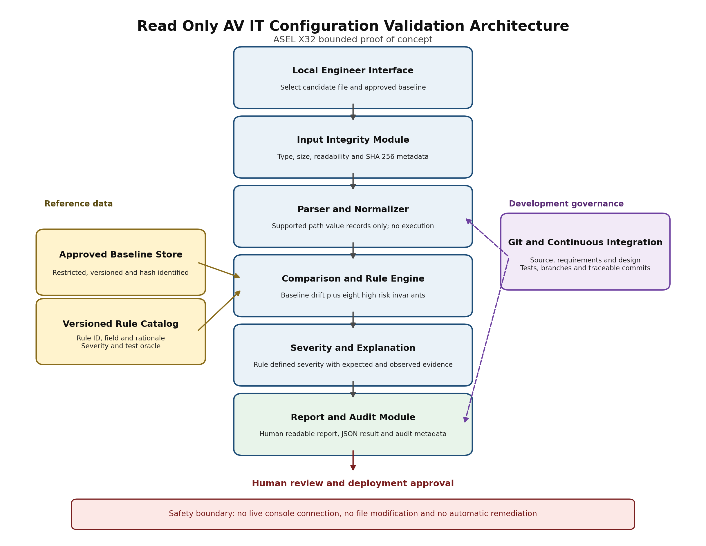
Figure 1. System architecture and trust boundaries for the read-only validator.
An engineer selects a sanitized scene and an approved baseline. The input-integrity layer verifies the extension, size, text structure, and checksum before any semantic processing. The parser converts recognized X32 path/value records into a normalized key-value model while preserving line numbers and raw evidence. The comparison engine evaluates a versioned rule catalog and approved baseline; the severity module assigns deterministic, documented ratings rather than opaque probabilities. The report module produces a human-readable finding with the expected value, observed value, source location, severity rationale, and rule identifier. Only an authorized engineer can approve operational action. Git history, automated tests, and rule-version identifiers provide traceability across requirements, code, tests, and reports (National Institute of Standards and Technology [NIST], 2011).
Table 1. Module-wise functional specifications
Module | Input | Output | Methodology
M1 Input/Integrity | Scene, baseline, size policy | Accepted input or rejection | Allowlist extension; size/encoding checks; SHA-256; fail closed
M2 Parser/Normalizer | Validated .scn text | Normalized records with line evidence | Deterministic path/value grammar; duplicate and malformed-line detection
M3 Baseline Manager | Approved baseline and version | Immutable comparison object | Checksum and version binding; least-privilege read access
M4 Rule Engine | Records, baseline, rule catalog | Pass/fail evaluations | Exact predicates for eight high-risk routing categories
M5 Severity/Explanation | Rule result and rationale | Critical/major/minor/informational finding | Rule-defined classification; expected-versus-observed evidence
M6 Report/Audit | Findings and run metadata | HTML/JSON report and audit record | Escaped output; timestamps; hashes; ruleset ID; no sensitive raw file retention
M7 Human Review | Explainable report | Approve, reject, or investigate decision | Named reviewer; four-eyes review for critical findings; no automatic remediation

Functional and Non-Functional Requirements
The functional requirements are deliberately testable and traceable. FR-01 accepts only an explicitly selected sanitized .scn file. FR-02 validates type, size, encoding, and structure. FR-03 parses supported path/value records without modifying the source. FR-04 binds each run to an approved baseline and checksum. FR-05 compares selected high-risk fields. FR-06 evaluates at least eight rules covering main, subwoofer, monitor, front-fill, critical-input, broadcast-card, bus/matrix-membership, and destination-conflict conditions. FR-07 assigns a rule-defined severity. FR-08 reports expected and observed evidence with rule and line identifiers. FR-09 records run metadata and ruleset version. FR-10 requires human disposition before any operational change. These requirements express what the system must do and can each be mapped to one or more tests, consistent with Letaw’s (2024) criteria for unambiguous, verifiable, and traceable requirements.
Table 2. Non-functional requirements and design constraints
Requirement | Measurable specification
NFR-01 Performance | Process each controlled file in 5 seconds or less on the evaluation workstation.
NFR-02 Accuracy | Target at least 90% precision and 90% recall on at least 40 controlled variants.
NFR-03 Reliability | Reject malformed or ambiguous input; never return a misleading partial pass.
NFR-04 Usability | Use plain-language findings with evidence and remediation guidance.
NFR-05 Maintainability | Keep parser, rules, severity, and reporting independently testable and documented.
NFR-06 Scalability | Support additional documented rules without changing parser contracts.
NFR-07 Security | Validate input, escape output, verify baseline integrity, and apply least privilege.
NFR-08 Privacy | Use sanitized/synthetic data and retain only minimal audit metadata.
NFR-09 Safety | Remain offline/read-only with no console control or automatic remediation.

Question 2: Version Control and Collaboration
The project is published at https://github.com/Rynphal88/av-it-configuration-validator. Its folder structure separates source code (src/av_validator), unit tests (tests), requirements and progress documentation (docs), architecture artifacts (design), rule data (rules), sanitized samples (sample-configs/sanitized), and generated reports (reports). This organization makes each deliverable discoverable and reduces the chance that generated output or confidential production files will be committed. The .gitignore file excludes caches, virtual environments, build products, and local report contents.
The repository uses main as the stable submission branch and develop as the integration branch. Short-lived feature branches isolate bounded changes; for example, feature/architecture-blueprint created the diagram and build script, then merged into develop with a non-fast-forward merge. Work reaches main only after tests pass, documentation is synchronized, and a review confirms that the safety boundary remains intact. This approach demonstrates parallel work without treating branch count as an end in itself. Git branches preserve independent histories, while pull requests create a reviewable place to discuss and approve changes (Davies, 2024; GitHub, n.d.-a, n.d.-b).
Table 3. Branch roles and collaboration evidence
Branch | Purpose | Current evidence
main | Stable, assessed baseline | Published Unit 3 milestone; receives reviewed milestone merges
develop | Integrated Unit 3 work | Parser, rules, tests, requirements, CI, and documentation
feature/architecture-blueprint | Isolated design artifact | Merged into develop through a recorded merge commit

Commit messages use an imperative, scoped pattern such as “docs: define system requirements and high-risk rule catalog,” “feat: add read-only parser and validation engine scaffold,” and “test: expand safe parser and engine coverage.” Each commit represents one coherent change, so reviewers can compare versions or revert a defect without discarding unrelated work. The current automated suite contains eight passing tests covering valid parsing, duplicate and malformed input, missing values, size limits, compliant rules, missing paths, and explainable evidence. The published traceability matrix distinguishes implemented evidence from planned controlled evaluation. GitHub Actions runs the suite on pushes and pull requests to main and develop. Together, branch controls, meaningful commits, CI, and versioned rules establish accountability: a finding can be traced from its report identifier to the rule, test, source revision, and approved baseline (NIST, 2011, 2019).

References
Davies, S. (2024). Blueprints: Creating, describing, and implementing designs for larger-scale software projects (Version 2.5). University of Mary Washington. https://open.umn.edu/opentextbooks/textbooks/blueprints-creating-describing-and-implementing-designs-for-larger-scale-software-projects-davis
GitHub. (n.d.). About branches. GitHub Docs. https://docs.github.com/en/pull-requests/collaborating-with-pull-requests/proposing-changes-to-your-work-with-pull-requests/about-branches
GitHub. (n.d.). About pull requests. GitHub Docs. https://docs.github.com/en/pull-requests/collaborating-with-pull-requests/proposing-changes-to-your-work-with-pull-requests/about-pull-requests
Letaw, L. (2024). Handbook of software engineering methods. Oregon State University. https://open.oregonstate.education/setextbook/
National Institute of Standards and Technology. (2011). Guide for security-focused configuration management of information systems (NIST SP 800-128). https://doi.org/10.6028/NIST.SP.800-128
National Institute of Standards and Technology. (2019). Secure software development framework (SSDF) version 1.1: Recommendations for mitigating the risk of software vulnerabilities (NIST SP 800-218). https://doi.org/10.6028/NIST.SP.800-218
Open Worldwide Application Security Project. (n.d.). Input validation cheat sheet. https://cheatsheetseries.owasp.org/cheatsheets/Input_Validation_Cheat_Sheet.html
Walker, V. (2022, March 16). 14 software architecture design patterns to know. Red Hat. https://www.redhat.com/en/blog/14-software-architecture-patterns

