**NBA 2021-2022 Infobot**

**A Final Project Requirement**

**Submitted to Mr. John Cristopher Mateo**

**College of Information and Communications Technology**

**West Visayas State University**

**La Paz, Iloilo City**

**In Partial Fulfillment**

**of the Requirements for the Subject**

**CCS 249 – Natural Language Processing**

**Bachelor of Science in Computer Science**

**By:**

**Gallena, Regino**

**Rapita, Kyla Joy**

**Sermonia, Journey Mariz**

**Tanque, Jaren Joseph**

**Torres, Aaron Raif**

**May 2024**

**Table of Contents**

**I. Introduction.......................................................................................................................**

**II. Flask Framework as the Backen..........................................................................................**

1. **Text Preprocessing ..........................................................................................**
2. **Sentiment Analysis..........................................................................................**

**III. React Framework for Frontend...........................................................................................**

**IV. How to Run........................................................................................................................**

1. **Introduction**

The NBA 2021-2022 InfoBot serves as a comprehensive digital resource designed to provide detailed information about the 2021-2022 NBA season. Utilizing advanced artificial intelligence, the InfoBot is capable of delivering prompt and accurate responses to inquiries regarding the season's key events, notable players, and game results. Users can engage with the chatbot, named Regie, to obtain data on MVPs, championship outcomes, and specific match details. This application aims to enhance the user’s understanding and engagement with the NBA by offering a reliable and efficient means of accessing pertinent season information.

1. **Backend**
2. **Text Processing**

The text processing aspect of the NBA 2021-2022 InfoBot project plays a crucial role in transforming raw textual data into a structured format that can be effectively utilized by machine learning models. Through a series of techniques and methods, the project aims to enhance the understanding and retrieval of relevant information regarding the NBA season.

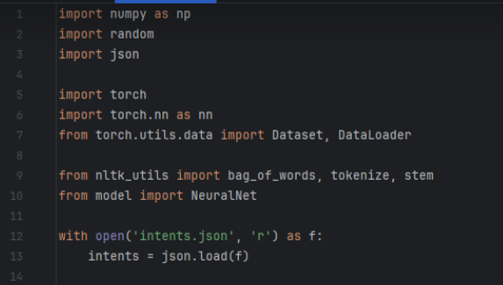

The first step involves libraries. In this case, Python libraries like nltk for language processing and numpy for numerical analysis.

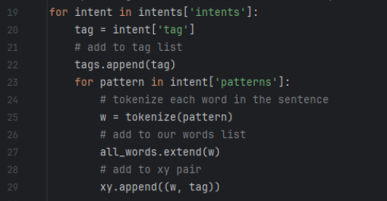

The code snippet provides the building blocks for understanding user input. It doesn't define intent itself, but the processed text it generates can be used later stages of the program to identify the user's intent (what they want to achieve) through separate techniques.

1. **Sentiment Analysis**

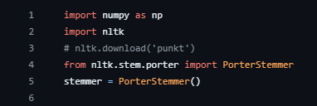

The code uses NumPy library, that is commonly used for scientific computing tasks in Python. It also imports the Natural Language Toolkit (NLTK), a popular library for NLP tasks.

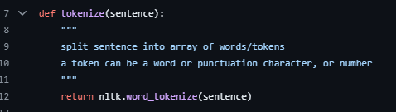

The tokenize function takes a sentence as input and utilizes NLTK's word tokenize function to split it into a list of individual words, tokens, punctuation characters, or numbers. For a new sentence, it tokenizes it into individual words.

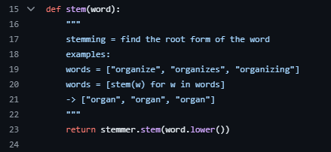

The stem function takes a word as input, converts it to lowercase, and applies the Porter Stemmer for stemming. Each word is then stemmed to its base form.

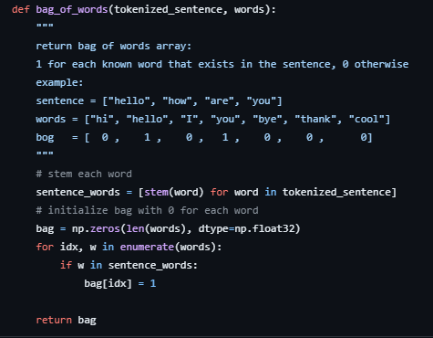

The bag-of-words function creates a representation showing the presence or absence of stemmed vocabulary words in the sentence. This bag-of-words representation is a common way to represent text data for various NLP tasks, such as sentiment analysis or document classification. It allows for document comparison based on word presence or absence, ignoring their order.

**III. Python Framework for Frontend**

The frontend of the NBA 2021-2022 InfoBot chatbot is Tkinter application. This Tkinter application specifically provides users with a graphical interface to interact with the NBA InfoBot. It can be run by executing the Python script containing the Tkinter code.

The frontend is composed of a single window where the interface of the NBA InfoBot is displayed. At the top of the window, a header labeled "NBA 2021-2022 InfoBot" is shown, followed by a divider line to separate the header from the chat area.

Below the header, the chat area consists of a text widget where the conversation between the user and the chatbot takes place. The chat area displays user messages and chatbot responses in a structured and readable format. The user can type messages in the entry box located at the bottom of the window and send them by pressing the Enter key or clicking the "Send" button.

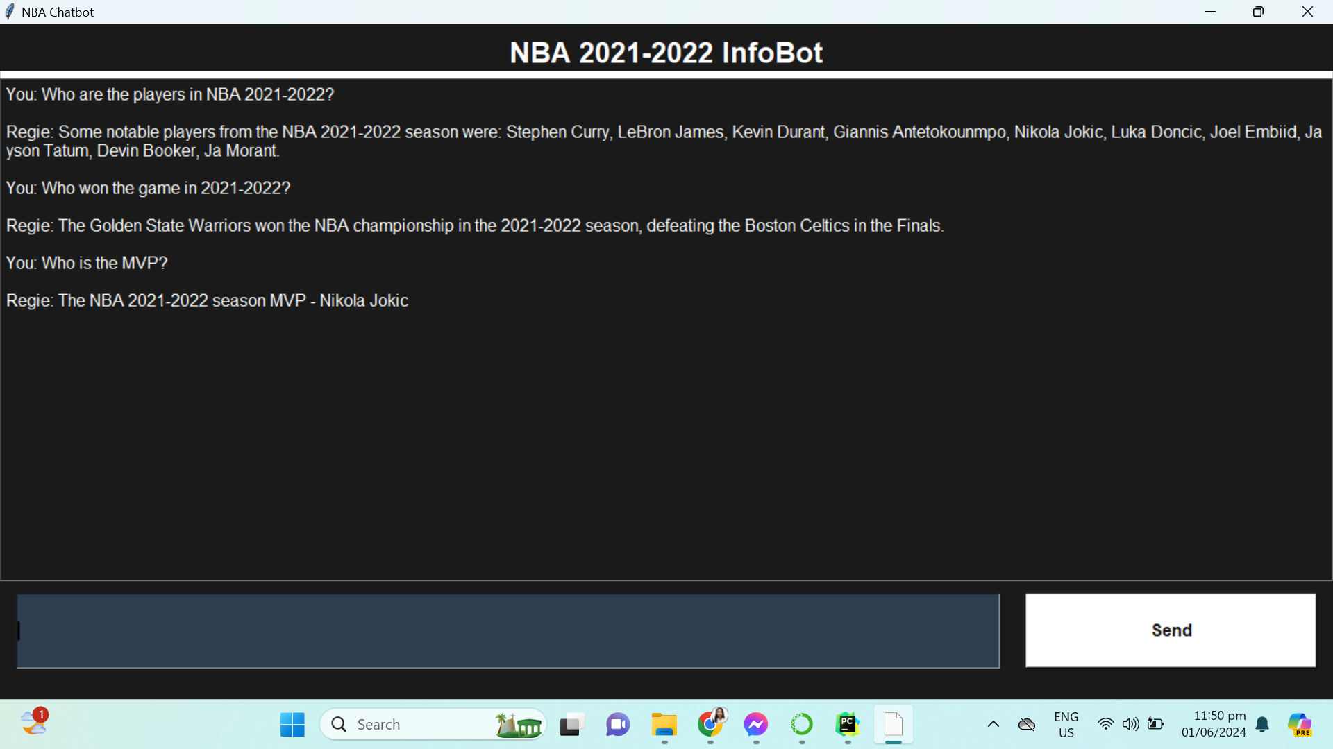

**IV. How to Run**

To run the NBA 2021-2022 InfoBot application, please follow the steps below:

1. **Download the Application:**
   * Download the backend and frontend folders into a main directory of your choice. All necessary libraries are included within these folders.
2. **Setting up the Backend:** a. Open a terminal window and navigate to the backend directory.  
    b. Activate the virtual environment by executingvenv\Scripts\activate.  
    c. Start the backend server by running the command python main.py.
3. **Setting up the Frontend:** a. Open a separate terminal window and navigate to the frontend directory.   
   b. Launch the frontend by running the Python script that initializes the Tkinter application.