

Functional Safety Concept Lane Assistance

**Document Version: [Version]**

**Template Version 1.0, Released on 2017-06-21**



# Document history

**[Instructions: Fill in the date, version and description fields. You can fill out the Editor field with your name if you want to do so. Keep track of your editing as if this were a real world project.**

**For example, if this were your first draft or first submission, you might say version 1.0. If this is a second submission attempt, then you'd add a second line with a new date and version 2.0]**

|  |  |  |  |
| --- | --- | --- | --- |
| Date | Version | Editor | Description |
|  |  |  |  |
|  |  |  |  |
|  |  |  |  |
|  |  |  |  |
|  |  |  |  |

# Table of Contents

**[Instructions: We have provided a table of contents. If you change the document structure, please update the table of contents accordingly. The table of contents should show each section of the document and page numbers or links. Most word processors can do this for you. In** [**Google Docs**](https://support.google.com/docs/answer/116338?co=GENIE.Platform%3DDesktop&hl=en)**, you can use headings for each section and then go to Insert > Table of Contents.** [**Microsoft Word**](https://support.microsoft.com/en-us/help/285059/how-to-create-a-table-of-contents-by-marking-text-in-word) **has similar capabilities]**

Document history

Table of Contents

Purpose of the Functional Safety Concept

Inputs to the Functional Safety Analysis

Safety goals from the Hazard Analysis and Risk Assessment

Preliminary Architecture

Description of architecture elements

Functional Safety Concept

Functional Safety Analysis

Functional Safety Requirements

Refinement of the System Architecture

Allocation of Functional Safety Requirements to Architecture Elements

Warning and Degradation Concept

# Purpose of the Functional Safety Concept

**[Instructions: Answer what is the purpose of a functional safety concept?]**

There are three purposes of the Functional Safety Concept.

* Refine the safety goals in what are called safety requirements.
* Allocate these safety requirements to the relevant parts of the system diagram.
* Refine the system architecture.

# Inputs to the Functional Safety Concept

## Safety goals from the Hazard Analysis and Risk Assessment

**[Instructions:**

**REQUIRED:**

**Provide the lane departure warning and lane keeping assistance safety goals as discussed in the lessons and derived in the hazard analysis and risk assessment.**

**OPTIONAL:**

**If you expanded the hazard analysis and risk assessment to include other safety goals, include them here.**

**]**

|  |  |
| --- | --- |
| **ID** | **Safety Goal** |
| Safety_Goal_01 | The oscillating sttering torque from the lane departure warning function shall be limited. |
| Safety_Goal_02 | The lane keeping assistance torque is applied only limited time duration. |
| Safety_Goal_03 | The use of camera in degraded view condition shall be limited. |

## Preliminary Architecture

**[Instructions: Provide a preliminary architecture for the lane assistance item. Hint: See Lesson 3: Item Definition]**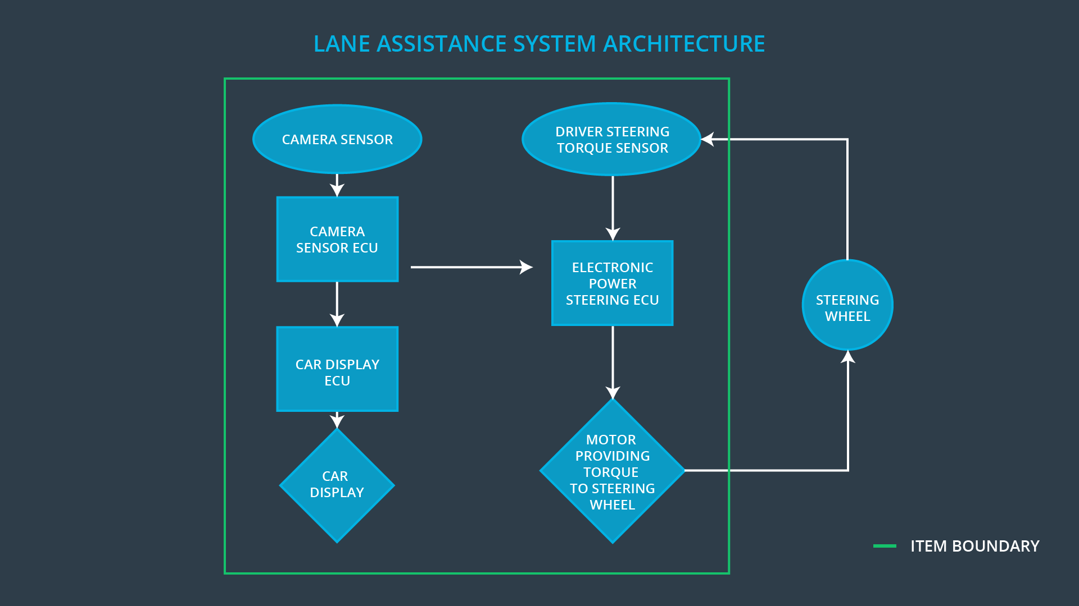

### Description of architecture elements

**[Instructions: Provide a description for each of the item elements; what is each element's purpose in the lane assistance item? ]**

|  |  |
| --- | --- |
| **Element** | **Description** |
| Camera Sensor | Camera sensor is responsible for capturing the vehicle driving condition including detactable lane lines. |
| Camera Sensor ECU | Camera Sensor ECU is responsible for measuring the distance from the lane line and making requests how much torque to generate to Electronic Power Steering ECU. |
| Car Display | Car Display is responsible for warning the driver of misuse of lane keeping system or letting the driver know of the lane departure or lane keeping system malfunction. |
| Car Display ECU | Car Display ECU is responsible for recieving the distance information from the Camera Sensor ECU and deciding whether or not send a warn signal to the Car DIsplay. |
| Driver Steering Torque Sensor | Driver Steering Torque Sensor is responsible for measureing driver steering torque. |
| Electronic Power Steering ECU | Electronic Power Steering ECU is responsible for recieving steering torque from Driver Steering Torque Sensor and the torque request from Camera Sensor ECU and then finalize the steering torque request to Motor. |
| Motor | Motor is responsible to provide torque to steering wheel. |

# Functional Safety Concept

The functional safety concept consists of:

* Functional safety analysis
* Functional safety requirements
* Functional safety architecture
* Warning and degradation concept

## Functional Safety Analysis

**[Instructions: Fill in the functional safety analysis table below.]**

|  |  |  |  |
| --- | --- | --- | --- |
| **Malfunction ID** | **Main Function of the Item Related to Safety Goal Violations** | **Guidewords (NO, WRONG, EARLY, LATE, MORE, LESS)** | **Resulting Malfunction** |
| Malfunction_01 | Lane Departure Warning (LDW) function shall apply an oscillating steering torque to provide the driver a haptic feedback | MORE | The lane departure warning function applies an oscillating torque with very high torque amplitude(above limit) |
| Malfunction_02 | Lane Departure Warning (LDW) function shall apply an oscillating steering torque to provide the driver a haptic feedback | MORE | The lane departure warning function applies an oscillating torque with very high torque frequency(above limit) |
| Malfunction_03 | Lane Keeping Assistance (LKA) function shall apply the steering torque when active in order to stay in ego lane | NO | The lane keeping assistance function is not limited in time duration which leads to misuse as an autonomous driving function |

## Functional Safety Requirements

**[Instructions: Fill in the functional safety requirements for the lane departure warning ]**

Lane Departure Warning (LDW) Requirements:

|  |  |  |  |  |
| --- | --- | --- | --- | --- |
| **ID** | **Functional Safety Requirement** | **ASIL** | **Fault Tolerant Time Interval** | **Safe State** |
| Functional  Safety  Requirement  01-01 | The lane keeping item shall ensure that the oscillating torque amplitude is below Max_Torque_Amplitude. | C | 50ms | Set vibration torque to zero |
| Functional  Safety  Requirement  01-02 | The lane keeping item shall ensure that the oscillating torque frequency is below Max_Torque_Frequency. | C | 50ms | Set vibration torque to zero |

Lane Departure Warning (LDW) Verification and Validation Acceptance Criteria:

|  |  |  |
| --- | --- | --- |
| **ID** | **Validation Acceptance**  **Criteria and Method** | **Verification Acceptance**  **Criteria and Method** |
| Functional  Safety  Requirement  01-01 | The Max_Torque_Amplitude is large enough to let drivers know the haptic feedback. | Verify that the amount of oscillating torque amplitude is below Max_Torque_Amplitude |
| Functional  Safety  Requirement  01-02 | The Max_Torque_Frequency is large enough to let drivers know the haptic feedback. | Verify that the amount of oscillating torque freqency is below Max_Torque_Freqency. |

**[Instructions: Fill in the functional safety requirements for the lane keeping assistance]**

Lane Keeping Assistance (LKA) Requirements:

|  |  |  |  |  |
| --- | --- | --- | --- | --- |
| **ID** | **Functional Safety Requirement** | **ASIL** | **Fault Tolerant Time Interval** | **Safe State** |
| Functional  Safety  Requirement  02-01 | Lane keeping assistance fucntion shall be time limited and the additional steering torque shall end after a given time interval so that the driver cannot misuse the system for autonomous driving. | B | 500ms | Shut off the system |

Lane Keeping Assistance (LKA) Verification and Validation Acceptance Criteria:

|  |  |  |
| --- | --- | --- |
| **ID** | **Validation Acceptance**  **Criteria and Method** | **Verification Acceptance**  **Criteria and Method** |
| Functional  Safety  Requirement  02-01 | The Max_Duration chosen really did dissuade drivers from taking their hands off the wheel. | The system really does turn off if the lane keeping assistance every exceeded Max_Duration. |

## Refinement of the System Architecture

**[Instructions: Include the refined system architecture. Hint: The refined system architecture should include the system architecture from the end of the functional safety lesson including all of the ASIL labels.]**

## Allocation of Functional Safety Requirements to Architecture Elements

**[Instructions: Mark which element or elements are responsible for meeting the functional safety requirement. Hint: Only one ECU is responsible for meeting all of the requirements.]**

|  |  |  |  |  |
| --- | --- | --- | --- | --- |
| **ID** | **Functional Safety Requirement** | **Electronic Power Steering ECU** | **Camera ECU** | **Car Display ECU** |
| Functional  Safety  Requirement  01-01 | The lane keeping item shall ensure that the oscillating torque amplitude is below Max_Torque_Amplitude. | **×** |  |  |
| Functional  Safety  Requirement  01-02 | The lane keeping item shall ensure that the oscillating torque frequency is below Max_Torque_Frequency. | **×** |  |  |
| Functional  Safety  Requirement  02-01 | Lane keeping assistance fucntion shall be time limited and the additional steering torque shall end after a given time interval so that the driver cannot misuse the system for autonomous driving. | **×** |  |  |

## Warning and Degradation Concept

**[Instructions: Fill in the warning and degradation concept.]**

|  |  |  |  |  |
| --- | --- | --- | --- | --- |
| **ID** | **Degradation Mode** | **Trigger for Degradation Mode** | **Safe State invoked?** | **Driver Warning** |
| WDC-01 | Trun off the functionality | Maximum torque is beyond Max_Torque_Amplitude | Yes | Car Display |
| WDC-02 | Trun off the functionality | Maximum torque is beyond Max_Torque_Freqency | Yes | Car Display |
| WDC-03 | Trun off the functionality | Maximum duration is beyond Max_Duration | Yes | Car Display |