Calib4IdeMaruyama

kotdijian

2020/9/28

## Introduction/ これはなんですか?

This is an R Markdown document for Intcal20 calibration of the 1st cultural layer of Ide Maruyama site, which is the oldest reported human occupation with AMS dates in the Japanese Archipelago as of 2020. First published on Noguchi (2020) Feasibility of pre-40k or before Upper Palaeolithic site in the Japanese Archipelago. *Communications of the Palaeo Perspective*, 2: ##-## (in Japanese).  
The reference of Ide Maruyama site excavation report is as following: Numazu City Board of Education (2011) *Ide Maruyama Site*. (in Japanese).  
You will get results and plots in step by step when you click *Run Current Chunk* triangle button at the right-above corner of each **Code Chunk**, which is appeared with glay back in this document.

これは2020年時点で日本列島最古の炭素年代測定値が報告されている井出丸山遺跡第1文化層（静岡県沼津市）の、Intcal20にもとづく較正年代を計算・表示するためのRマークドキュメントです。  
初出：野口　淳(2020)日本列島における後期旧石器時代以前、または4万年前以前の遺跡の可能性.**旧石器時代研究への視座**2:##-##、八ヶ岳旧石器研究グループ  
井出丸山遺跡報告：沼津市教育委員会(2011)『井出丸山遺跡』

灰色の背景で表示されている**コード・チャンク**の右上に表示されている右向き三角形の*Run Current Chunk*ボタンをクリックすることで、順にプログラムが実行され結果が表示されます。

## Require package/ 必要なパッケージ

This .Rmd requires following packages. Please install the latest version before running (chunk01).

このRマークドキュメントでは以下のパッケージを必要とします。最新のバージョンをインストールして実行してください（チャンク01）。

* rcarbon (<https://cran.r-project.org/web/packages/> rcarbon/vignettes/rcarbon.html)
* Bchron (<https://cran.r-project.org/web/packages/> Bchron/vignettes/Bchron.html)

# install and activate packages/必要なパッケージのインストールとアクティベート  
  
if(!require("rcarbon")) install.packages('rcarbon', repos='http://cran.us.r-project.org')  
if(!require("Bchron")) install.packages('Bchron', repos='http://cran.us.r-project.org')   
if(!require("ggplot2")) install.packages('ggplot2', repos='http://cran.us.r-project.org')   
  
library(rcarbon)  
library(Bchron)  
library(ggplot2)

## Data source/ ソースデータ

# 測定ID、測定年代、誤差を入力  
Age.IdeM <- data.frame(  
 ID = c("IAAA-63169","IAAA-63170","IAAA-63171","IAAA-63172","IAAA-63173","IAAA-63174"),  
 conventional_date = c(32720, 32920, 33040, 33180, 33230, 32770),  
 error = c(190, 200, 190, 180, 190, 170)  
)  
  
Age.IdeM

## ID conventional_date error  
## 1 IAAA-63169 32720 190  
## 2 IAAA-63170 32920 200  
## 3 IAAA-63171 33040 190  
## 4 IAAA-63172 33180 180  
## 5 IAAA-63173 33230 190  
## 6 IAAA-63174 32770 170

# calibration of each dates by rcarbon/ rcarbonによる個別の年代測定値の較正

Calibrating each date by Intcal20 then show summary (Median, OneSigma and TwoSigma BP).

Intcal20による較正年代を個別の測定値ごとに計算し、中央値、1σ範囲、2σ範囲を表示します。

Age <- calibrate(x = Age.IdeM$conventional_date,  
 errors = Age.IdeM$error,  
 calCurves = 'intcal20'  
 )

## [1] "Calibrating radiocarbon ages..."  
## | | | 0% | |============ | 17% | |======================= | 33% | |=================================== | 50% | |=============================================== | 67% | |========================================================== | 83% | |======================================================================| 100%  
## [1] "Done."

Age$metadata[1] <- Age.IdeM[1] #rewrite ID as source data  
summary(Age)

## DateID MedianBP OneSigma_BP_1 TwoSigma_BP_1  
## 1 IAAA-63169 37077 37375 to 36832 37582 to 36533  
## 2 IAAA-63170 37334 37581 to 37016 38271 to 36738  
## 3 IAAA-63171 37509 37779 to 37050 38510 to 36932  
## 4 IAAA-63172 37820 38241 to 37350 38778 to 37095  
## 5 IAAA-63173 37936 38378 to 37456 38900 to 37172  
## 6 IAAA-63174 37139 37402 to 36922 37601 to 36634

par(mfrow=c(2,3))   
plot(Age[1], HPD=TRUE, credMass=0.95)  
title(main = Age.IdeM$ID[1])  
plot(Age[2], HPD=TRUE, credMass=0.95)  
title(main = Age.IdeM$ID[2])  
plot(Age[3], HPD=TRUE, credMass=0.95)  
title(main = Age.IdeM$ID[3])  
plot(Age[4], HPD=TRUE, credMass=0.95)  
title(main = Age.IdeM$ID[4])  
plot(Age[5], HPD=TRUE, credMass=0.95)  
title(main = Age.IdeM$ID[5])  
plot(Age[6], HPD=TRUE, credMass=0.95)  
title(main = Age.IdeM$ID[6])

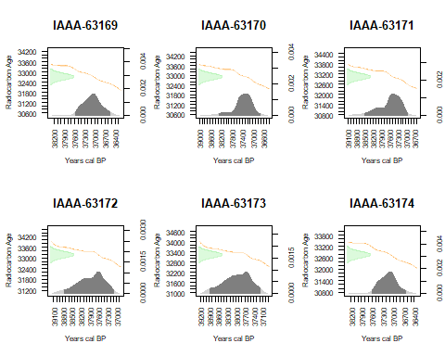

降順でマルチプロットを表示します。

multiplot(Age, decreasing=TRUE, rescale=TRUE, HPD=TRUE)  
title(main = 'Ide Maruyama1 multiplot of caliblated 14C dates')

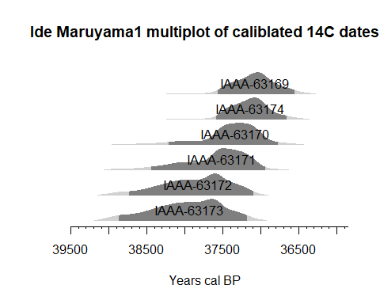

# Summed Probability Distribution of given data/累積確率分布

6点のサンプルに対する較正年代値の累積確率分布を計算し、500年移動平均のライン（青破線）を表示します。37,300calBPにピークを確認できます。

Age.spd = spd(Age,  
 timeRange = c(40000,35000))

## [1] "Extracting and aggregating..."  
## [1] "Done."

Age.bins = binPrep(sites = Age.IdeM$ID,  
 ages = Age.IdeM$conventional_date,  
 h=100)  
Age.spd.bins = spd(Age,  
 bins = Age.bins,  
 timeRange = c(40000,35000))

## [1] "Extracting and aggregating..."  
## | | | 0% | |============== | 20% | |============================ | 40% | |========================================== | 60% | |======================================================== | 80% | |======================================================================| 100%  
## [1] "Done."

Age.bins.med = binMed(x = Age, bins = Age.bins)

## [1] "Extracting and aggregating..."  
## | | | 0% | |============== | 20% | |============================ | 40% | |========================================== | 60% | |======================================================== | 80% | |======================================================================| 100%  
## [1] "Done"

plot(Age.spd.bins)  
plot(Age.spd.bins,   
 add = TRUE, runm = 500, type = "simple", col = "blue", lwd = 1.5, lty = 2)  
barCodes(Age.bins.med,yrng = c(0,0.0005), col = "blue")  
title(main = 'Ide Maruyama1 Summed Probability Distribution')

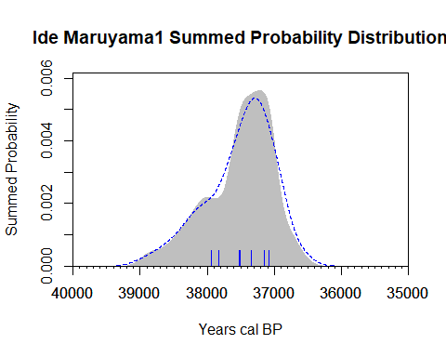

# Multiplot published in CPP2 short report

Age2 = BchronCalibrate(ages=Age.IdeM$conventional_date,  
 ageSds=Age.IdeM$error,  
 ids = Age.IdeM$ID,  
 positions = c(0,2,4,6,8,10),  
 calCurves=rep('intcal20',6))  
  
summary(Age2)

## 95% Highest density regions for IAAA-63169  
## $`94.6%`  
## [1] 36533 37580  
##   
##   
## 95% Highest density regions for IAAA-63170  
## $`94.7%`  
## [1] 36734 38269  
##   
##   
## 95% Highest density regions for IAAA-63171  
## $`94.7%`  
## [1] 36933 38514  
##   
##   
## 95% Highest density regions for IAAA-63172  
## $`94.8%`  
## [1] 37099 38773  
##   
##   
## 95% Highest density regions for IAAA-63173  
## $`94.8%`  
## [1] 37181 38898  
##   
##   
## 95% Highest density regions for IAAA-63174  
## $`94.6%`  
## [1] 36633 37600

plot(Age2,   
 dateHeight = 1,  
 dateLabels = TRUE  
 ) +  
 labs(x = 'Age (years BP)',  
 y = '',  
 title = 'Ide Maruyama 1 multiplot by Bchron') +  
 scale_y_continuous(breaks = NULL)

