**This is the resubmission of our earlier manuscript**

**TBME-00661-2015 entitled**

***“A Variance Distribution Model of Surface EMG Signals Based on Inverse Gamma Distribution.”***

**This file also includes a response letter to the reviewers.**

September 7, 2016

**Reply to reviewers’ comments** (HAYASHI, H. *et al.*: A Variance Distribution Model of Surface EMG Signals Based on Inverse Gamma Distribution)

Professor Bin He

Editor-in-Chief

*IEEE Transactions on Biomedical Engineering*

Director, Institute for Engineering in Medicine

Distinguished McKnight University Professor of Biomedical Engineering

Medtronic-Bakken Endowed Chair for Engineering in Medicine, University of Minnesota

6-124 Nils Hasselmo Hall, 312 Church St. SE, Minneapolis, MN 55455

Title: A Variance Distribution Model of Surface EMG Signals Based on Inverse Gamma Distribution

Dear Professor Bin He,

Thank you to you and the reviewers for the valuable suggestions and constructive comments on our earlier manuscript. We have accepted all suggestions and revised the manuscript accordingly. The resubmitted file contains our responses to the reviewers (summary of changes) and the revised manuscript with changes highlighted in yellow. We apologize for the delayed reply, and would trust you will forward our responses and the manuscript to the same reviewers.

Yours sincerely,

Hideaki Hayashi, Dr. Eng. (corresponding author)

4-1 Kagamiyama 1-chome, Higashi-Hiroshima-shi, Hiroshima, 739-8527 Japan

Institute of System Cybernetics, Graduate School of Engineering, Hiroshima University

Biological Systems Engineering Laboratory

Tel: +81-82-424-7677

E-mail: hayashi@bsys.hiroshima-u.ac.jp

**Title: A Variance Distribution Model of Surface EMG Signals Based on Inverse Gamma Distribution**

**- Authors’ Response and List of Changes -**

**Associate Editor’s Comments**

**General Comments**

The reviewers found merit in the study but all of them suggested anyway extensive revisions. The main concerns are related to a poor discussion on the assumptions and limitations, lack of clarity in some of the analytical derivations, and, especially, problems in relation to the experiments (not all results shown, relatively small number of subjects, etc.). The revisions requested are too extensive for proceeding but a resubmission may be considered, due to the general positive consideration of the work by the reviewers.

**Responses**

First, we thank you and the reviewers for the constructive comments. In line with the suggestions made, we have conducted further experiments and included additional discussions in the manuscript.

The major changes from the previous manuscript are as follows:

1. The variance distribution estimation method has been modified due to the erroneous nature of the previous equations for estimation. All experiments were re-conducted using the modified method.

2. Comparison with estimation using raw EMG signals (marginal likelihood maximization) was conducted.

3. Some simulation experiments were re-conducted using a wider range of parameters.

4. Variance distribution estimation experiments involving the use of EMG signals simulated with time-varying force have been added.

5. Five more subjects were added in the EMG analysis.

6. Regression analysis was conducted to clarify the relationship between muscle force and estimated variance distribution statistics. The results were also compared with the outcomes of maximum likelihood estimation.

7. More comprehensive discussions of signal-dependent noise and EMG distribution in the proposed model and comparison with related papers have been added.

8. The paper has been structurally simplified by moving all results into one section and discussions into another.

**Title:** **A Variance Distribution Model of Surface EMG Signals Based on Inverse Gamma Distribution**

**- Authors’ Responses and List of Changes -**

**Reviewer Comments**

**Reviewer #1**

* **General Comments Rev #1**

The manuscript proposes to model the variance distribution of surface EMG signals using inverse gamma distribution and Bayesian estimation. The model allows the representation of noise superimposed onto variance therefore avoiding the constraint embedded in the conventional maximum likelihood (ML) method, which assumes that variance is constant. The simulation results illustrate that the proposed method outperforms the maximum likelihood method with respect to estimation of average of variance and variance of variance. Also, the experiment on real EMG signals reveals that can express noise superimposed onto variance depending on muscle force. Therefore, the manuscript includes several merits but needs to address the following comments before publication.

* **Comment Rev #1-1**

In lines 21-22 of column 2 in page 2, the authors describe that the P(x_t) must be a constant. This makes the reviewer confused. According to equation (5), P(x_t) should be a probability density function. The authors need to explain this point carefully.

**Response to Rev #1-1:**

Thank you very much for your valuable comments. This confusion was caused by an error in the definition of variables in Section II-B. In Equation (5), x_t expresses a stochastic variable, whereas x_t in Equation (7) expresses an observed value. Properly speaking, these should have been expressed in different forms.

In the revised manuscript, a stochastic variable representing an EMG signal in the model is expressed by x, and an observed EMG signal at *t* is expressed by x_t.

The changes from the previous manuscript are outlined below.

**Modification Rev #1-1**

**II. A. Model Structure**

**Page 2, Fig. 1**

**Before**

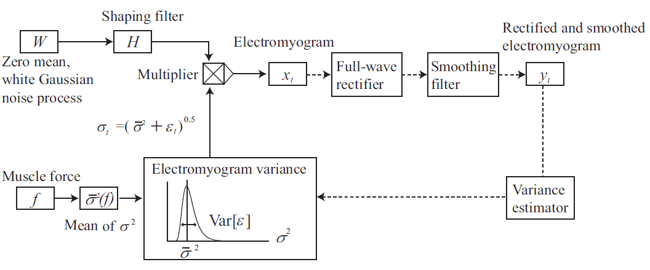

**After**

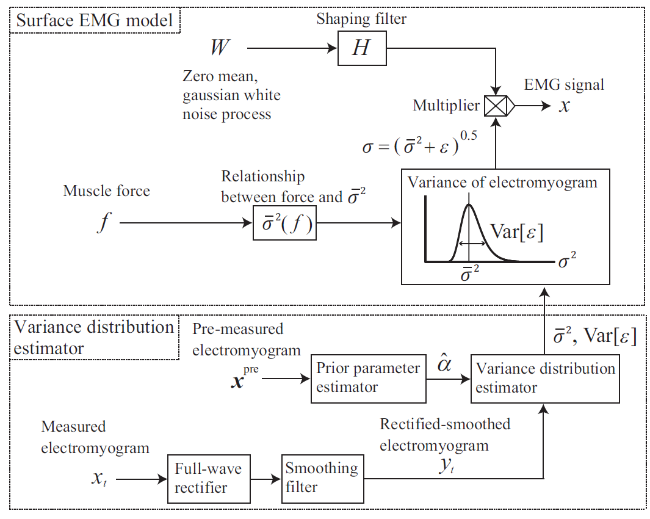

**Page 2, column 1, equation (5)**

**Before**

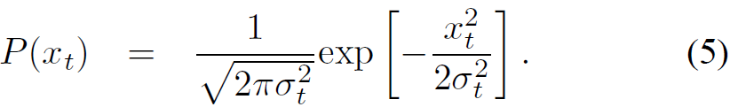

**After**

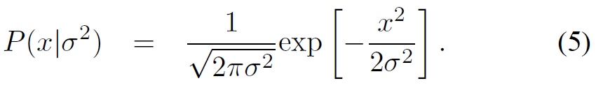

* **Comment Rev #1-2**

The equation (12) and equation (17) seem to be conflict with each other. According to equation (12), when we have a segment of EMG signals, we obtain different estimation of average of variance at different time point t. That is, if the length of the EMG signals is L, we will have L estimations. However, according to equation (17), we only obtain a estimation for a segment of EMG signals due to the expectation operator, E〖[y_t]〗^2. Maybe there is a mistake in equation (12), the authors should carefully check it.

**Response to Rev #1-2**

As you indicated, Equations (12) and (17) were in mutual conflict. This was due to the erroneous nature of the variance distribution estimation method described in the manuscript. First, in the proposed model, it is assumed that variance is initially generated from a certain distribution such as inverse gamma distribution and x is then generated from the associated Gaussian distribution. For analysis of noise superimposed onto EMG variance, it is necessary to estimate the distribution of. However, the actual discussion in Section II-B of the previous manuscript covered estimation to determine the posterior probability of given an observed EMG signal. These differ in that the former represents the distribution of a stochastic variable, meaning that there is only one solution regardless of the length of observation, whereas the latter represents uncertainty in estimation of an unobserved variable at a time point *t,* meaning that there are *L* estimations for *L* signals.

Accordingly, the estimation method described in Section II-B has been thoroughly revised. However, as an approximated estimation was applied on the basis of rectified and smoothed signals, the only change in the actual procedure was a constant term in. All experiments were also reconducted using the revised estimation procedure.

Changes from the previous manuscript are outlined below.

**Modification Rev #1-2**

**II. B. Estimation of Variance Distribution**

**Page 2, column 1, line 8 from bottom**

“This subsection outlines... The next subsection outlines the method used to approximate variance distribution using rectified and smoothed EMG signals for the achievement of real-time estimation.”

**II. C. Estimation Using Rectified and Smoothed EMG Signals**

**Page 3, column 1, line 22 from top**

“... based on (7) and (8).”

* **Comment Rev #1-3**

The authors only show the experiment results based on the rectified and smoothed signals, i.e. based on the equation (17). Can the author also show the results based on raw EMG signals? i.e. based on the equation (12). We need to compare these two types of result to verify the necessity of rectification and smoothness of EMG signals. If we also can obtain excellent results with raw EMG signals, such preprocessing of EMG signals will be unnecessary.

**Response to Rev #1-3**

First, the proposed EMG variance distribution estimation method based on rectified and smoothed signals (Equation (17) in the previous manuscript) was developed by approximating the approach based on raw EMG signals (equations (7)–(10) in the revised manuscript). The use of rectified and smoothed signals enables the real-time estimation, while the raw EMG-based method requires the repetitive calculation associated with nonlinear optimization. As you stated, however, accuracy comparison of the rectified and smoothed signal-based method and the raw signal-based method is necessary.

In the revised manuscript, the rationale behind the development of the rectified and smoothed signal-based method has been clarified, and comparison of the two methods has been added.

**Modification Rev #1-3**

**II. B. Estimation of Variance Distribution**

**Page 2, column 2, line 16 from bottom**

“However, this estimation procedure requires... using rectified and smoothed EMG signals for the achievement of real-time estimation.”

**III. A. Simulation**

**Page 3, column 2, line 10 from top**

“To verify the validity of approximation... was used in smoothing processing.”

**IV. Results**

**Page 5, column 1, line 8 from top**

“Fig. 5 shows the average error rates... are also given.”

**Page 5, Fig. 5**

**Added**

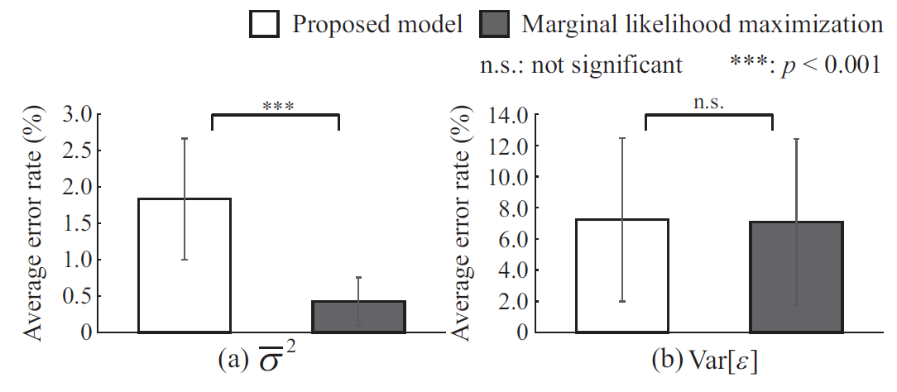

**V. Discussion**

**Page 6, column 1, line 5 from bottom**

“In Fig. 5, the average error rate... is more difficult to estimate than the mean of variance.”

* **Comment Rev #1-4**

In lines 11-12 of column 2 in page 3, why the scale parameter is tuned and the shape parameter is fixed to obtain the average percentage error? Why do not tune the shape parameter?

**Response to Rev #1-4**

The revised manuscript indicates that the shape parameter was also tuned during average percentage error calculation.

**Modification Rev #1-4**

**III. A. Simulation**

**Page 3, column 2, line 19 from top**

“Average percentage errors were calculated by changing the true values 60 times (),”

* **Comment Rev #1-5**

In Fig. 3, Fig. 4, Fig. 5 and Fig. 9, the meaning of the error bar in each figure is suggested to be added in the figure caption.

**Response to Rev #1-5**

The error bar represents the standard deviation of average error rates calculated by changing the true values of variance distribution parameters. In the revised manuscript, this information has been added to the figure caption.

**Modification Rev #1-5**

**IV. Results**

**Caption in Fig. 5, Fig. 6, Fig. 7, and Fig. 8**

“Error bars represent standard deviations for all trials.”

* **Comment Rev #1-6**

In the experiment of real EMG signals, the advantage of the proposed method comparing with the ML method should be illustrated. For example, does the proposed can outperform the ML method with respect to the muscle force estimation? In order to comprehensively demonstrate the effectiveness of the proposed method, the muscle force estimation should not be the future work because the experiment data were already collected. The author needed to present the advantage of the proposed model with the real data. As both models were to describe the relationship between force and EMG signals, this review suggests computing the variance using the MLE method and comparing the accuracy of distinguishing different force level of two methods.

**Response to Rev #1-6**

Regression analysis was conducted to establish the relationship between muscle force and estimated EMG variance statistics. The result showed that the mean of variance and the variance of variance estimated using the proposed model can be used to predict muscle force better than maximum likelihood estimation values.

In the revised manuscript, the results of regression analysis have been added to the experiment section.

**Modification Rev #1-6**

**III. B. EMG Analysis**

**Page 4, column 2, line 11 from bottom**

“Regression analysis was also conducted... was conducted for full samples ( and ) and small samples ( and ).”

**IV. Results**

**Page 6, column 1, line 3 from top**

“In regression analysis regarding the relationships between... and *p* values for the *F* test.”

**Page 7, Fig. 14**

**Added**

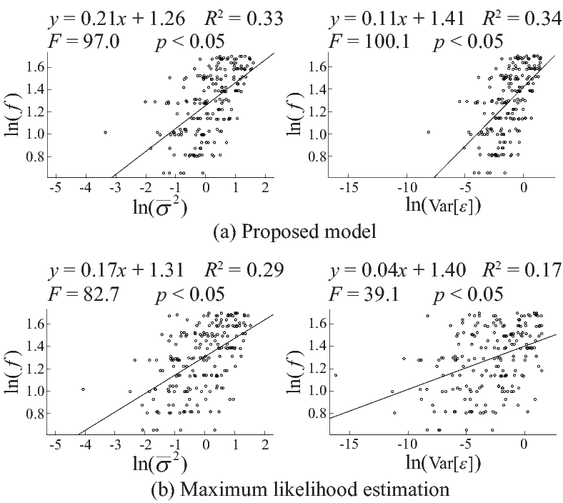

**V. Discussion**

**Page 7, column 2, line 12 from top**

“The regression analysis results shown in Fig. 14... have potential in the estimation of muscle force *f*.”

* **Comment Rev #1-7**

In the simulation experiment, the raw signals were first rectified and smoothed, and then down sampled. This review did not understand why put the rectification and smooth process before down sampling. People usually set different sampling frequency to record the signals, and then do rectification. So this review suggested that the down sampling should put before the rectification and smooth.

**Response to Rev #1-7**

The theoretical structure of the proposed model was developed in anticipation of application to real-world problems. At the laboratory level, as you pointed out, raw EMG signals can be recorded at an arbitrary frequency depending on the measuring instrument. However, in some situations, only rectified and smoothed signals can be measured (e.g., in cases involving the use of electrodes for MyoBock, which is currently the most popular myoelectric hand). In such situations, down-sampling is more effective because the frequency of rectified and smoothed signals is low. Accordingly, the amount of transferred information from down-sampling can be reduced, thereby allowing measurement using numerous electrodes, for example.

The Introduction section of the revised manuscript contains text to clarify the motivation behind signal rectification and smoothing before down-sampling.

**Modification Rev #1-7**

**I. Introduction**

**Page 1, column 2, line 4 from top**

“This method is useful in practice because the processed signals are composed of low-frequency components, and the sampling frequency can therefore be reduced to some extent.”

* **Comment Rev #1-8**

There were three different signals generated in the simulation experiment. Is there any difference for the performances of both models on these signals?

**Response to Rev #1-8**

The three signals in Fig. 2 , and represent the variance of EMG signals, artificially generated EMG signals, and smoothed/rectified EMG signals, respectively. These signals were shown to clarify the procedure for the generation of, and the proposed method involves the use of for variance distribution estimation after all.

* **Comment Rev #1-9**

In fig 4, the error rate of the MLE method is lower than the proposed method when L was 1000 and 500. It seemed that the MLE method performed better than the proposed method when L was big. How about the results when L was bigger than 1000?

**Response to Rev #1-9**

An additional experiment was conducted with *L* set to a value exceeding than 1,000. Related maximum likelihood estimation showed slightly better results than the proposed method when *L* was greater than 1,000, although the error rates of both methods decreased as *L* increased. This is because the estimator of the maximum likelihood method approaches the true value as the number of samples increases in line with the law of large numbers, as does the estimator of the proposed method because the influence of the approximated term (the second term in Equation (14)) is diminished.

In the revised manuscript, results from the use of an *L* value exceeding 1,000 have been added to Fig. 7.

**Modification Rev #1-9**

**IV. Results**

**Page 5, Fig. 7**

**Before**

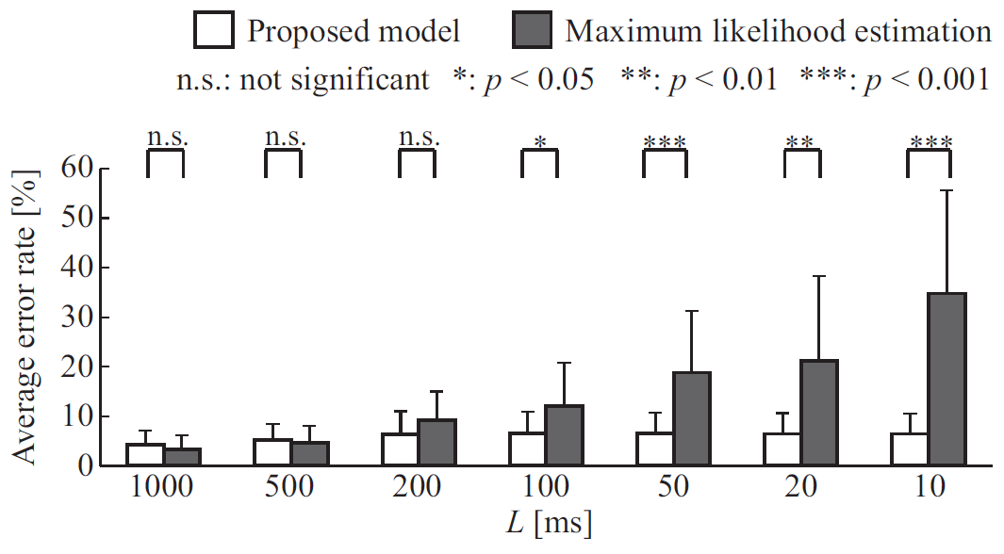

**After**

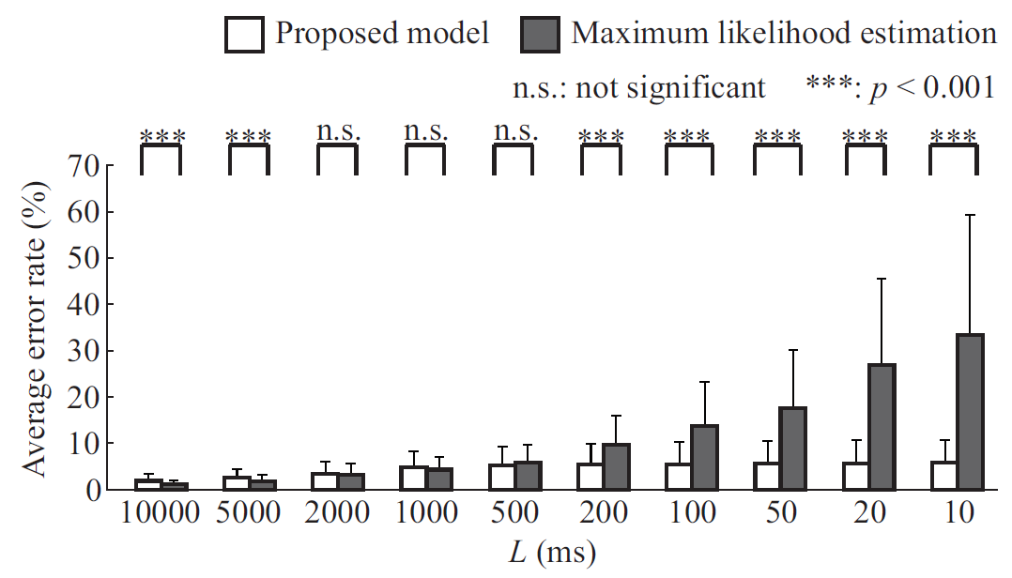

* **Comment Rev #1-10**

Five subjects were not enough for a journal paper. More subjects should be tested in the EMG Analysis part.

**Response to Rev #1-10**

The revised manuscript reports the use of five more subjects for a total of ten in the EMG analysis experiment. Thank you very much for your valuable suggestions.

**Modification Rev #1-10**

**III. B. EMG Analysis**

**Page 4, column 1, line 3 from bottom**

“For EMG signal recording, ten right-handed subjects (average age: 22.6 0.8) were seated, “

**Title: A Variance Distribution Model of Surface EMG Signals Based on Inverse Gamma Distribution**

**- Authors’ Response and List of Changes -**

**Reviewer Comments**

**Reviewer #2**

* **General comments**

I would like congratulate the authors for the clarity in presentation of their work. It made the manuscript very easy to read and understand.

I have a few suggestion to further improve your manuscript:

* **Comment Rev #2-1**

Eq. (5): Following the work of Hogan, you have modelled the EMG with a Gaussian function. Earlier work (e.g. http://www.ncbi.nlm.nih.gov/pubmed/23047056 as well as Clancy's work [12]) has shown that the EMG at low contraction levels has a Laplacian distribution as as the force increases, presumably because more motor units fire, the distribution becomes a Gaussian. How does this finding affect your modelling. Please cite and discuss this in relation to model.

**Response to Rev #2-1**

Thank you very much for your valuable comments. Although the proposed model involves the assumption of Gaussian distribution in an EMG signal for each variance value , the marginal distribution of EMG is no longer Gaussian due to the superimposition of noise onto variance. In parameter estimation, as the proposed model involves the assumption of inverse gamma distribution for the distribution of , , the marginal distribution of EMG is equivalent to Student’s *t*-distribution. This *t*-distribution is characterized by kurtosis depending on its distribution parameter, and this is associated with the kurtosis analysis conducted in the earlier works you noted.

The revised manuscript cites papers discussing the shape of EMG distribution and discusses the relationship between the proposed model and earlier works.

**Modification Rev #2-1**

**V. Discussion**

**Page 7, column 2, line 18 from bottom**

“The other is the property of marginal distribution for EMG signals. Hogan and Mann... with fixed kurtosis and changing variance depending on muscle force.”

* **Comment Rev #2-2**

Please discuss your finding in terms of signal dependent noise in EMG in more details. You have [20] in your references but the discussion around it is very limited to two lines in the Intro. This is a major piece of work and your results must be discussed in that light, although you discuss [21] a bit too.

**Response to Rev #2-2**

Harris and Wolpert assumed that neural commands have signal-dependent noise whose standard deviation increases linearly with the absolute value of the neural control signal in [20]. Jones *et al.* experimentally showed that the standard deviation of force is proportional to the mean force during isometric contraction in [21]. The similarity between these studies is that the standard deviation of signals is proportional to their mean. The same relationship is also found in the proposed model; the standard deviation of is proportional to the mean of even though the proposed model only assumes the distribution of and the fixedness of one of the distribution parameters.

The revised manuscript contains discussion of the relationship between the proposed model and earlier works in terms of signal-dependent noise.

**Modification Rev #2-2**

**V. Discussion**

**Page 7, column 2, line 22 from top**

“The proposed model involves the assumption that EMG variance becomes a random variable... can also be established in EMG variance.”

* **Comment Rev #2-3**

How does your new model track a changing force? Please include simulation (and ideally real) data showing your algorithm can track ramp and half-sine force levels. I think if the detrimental effect would be larger for large force levels.

**Response to Rev #2-3**

We have added a variance distribution estimation experiment for artificially generated EMG signals with time-varying force. Although the dispersion of estimation was larger for higher force levels as you stated, the results showed that the proposed model can be used to track time-varying variance distribution if the cut-off frequency and the window length are appropriately set.

**Modification Rev #2-3**

**V. Experiment**

**Page 4, column 1, line 9 from top**

“Finally, variance distribution estimation for artificial EMG signals simulated with changing force was... The remaining parameters were set as ms, Hz, and .”

* **Comment Rev #2-4**

Page 3, section 3 where you have all the %s. It is so difficult to follow and you have the same results in figure 3 and 4 anyway. Please update this section.

**Response to Rev #2-4**

Numerical values overlapping with figures have been removed to improve readability. Thank you for your constructive comments.

**Modification Rev #2-4**

**Page 3, column 2, line 18 from top in the previous manuscript**

**Deleted**

“The average error rates for the proposed model were: 500 [Hz]: 4.32.9 [%]; 200 [Hz]: 4.32.9 [%]; 100 [Hz]: 4.32.9 [%]... and 10 [ms]: 34.820.8 [%].”

**Title: A Variance Distribution Model of Surface EMG Signals Based on Inverse Gamma Distribution**

**- Authors’ Response and List of Changes -**

**Reviewer Comments**

**Reviewer #3**

* **General comments**

This study presents a model to describe the distribution of the variance of the surface EMG signal. The EMG signal is represented as Gaussian signal, with noise additive to the variance of the signal. The paper follows the general model proposed by Hogan and Mann some time back. The performance of the new estimation method is examined for rectified, smoothed and down-sampled synthetic signals with -different window lengths and down-sampling rates. The results suggest that the proposed method can be used to estimate the signal variance, and performs better than the maximum likelihood method for small numbers of samples.

* **Comment Rev #3-1 and #3-2**

A main feature of the model is the addition of noise to the variance of the signal. What is the rationale for adding noise to the variance of the EMG signal in this way and what effect does the representation of noise within the model have? More usually noise, with a given variance, is considered to be added to the EMG signal itself, representing the contribution of the various noise sources to the voltage recorded.

If the magnitude of the noise is large, adding noise to the variance of the signal would presumably result in EMG signal variance with lower variance itself, when compared to a case where noise is added directly to the signal? The reasoning seems to be an underlying assumption that the noise is proportional to the force. This should be more fully explained, and the justification and consequences of the assumption outlined. What effect would this have on the estimated posterior variance presented in Fig. 9, for example?

**Response to Rev #3-1 and #3-2**

Thank you very much for your valuable comments. First, signal-dependent noise is noise superimposed on neural commands, whose standard deviation increases linearly with the absolute value of neural control signals (Harris and Wolpert, 1998). Since the amplitude of EMG signals increases as the commanded muscle force increases, the amplitude of EMG signals should vary in the presence of signal-dependent noise. In the proposed model, it is assumed that this variation equates to stochastic variation in EMG variance. This differs from electric noise arising in the signal itself in voltage recording.

To represent this phenomenon, the proposed model involves the assumption that the variance of EMG is a random variable that follows inverse gamma distribution with a fixed shape parameter. It should be noted that no relationship between noise and force is assumed. Consequently, the proposed model derives that the standard deviation of is proportional to the mean of , and that the marginal distribution of EMG is characterized by kurtosis, whereas the distribution of EMG is Gaussian if noise is added to EMG signals themselves. These outcomes are indirectly backed up by similar results demonstrated in previous research (Jones *et al.*, 2002).

To clarify the above, the Discussion section of the revised manuscript includes additional commentary on the assumptions of the proposed model and its outcomes and on relations with previous studies.

**Modification Rev #3-1 and #3-2**

**V. Discussion**

**Page 7, column 2, line 22 from top**

“The proposed model involves the assumption that EMG variance becomes a random variable... with fixed kurtosis and changing variance depending on muscle force.”

* **Comment Rev #3-3**

The simulation results indicate superior performance of the proposed estimation method for small window lengths and low ‘down-sampling’ frequencies, when compared with the maximum likelihood method. These results are based on a phenomenological model, and upon assumptions regarding the distribution of the signal which are also inherent in the estimation method. The findings would be strengthened if similar findings were observed for the experimental EMG data. Though the ‘true’ value of the signal variance is not known for the experimental data, a divergence of the behavior of the proposed estimation method and the maximum likelihood method for low window lengths and at lower frequencies of down-sampling would support the simulation results.

**Response to Rev #3-3**

In response to this input, a variance distribution estimation experiment was conducted with experimental EMG data. Although the true variance distribution cannot be known as per your observation, muscle force observed during the EMG recording can be calculated. Accordingly, evaluation of variance distribution parameter estimation capability for the proposed model and the maximum likelihood method was conducted based on evaluation of estimation capability for muscle force from estimated distribution statistics using regression analysis.

The revised manuscript specifies the results of regression analysis and includes discussion of the advantages of the proposed model for EMG analysis.

**Modification Rev #3-3**

**III. B. EMG Analysis**

**Page 4, column 2, line 11 from bottom**

“Regression analysis was also conducted... was conducted for full samples ( and ) and small samples ( and ).”

**IV. Results**

**Page 6, column 1, line 3 from top**

“In regression analysis regarding the relationships between... and *p* values for the *F* test.”

**Page 7, Fig. 14**

**Added**



**V. Discussion**

**Page 7, column 2, line 12 from top**

“The regression analysis results shown in Fig. 14... have potential in the estimation of muscle force *f*.”

* **Comment Rev #3-4**

The structure of the paper would be simplified by moving all of the Results into one section, and similarly the Discussion into a single section, rather than splitting them across multiple sections. Related to this, a discussion of the main model assumptions and limitations is missing from the paper and should be included.

**Response to Rev #3-4**

In the revised manuscript, the Results and the Discussion sections have each been summarized in a single section. Discussion of the main model assumptions have been added to the Discussion section, and the limitations of the proposed model have been described in the Conclusion section.

**Modification Rev #3-4**

**Deleted**

III. Simulation, IV. EMG Analysis

**Added**

III. Experiments, IV. Results, V. Discussion

* **Comment Rev #3-5**

A discussion of the reasons for the better performance of the proposed variance estimation method when compared with the Maximum likelihood estimation method should be included.

**Response to Rev #3-5**

For estimation of the mean of variance , the proposed method is considered to outperform maximum likelihood estimation because the latter is sensitive to outliers and bias in data measurement in principle, whereas the low-pass filter used in the proposed model smooths data and mitigates such adverse influences. For estimation of the variance of variance , the maximum likelihood method involves the assumption that variance is constant in each division, and does not allow adequate expression of noise superimposed onto variance independently at individual times. In contrast, the proposed model involves the assumption that variance is independent at each time, and enables estimations to determine the distribution of the population.

In the revised manuscript, the above points have been clarified in the Discussion section.

**Modification Rev #3-5**

**V. Discussion**

**Page 6, column 2, line 4 from bottom**

“This is because the maximum likelihood method is sensitive to outliers and bias in data measurement in principle, whereas the low-pass filter involved in the proposed model smooths data and mitigates such adverse influences.”

**Page 7, column 1, line 5 from top**

“This is because the maximum likelihood method involves the assumption... can be estimated with an average error rate of less than about 10 %.”

* **Comment Rev #3-6**

Some of the figures are very small in size and difficult to read.

**Response to Rev #3-6**

Some figures have been enlarged by limiting the number of graphs to improve readability in the revised manuscript.

**Modification Rev #3-6**

**Page 6, Fig. 12 and Fig. 13**

**Before:**

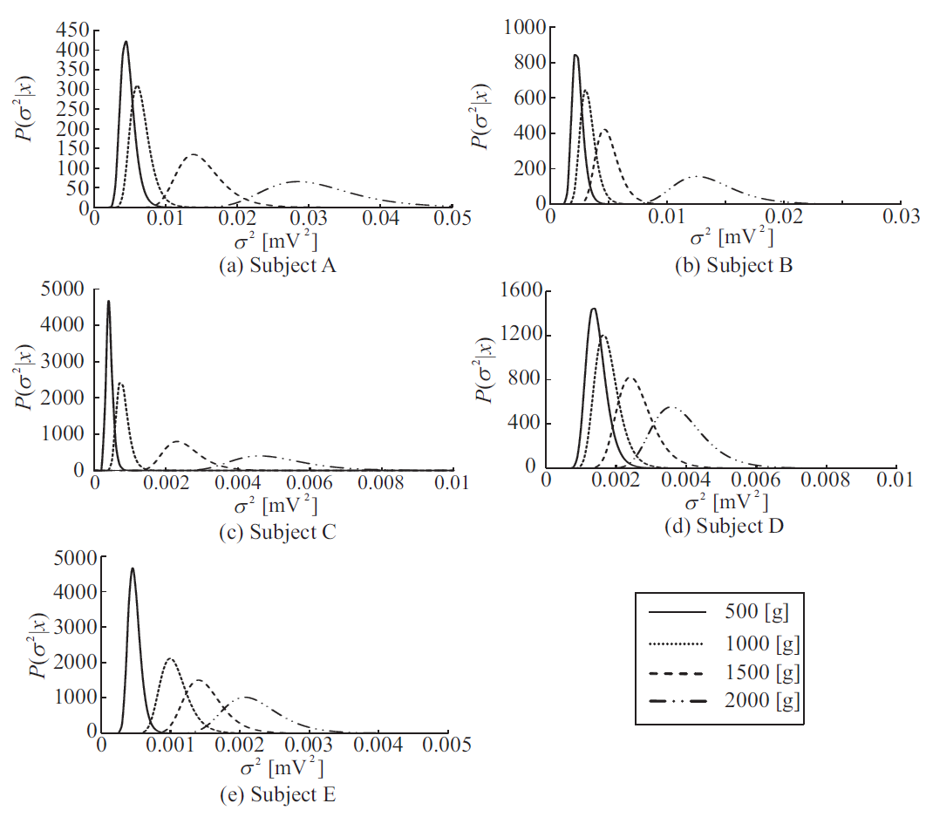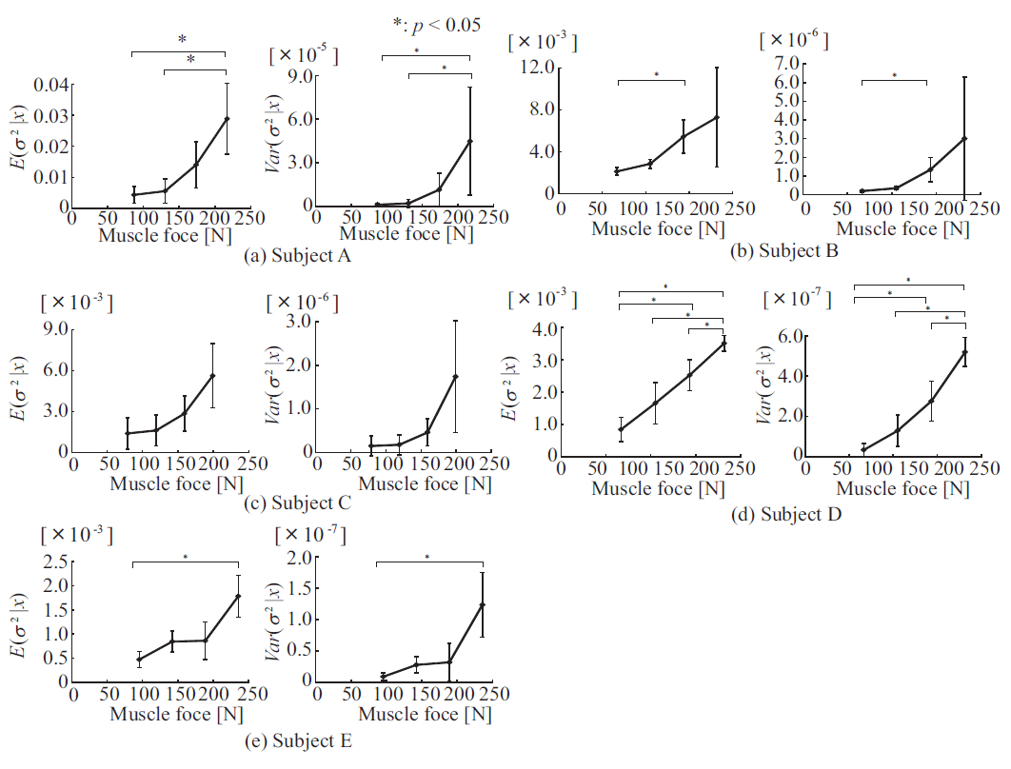

**After:**

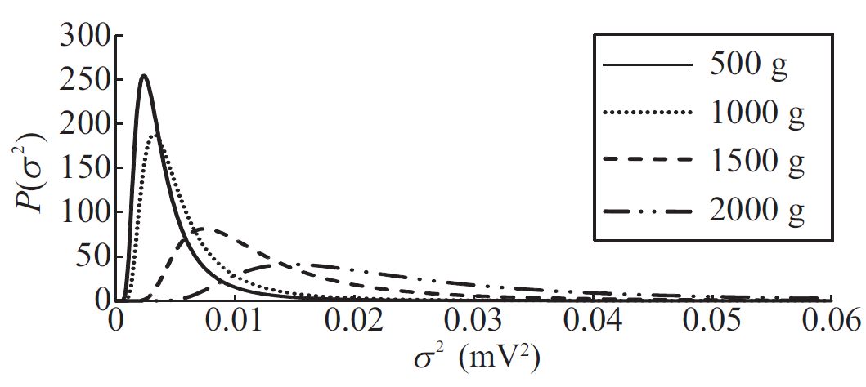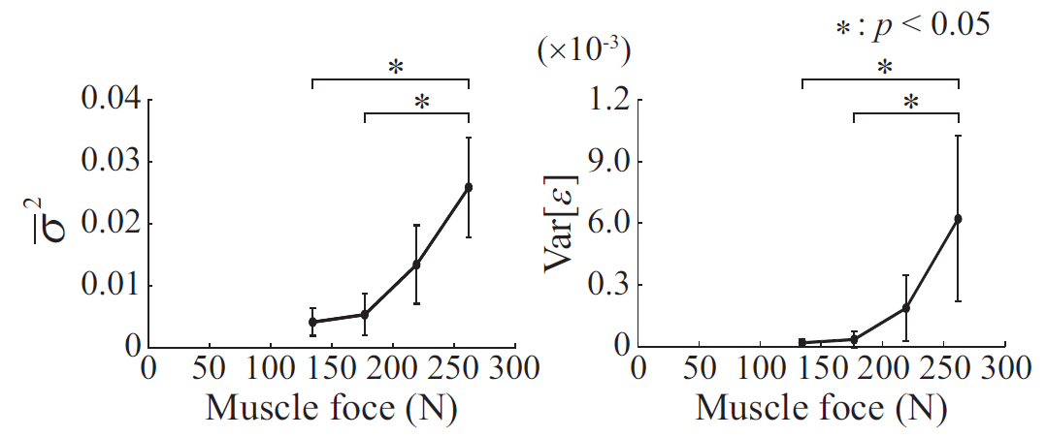

* **Specific Comment Rev #3-1**

P. 1: For the force-EMG relationship, in addition to reference [12] see also classic references from Milner-Brown and Stein (1975), Woods and Bigland-Ritchie (1983), and Lawrence and De Luca (1983).

**Response to Rev #sc3-1**

The relevant literatures have been cited in the Introduction section.

**Modification Rev #sc3-1**

**I. Introduction**

**Page 1, column 1, line 11 from top**

“In view of the need for appropriate feature extraction in the achievement of these applications, various quantitative evaluation methods for EMG signals have been proposed [12]–[22].”

* **Specific Comment Rev #3-2**

p. 2, line 38: How is the value of alpha set?

**Response to Rev #sc3-2**

In the previous manuscript, the procedure for alpha estimation was outlined entirely in the Appendix, which was not reader-friendly. In the revised manuscript, Section II-B (Estimation of Variance Distribution) has been thoroughly revised to outline the main part of alpha estimation.

**Modification Rev #sc3-2**

**II. B. Estimation of Variance Distribution**

**Page 2, column 1, line 8 from bottom**

“This subsection outlines estimation to determine the distribution... be estimated from recorded EMG signals.”

* **Specific Comment Rev #3-3**

Units e.g. ms, Hz etc. should not be included in square brackets []

**Response to Rev #sc3-3**

The square brackets around units have been excluded from the text. In line with IEEE format, brackets around units in figures have been replaced with parentheses.

**Modification Rev #sc3-3**

**III. A. Simulation etc.**

All of square brackets around units have been excluded.

* **Specific Comment Rev #3-4**

P. 3, line 7-8. Some further explanation of the ‘empirical’ method by which the hyperparameters are chosen should be included in the main text, even if the method details are included in the Appendix.

**Response to Rev #sc3-4**

As stated in Response to Rev #sc3-2, the estimation procedure for prior parameters is partially outlined in Section II-B in the revised manuscript. The name of the technique has been changed from the empirical Bayes method to marginal likelihood estimation for more accurate expression in this context.

**Modification Rev #sc3-4**

**II. B. Estimation of Variance Distribution**

**Page 2, column 1, line 8 from bottom**

“This subsection outlines estimation to determine the distribution... be estimated from recorded EMG signals.”

* **Specific Comment Rev #3-5**

P. 3, Results: How was the ‘average error rate’ defined?

**Response to Rev #sc3-5**

The average error rate is the average value of error rates defined as |true value – estimated value|/(true value) * 100. This definition has been added to Section III-A of the revised manuscript.

**Modification Rev #sc3-5**

**III. A. Simulation**

**Page 3, column 2, line 8 from top**

“As an index of accuracy, the error rate was defined as |true value – estimated value|/(true value)100.”

* **Specific Comment Rev #3-6**

P. 4, line 60: ‘These results indicate... EMG signals’. As the performance of the method has been assessed here for simulated data based upon a specific model with certain assumptions, this sentence should be qualified to say for ‘simulated EMG signals generated using a model...’

**Response to Rev #sc3-6**

As you indicated, the expression here was imprecise. As the discussion has been thoroughly revised, the corresponding text has been deleted from the revised manuscript.

**Modification Rev #sc3-6**

**Page 4, column 1, line 2 from bottom in the previous manuscript**

**Deleted:**

“These results indicate that the proposed model can be used to estimate the variance distribution of EMG signals.”

* **Specific Comment Rev #3-7**

P. 4, EMG Analysis: Some further details of the EMG recording methods are needed. What was the inter electrode distance, filter settings, electrode position etc. How was the weight attached?

What instructions were provided to the subjects? Were they instructed to lift their wrist with the weight above the desk? If so, by how much and how was this controlled?

**Response to Rev #sc3-7**

Further details of EMG recording have been added to the revised manuscript.

A pair of Ag/AgCl electrodes placed 2 cm apart was attached to the skin surface over the biceps brachii. A multi-telemeter system (NIHON KOHDEN, WEB-5000; high-frequency cutoff: 100 Hz; low-frequency cutoff: 5.3 Hz) was used for measurement. The subjects were weighted with a load hanging vertically from a wristband on the right wrist, and were instructed to maintain a right-angled elbow position for 10 seconds with the elbow resting on a desk. Only the elbow touched the desk, and the load was suspended in the air.

To clarify these settings, an image from experiment and additional commentary have been included in the revised manuscript.

**Modification Rev #sc3-7**

**Page 4, Fig. 4**

**Before**

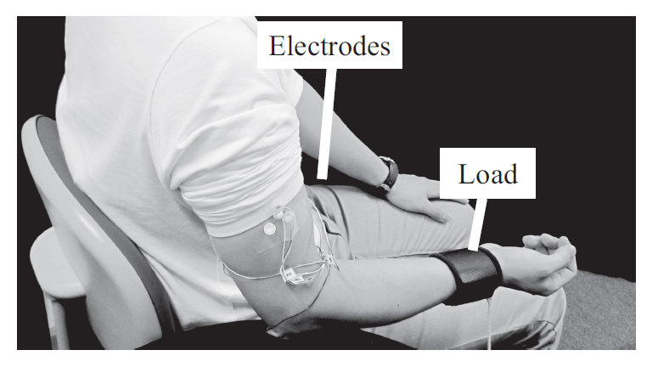

**After**

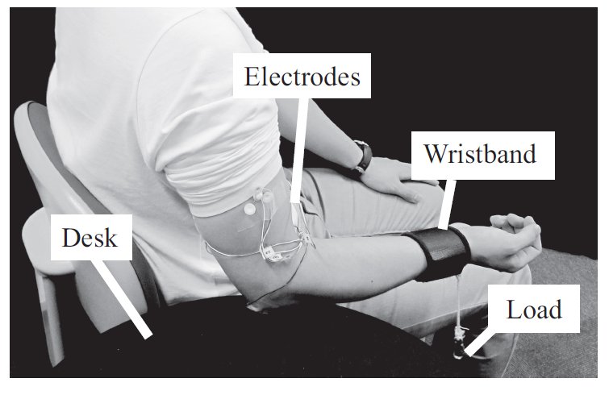

**III. B. EMG Analysis**

**Page 4, column 2, line 3 from top**

“EMG signals were recorded from a pair of Ag/AgCl electrodes... was used for measurement.

* **Specific Comment Rev #3-8**

P 5, line 22: a more thorough explanation of how the muscle force was estimated is required, with the corresponding equations.

**Response to Rev #sc3-8**

The equation used for muscle force estimation has been added to the revised manuscript.

**Modification Rev #sc3-8**

**Page 4, equation (22)**

“”

* **Specific Comment Rev #3-9**

P5. Results and Discussion: What window was used to smooth the data presented in Fig. 7?

**Response to Rev #sc3-9:**

As the smoothed data in Fig. 7 were calculated using a Butterworth low-pass filter rather than the moving average, no window was used in the calculation. Commentary on the parameters used for the Butterworth low-pass filter have been added to the figure caption.

**Modification Rev #sc3-9**

**Page 6, caption in Fig. 11**

“second-order Butterworth low-pass filter (cut-off frequency : 1 Hz) was used in smoothing processing.”

* **Specific Comment Rev #3-10**

A more comprehensive discussion of the method, assumptions, limitations and results is needed.

**Response to Rev #sc3-10**

In relation to *Response to Rev #3-1 and #3-2* and *Response to Rev #3-4*, further content has been added to the Discussion section, and related limitations have been outlined in the Conclusion section. Thank you very much for your constructive comments.

**Modification Rev #sc3-10**

**V. Discussion**

**Page 7, column 2, line 22 from top**

“The proposed model involves the assumption that EMG variance becomes a random variable... with fixed kurtosis and changing variance depending on muscle force.”