
المملكة العربية السعودية
وزارة التعليم
كلية الحاسب
قسم علوم الحاسب
Kingdom of Saudi Arabia Ministry of Education
College of Computer
Computer Science Department

MASARAK
Intelligent Career Guidance for Computer Related
Fields Using AI and NLP Techniques

Students:
Rand Al-Wdhakhy | 431202616
Ryouf Al-Mutairi | 431200975
Hour Al-Hejress | 432205415
Duna Al-Aqili | 432216237

Supervisor:
Reem Al-Julidan

A project report submitted to Qassim University in partial fulfillment of the requirements for the degree of B.Sc. in Computer Science
Qassim - Saudi Arabia
1447/1448(2026)

Certificate

It is certified that this project report has been prepared and written under my direct supervision and guidance. This project report is approved for submission for its evaluation.

Reem Al-Julidan

Dedication

To our beloved families, whose unconditional love, patience, and unwavering support have been our greatest source of strength throughout our academic journey. Their encouragement and belief in us have inspired us to persevere and achieve our goals.
To our supervisor, Reem Al-Julidan, for her continuous guidance, support, and encouragement, which have greatly contributed to the completion of this work.
This work is also dedicated to everyone who supported, motivated, and believed in us along the way. Their presence and encouragement have played a significant role in helping us reach this milestone.

Rand Al-Wdhakhy, Ryouf Al-Mutairi, Hour Al-Hejress, Duna Al-Aqili

Acknowledgement

First and foremost, we would like to express our deepest gratitude and sincere appreciation to our supervisor, Reem Al-Julidan, for her continuous support, invaluable guidance, and insightful feedback throughout all stages of this project. Her encouragement, patience, and constructive advice have played a fundamental role in shaping the direction and quality of this work.

We would also like to extend our sincere thanks to Qassim University for providing us with the academic environment, resources, and opportunities that enabled us to successfully carry out this project. The knowledge and experience we have gained throughout our studies have been essential in supporting the development of this work.
In addition, we would like to acknowledge the efforts of all faculty members who contributed to our academic journey, as their dedication and teaching have helped us build the foundation required to undertake this project.

Finally, we would like to express our heartfelt appreciation to our families and friends for their continuous encouragement, understanding, and unwavering support. Their motivation and belief in us have been a constant source of strength throughout this journey.
Each team member would also like to extend personal gratitude to everyone who supported her during the completion of this project.

Rand Al-Wdhakhy, Ryouf Al-Mutairi, Hour Al-Hejress, Duna Al-Aqili

Abstract

Many students and graduates in computer-related fields face difficulties in choosing suitable career paths due to unclear direction, lack of awareness of required skills, and rapid changes in labor market demands.
This project, entitled “Masarak”, is a proposed AI-based career guidance system that utilizes Artificial Intelligence (AI) and Natural Language Processing (NLP) techniques to analyze user skills, identify skill gaps, and provide personalized career recommendations and learning pathways. The project focuses on the requirement analysis and system design phase, presenting the overall system architecture and the main modules. The system is also designed to support users in understanding current job market requirements and improving their professional development. The proposed system aims to help users align their skills with labor market needs in the Kingdom of Saudi Arabia.

Table of Contents
Certificate ii
Dedication iii
Acknowledgement iv
Abstract v
List of Tables viii
List of Figures viii
Chapter One 1
INTRODUCTION 1
1.1 Introduction 1
1.2 Project Scope 2
1.3 Aim and Objectives 3
1.4 Motivation 4
1.5 Project Plan and Schedule 4
1.6 Outline of the Report 5
Chapter TWO 6
Literature REVIEW 6
2.1 Introduction 6
2.2 Background 6
2.2.1 Artificial Intelligence (AI) 6
2.2.2 Machine Learning (ML) 6
2.2.3 Natural Language Processing (NLP) 7
2.2.4 Skill Gap Analysis 8
2.2.5 Decision Support Systems (DSS) 8
2.3 Existing Related Systems 9
2.3.1 Comparative Analysis of Existing and Proposed Systems 10
2.4 Contribution 11
2.5 Outline of the Report 11
Chapter Three 12
PROBLEM ANALYSIS 12
3.1 Introduction 12
3.2 Problem Specification 12
3.2.1 Problem Statement 12
3.2.2 Proposed Solution 13
3.2.3 Alternative Solutions 13
3.2.4 Benefits of the Proposed Solution 13
3.2.5 Required Skills and Expertise 14
3.3 System Analysis 15
3.3.1 System Environment 15
3.3.2 Stakeholders 15
3.3.3 System Context Diagram 16
3.4 Requirement Collection 16
3.5 Requirement Analysis 18
3.6 Requirement organization 20
3.7 Implementation and Evaluation Plan 21
3.7.1 Technical Tools and Programming Languages 22
3.8 Summary 22
3.9 Outline of the Report 23
Chapter Four 24
SYSTEM DESIGN 24
4.1 Introduction 24
4.2 System Design Specification 24
4.3 Design Architecture 26
4.3.1 System Architecture 26
4.3.2 Use Case Diagram 26
4.3.3 Entity-Relationship Diagram (ERD) 27
4.4 User Interface Design 28
4.5 Pseudocode/Algorithms/Scenario 29
4.5.1 Career Recommendation 29
4.5.2 Skill Gap Analysis 30
4.5.3 Scenario 31
4.6 Summary 32
4.7 Outline of the Report 32
References 33
Appendix 36
Appendix 1 : User Needs Questionnaire 36
Appendix 2: Entity-Relationship Diagram 37

List of Tables
Table 1: Comparative Analysis of Existing and Proposed Systems 10
Table 2: Identified Problems in Career Path Selection 14
Table 3: Summary of Survey Findings (n = 27) 17
Table 4: Functional Requirement 18
Table 5: Non-Functional Requirement 19

List of Figures
Figure 1: Gantt chart of MASARAK phase1 schedule 4
Figure 2: Masarak System Context Diagram 16
Figure 3: System Architecture of the Masarak Mobile Application 26
Figure 4: Use Case Diagram 26
Figure 5: Entity-Relationship Diagram of Masarak 28
Figure 6 :Masarak User Interface Screens 29
Figure 7: Readiness Score Calculation Formula 31

Chapter One

INTRODUCTION

1.1 Introduction
Computer Science, Information Technology, Software Engineering, Information Systems, and other computer-related fields represent rapidly evolving and interdisciplinary fields that form the foundation of modern digital transformation. These fields collectively focus on the theoretical principles and practical applications of computing technologies, including algorithm design, software development, database systems, cybersecurity, network infrastructure, artificial intelligence, and intelligent information systems. Over the past decades, computing-related fields have expanded to encompass advanced areas such as machine learning, data science, cloud computing, and intelligent decision-support systems, enabling automated analysis, predictive modeling, and personalized digital services [1] [2].

Despite the growing global demand for computing professionals, both students and graduates of computer-related programs face significant challenges in navigating their career development journeys. Students in early academic stages often experience uncertainty when exploring specialized pathways within computing domains, while graduates encounter difficulties in aligning their acquired competencies with labor market expectations. The rapid evolution of technologies, increasing specialization diversity, and continuously shifting industry requirements create ambiguity in identifying suitable career directions and measuring professional readiness. Consequently, a structural gap persists between academic preparation and real-world workforce demands [3].

The global labor market is undergoing continuous transformation driven by digital innovation, automation, and emerging technologies [4]. Modern employment environments increasingly require advanced digital competencies, analytical thinking, and adaptive skill development. Traditional career advisory approaches, however, rely largely on static guidance and generalized recommendations, lacking structured skill gap analysis, readiness assessment, and data-driven personalization mechanisms [5]. As a result, existing advisory models are insufficient to effectively support computing students and graduates in making informed and strategic career decisions.

From a computing perspective, addressing this challenge lies at the intersection of Artificial Intelligence (AI), Machine Learning (ML), and Intelligent Decision Support Systems (IDSS). These technologies enable structured data analysis, predictive modeling, competency profiling, and intelligent recommendation generation to support systematic career planning and specialization alignment [6].

In response to this identified need, the project Masarak is proposed as an integrated AI-powered career development system designed for students and graduates of computer-related fields. The system aims to bridge the gap between academic competencies and labor market demands by integrating structured skill profiling, specialization mapping, readiness scoring, labor market alignment, and intelligent career guidance within a unified and scalable architecture.

1.2 Project Scope
The Masarak project is positioned within the domain of Artificial Intelligence–enabled intelligent information systems that support workforce development and career decision-making processes. The growing adoption of Artificial Intelligence technologies across sectors in the Kingdom of Saudi Arabia reflects national efforts to leverage data and digital innovation to improve services, enhance productivity, and empower human capital development [7]. In parallel, national workforce initiatives emphasize the importance of developing skills aligned with labor market demands, highlighting the need for intelligent systems that assist individuals in identifying required competencies and planning their career progression effectively [8].
Within this context, the Masarak system focuses on the design and implementation of an integrated mobile application that applies Artificial Intelligence techniques to support personalized career path engineering. The project scope includes enabling users to upload their resumes in PDF format, which are analyzed using Natural Language Processing methods to extract relevant skills, qualifications, and experience. Such AI-driven text analysis techniques allow unstructured documents to be transformed into structured data suitable for automated comparison and evaluation [9]. The system subsequently performs skill gap analysis by comparing extracted user competencies with requirements derived from publicly available job postings collected through automated data acquisition mechanisms, thereby facilitating evidence-based career readiness assessment.
Furthermore, the project scope encompasses the automated generation of personalized learning roadmaps that recommend relevant courses, certifications, and training opportunities aimed at addressing identified skill gaps. The system also incorporates an AI-based interview simulation module that generates adaptive technical and behavioral questions and provides feedback to improve interview preparedness. In addition, the mobile application presents a visualization dashboard illustrating emerging skills and market trends derived from aggregated job market data analysis, supporting proactive career planning and awareness of future workforce demands [10].

Despite these capabilities, the project scope is limited to providing career guidance, skill gap identification, learning pathway recommendation, and interview preparation support. Moreover, the project relies on publicly accessible job market information and representative learning resource repositories to ensure feasibility within academic constraints while maintaining alignment with contemporary Artificial Intelligence applications in career development and workforce intelligence.

1.3 Aim and Objectives
Aim
The aim of this project is to design and develop an AI-driven career development mobile application that provides personalized, data-driven career guidance and recommendations for students and graduates of computer-related fields by analyzing their technical competencies, identifying skill gaps, and aligning their profiles with evolving labor market demands in the computing sector.

Objectives
- To analyze labor market data in order to identify key computing-related skills required for specialized career pathways in the computing sector.
- To design a structured skill profiling model that captures students’ technical competencies, academic background, projects, and career interests.
- To develop an AI-driven matching mechanism that aligns computing students’ profiles with relevant computing career domains such as software engineering, data science, artificial intelligence, and cybersecurity.
- To implement a skill gap analysis module that identifies missing technical competencies relative to selected computing roles.
- To design and develop an integrated system prototype that connects the front-end interface with back-end data processing and intelligent recommendation components.
- To design and implement an AI-based interview simulation module that generates technical and behavioral questions relevant to computing professions and provides structured feedback.
- To evaluate the system’s effectiveness in delivering accurate and meaningful career recommendations for students in computing-related disciplines.

1.4 Motivation
The Masarak project is developed in response to the growing need to enhance workforce readiness in the Kingdom of Saudi Arabia amid rapid economic diversification and technological transformation. With Saudi Vision 2030 emphasizing human capital development as a pillar of sustainable growth [8], aligning educational outcomes with labor market demands has become a strategic priority [11]. Despite ongoing educational reforms, a skills gap persists, affecting graduate employability in high-demand sectors like technology and management [12]. Additionally, many graduates lack structured career guidance on required competencies and recruitment expectations [12]. In response, Masarak proposes an AI-powered mobile application to analyze skill gaps, develop personalized professional pathways, and offer interview preparation tools aligned with the Saudi labor market. This initiative aims to enhance professional readiness and support national development goals toward a competitive knowledge-based economy [8], [11].

1.5 Project Plan and Schedule
The project plan for Masarak was organized into structured and realistic phases to ensure steady progress throughout the semester. The tasks were scheduled both sequentially and in parallel to reflect the actual workflow of the project. The initial stage focused on project planning and completing Chapter One, followed by literature review conducted alongside problem and system analysis. After defining the system requirements, the design phase was initiated, including UML modeling, database design, system architecture, and interface design.
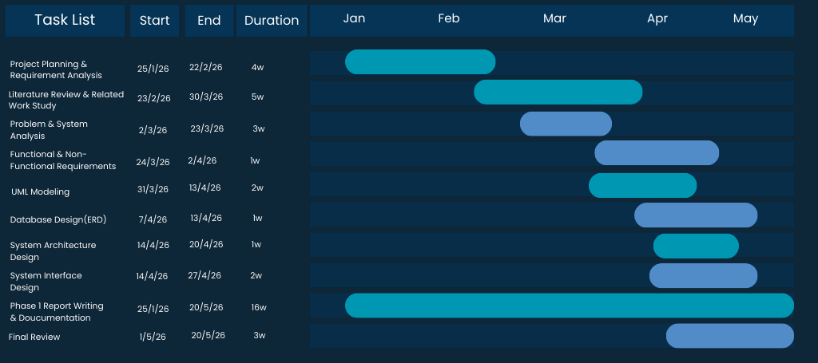
Report writing was carried out continuously from the beginning of the project to ensure proper documentation of each stage. A final review and formatting phase was scheduled before submission. The detailed timeline, including task durations, start and finish dates, and task sequence, is presented in the Gantt chart below.
Figure 1: Gantt chart of MASARAK phase1 schedule

1.6 Outline of the Report
This chapter introduces the proposed system, Masarak, and provides the foundational context of the project. It begins with an overview of Artificial Intelligence and intelligent decision-support systems in career development. The chapter then defines the project scope, clarifying system boundaries and functionalities.

It further presents the project aim and objectives, outlining the intended outcomes of the system. In addition, the motivation behind the project is discussed, emphasizing its relevance to workforce development and future career planning. Finally, the chapter concludes with the project plan, describing the development phases and implementation timeline.

Chapter TWO

Literature REVIEW

2.1 Introduction
This chapter presents a review of the academic and technical foundations related to the Masarak system. It outlines the main research areas that support Artificial Intelligence–based career development platforms and highlights the importance of intelligent technologies in modern decision-support environments. As digital transformation continues to reshape labor markets, AI-driven systems have gained increasing attention for their ability to provide personalized and data-oriented recommendations [3], [4], [13].
In addition, this chapter examines relevant studies and existing systems that apply Artificial Intelligence and Machine Learning techniques in career guidance, skill analysis, and recommendation systems [14], [6]. By reviewing previous research and evaluating related approaches, this chapter establishes the theoretical context of the project and identifies the research gap that motivates the development of Masarak.

2.2 Background

2.2.1 Artificial Intelligence (AI)
Artificial Intelligence (AI) refers to the simulation of human intelligence processes by computational systems. These processes include learning, reasoning, problem-solving, perception, and decision-making. AI systems are designed to analyze large volumes of data, identify patterns, and generate intelligent outputs that support complex decision environments [15].
In recent years, AI has become a foundational technology in intelligent information systems, particularly in domains requiring predictive analysis and personalized recommendations. AI-driven platforms are increasingly adopted in education, workforce development, healthcare, and financial services due to their ability to process structured and unstructured data efficiently. The integration of AI into decision-support environments enhances automation, accuracy, and scalability of digital solutions.

2.2.2 Machine Learning (ML)
Machine Learning (ML) is a subfield of Artificial Intelligence that focuses on developing algorithms capable of learning from data and improving performance without explicit programming [16]. ML models identify hidden patterns within datasets and generate predictive outputs based on statistical inference and optimization techniques [16].
ML techniques are widely applied in recommendation systems, classification models, clustering analysis, and predictive analytics. Supervised and unsupervised learning approaches enable intelligent systems to analyze user behavior, detect trends, and produce adaptive outputs. The effectiveness of ML-based systems lies in their ability to continuously improve as more data becomes available, thereby increasing prediction accuracy and system reliability.
Within the Masarak system, AI and Machine Learning serve as the core enabling technologies. ML algorithms are utilized to analyze user profiles, identify skill patterns, and support data-driven career recommendations. Through intelligent data processing and adaptive modeling, the system aims to provide personalized career pathway suggestions aligned with labor market requirements.

2.2.3 Natural Language Processing (NLP)
Natural Language Processing (NLP) has become one of the most influential subfields of Artificial Intelligence, particularly in systems that rely on understanding and processing large volumes of textual data. NLP enables machines to transform unstructured human language into structured representations that support automated reasoning and intelligent decision-making [17]. As digital documentation continues to expand across industries, NLP has become fundamental in domains such as healthcare, education, and especially recruitment systems.
Recent technological developments highlight the growing role of NLP in employment platforms, where automated resume screening and job description analysis are increasingly adopted. Industry-based explanations demonstrate that NLP techniques such as tokenization, named entity recognition, and semantic similarity allow systems to extract structured skill representations from unstructured resume documents. These capabilities enable scalable resume parsing and competency modeling, reducing manual evaluation efforts while improving consistency and efficiency.
The literature indicates that intelligent recruitment systems increasingly depend on NLP to automate candidate–job matching processes [18] [19]. By converting resume content into machine-readable formats, NLP facilitates downstream analytical processes [18] [19], including skill comparison and recommendation engines.
Within the Masarak system, NLP represents the foundational layer that enables automated resume interpretation [16]. The extracted structured skill data serves as input for the Skill Gap Analysis module and personalized recommendation mechanisms. Therefore, NLP forms the technological basis upon which the system’s career alignment functionality is built.

2.2.4 Skill Gap Analysis
Skill Gap Analysis has emerged as a critical concept in workforce development and human capital research. It refers to the systematic identification of discrepancies between existing competencies and those required by the labor market [20]. As technological transformation accelerates, identifying and addressing skill mismatches has become essential for improving employability and workforce readiness [10].
Global labor market reports emphasize that rapid digitalization and automation are reshaping skill demands across industries. Continuous assessment of competency gaps allows institutions and individuals to adapt to evolving market expectations. Workforce intelligence systems increasingly incorporate analytical models that compare user competencies with market requirements to generate targeted upskilling recommendations.
Research and policy discussions consistently highlight the importance of structured skill assessment frameworks to bridge the gap between academic preparation and industry needs. This shift from generalized career advice to data-driven competency evaluation represents a major evolution in career development systems.
In the Masarak system, Skill Gap Analysis operates as the decision-making core. By comparing structured skill data extracted through NLP with labor market requirements, the system quantifies competency gaps and generates actionable recommendations [19]. This mechanism supports informed career planning and structured learning pathway generation, particularly within computing-related disciplines [10].
The integration of Skill Gap Analysis strengthens the system’s ability to align academic competencies with workforce expectations, contributing to more adaptive and data-informed career development.

2.2.5 Decision Support Systems (DSS)
Decision Support Systems (DSS) are computer-based information systems designed to support complex decision-making processes by analyzing structured and unstructured data [6]. According to Power, DSS integrate data, analytical models, and user-friendly interfaces to assist individuals and organizations in making informed and evidence-based decisions.
DSS have evolved significantly with the advancement of artificial intelligence and data analytics. Modern decision support systems incorporate predictive modeling, data mining, and intelligent recommendation mechanisms to enhance decision accuracy and reduce uncertainty. These systems are widely applied in domains such as healthcare, finance, education, and workforce planning.
In the context of digital transformation initiatives, decision support technologies play a critical role in enabling data-driven strategies. Saudi Arabia’s national data and AI strategy emphasize the importance of intelligent systems and advanced analytics in supporting economic development and workforce readiness . This reflects the increasing reliance on AI-powered decision systems at both institutional and national levels.
Within the Masarak system, Decision Support Systems form the analytical core responsible for transforming processed user data into actionable career recommendations. By integrating outputs from the NLP module and the Skill Gap Analysis component, the system provides structured guidance that supports informed career decision-making [19] [6]. Therefore, DSS principles underpin the system’s ability to convert data into meaningful, personalized recommendations aligned with labor market requirements [6].

2.3 Existing Related Systems
Several existing digital applications provide career guidance and job recommendation services; however, most of these systems address isolated components of the career development lifecycle rather than offering a fully integrated, data-driven framework tailored to computing-related disciplines.

Professional networking platforms such as LinkedIn [21] employ recommender system techniques, including profile-based ranking and large-scale data analytics, to suggest job opportunities based on users declared skills, professional experiences, and behavioral interactions. These systems primarily rely on keyword similarity, engagement patterns, and implicit feedback mechanisms. While effective for professional visibility and networking expansion, such platforms generally do not perform structured skill gap quantification, readiness-level scoring, or specialization mapping within computing career domains.

Similarly, online learning platforms such as Coursera [22] and Edraak [23] provide extensive educational resources, certification programs, and structured skill development tracks. Their recommendation engines are typically interest-driven or interaction-based, suggesting courses aligned with user browsing history or selected topics. However, these platforms do not systematically conduct resume-to-job alignment, nor do they dynamically compare individual competencies against real-time labor market requirements specific to computing roles.

In academic literature, machine learning approaches have been proposed to enhance recruitment and job matching processes. For instance, bilateral recommendation models analyze both candidate profiles and job descriptions to improve compatibility scoring and mutual relevance [14]. More recent research has explored AI-based career recommendation systems that utilize data mining and predictive modeling to personalize occupational suggestions [13]. Although these approaches improve matching accuracy, many studies focus primarily on algorithmic performance metrics rather than integrating skill gap detection, quantified readiness assessment, personalized development roadmap generation, and interview readiness evaluation within a unified intelligent architecture.

Therefore, despite the availability of networking platforms, online learning systems, and job matching algorithms, the development of a comprehensive AI-driven career engineering framework specifically designed for students in computing-related disciplines remains insufficiently addressed. This identified gap motivates the development of Masarak as an integrated artificial intelligence–based career development system that combines structured skill profiling, labor market alignment, readiness scoring, and AI-powered interview simulation within a single scalable architecture.

2.3.1 Comparative Analysis of Existing and Proposed Systems
This subsection presents a structured comparative analysis between existing related platforms and the proposed Masarak system. The comparison focuses on key functional aspects of career development support in computing-related disciplines, including recommendation mechanisms, skill gap detection, readiness assessment, labor market alignment, personalized development planning, and interview preparation support. The purpose of this comparison is to clearly identify the limitations of existing systems and demonstrate how Masarak addresses the identified gap through an integrated Al-driven framework.

Table 1: Comparative Analysis of Existing and Proposed Systems
System/ Platform | Target Users | Recommendation Type | Skill Gap Analysis | Readiness Scoring | Labor Market Alignment | Personalized Roadmap | Interview Preparation
LinkedIn | Professionals  /Graduates | Job-based |  |  |  |  | No
  No
  No
  Partial
  No
Coursera | Students/ Professionals | Course-based
  No
  No
  No
  Partial
  No
Edraak | Students
  Course-based
  No
  No
  No
  No
  No
ML-based Career Recommender Models | Students/  Job Seekers
  Algorithm-based
  Partial
  No
  Limited
  No
  No
Masarak | Students/ Graduates (Computing Fields) |  | Yes |  |  | Yes | Yes
  Skill-based/
  Career domain
  Yes
  Yes

2.4 Contribution
Based on the limitations identified in existing platforms and related research, the Masarak system presents several contributions to the domain of AI-driven career development, with a focus on improving professional readiness through data-driven analysis and personalized guidance [3].

First, the system employs structured skill gap engineering to quantify user readiness by performing similarity-based matching between extracted resume data and aggregated labor market requirements. This approach enables the identification of competency deficiencies in a measurable manner, providing users with a clear understanding of their current professional standing relative to market expectations, building upon established bilateral recommendation and skill gap analysis frameworks [14], [24].

Second, Masarak is designed to support automated learning roadmap generation derived directly from identified competency gaps. By transforming analytical outcomes into actionable development strategies, the system supports users in prioritizing relevant learning activities and progressing toward targeted career objectives in a structured and systematic way, extending the capabilities of domain-aware learning pathway recommendations [25].

Third, the platform incorporates an AI-driven interview simulation module that generates adaptive technical and behavioral questions aligned with the user’s profile and targeted role. In addition to question generation, the module provides structured performance-based feedback, allowing users to evaluate their responses and improve interview readiness through iterative practice, inspired by recent advancements in AI-based employability enhancement tools [26].

Finally, the integration of labor market analytics, personalized recommendations, and career preparation tools within a unified scalable architecture distinguishes Masarak from fragmented existing solutions. This unified design enhances user experience, supports continuous skill development, and enables a coherent transition from skill assessment to career preparation within a single platform.

2.5 Outline of the Report
This chapter presented the theoretical background and related work relevant to the MASARAK system. It discussed Artificial Intelligence (AI), Machine Learning (ML), Natural Language Processing (NLP), Skill Gap Analysis, and Decision Support Systems (DSS). It also reviewed existing career guidance and learning platforms and compared their main features with the proposed MASARAK system to identify the research gap and clarify the contribution of the project.

The next chapter focuses on the analysis and requirements of the proposed system. It presents the problem specification, proposed solution, stakeholders, system requirements, survey findings, and the functional and non-functional requirements that will guide the design and development of MASARAK.

Chapter Three

PROBLEM ANALYSIS

3.1 Introduction
This chapter presents the analysis process of the Masarak system. It explains how the identified problem is translated into system requirements and technical specifications. The chapter outlines the problem definition, requirement collection and analysis, system organization, and the planned implementation strategy.

The purpose of this chapter is to define what the system will do, how it will function, and which technologies will be used to develop an AI-driven career development platform for students and graduates in computing-related fields.

3.2 Problem Specification

3.2.1 Problem Statement
The rapid growth of computing-related disciplines such as Computer Science, Information Technology, Artificial Intelligence, Data Science, and Cybersecurity has created a wide range of career opportunities for graduates. However, the diversity of these fields also makes it difficult for students and recent graduates to clearly identify suitable career pathways within the computing sector.

Many students and recent graduates face uncertainty when selecting a specialization that aligns with their skills, interests, and long-term career goals. In addition, the fast evolution of technologies and the increasing demand for specialized technical skills create challenges for individuals who are trying to understand the competencies required for different computing professions. As a result, many graduates struggle to determine the most appropriate career direction and the skills needed to achieve their professional objectives [3], [4].

Another challenge is the gap between academic preparation and labor market expectations. Although students acquire theoretical knowledge during their academic studies, they may lack awareness of practical industry requirements and emerging skill demands. This gap often leads to confusion when searching for employment opportunities and selecting suitable learning pathways for career development [11], [12].

3.2.2 Proposed Solution
To address these challenges, the proposed system Masarak is designed as an Artificial Intelligence–powered career development platform that assists computing students and recent graduates in identifying suitable career paths based on their technical skills and professional interests.

The system analyzes user profiles and resumes to extract relevant skills using Natural Language Processing techniques. These extracted skills are then compared with the requirements of various computing-related job roles obtained from job market data. Based on this comparison, the system generates personalized career recommendations and identifies potential skill gaps that need to be addressed in order to reach specific career goals [16], [17], [22].

Furthermore, the system recommends appropriate learning resources, courses, and certifications that can help users improve their competencies and enhance their employability. By integrating intelligent data analysis with career guidance mechanisms, Masarak enables users to make informed career decisions and better prepare for professional opportunities in the computing field [15].

3.2.3 Alternative Solutions
Several existing resources attempt to support career development and job preparation for students and graduates. These include professional networking platforms such as LinkedIn, online job portals, university career advisory services, and online learning platforms that offer technical courses and training programs [21], [22], [23].

Although these resources provide useful information, they often deliver generalized guidance rather than personalized recommendations tailored to individual skills and career goals. Most job portals mainly focus on displaying job opportunities, while learning platforms provide educational materials without directly connecting skill development with specific career pathways. Consequently, users may still face difficulties in identifying the most suitable career direction and required competencies [14], [13].

3.2.4 Benefits of the Proposed Solution
The Masarak system offers several advantages that support students and graduates in their career development journey. First, the system provides personalized career recommendations based on the user's individual skills and interests rather than relying on general career advice.

Second, the system performs skill gap analysis by comparing a user’s current competencies with the requirements of various computing-related job roles. This enables users to clearly identify the skills they need to develop in order to achieve their desired career objectives [24], [27].

Third, the platform recommends relevant learning resources and professional development opportunities that can help users enhance their technical abilities and improve their readiness for the labor market. By offering structured guidance and data-driven recommendations, the system supports individuals in planning their career development more effectively [17].

3.2.5 Required Skills and Expertise
Developing the Masarak system requires a combination of technical and analytical expertise. Artificial Intelligence and Machine Learning techniques are required to analyze user data and generate intelligent recommendations based on skill patterns and career requirements [15], [16].

Natural Language Processing is also necessary for extracting relevant information from resumes and textual data sources. In addition, web development technologies are required to design and implement the system interface and ensure an efficient and user-friendly experience [28].

Database management skills are essential for storing and organizing user profiles, job market information, and learning resources. Furthermore, data analysis techniques are important for interpreting labor market trends and supporting data-driven decision-making processes within the system [29]. These technical competencies are critical for building intelligent career guidance platforms that effectively support professional development and workforce readiness.

Table 2: Identified Problems in Career Path Selection
Affected Users | Impact | Problem
Students and graduates |  | Difficulty identifying suitable computing career paths
  Unclear career direction
Job seekers | Skills mismatch with job market | Lack of awareness about required industry skills
Students and graduates | Difficulty keeping up with required competencies | Rapid technological changes in computing fields

3.3 System Analysis

3.3.1 System Environment
Masarak is designed as a mobile-based intelligent application that supports students and recent graduates in planning their career paths using AI-driven analysis. The system follows a client–server architecture in which the mobile application serves as the user interface, while a backend server is responsible for data processing, storage, and AI-related services.

The system operates within an online cloud environment, as continuous internet connectivity is required to upload CV files, process textual data, and retrieve updated job market information. The system environment consists of several integrated components that work together to deliver intelligent career guidance.

The mobile application enables users to upload their CVs, review skill-gap analysis results, receive personalized learning roadmaps, and interact with the interview simulation module. The backend server processes incoming requests, executes the NLP pipeline, performs skill-gap computations, and generates personalized recommendations based on labor market requirements.

An online database is used to store user profiles, extracted skills, recommended learning pathways, and job requirements collected from publicly available job platforms. Additionally, the system integrates an external LLM-based API to perform advanced language processing tasks, including skill extraction and interview question generation.

The system relies on two primary types of data: user-provided data, such as CV documents and preferences, and job market data obtained from publicly available job descriptions. This integrated environment enables Masarak to provide real-time, evidence-based career guidance through automated skill analysis and intelligent decision-support mechanisms.

3.3.2 Stakeholders
Stakeholders are individuals or groups who interact with the system or are affected by its outcomes. In Masarak, stakeholders are categorized into primary, secondary, and technical groups.
The primary stakeholders are students and recent graduates who use the application to upload their CVs, receive skill-gap analysis, and follow recommended learning pathways. They represent the main beneficiaries of the system.
Secondary stakeholders include universities and academic advisors, who may benefit from aggregated insights regarding common skill gaps among students. Such insights can support curriculum improvements and targeted training initiatives. Employers and recruitment platforms are also considered indirect stakeholders, as the system aims to align user competencies with job market requirements, thereby improving job readiness and matching efficiency.
Technical and administrative stakeholders include the system developers, who are responsible for development, maintenance, and continuous improvement of the application. The system administrator oversees system configuration, monitors performance, updates job data sources, and ensures overall system reliability and security.

3.3.3 System Context Diagram
The System Context Diagram illustrates how the Masarak system interacts with external entities and highlights the flow of information between the system and its surrounding environment. Masarak is positioned at the center of the diagram and communicates with users, job data sources, external AI services, and the system administrator.

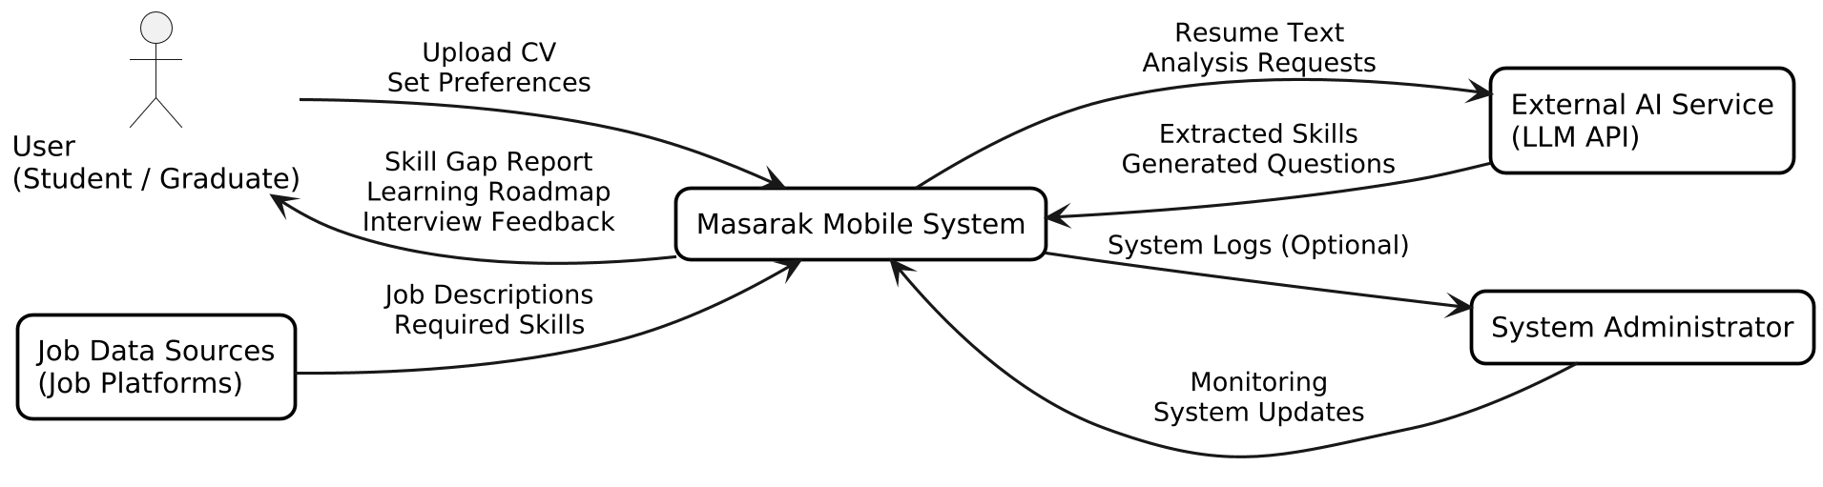
Figure 2: Masarak System Context Diagram

3.4 Requirement Collection
The requirement collection phase represents a critical stage within the system analysis process, as it ensures that the Masarak system is developed based on empirically validated user needs rather than theoretical assumptions [30]. While Chapter One established the conceptual problem of career misalignment and skill gaps within computing-related disciplines, this phase was conducted to empirically examine whether these challenges are reflected in the experiences of students and recent graduates and to translate the identified concerns into measurable system requirements.

To achieve this objective, a structured online survey was designed and distributed to individuals studying or recently graduated from computing-related disciplines, including Computer Science, Software Engineering, Information Technology, and Cybersecurity. The survey was designed to capture key indicators related to awareness of labor market requirements, clarity of computing career specialization, identification of required technical skills, confidence in technical interview preparation, and the perceived usefulness of intelligent career guidance systems [3], [29]. These dimensions were derived directly from the research objectives presented in Section 1.3, particularly those associated with skill profiling, labor market alignment, and interview readiness.

Data was collected using an online questionnaire platform in order to ensure accessibility and encourage wider participation [30]. The survey link was shared through academic communication channels targeting computing students and recent graduates. A total of twenty-seven valid responses were obtained. The participants represented different academic stages, including early-stage undergraduate students (23%), senior students approaching graduation (35%), and recent graduates (42%). This distribution provided perspectives from individuals at various stages of career planning, ranging from early exploration of specialization options to active preparation for employment.
The collected responses were analyzed using descriptive statistical methods in order to identify recurring patterns and common challenges among participants [30]. Frequency analysis was applied to determine the prevalence of specific issues related to career planning and professional readiness. The summarized results of the survey are presented in Table 3.

Table 3: Summary of Survey Findings (n = 27)
Identified Issue | Percentage of Respondents
Uncertainty in selecting a computing specialization | 54%
Limited awareness of required technical skills | 100%
Lack of structured career guidance | 54%
Difficulty identifying relevant courses or certifications | 58%
Low or neutral confidence in technical interviews | 89%
Interest in AI-based career recommendation system | 92%

The statistical findings provide empirical support for the conceptual problem discussed in Chapter One. More than half of the respondents indicated uncertainty in selecting a suitable computing specialization, suggesting that many students and recent graduates experience difficulty in defining clear career directions within the computing field. Furthermore, the majority of participants reported limited awareness of the technical skills required for their intended roles, and many indicated that they had not previously compared their competencies with labor market expectations [3].

Additionally, a considerable proportion of respondents reported the absence of structured career guidance and difficulty identifying appropriate learning resources or certifications that could strengthen their professional readiness [29]. These findings highlight the need for systems that provide structured guidance and targeted skill development recommendations.

In terms of interview preparedness, most participants reported either neutral or low confidence in technical interviews. This observation indicates the need for practical preparation mechanisms that allow users to practice interview scenarios and receive structured feedback [31].

Overall, the results demonstrate a clear demand for intelligent systems capable of supporting career planning through structured skill analysis, personalized development guidance, and interview preparation support. Consequently, the findings obtained during the requirement collection phase directly informed the functional design of the Masarak system, particularly the Skill Gap Analysis component, the Personalized Learning Roadmap module, and the AI-based Interview Simulation module. By grounding system requirements in empirical user feedback, this phase ensures that the proposed system aligns with real user needs and practical career development challenges.

3.5 Requirement Analysis
Requirement analysis is an essential phase in system development in which the collected requirements are examined, structured, and translated into clear system specifications [32]. This process ensures that the proposed system meets user needs while maintaining technical feasibility and operational efficiency [33].
In the proposed Masarak career guidance system, requirement analysis focuses on identifying the system’s functional specifications and defining the services the system must provide to support students in analyzing their skills, evaluating career readiness, and receiving personalized career recommendations [34].

The system requirements are categorized into two main types [35]:

- Functional Requirements, which describe the core operations and services that the system must perform [36].
- Non-Functional Requirements, which describe the quality attributes of the system such as performance, usability, security, and reliability [37].

The following tables summarize the main functional and non-functional requirements of the proposed system.
Functional requirements define the core operations and services that the Masarak system must perform to support users in analyzing their skills and planning their career paths. These requirements describe how users interact with the system and the main features provided by the platform. The primary functional requirements of the proposed system are summarized in Table 4.

Table 4: Functional Requirement
  Description
  Functional Requirement
  ID
 |  | FR1
  The system allows users to create an account and securely log in.
  User Registration and Login
 |  | FR2
  Users can manage their personal information,
  skills, and academic background.
  User Profile Management
 |  | FR3
  The system analyzes uploaded resumes to extract relevant skills and experiences.
  Resume Upload and Analysis
 |  | FR4
  The system provides career path recommendations based on user skills and interests.
  Career Recommendation
 |  | FR5
  The system identifies missing skills required for specific career paths.
  Skill Gap Identification
The system evaluates the user's readiness for selected computing careers. | Readiness Evaluation | FR6
 |  | FR7
  The system generates a personalized roadmap of recommended skills and courses.
  Learning Roadmap Generation
 |  | FR8
  The system provides interview questions or simulated interview preparation.
  Interview Preparation

Non-functional requirements describe the quality attributes and operational characteristics of the Masarak system. These requirements ensure that the system performs efficiently, securely, and reliably while providing positive user experience. The main non-functional requirements of the system are presented in Table 5.

Table 5: Non-Functional Requirement
  Description
  Non-Functional
  Requirement
  ID
The system should respond quickly when analyzing resumes or generating recommendations. | Performance | NFR1
The interface should be simple and user-friendly for students. | Usability | NFR2
User data and resumes must be securely stored and protected. | Security | NFR3
The system should support an increasing number of users. | Scalability | NFR4
The system should operate continuously with minimal failures. | Reliability | NFR5
The system should work on different devices and platforms. | Compatibility | NFR6

3.6 Requirement organization
Requirement organization is an important step in system analysis, as it helps structure the collected requirements in a clear and measurable way. Organizing requirements allows developers and stakeholders to better understand the system’s expected behavior and ensures that each requirement can be evaluated during system development and testing [37].
In the Masarak system, the identified requirements are organized into structured categories in order to improve clarity and traceability. The requirements are primarily divided into functional requirements and non-functional requirements [28].Functional requirements describe the main services and operations that the system must provide, such as user registration, resume analysis, career recommendation, and skill gap identification. These requirements define how users interact with the system and how the system processes user data to generate meaningful career guidance.
Non-functional requirements, on the other hand, focus on the quality attributes of the system rather than specific services. These requirements include system performance, security, reliability, scalability, and usability [28].
Organizing the requirements in a structured format helps ensure that each requirement is clear, measurable, and directly related to the system objectives. This structured organization also supports future stages of system development, including implementation, testing, and system evaluation [35].

3.7 Implementation and Evaluation Plan
This section describes the implementation and evaluation plan for the Masarak system, focusing on how the project will be developed, monitored, and continuously improved throughout the development process.

The implementation of the system will be carried out in structured phases to ensure efficient development and integration of all system components. This approach is consistent with software life cycle process standards, which define processes for software development, operation, maintenance, and improvement [38]. Initially, the basic functionalities will be developed, including the mobile application interface, user input handling, and CV upload features. After that, the system will integrate AI-based modules such as natural language processing for extracting skills and performing skill gap analysis. Finally, advanced features such as interview simulation and recommendation generation will be implemented and refined.

During the development process, continuous monitoring will be applied to track system performance and identify potential issues. Regular testing will be conducted to ensure that each component functions correctly and integrates smoothly with other parts of the system. Software testing standards emphasize defined testing concepts and processes that can be applied across software development life cycle models [39]. Any detected issues will be analyzed and resolved to improve system reliability and efficiency.

The evaluation process will focus on assessing both system performance and user experience. Functional evaluation will verify that the system performs its intended tasks accurately, such as analyzing CVs, identifying skill gaps, and generating recommendations. In addition, user-based evaluation will be conducted by collecting feedback from potential users to assess usability, clarity, and usefulness of the system.

The results of the evaluation will be used to improve the system during development and implementation. This includes refining system features, improving accuracy, and enhancing user interaction. This continuous improvement approach ensures that the Masarak system evolves into a reliable and effective solution for career path planning.

3.7.1 Technical Tools and Programming Languages
The development of the Masarak system requires the use of appropriate technical tools and programming languages to ensure efficiency, scalability, and reliability. The selected technologies are chosen based on their suitability for building an AI-driven mobile application.
The mobile application will be developed using a cross-platform framework that enables deployment on multiple mobile operating systems. This approach ensures flexibility, reduced development time, and a consistent user experience across devices.
For the backend, Python will be used due to its strong support for data processing and artificial intelligence applications [40]. Python provides powerful libraries that facilitate the implementation of Natural Language Processing (NLP) techniques required for analyzing CV data and extracting relevant skills.
The system will integrate external AI services through an API to support advanced language processing tasks such as generating interview questions and evaluating user responses. This approach allows the system to leverage existing AI capabilities instead of building complex models from scratch.
A cloud-based database will be used to store user data, extracted skills, and system outputs. This ensures data availability, scalability, and efficient data management.
In addition, version control tools such as Git will be used to manage the development process and support collaboration among team members [41].
The selection of these tools is based on their performance, ease of use, and compatibility with AI-based systems, ensuring that the Masarak system can be efficiently developed and maintained.

3.8 Summary
This chapter presented the system analysis and design aspects of the proposed Masarak platform. It began by defining the core problem related to career path uncertainty and skill misalignment among computing students and recent graduates. The chapter then discussed the proposed AI-based solution designed to support users in identifying suitable career paths through automated skill analysis and personalized recommendations.

In addition, the chapter examined alternative solutions and highlighted the advantages offered by the Masarak system, including skill gap analysis, personalized learning roadmaps, and interview preparation support. The system environment and stakeholders were also described in order to illustrate how different entities interact with the system.

Furthermore, the requirement collection process was conducted through a structured survey targeting computing students and graduates. The findings confirmed the existence of significant challenges related to career guidance, technical skill awareness, and interview preparation. These findings were used to derive the system requirements.

Finally, the chapter presented the functional and non-functional requirements that define the expected capabilities and quality attributes of the system. These requirements provide the foundation for the implementation and evaluation phase, which will be discussed in the following chapter.

3.9 Outline of the Report
This chapter presents the analysis process of the Masarak system, translating the identified problem into structured system requirements and technical specifications. It begins with the problem specification, presenting the problem statement, the proposed solution, alternative solutions, the benefits of the proposed solution, and the required skills and expertise needed for development.

The chapter then presents the system analysis, describing the system environment, the stakeholders, and the system context diagram, which illustrates how Masarak interacts with external entities. It further discusses the requirement collection phase, presenting the survey methodology and findings that empirically support the identified problem, followed by the requirement analysis, which classifies the system's functional and non-functional requirements, and the requirement organization, which structures these requirements for clarity and traceability.

Finally, the chapter presents the implementation and evaluation plan, outlining the development phases and the technical tools and programming languages selected for building the system. The next chapter, Chapter Four, presents the system design, covering the system design specification, the design architecture, and the pseudocode and algorithms underlying the system's core modules.

Chapter Four

SYSTEM DESIGN

4.1 Introduction
This chapter provides a detailed technical representation of the Masarak system’s design phase, transitioning from the conceptual requirements identified in Chapter Three to a structured architectural framework. The primary objective of this chapter is to delineate the internal logic, modular components, and algorithmic processes that enable the system to deliver personalized career guidance. By integrating Artificial Intelligence (AI) and Natural Language Processing (NLP) [17], the design ensures a seamless data flow between the mobile user interface and the backend analytical engines. The following sections cover the system’s design specifications, architectural diagrams, and the core logic governing the skill assessment and recommendation modules.

4.2 System Design Specification
This section presents the design specification of the Masarak system and identifies the main components required to build the proposed mobile application. The system is designed as an integrated intelligent platform in which multiple modules work together to support students and graduates in planning their career paths, analyzing their skills, and improving their professional readiness through a structured system architecture [35].

Mobile User Interface
The Mobile User Interface represents the main interaction layer between the user and the system. Through this interface, users can register, log in, upload their resumes, view recommendations, review skill gap results, access learning roadmaps, and use the interview simulation feature. The interface is designed to be simple, responsive, and user-friendly in order to improve usability and user experience [28].

Authentication Module
The Authentication Module is responsible for user registration, login, and account security. It ensures that only authorized users can access personal data and system services through secure authentication mechanisms [28].

Resume Upload Module
The Resume Upload Module allows users to upload CV files in supported formats. After receiving the file, the module transfers the content to the processing layer for further analysis.

NLP Skill Extraction Module
The NLP Skill Extraction Module is one of the core intelligent components of the system. It applies Natural Language Processing techniques to analyze resume content and extract structured information such as technical skills, certifications, academic background, and project experience [17], [42].

Skill Gap Analysis Module
The Skill Gap Analysis Module compares the extracted user competencies with the required skills of selected computing career roles. Based on this comparison, the system identifies missing skills and areas that require improvement [24], [27].

Career Recommendation Module
The Career Recommendation Module uses the analyzed profile and extracted skills to generate personalized career path suggestions. These recommendations are aligned with domains such as software engineering, cybersecurity, data science, and artificial intelligence.

Learning Roadmap Module
The Learning Roadmap Module provides users with recommended courses, certifications, and learning activities based on the identified skill gaps. This helps users build structured development plans for their target careers.

Interview Simulation Module
The Interview Simulation Module supports interview preparation by generating technical and behavioral questions related to the selected career path. It also provides feedback to improve confidence and interview performance [26].

Database
The Database is responsible for storing user accounts, uploaded resumes, extracted skills, recommendations, learning resources, and system outputs. It supports organized data management, efficient retrieval, and future scalability [43].

Admin Module
The Admin Module is used for system monitoring, resource management, and maintaining platform reliability. It enables administrators to supervise performance and update system resources when required.
The integration of these components creates a complete intelligent mobile application capable of supporting users from initial skill assessment to career recommendation and professional preparation.

4.3 Design Architecture
This section presents the design architecture of the Masarak system. It illustrates the structural components of the mobile application and explains how different modules interact with each other. The architecture diagrams help clarify data flow, system behavior, and the relationship between users, internal modules, and external services.

4.3.1 System Architecture
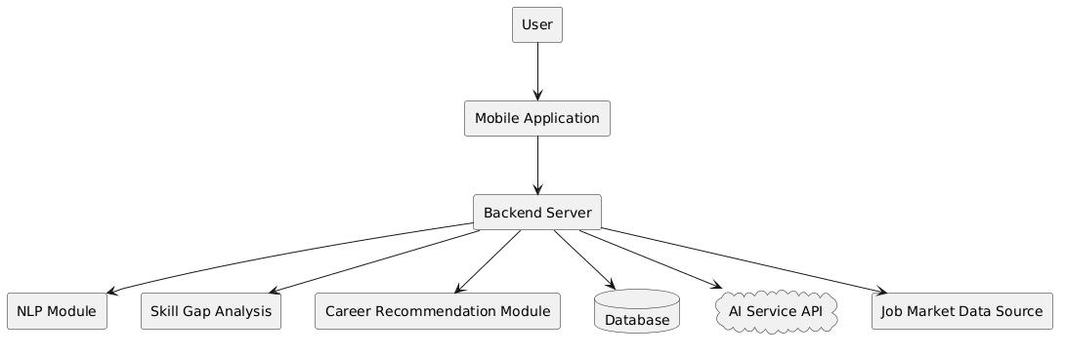
Figure 3: System Architecture of the Masarak Mobile Application

4.3.2 Use Case Diagram
The Use Case Diagram illustrates the main interactions between the Masarak system and its users [37], [44]. It shows the core functions provided by the mobile application, including user registration, CV upload, resume analysis, career recommendation, skill gap identification, learning roadmap generation, and interview preparation. This diagram
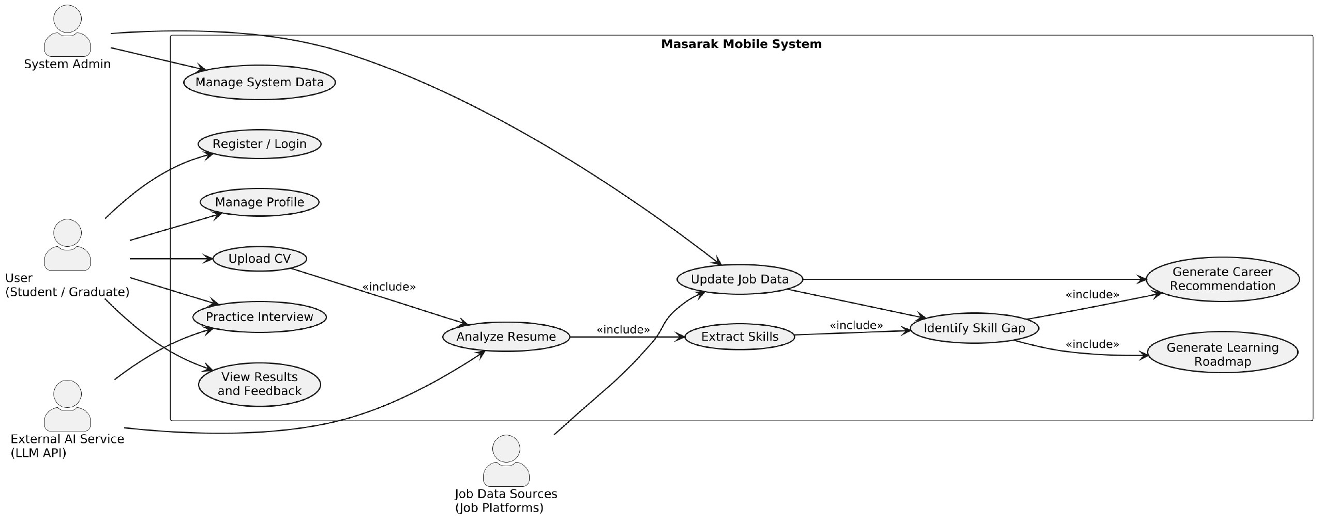
helps clarify how students and graduates interact with the system to receive personalized career guidance.
Figure 4: Use Case Diagram

4.3.3 Entity-Relationship Diagram (ERD)
The Entity-Relationship (ER) Diagram represents the conceptual database design of the Masarak system [45]. It provides a structured overview of the system’s data architecture by illustrating its main entities, their attributes, and the relationships between them. The diagram is organized into four main modules: User Module, Skill Module, AI Module, and Career Module, which together form the core structure of the system.

The User Module contains the User entity as the central component, along with Profile, Education, and Experience entities, which store detailed user information in a normalized structure. This separation improves data organization and reduces redundancy [46].

The Skill Module defines both technical and soft skills through the Skill entity. The relationship between users and skills is managed using the UserSkill entity, which also captures skill proficiency levels and sources. In addition, the SkillGap entity is used to identify missing skills by comparing user capabilities with system or career requirements [47].

The AI Module introduces intelligent functionalities within the system. The CV entity represents uploaded resumes, while the ResumeAnalysis entity stores the results of analyzing these CVs to extract relevant skills and insights. The LearningRoadmap entity, together with RoadmapItem, provides a structured learning path by recommending skills in a sequential format [37].

The Career Module focuses on job market alignment and career guidance. It includes the Job entity and its required skills through JobSkill. The CareerPath entity defines possible career directions, while CareerPathSkill specifies the required competencies for each path. Based on this data, the Recommendation entity generates personalized career suggestions for users using matching scores [43].

The relationships among entities are designed according to normalization principles to ensure data consistency, reduce redundancy, and maintain referential integrity. Overall, the ER diagram supports efficient data management and enables intelligent features such as resume analysis, skill gap detection, learning recommendations, and personalized career path generation. See Appendix 3 for full ER diagram.

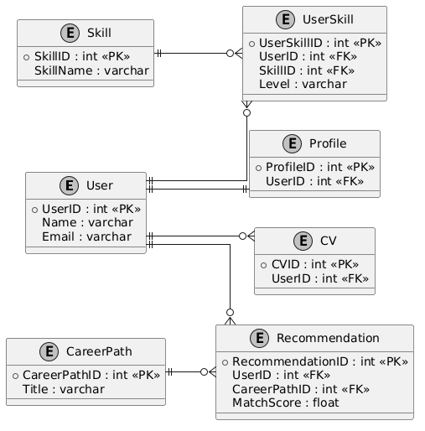
Figure 5: Entity-Relationship Diagram of Masarak

4.4 User Interface Design
This section presents the designed user interface screens for the Masarak application. The interfaces were developed to demonstrate the main system functions and user journey, including authentication, dashboard, career recommendations, CV upload, skill gap analysis, learning roadmap, interview simulation, and profile management. Each interface is designed to provide a clear and user-friendly experience while supporting the system’s main functionalities.
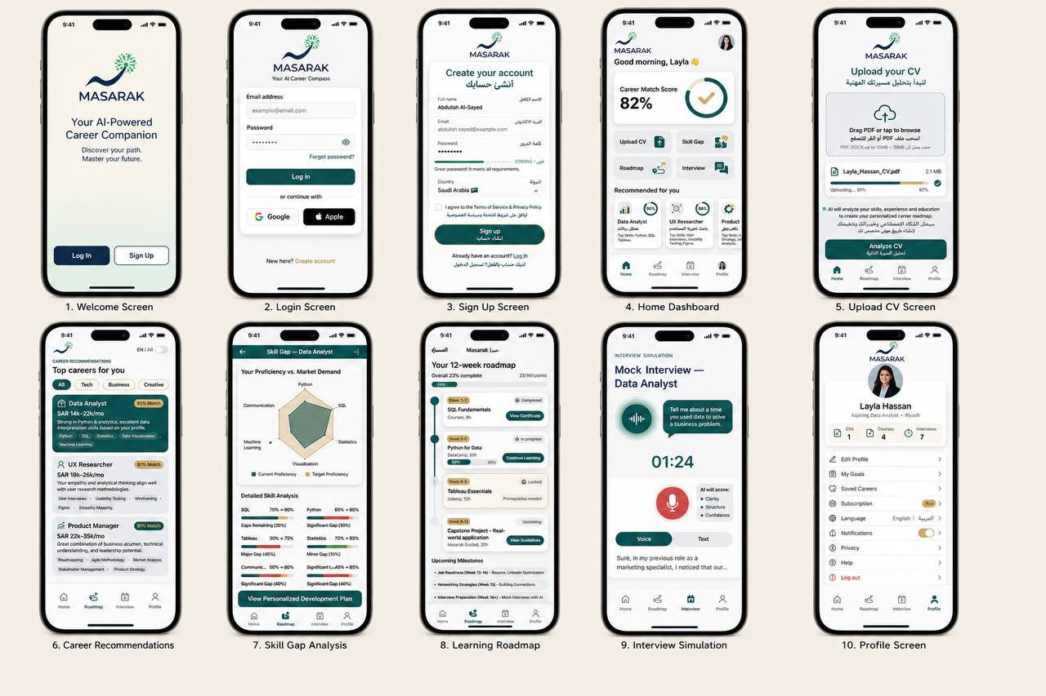
Figure 6 :Masarak User Interface Screens

4.5 Pseudocode/Algorithms/Scenario

4.5.1 Career Recommendation
Algorithm Description:
The Career Recommendation algorithm is designed to identify suitable career paths for users by analyzing multiple attributes, including their skills, interests, personality traits, and educational background.

The system compares the user’s profile with a predefined set of careers stored in the database. For each career, a matching score is computed using a weighted scoring formula, where each attribute contributes based on its assigned importance. The weights (W1–W4) represent the relative importance of each factor, and their sum is typically equal to 1.

The careers are then ranked according to their scores, and the top matches are returned as recommendations.
Pseudocode:
Algorithm Career_Recommendation
Input:
User_Profile (Skills, Interests, Personality, Education)
Output:
Ranked list of Recommended Careers
Begin
1. Load Career_Database
2. Initialize Recommended List as empty
3. For each Career in Career Database do:
a. Compute Skill_Match
b. Compute Interest_Match
c. Compute Personality_Match
d. Compute Education_Match
e. Score = (Skill_Match × W1) +
(Interest_Match × W2) +
(Personality_Match × W3) +
(Education_Match × W4)
f. If Score ≥ Threshold then
Add (Career, Score) to Recommended_List
4. Sort Recommended_List in descending order based on Score
5. Return Top N careers
End

Scenario:
The user interacts with the system and fills out their profile with the following information:
- Skills: Communication, Creativity
- Interests: Media, Design
- Personal Traits: Creative, Social
- Education: High School Graduate

Process:
The system compares the user’s profile with all jobs stored in the database and calculates a matching score for each job based on weighted criteria.

Result:
The system recommends the following jobs:
- Graphic Designer
- Digital Marketer
- Content Creator
These jobs are recommended because they closely match the user’s skills, interests, and personal traits.

4.5.2 Skill Gap Analysis
The Skill Gap Analysis Module serves as the primary decision-making engine of the Masarak system. This section details the algorithmic approach used to quantify the alignment between a user’s current profile and their target career path [27]:
Data Transformation: The process begins by receiving structured competency data from the NLP Skill Extraction Module, which parses the user's resume for technical skills, certifications, and project experiences [42].
Comparative Matching: The module executes a bilateral comparison between the extracted user skills and the dynamic requirements stored in the Job Market Data Source. This ensures that the user's capabilities are measured against real-time industry standards in the Saudi market [8].
Gap Identification: Through this comparison, the system identifies "missing competencies "technical or soft skills present in industry job descriptions but absent from the user’s profile [3], [48].
Readiness Scoring Mechanism: To provide a measurable indicator of career readiness (Functional Requirement FR6), the system calculates a Readiness Score using a matching algorithm [49]. This score is determined by the ratio of matched skills to the total requirements for the role, as shown in Figure 6:
Readiness Score=( $\frac{Count of matched skills}{Total required skills fot the role }*100 )$

Figure 7: Readiness Score Calculation Formula
Output Generation: This analytical output directly feeds into the Learning Roadmap Module, ensuring that subsequent training recommendations are evidence-based and targeted toward addressing specific professional deficiencies [27].

4.5.3 Scenario
The following scenario describes how a user interacts with the Masarak system to receive personalized career guidance.

- The user logs into the Masarak mobile application using their account credentials.
- The user completes or updates their profile information, including academic background and skills.
- The user uploads their CV in PDF format through the application interface.
- The system analyzes the uploaded CV using Natural Language Processing techniques to extract relevant skills and experience.
- The system compares the extracted skills with job market requirements obtained from job data sources.
- The system performs skill gap analysis to identify missing or underdeveloped skills.
- The system generates personalized career recommendations based on the user’s profile and analysis results.
- The system provides a customized learning roadmap that includes suggested courses and certifications.
- The user can access the interview simulation module to practice technical and behavioral questions.
- The system provides feedback on the user’s responses.
- The user reviews the final results, including recommendations, skill gap report, and learning roadmap.

4.6 Summary
Chapter Four has presented the comprehensive design specifications for the Masarak platform, illustrating how integrated AI modules collaborate to support career engineering. By defining the system architecture and the specific logic behind the Skill Gap Analysis, the report has established a clear blueprint for the implementation phase. The proposed design effectively addresses the complexities of the computing labor market by transforming unstructured resume data into actionable professional insights [42]. The subsequent chapters will focus on the implementation and evaluation of these designed components to verify their effectiveness in enhancing graduate employability.

4.7 Outline of the Report
This chapter presents the system design of Masarak, translating the requirements defined in Chapter Three into a structured technical framework. It begins with the system design specification, identifying the main components required to build the mobile application. The chapter then presents the design architecture, illustrated through the system architecture diagram, the use case diagram, and the entity-relationship diagram, showing how the system's modules interact with users and with each other. It further presents the pseudocode and algorithms underlying the Career Recommendation and Skill Gap Analysis modules, supported by a scenario.

The next chapter, Chapter Five, presents the system implementation, covering the implementation and evaluation plan, the technical tools and programming languages, the code structure, and a discussion of the implementation outcomes.

References

[1] | Artificial Intelligence: A Modern Approach, 4th ed. Hoboken, NJ, USA: Pearson, 2020. S. Russell and P. Norvig,.
[2] | Ian and Bengio, Yoshua and Courville, Aaron Goodfellow, Deep Learning. Cambridge, MA, USA: MIT Press, 2016.
[3] | World Economic Forum. (2023) The Future of Jobs Report 2023. [Online]. https://www.weforum.org/reports/the-future-of-jobs-report-2023
[4] | OECD, "OECD Employment Outlook 2023," OECD Publishing, Paris, 2023.
[5] | National Career Development Association. (2022) Career Development and Counseling. [Online]. https://www.ncda.org/
[6] | D. J. Power. (2021) Decision Support Systems: Concepts and Resources. [Online]. http://dssresources.com/dssbook/preface.html
[7] | (2024) National Strategy for Data & AI. [Online]. https://sdaia.gov.sa/en/SDAIA/SdaiaStrategies/Pages/sdaiaAnd2030Vision.aspx
[8] | Human Capability Development Program. (2021) Aligning Educational Outputs with Labor Market Needs. [Online]. https://www.vision2030.gov.sa/en/explore/programs/human-capability-development-program/
[9] | IBM. (2021) What is text mining? [Online]. https://www.ibm.com/think/topics/text-mining
[10] | World Economic Forum, "The Future of Jobs Report 2025," 2025. [Online]. https://www.weforum.org/publications/the-future-of-jobs-report-2025/digest/
[11] | A. Alghfais. (2024) Future of Work Initiative: Vision 2030 sets goals to align educational outputs with labor market needs. [Online]. https://www.hrsd.gov.sa/media-center/news/108102
[12] | R. Alshammari. (2024) Human Capital Development and Economic Productivity in Saudi Arabia. [Online]. https://www.researchgate.net/publication/397413865_Human_capital_development_and_economic_productivity_in_Saudi_Arabia_A_review_paper_evaluating_vision_2030_education_and_labor_reforms
[13] | S. Kumar A. Singh, "AI-based career recommendation systems using machine learning techniques," International Journal of Advanced Computer Science and Applications, vol. 12, no. 6, pp. 45-53, 2021.
[14] | J. Malinowski, T. Jambor, and M. Wegrzyn-Wolska, "Matching people and jobs: A bilateral recommendation approach," Decision Support Systems, pp. 385–394, 2010.
[15] | IBM. (2025) Can AI Decision-Making Emulate Human Reasoning? [Online]. https://www.ibm.com/think/insights/ai-decision-making
[16] | IBM. (2025) What is Machine Learning? [Online]. https://www.ibm.com/think/topics/machine-learning
[17] | Daniel Jurafsky and James H. Martin, Speech and Language Processing.: Stanford University, 2026. [Online]. https://web.stanford.edu/~jurafsky/slp3/
[18] | A. Joshi, S. V. Pede, P. Kolekar, and A. Metkar, "Resume Parsing and Skill Extraction using Custom Pattern Matching algorithm and Gemini API," , 2024. [Online]. https://doi.org/10.1109/ICCUBEA61740.2024.10775064
[19] | Prajwal Pal, Nikhil Nikhare, and Sairaj Rananaware. (2025) AI-Driven Career Guidance, Personalized Job & Skill Recommendations. [Online]. https://ijsdr.org/papers/IJSDR2507101.pdf
[20] | ILOSTAT. (2019) Education and Mismatch Indicators (EMI database). [Online]. https://ilostat.ilo.org/methods/concepts-and-definitions/description-education-and-mismatch-indicators/
[21] | LinkedIn Corporation, "About LinkedIn," 2024. [Online]. https://www.linkedin.com/
[22] | Coursera Inc., "About Coursera," 2024. [Online]. https://www.coursera.org/
[23] | Edraak, "About Edraak," 2024. [Online]. https://www.edraak.org/
[24] | A. S. Naffeti and M. Z. Moghaddam, "Skill gap analysis using machine learning techniques," IEEE Access, pp. 150821–150832, 2021.
[25] | M. Elbadrawy and G. Karypis, "Domain-aware grade prediction and learning pathway recommendation," in Proc. 22nd ACM SIGKDD Int. Conf. Knowl. Discov. Data Min., 2016.
[26] | S. B. Kakkar, "AI-based mock interview system for enhancing employability skills," Procedia Computer Science, pp. 1148–1155, 2022.
[27] | S. K. Sood and R. Rani, "A Framework for Skill Gap Analysis in Higher Education using Big Data Analytics," Journal of Computing in Higher Education, pp. 605–625, 2020. [Online]. https://link.springer.com/article/10.1007/s12528-019-09244-w
[28] | Roger S Pressman and Bruce R Maxim, Software Engineering: A Practitioner’s Approach. New York, NY: McGraw-Hill Education, 2020.
[29] | OECD, "Career Guidance for Adults in a Changing World of Work," 2021. [Online]. https://www.oecd.org/content/dam/oecd/en/publications/reports/2021/01/career-guidance-for-adults-in-a-changing-world-of-work_0c903ffd/9a94bfad-en.pdf
[30] | J. W. Creswell, Research Design: Qualitative, Quantitative, and Mixed Methods Approaches. Thousand Oaks, CA, USA: SAGE Publications, 2014.
[31] | D. Jackson, "The contribution of work-integrated learning to undergraduate employability skill outcomes," Asia-Pacific Journal of Cooperative Education, pp. 99–115, 2013.
[32] | IEEE, "IEEE Recommended Practice for Software Requirements Specifications," New York, IEEE Std 830-1998, 1998.
[33] | IEEE, "IEEE Guide for Developing System Requirements Specifications," New York, IEEE Std 1233-1998, 1998.
[34] | P. A. Laplante, Requirements Engineering for Software and Systems, 4th ed. New York, NY: Auerbach Publications, 2022.
[35] | K. E. Wiegers J. Beatty, Software Requirements, 3rd ed. Redmond, WA: Microsoft Press, 2013.
[36] | IEEE Computer Society, "Software Requirements Specifications," 2024. [Online]. https://www.computer.org/resources/software-requirements-specifications
[37] | lan Sommerville,. Harlow, England: Pearson Education, 2016, pp. 144-146.
[38] | International Organization for Standardization, "ISO/IEC/IEEE 12207:2017: Systems and software engineering - Software life cycle processes," 2017. [Online]. https://www.iso.org/standard/63712.html
[39] | IEEE Standards Association, "IEEE/ISO/IEC 29119-1-2021: Software and systems engineering - Software testing - Part 1: General concepts," 2021|2022. [Online]. https://standards.ieee.org/ieee/29119-1/10779/
[40] | Python Software Foundation. (2026) PythonForArtificialIntelligence. [Online]. https://wiki.python.org/moin/PythonForArtificialIntelligence.html
[41] | Git Project. git Documentation. [Online]. https://git-scm.com/docs/git
[42] | F. Siddique, "Automated Resume Screening System using Natural Language Processing and Machine Learning," International Journal of Computer Applications, pp. 33–38, 2021. [Online]. https://www.ijcaonline.org/archives/volume174/number23/siddique-2021-ijca-921134.pdf
[43] | Henry Korth, S. Sudarshan Abraham Silberschatz, Database System Concepts, 7th ed. New York, USA,NY: McGraw-Hill, 2020.
[44] | IBM. (2017) Use-case diagrams in UML modeling. [Online]. https://www.omg.org/spec/UML/2.5.1/About-UML
[45] | IEEE (Institute of Electrical and Electronics Engineers, "IEEE Recommended Practice for Software Design Descriptions," New York, NY, USA, IEEE Std 1016-1998, 1998.
[46] | Carolyn Begg Thomas Connolly, Database Systems: A Practical Approach to Design, Implementation, and Management, 6th ed. Harlow, Uk: Pearson, 2015.
[47] | Shamkant Navathe Ramez Elmasri, Fundamentals of Database Systems, 7th ed. Boston, USA,MA: Pearson, 2016.
[48] | J. J. Heckman and T. Kautz, "Hard Evidence on Soft Skills," Labour Economics, pp. 451–464, 2012.
[49] | M. S. Neisary, "A Mathematical Model for Career Readiness and Skill Matching in Computing Fields," International Journal of Advanced Computer Science and Applications (IJACSA), 2021. [Online]. https://thesai.org/Publications/IJACSA

Appendix

Appendix 1 : User Needs Questionnaire
This appendix presents the survey used to collect user requirements for the Masarak system. The questionnaire was distributed using Google Forms to gather responses from students and graduates regarding career guidance challenges and system needs.
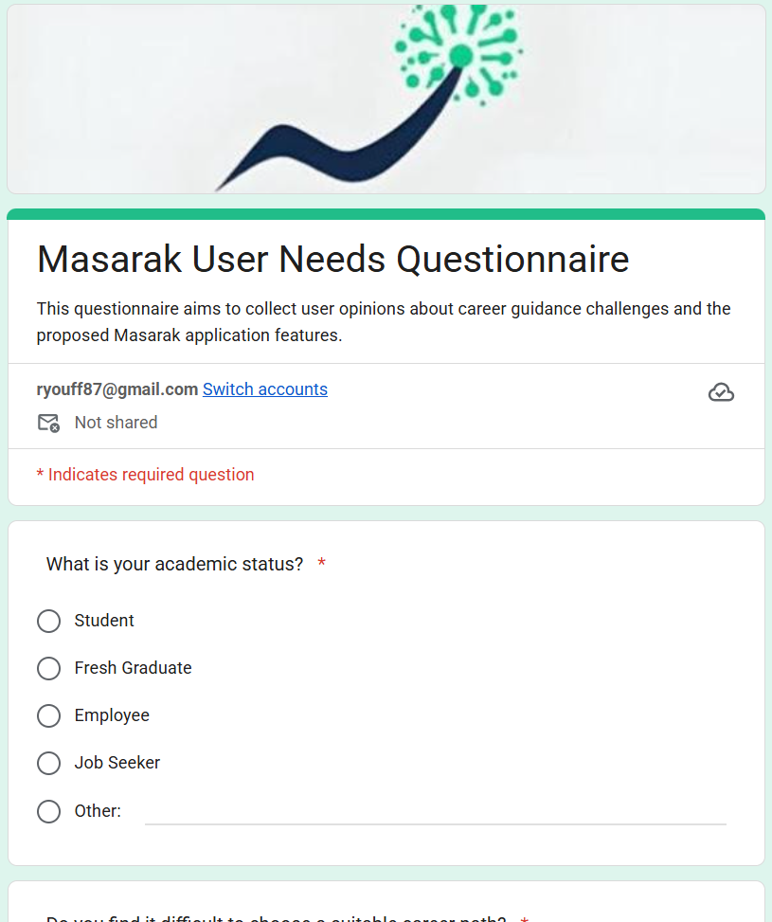

Survey Link: https://docs.google.com/forms/d/e/1FAIpQLSer3DbUTr-MdBY1BBxfrogax0_dODIBPHwhHyxXcC0hvW8o0w/viewform?usp=header
The questionnaire included questions about academic status, career path difficulty, awareness of required skills, and interest in AI-based career guidance features.

Appendix 2: Entity-Relationship Diagram
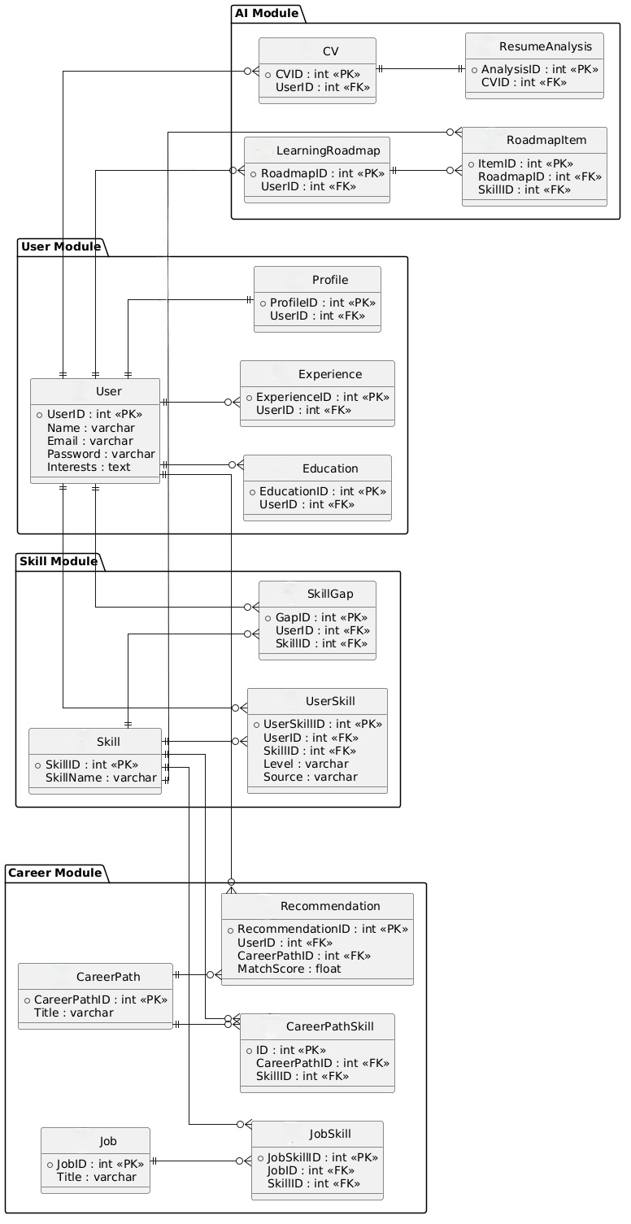
This appendix presents the complete ER diagram of the Masarak system, showing all modules and relationships in a unified view.

