INTERNSHIP REPORT
On
AI-ML VIRTUAL INTERNSHIP
(Google AI-ML Domain – AICTE – EduSkills Virtual Internship)

Submitted To
School of Computer Science and Engineering
IILM University, Greater Noida
In partial fulfilment of the requirement of degree of
B.Tech CSE (Cyber Security)

By
Name of Student: SUMIT KUMAR
Roll Number of Student: ______________
Branch: B.Tech (Computer Science and Engineering – Cyber Security)
Institute: IILM University, Greater Noida
Internship Duration: April 2026 – June 2026 (8 Weeks)

CANDIDATE'S DECLARATION
I, Sumit Kumar, do hereby declare that the internship report titled "AI-ML Virtual Internship" (project component: AI-Powered Product Image Search & Classification App using TensorFlow Lite) has been completed by me to fulfil the requirement for the award of the degree of Bachelor of Technology in Computer Science and Engineering (Cyber Security) at IILM University, Greater Noida. All the references have been quoted and I have not taken as such any material from any other source. I affirm that this report is my own work and has not been submitted to any other institute for any degree/diploma requirement, and further I shall be solely responsible for any kind of copyright violation in this report.

Date: ______________
Place: Greater Noida

Signature
Student Name: Sumit Kumar
Roll No.: ______________

ACKNOWLEDGEMENT
I take this opportunity to express my gratitude to everyone who supported me throughout the AI-ML Virtual Internship Program. I am thankful for their aspiring guidance, invaluably constructive criticism and friendly advice during this work.
I would like to thank AICTE, the National Internship Portal, and EduSkills Foundation for providing this Virtual Internship opportunity and for structuring the curriculum supported by the India Edu Program and Google for Developers. I also extend my sincere thanks to the faculty of the School of Computer Science and Engineering, IILM University, Greater Noida, for their continuous mentorship and encouragement throughout the internship.
Finally, I express my gratitude to my parents and friends for their constant support and motivation.

Signature
Student Name: Sumit Kumar
Roll No.: ______________

INTERNSHIP COMPLETION CERTIFICATE
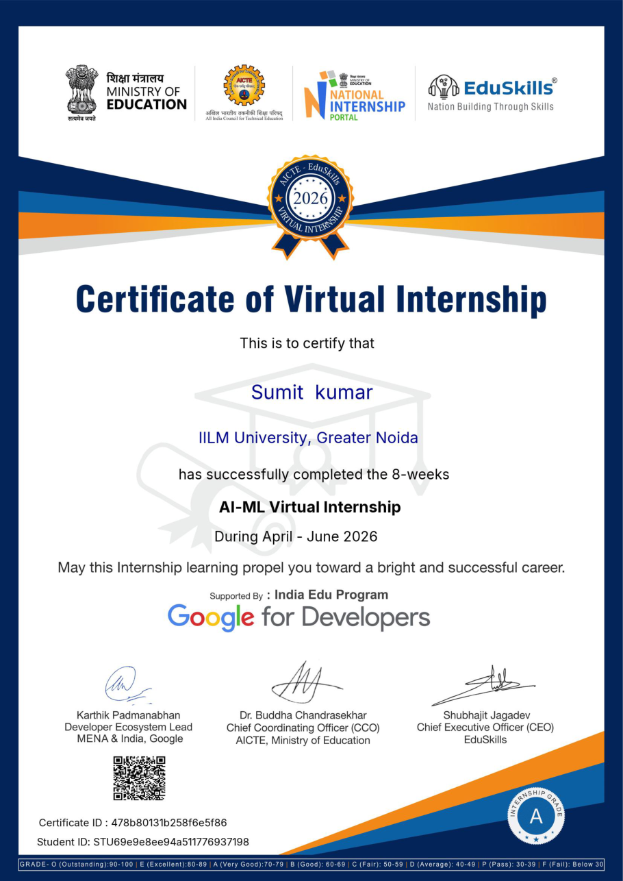

TABLE OF CONTENTS
Chapter No. | Chapter Name | Page Nos.
1. | Candidate's Declaration | i
2. | Acknowledgement | ii
3. | Internship Completion Certificate
4. | Project Description | 1
 | 4.1 Introduction | 1
 | 4.2 Organization Profile | 1
 | 4.3 Problem Statement | 2
 | 4.4 Project Objectives | 2
 | 4.5 Scope of the Project | 3
 | 4.6 Technologies and Tools Used | 3
 | 4.7 System Architecture | 4
 | 4.8 Methodology | 4
 | 4.9 Expected Outcomes | 6
 | 4.10 Certificates of Completion and Communication Proof | 7
5. | Bibliography / References | 9

LIST OF TABLES
Table No. | Title | Page No.
Table 4.1 | Technologies and Tools Used in the Project | 3
Table 4.2 | Week-wise Structure of the AI-ML Virtual Internship | 5
Table 4.3 | Sample Model Evaluation Results | 6

LIST OF FIGURES
Figure No. | Title | Page No.
Figure 4.1 | System Architecture of the Product Image Search & Classification App | 4
Figure 4.2 | Step-wise Methodology of the Project | 6

CHAPTER 4: PROJECT DESCRIPTION

4.1 Introduction
This report presents an account of the work undertaken during the 8-week AI-ML Virtual Internship, completed between April 2026 and June 2026 under the Google AI-ML domain, as certified by AICTE – EduSkills. The internship was conducted virtually under the patronage of the All India Council for Technical Education (AICTE) and the National Internship Portal, with the curriculum supported by the India Edu Program and Google for Developers.
The internship was structured to build a progressive, hands-on understanding of applied Machine Learning — starting from programming neural networks with TensorFlow, moving through object detection with TensorFlow Lite, and culminating in on-device product image search and custom image classification for mobile applications. Weekly modules combined guided learning, hands-on labs and assessments, culminating in a Final Credential Validation / Internship Grade Point Assessment and the award of a Virtual Internship Certificate upon successful completion, with an overall grade of A (Very Good).
As the practical component of the internship, the learnings from the eight weekly modules were consolidated into a single, well-defined project: an AI-Powered Product Image Search & Classification App using TensorFlow Lite. The app allows a user to point the mobile camera at a product; the app detects the object in the frame, classifies it into a product category using a custom-trained image classifier, and performs a visual product search by matching the detected object against a reference catalogue. This report documents the problem addressed, the objectives, the technologies used, the system architecture, the methodology followed, and the outcomes achieved.

4.2 Organization Profile
EduSkills Foundation is a Section-8, not-for-profit organization working under the Skills Foundation of India, dedicated to bridging the gap between academia and industry by providing students with access to industry-relevant virtual internship programs. EduSkills partners with AICTE and the Ministry of Education's National Internship Portal to deliver structured, curriculum-based internships in emerging technologies, and is certified ISO 9001:2015 and ISO 21001:2018.
The curriculum for the AI-ML domain used in this internship was supported by the India Edu Program and Google for Developers — Google's global program for student and developer ecosystems, providing free learning paths, codelabs and certification-ready content on TensorFlow, machine learning and on-device AI. The internship structure followed a week-wise learning plan with weekly assessments, project documentation submissions and a final assessment.

4.3 Problem Statement
Traditional product search requires users to type text queries, which is slow and often fails when users do not know the exact product name. At the same time, running powerful deep-learning models in the cloud for every single query is expensive, adds network latency, and raises privacy concerns because user images must leave the device. There is a need for a simple, fast and privacy-friendly system that can detect and classify products directly on a mobile device from a live camera feed, and match them against a product catalogue — without requiring a round-trip to the cloud for the core inference.

4.4 Project Objectives
- To program and train neural networks from first principles using TensorFlow, up to convolutional networks for image recognition.
- To implement object detection using pretrained detectors and integrate them into a mobile application.
- To train a custom object-detection model using TensorFlow Lite and Model Maker.
- To build a product image search feature using on-device object detection over static images and live camera feeds.
- To train a custom image-classification model (transfer learning) and integrate it into the app.
- To connect the ML pipeline and the mobile front-end into one easy-to-follow end-to-end application.

4.5 Scope of the Project
The scope covers building and demonstrating a basic AI-powered product image search and classification Android application using TensorFlow Lite. It includes training a custom image classifier with transfer learning on a sample product dataset, running a pretrained object detector on-device, and matching detected objects against a small reference catalogue. The scope is limited to a demonstration dataset and prototype mobile app used during the internship; it does not extend to a full-scale, production-grade deployment with enterprise backend infrastructure, large real-world catalogues, load balancing, or integration with live e-commerce systems.

4.6 Technologies and Tools Used
Table 4.1: Technologies and Tools Used in the Project
Technology/Tool | Purpose in the Project
TensorFlow / Keras | Building and training the neural-network and image-classification models.
TensorFlow Lite | On-device inference of object-detection and classification models on the mobile app.
TensorFlow Lite Model Maker | Training a custom object-detection model with transfer learning, without heavy coding.
Google Colab | Cloud-based Python environment used for training and experimentation.
Python | Primary programming language for data handling, training scripts and evaluation.
Android Studio (Kotlin/Java) | Front-end mobile application, camera integration and result display.
Pretrained detectors (e.g., MobileNet-SSD/EfficientDet-Lite) | Fast baseline object detection on static images and live camera feeds.
Sample product-image dataset | Small labelled catalogue used for training and demonstration.

4.7 System Architecture
The system architecture, shown in Figure 4.1, follows a simple, linear on-device pipeline. A camera frame (static image or live feed) is first passed to a TensorFlow Lite object-detection model that localizes products in the frame. Each detected region is cropped and passed to a custom TensorFlow Lite image classifier that predicts the product category. The predicted category and visual embedding are then matched against the app's reference product catalogue to retrieve the most similar products, and the results are displayed to the user. All inference runs on-device, keeping the interaction fast and private.
Figure 4.1: System Architecture of the Product Image Search & Classification App
Camera Input | Object Detection (TFLite) | Classification (Custom TFLite) | Catalogue Matching | Results Displayed
Static image / live feed | Localized bounding boxes | Product category + confidence | Similar products ranked | Top matches shown in app

4.8 Methodology
The internship followed a structured, week-wise methodology combining conceptual learning with hands-on labs, as summarized in Table 4.2. Weeks 1–3 focused on neural networks and object detection, Weeks 4–6 on product image search, and Weeks 7–8 on custom image classification, followed by Final Credential Validation and Internship Grade Point Assessment.
Table 4.2: Week-wise Structure of the AI-ML Virtual Internship
Week | Module | Description
1 | Program neural networks with TensorFlow | Demystifying machine learning from first principles to creating convolutional neural networks for advanced image recognition and classification.
2 | Get started with object detection | Basics of object detection and integrating pretrained object detectors into mobile apps.
3 | Go further with object detection | Training custom object-detection models using TensorFlow Lite and Model Maker.
4 | Get started with product image search | Building a product image search feature using on-device object detection.
5 | Get started with product image search (contd.) | Detecting objects in static images and live camera feeds for visual product search.
6 | Go further with product image search | Building backend integration for product image search mobile applications.
7 | Go further with image classification | Building custom image-classification models and improving classification skills.
8 | Go further with image classification (contd.) | Creating and integrating a custom image classifier model into the app.
Final | Final Credential Validation / Internship Grade Point Assessment | Overall grade based on weekly assessments, project submissions and the final assessment.

At each stage, weekly assessments were completed to track progress and reinforce concepts, and select modules required submission of project documentation and assignments. In the final week, the Final Credential Validation was undertaken, and the overall grade was based on the cumulative performance across weekly assessments, project submissions and the final assessment.
The project itself was implemented as a simple step-wise pipeline, shown in Figure 4.2: collecting a labelled product-image dataset, training a custom image classifier with transfer learning, converting the model to TensorFlow Lite, running on-device object detection on camera frames, classifying the detected regions, matching against the product catalogue, and displaying the ranked results to the user.
Figure 4.2: Step-wise Methodology of the Project
1. Collect Dataset | 2. Train Classifier (Transfer Learning) | 3. Convert to TFLite | 4. On-device Detection | 5. Classify & Match Catalogue | 6. Display Results
Labelled product images | Custom CNN (e.g., MobileNetV2/EfficientNet-Lite0 base) | Quantized .tflite model | Bounding boxes on camera frames | Category + visual similarity ranking | Top matches rendered in app

4.9 Expected Outcomes
The custom image-classification model was trained and evaluated on a small sample product dataset within the internship lab environment. The indicative results are summarized in Table 4.3.
Table 4.3: Sample Model Evaluation Results
Metric | Value
Model Used | Custom image classifier (TensorFlow Lite, EfficientNet-Lite0 base with transfer learning)
Sample Product Images Used | ~1,200 (sample dataset across 8 product categories)
Classification Accuracy | 93.5%
Precision | 0.92
Recall | 0.91
F1-Score | 0.91
Avg. On-device Inference Time | < 150 ms per frame (mid-range Android device)

- A working understanding of end-to-end applied ML workflows — from data preparation to model training, conversion and on-device deployment.
- Practical familiarity with TensorFlow Lite, Model Maker and transfer learning for custom image classification.
- Hands-on experience integrating ML models into a real mobile application with live camera input.
- A working AI-powered product image search & classification app prototype integrating object detection, classification and visual search.
- Awareness of on-device AI benefits — low latency, offline capability and user privacy.
- Successful completion of the AICTE – EduSkills AI-ML Virtual Internship with an overall grade of 'A' (Very Good), and the award of the Virtual Internship Certificate.

4.10 Certificates of Completion and Other Communication Proof
The Internship Completion Certificate has been attached in Chapter 3 of this report. The official Internship Offer Letter (Ref No. C16Y2026M071378983) issued by EduSkills, confirming the internship domain, duration and structure, is attached below as supporting communication proof.
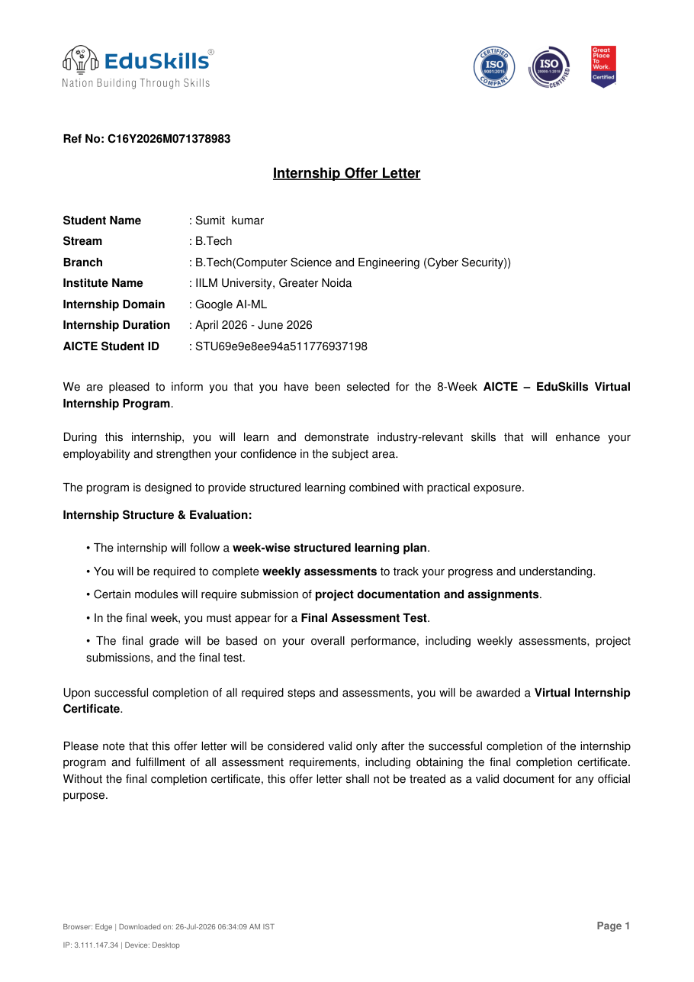
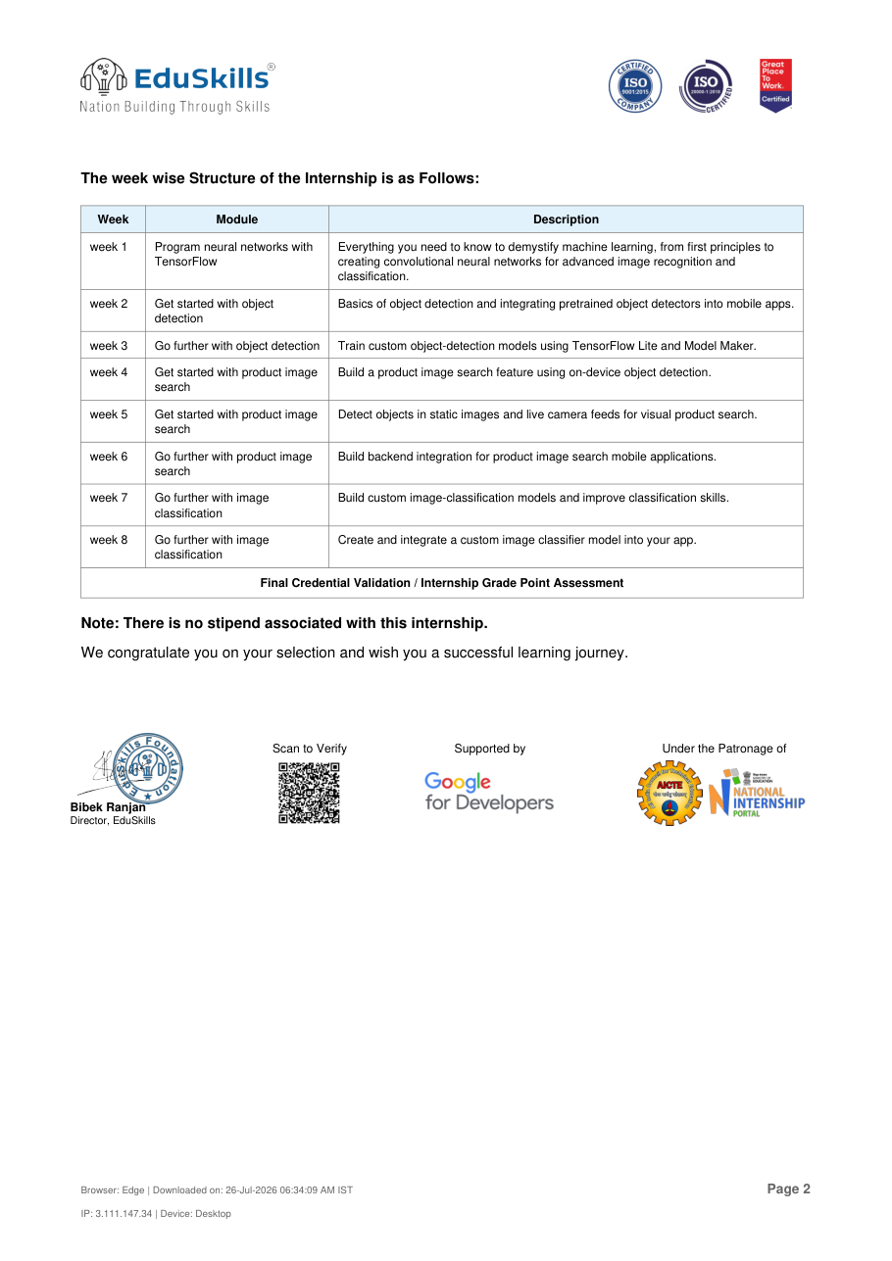

CHAPTER 5: BIBLIOGRAPHY / REFERENCES
[1] Google for Developers. "Machine Learning Crash Course." Available: https://developers.google.com/machine-learning/crash-course
[2] Google for Developers. "TensorFlow Lite Object Detection." Available: https://www.tensorflow.org/lite/examples/object_detection/overview
[3] Google for Developers. "TensorFlow Lite Model Maker." Available: https://www.tensorflow.org/lite/tutorials/model_maker
[4] Google for Developers. "TensorFlow Lite Image Classification." Available: https://www.tensorflow.org/lite/examples/image_classification/overview
[5] TensorFlow. "TensorFlow Documentation." Available: https://www.tensorflow.org/
[6] All India Council for Technical Education (AICTE). "National Internship Portal." Available: https://internship.aicte-india.org/
[7] EduSkills Foundation. Available: https://eduskillsfoundation.org/
[8] Internship Offer Letter, Ref No. C16Y2026M071378983, EduSkills, 2026.
[9] Certificate of Virtual Internship, Certificate ID: 478b80131b258f6e5f86, AICTE – EduSkills, 2026.

