Android Home Work

Planned Technologies:

1. Persistent data storage (SugarORM)
2. UI
   1. Advanced Recycler View
   2. Activity Fragments / Dialog
3. Permission Handling
4. Toolbar/Menu
5. Material Design Resources

Design Sketch

* **Main Activity:**

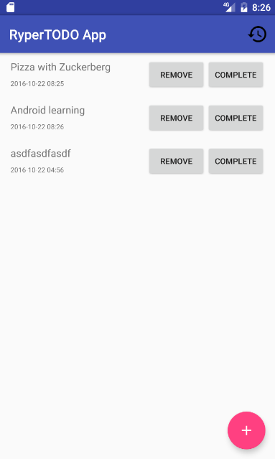

* **History (Completed tasks):**

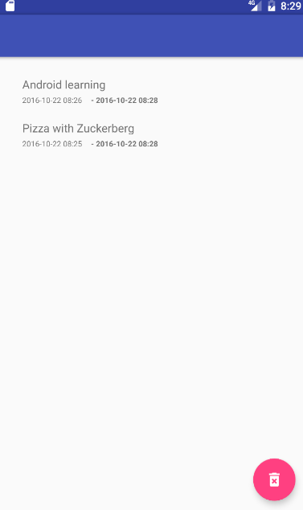

If the user clicks the trash can icon the full log will be deleted permanently.

History can be opened by clicking the  button in the main Activity

* **New Todo Dialog:**

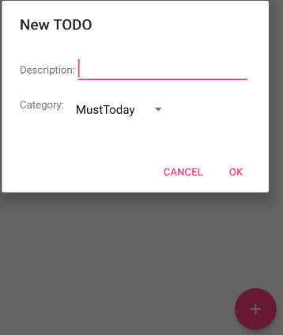

This dialog is going to appear, if the user clicks the + button in the bottom right corner of the MainActivity

Detailed Description

1. **Persistent data storage (SugarORM)**

The data will be stored in a database. I planned two tables : TodoHistory,TodoProgress. Both of them would store: Description about the todo (string), time when todo is added (long), category (string). TodoHistory is only extended with one more column: time when completed (long).

This way the time can be easily formatted to the desired date format. Sadly SQLite cannot store Date, so this is why I choose to store a long. I plan to use Unix Timestamp ( System.currentTimeMillis() ).

These saved data, will be loaded every time when the application starts.

1. **UI**
   1. **Advanced Recycler View**

<https://github.com/h6ah4i/android-advancedrecyclerview>

I plan to use an external library to get used to other people’s work. My intent with this is to implement a recycleView where you can reorder the items with a long touch + drag;

* 1. **Activity Fragments/Dialog**

I will implement the dialog with fragment, this way the mainActivity will be more cleaner. Also in the AddTodoDialog I plan two fields: Description, Category. The Description will be a TextInput, and the Category will be a ComboBox. The Todos in the main activity will be ordered by their categories. This way the category will mean priority, and the user can easily see which need to be done first.

1. **Permission Handling**

I Will implement permission handling to get access to the external/internal storage.

1. **Toolbar/Menu**

I want to use the menu only for navigation. As you can see in the first picture, you can see

the icon, this icon will be used to navigate between history and mainActivity.

1. **Material Design Resources**

I planning to use external resources. For example: , , 