|  |  |
| --- | --- |
| **Ex. No: 1** | **Regression** |
| **Date: 30-12-2022** |

# Aim:

To build a multiple linear regression model to predict the sale price of the house.

# Algorithm:

**Multiple Linear Regression:**

* Import the necessary modules and the csv file.
* Fill the null values present in the data and pre-process the data.
* Use variance influence factor in the data and check for correlation and select the columns that have variance influence factor lesser than 3.
* Split the data into train and test using train-test-split from sklearn library.
* Import Linear regression from sklearn and fit the model.
* Predict the values using the test data and print the accuracy metrics.

# Simple Linear Regression:

* Import the necessary modules and the csv file.
* Fix the dependent variable and independent variable calculate the slope and y-intercept using the mathematical formula calculate the variances of dependent and independent variable.
* Calculate the root mean square of the predicted values and find the line of best fit.

# Program:

import numpy as np import pandas as pd

import matplotlib.pyplot as plt df=pd.read_csv('house_pred.csv') df.head()

df.info() df.describe()

columns_numerical=df.select_dtypes(exclude='object') column_numerical=columns_numerical.columns column_numerical

columns_object=df.select_dtypes(include='object') column_object=columns_object.columns column_object

columns_numerical.info()

df['LotArea'].mean()

df['LotArea'].median()

columns_numerical['LotFrontage'].fillna(value=columns_numerical['LotFront age'].mean(),inplace=True)

columns_numerical['MasVnrArea'].fillna(value=columns_numerical['MasVnrAre a'].mean(),inplace=True)

columns_numerical['GarageYrBlt'].fillna(value=columns_numerical['GarageYr Blt'].median(),inplace=True)

columns_numerical.info() columns_object.info()

columns_object.drop(['Alley','FireplaceQu','PoolQC','Fence','MiscFeature'

],inplace=True,axis=1) df1=columns_object.isna().sum() df1

columns_object.fillna(method='ffill',inplace=True) columns_object.columns df_uni=columns_object.describe(include='object').T

def dummies(x): a=pd.get_dummies(columns_object[x],drop_first=True) return a

column_object=list(columns_object.columns) len(column_object) columns_object.describe(include='object').T

a=pd.DataFrame()

for i in column_object: c=dummies(i) a=pd.concat([a,c],axis=1)

#c.drop_duplicates(inplace=True)

#l=a.columns[a.columns.duplicated()] #s=list(a.columns.drop_duplicates())

a=a.loc[:,~a.columns.duplicated()] len(l)

len(s) df_final=a.join(columns_numerical) df_final

def iqr(x):

q1=df_final[x].quantile(0.25) q3=df_final[x].quantile(0.75) iqr=q3-q1

upper=q3+1.5*iqr lower=q1-1.5*iqr print(i) print(upper,lower) return upper,lower

df_f=df_final.copy()

for i in column_numerical: a,b=iqr(i)

df_f=df_f[(df_f[i]>b) | (df_f[i]<a)] df_f plt.boxplot(df_final['EnclosedPorch'])

for i in column_numerical: plt.boxplot(df_final[i])

import seaborn as sns

sns.boxplot(columns_numerical)

plt.figure(figsize=(8,250)) c=1

for i in columns_numerical: ax=plt.subplot(38,1,c)

sns.boxplot(columns_numerical[i],orient='h',x=columns_numerical[i]) c+=1

plt.show() df_final

x=df_final.iloc[:,:-1].values y=df_final.iloc[:,-1].values x.shape

x=pd.DataFrame(x) x.columns=df_final.columns[:-1] x['intercept']=1

vif=pd.DataFrame() vif['variables']=x.columns

from statsmodels.stats.outliers_influence import variance_inflation_factor vif['values']=[variance_inflation_factor(x.values,i) for i in range(x.shape[1])]

vif e=vif[vif['values']>3]

out=e['variables'].values[:-1] df_final.drop(out,axis=1,inplace=True)

from sklearn.model_selection import train_test_split

x_train,x_test,y_train,y_test=train_test_split(x,y,test_size=0.3,random_s tate=42)

from sklearn.linear_model import LinearRegression reg=LinearRegression()

reg.fit(x_train,y_train)

y_pred=reg.predict(x_test) from sklearn.metrics import

r2_score,mean_absolute_error,mean_squared_error print("R2 score:",r2_score(y_pred,y_test))

print("Mean squared error:",mean_squared_error(y_pred,y_test)) print("Mean absolute error:",mean_absolute_error(y_pred,y_test))

x=x.values x

df_test=pd.read_csv('test.csv') df_test.info()

df_test.drop(['Alley','FireplaceQu','PoolQC','Fence','MiscFeature'],axis= 1,inplace=True)

df_test_num=df_test.select_dtypes(exclude='object') df_test_obj=df_test.select_dtypes(include='object')

df_test_num.info()

df_test_num['LotFrontage'].fillna(value=columns_numerical['LotFrontage']. mean(),inplace=True) df_test_num['MasVnrArea'].fillna(value=columns_numerical['MasVnrArea'].me an(),inplace=True) df_test_num['GarageYrBlt'].fillna(value=columns_numerical['GarageYrBlt']. median(),inplace=True)

df_test_obj.describe().T

df_test_obj.fillna(method='ffill',inplace=True) def dummies(x):

a=pd.get_dummies(df_test_obj[x],drop_first=True) return a

b=pd.DataFrame()

for i in column_object: c=dummies(i) b=pd.concat([b,c],axis=1)

#c.drop_duplicates(inplace=True)

l=b.columns[b.columns.duplicated()] s=list(b.columns.drop_duplicates()) b=b.loc[:,~b.columns.duplicated()]

len(b.columns) b=b.join(df_test_num) len(b.columns) w=vif[vif['values']<3] w=w['variables'].values

for i in w:

if i not in b.columns: b[i]=0

test_x=b[w] test_x.columns=x_train.columns test_x['intercept']=1

test_x

x_train house_price_predict=reg.predict(test_x) test_x['SalePrice']=house_price_predict test_x.head()

df_test['SalePrice']=house_price_predict df_test.to_csv('Predicted House Price.csv')

import numpy as np

import matplotlib.pyplot as plt import pandas as pd

import math df=pd.read_csv('data1.csv') df.head()

x=df['x'].values

y=df['y'].values mean_x=np.mean(x) mean_y=np.mean(y) r=f=d=0

f=((x-mean_x)*(y-mean_y)).sum()

d=(np.sqrt(((x-mean_x)**2)*((y-mean_y)**2))).sum() r=f/d

S_y=((np.sqrt((y-mean_y)**2))).sum()/(len(y)-1)

S_x=((np.sqrt((x-mean_x)**2))).sum()/(len(x)-1) b1=r*(S_y/S_x)

b1

b0=mean_y-b1*mean_x b0

r

rmse=math.sqrt((1/len(y))*((y-mean_y)**2).sum()) rmse

mae=(abs(y-mean_y).sum())/len(y) mae

print("Root mean squared error:",rmse) print("Mean absolute error:",mae)

# Output Screenshot:

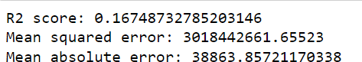

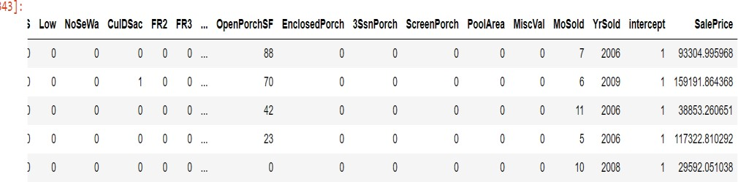

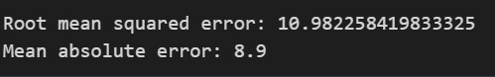

**Result:**

Hence, the multiple regression model is built and the sale price of the house is predicted and a simple linear regression model is built.

|  |  |
| --- | --- |
| **Ex. No: 2** | **Logistic Regression** |
| **Date: 06-01-2023** |

# Aim:

To build a logistic regression model to classify customer status.

# Algorithm:

* Import the necessary modules and the csv file.
* Fill the null values present in the data and pre-process the data.
* Split the data into train and test using train-test-split from sklearn library.
* Using the standard scaler normalize the train data and the test data.
* Import Logistic regression from sklearn and fit the model.
* Predict the values using the test data and print the confusion matrix and classification report.

# Program:

import numpy as np import pandas as pd

import matplotlib.pyplot as plt import seaborn as sns

df=pd.read_csv('telecom_customer_churn.csv') df.head()

df.info()

df.drop(['Churn Category','Churn Reason'],axis=1,inplace=True) obj_col=df.select_dtypes(include='object')

for i in obj_col: print(i,":",obj_col[i].unique())

obj_col.drop(['Customer ID','City'],axis=1,inplace=True) obj_col['Offer'].value_counts().index[0]

for i in obj_col: obj_col[i].fillna(method='ffill',inplace=True)

for i in obj_col: print(i,":",obj_col[i].unique())

df_obj=pd.DataFrame()

from sklearn.preprocessing import LabelEncoder le=LabelEncoder()

for i in obj_col: df_obj[i]=le.fit_transform(obj_col[i])

df_obj.head() df_obj.info()

num_col=df.select_dtypes(exclude='object') num_col.head()

num_col.info() num_col.describe()

plt.figure(figsize=(8,250)) c=1

for i in num_col: ax=plt.subplot(38,1,c)

sns.boxplot(num_col[i],orient='h',x=num_col[i]) c+=1

plt.show()

num_col.drop(['Zip Code','Latitude','Longitude'],axis=1,inplace=True) sns.kdeplot(num_col['Avg Monthly Long Distance Charges']) sns.kdeplot(num_col['Avg Monthly GB Download'])

num_col['Avg Monthly Long Distance Charges'].fillna(num_col['Avg Monthly Long Distance Charges'].mean(),inplace=True)

num_col['Avg Monthly GB Download'].fillna(num_col['Avg Monthly GB Download'].mean(),inplace=True)

num_col.info() df_final=df_obj.join(num_col) df_final.head()

x=df_final.iloc[:,:-1] y=df_final.iloc[:,-1].values

from sklearn.model_selection import train_test_split

x_train,x_test,y_train,y_test=train_test_split(x,y,test_size=0.3,random_s tate=42)

l=x_train.select_dtypes(include=['int64','float64']).columns from sklearn.preprocessing import StandardScaler sc=StandardScaler()

x_train[l]=sc.fit_transform(x_train[l]) x_test[l]=sc.transform(x_test[l])

x_train=x_train.values x_test=x_test.values

x_train x_test

from sklearn.linear_model import LogisticRegression reg=LogisticRegression()

reg.fit(x_train,y_train) y_pred=reg.predict(x_test)

from sklearn.metrics import accuracy_score,confusion_matrix,classification_report

print(confusion_matrix(y_pred,y_test)) print(classification_report(y_pred,y_test))

print("Accuracy of model is:",accuracy_score(y_pred,y_test))

# Output Screenshot:

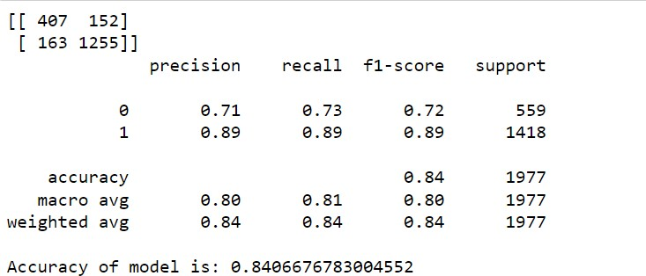

**Result:**

Hence, the logistic regression model is built, and the customer status is classified.

|  |  |
| --- | --- |
| **Ex. No: 3** | **Decision Tree from scratch** |
| **Date: 13-01-2023** |

# Aim:

To build a decision tree classifier from scratch.

# Algorithm:

* Import the necessary modules and the csv file.
* Fill the null values present in the data and pre-process the data.
* Create a class and define the functions for building the tree, calculating information gain and gini index, print the tree, fit and predict the values.
* Split the data into train and test data using train test split.
* Create a object for Decision Tree Classifier and fit the model.
* Predict the values using the test data and print the accuracy score.

# Program:

import numpy as np import pandas as pd

df=pd.read_csv('classification.csv') df.head()

class Node():

def

init (self,feature_index=None,threshold=None,left=None,right=None,i nfo_gain=None,value=None):

self.feature_index=feature_index self.threshold=threshold self.left=left

self.right=right self.info_gain=info_gain

self.value=value

class DecisionTreeClassifier():

def

init (self, min_samples_split=2, max_depth=2): self.root = None

self.min_samples_split = min_samples_split self.max_depth = max_depth

def build_tree(self, dataset, curr_depth=0): X, Y = dataset[:,:-1], dataset[:,-1]

num_samples, num_features = np.shape(X) if num_samples>=self.min_samples_split and

curr_depth<=self.max_depth:

best_split = self.get_best_split(dataset, num_samples, num_features)

if best_split["info_gain"]>0: left_subtree =

self.build_tree(best_split["dataset_left"], curr_depth+1) right_subtree =

self.build_tree(best_split["dataset_right"], curr_depth+1) return Node(best_split["feature_index"],

best_split["threshold"],left_subtree, right_subtree, best_split["info_gain"])

leaf_value = self.calculate_leaf_value(Y) return Node(value=leaf_value)

def get_best_split(self, dataset, num_samples, num_features): best_split = {}

max_info_gain = -float("inf")

for feature_index in range(num_features): feature_values = dataset[:, feature_index] possible_thresholds = np.unique(feature_values) for threshold in possible_thresholds:

dataset_left, dataset_right = self.split(dataset, feature_index, threshold)

if len(dataset_left)>0 and len(dataset_right)>0:

y, left_y, right_y = dataset[:, -1], dataset_left[:,

-1], dataset_right[:, -1]

curr_info_gain = self.information_gain(y, left_y,

right_y, "gini")

if curr_info_gain>max_info_gain: best_split["feature_index"] = feature_index best_split["threshold"] = threshold best_split["dataset_left"] = dataset_left best_split["dataset_right"] = dataset_right best_split["info_gain"] = curr_info_gain max_info_gain = curr_info_gain

return best_split

def split(self, dataset, feature_index, threshold): dataset_left = np.array([row for row in dataset if

row[feature_index]<=threshold])

dataset_right = np.array([row for row in dataset if row[feature_index]>threshold])

return dataset_left, dataset_right

def information_gain(self, parent, l_child, r_child,mode='gini'): weight_l = len(l_child) / len(parent)

weight_r = len(r_child) / len(parent) if mode=="gini":

gain = self.gini_index(parent) - (weight_l*self.gini_index(l_child) + weight_r*self.gini_index(r_child))

else:

gain = self.entropy(parent) - (weight_l*self.entropy(l_child)

+ weight_r*self.entropy(r_child)) return gain

def gini_index(self, y): class_labels = np.unique(y) gini = 0

for cls in class_labels:

p_cls = len(y[y == cls]) / len(y) gini += p_cls**2

return 1 - gini

def calculate_leaf_value(self, Y): Y = list(Y)

return max(Y, key=Y.count)

def print_tree(self, tree=None, indent=" "): if not tree:

tree = self.root

if tree.value is not None: print(tree.value)

else:

print("X_"+str(tree.feature_index), "<=", tree.threshold, "?", tree.info_gain)

print("%sleft:" % (indent), end="") self.print_tree(tree.left, indent + indent) print("%sright:" % (indent), end="") self.print_tree(tree.right, indent + indent)

def fit(self, X, Y):

dataset = np.concatenate((X, Y), axis=1) self.root = self.build_tree(dataset)

def predict(self, X):

preditions = [self.make_prediction(x, self.root) for x in X] return preditions

def make_prediction(self, x, tree):

if tree.value!=None: return tree.value feature_val = x[tree.feature_index] if feature_val<=tree.threshold:

return self.make_prediction(x, tree.left) else:

return self.make_prediction(x, tree.right) x=df.iloc[:,:-1].values

y=df.iloc[:,-1].values.reshape(-1,1)

from sklearn.model_selection import train_test_split x_train,x_test,y_train,y_test=train_test_split(x,y,random_state=42,test_s

ize=0.3) tree=DecisionTreeClassifier(min_samples_split=3) tree.fit(x_train,y_train)

tree.print_tree()

y_pred=tree.predict(x_test)

from sklearn.metrics import accuracy_score accuracy_score(y_pred,y_test)

# Output Screenshot:

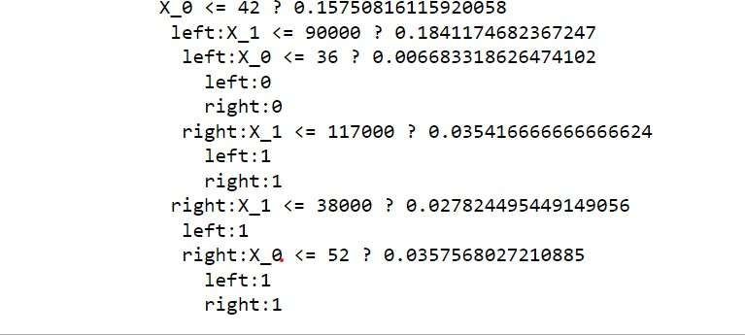

**Result:**

Hence, the decision tree classifier is built from scratch and the purchased status is classified.

|  |  |
| --- | --- |
| **Ex. No: 4** | **Hyper parameter Tuning** |
| **Date: 20-01-2023** |

# Aim:

To build an hyperparameter tuning model using grid search and random search.

# Algorithm:

* Import the necessary modules and the csv file.
* Fill the null values present in the data and pre-process the data.
* Split the data into train and test data using train test split.
* Import GridSearchCV and RandomSearchCV and declare the parameters for each model.
* Train the model with the predicted values and predict the values and print the accuracy score.

# Program:

import numpy as np import pandas as pd

import matplotlib.pyplot as plt import warnings warnings.filterwarnings('ignore')

df=pd.read_csv('Telco-Customer-Churn.csv') df.head()

df.info() df.describe()

df.drop('customerID',inplace=True,axis=1)

df['TotalCharges']=df['TotalCharges'].apply(pd.to_numeric,errors='coerce'

)

df.isnull().sum() import seaborn as sns

sns.kdeplot(df['TotalCharges']) print(df['TotalCharges'].mean(),df['TotalCharges'].median())

df['TotalCharges'].fillna(df['TotalCharges'].mean(),inplace=True) a=df.select_dtypes(include='object')

for i in a:

print(i,':',df[i].unique())

df['MultipleLines']=df['MultipleLines'].replace('No phone service','No') df['OnlineBackup']=df['OnlineBackup'].replace('No internet service','No') df['OnlineSecurity']=df['OnlineSecurity'].replace('No internet

service','No') df['DeviceProtection']=df['DeviceProtection'].replace('No internet

service','No')

df['StreamingTV']=df['StreamingTV'].replace('No internet service','No') df['TechSupport']=df['TechSupport'].replace('No internet service','No') df['StreamingMovies']=df['StreamingMovies'].replace('No internet

service','No')

from sklearn.preprocessing import LabelEncoder,StandardScaler le=LabelEncoder()

a=a.columns

df[a]=df[a].apply(lambda x : le.fit_transform(x)) df.info()

x=df.iloc[:,:-1].values

y=df.iloc[:,-1].values

from sklearn.model_selection import train_test_split x_train,x_test,y_train,y_test=train_test_split(x,y,test_size=0.3,random_s

tate=42)

s=StandardScaler() x_train=s.fit_transform(x_train) x_test=s.transform(x_test)

## KNN

from sklearn.model_selection import GridSearchCV,RandomizedSearchCV from sklearn.neighbors import KNeighborsClassifier

knn=KNeighborsClassifier() knn.fit(x_train,y_train)

knn_p={'n_neighbors':np.arange(1,50)} print("Grid Search:")

grid_knn=GridSearchCV(knn,knn_p,scoring='accuracy',cv=9,n_jobs=-1) grid_knn.fit(x_train,y_train)

print(grid_knn.best_params_) print(grid_knn.best_score_)

print("\nRandomized Search:") rand_knn=RandomizedSearchCV(knn,knn_p,scoring='accuracy',cv=9,n_jobs=-1)

rand_knn.fit(x_train,y_train) print(rand_knn.best_params_) print(rand_knn.best_score_)

from sklearn.metrics import accuracy_score y_pred=knn.predict(x_test) y_pred_grid=grid_knn.predict(x_test) y_pred_rand=rand_knn.predict(x_test)

print("Normal KNN:",accuracy_score(y_pred,y_test)) print("Grid Search KNN:",accuracy_score(y_pred_grid,y_test))

print("Random Search KNN:",accuracy_score(y_pred_rand,y_test)) ## Logistic Regression

from sklearn.linear_model import LogisticRegression

lr=LogisticRegression() lr.fit(x_train,y_train)

lr_params={'solver':['newton-cg','lbfgs','sag'],'C':np.logspace(-

3,2.45,7),'penalty':['l1','l2']}

print("Grid Search:") grid_lr=GridSearchCV(lr,lr_params,scoring='accuracy',cv=9,n_jobs=-1) grid_lr.fit(x_train,y_train)

print(grid_lr.best_params_) print(grid_lr.best_score_)

print("\nRandomized Search:") rand_lr=RandomizedSearchCV(lr,lr_params,scoring='accuracy',cv=9,n_jobs=-

1)

rand_lr.fit(x_train,y_train) print(rand_lr.best_params_) print(rand_lr.best_score_)

y_pred=lr.predict(x_test) y_pred_grid=grid_lr.predict(x_test) y_pred_rand=rand_lr.predict(x_test)

print("Normal Logistic Regression:",accuracy_score(y_pred,y_test)) print("Grid Search Logistic

Regression:",accuracy_score(y_pred_grid,y_test)) print("Random Search Logistic

Regression:",accuracy_score(y_pred_rand,y_test)) ## Naive Bayes Classification

from sklearn.naive_bayes import GaussianNB

gnb=GaussianNB() gnb.fit(x_train,y_train)

gnb_params={'var_smoothing':np.logspace(5,-7,79)} print("Grid Search:")

grid_gnb=GridSearchCV(gnb,gnb_params,scoring='accuracy',cv=9,n_jobs=-1)

grid_gnb.fit(x_train,y_train) print(grid_gnb.best_params_) print(grid_gnb.best_score_)

print("\nRandomized Search:") rand_gnb=RandomizedSearchCV(gnb,gnb_params,scoring='accuracy',cv=9,n_jobs

=-1)

rand_gnb.fit(x_train,y_train) print(rand_gnb.best_params_) print(rand_gnb.best_score_)

y_pred=gnb.predict(x_test) y_pred_grid=grid_gnb.predict(x_test) y_pred_rand=rand_gnb.predict(x_test)

print("Normal Naive Bayes:",accuracy_score(y_pred,y_test)) print("Grid Search Naive Bayes:",accuracy_score(y_pred_grid,y_test))

print("Random Search Naive Bayes:",accuracy_score(y_pred_rand,y_test)) ## Decision Trees

from sklearn.tree import DecisionTreeClassifier dtc=DecisionTreeClassifier() dtc.fit(x_train,y_train)

dtc_params={'criterion':['gini','entropy'],'max_depth':np.arange(1,20),'m in_samples_split':np.arange(1,10)

,'max_features':np.arange(1,7)}

print("Grid Search:") grid_dtc=GridSearchCV(dtc,dtc_params,scoring='accuracy',cv=9,n_jobs=-1) grid_dtc.fit(x_train,y_train)

print(grid_dtc.best_params_) print(grid_dtc.best_score_)

print("Randomized Search:") rand_dtc=RandomizedSearchCV(dtc,dtc_params,scoring='accuracy',cv=9,n_jobs

=-1)

rand_dtc.fit(x_train,y_train) print(grid_dtc.best_params_)

print(grid_dtc.best_score_)

y_pred=dtc.predict(x_test) y_pred_grid=grid_dtc.predict(x_test) y_pred_rand=rand_dtc.predict(x_test)

print("Normal Decision Tree:",accuracy_score(y_pred,y_test)) print("Grid Search Decision Tree:",accuracy_score(y_pred_grid,y_test)) print("Random Search Decision Tree:",accuracy_score(y_pred_rand,y_test))

## Support Vector Machines

from sklearn.svm import SVC

svc=SVC() svc.fit(x_train,y_train)

svc_params={'C':[0.1,1,10,100],'gamma':[0.1,0.001,0.01,0.001],'kernel':['

poly','sigmoid','rbf']}

print("Grid Search:") grid_svc=GridSearchCV(svc,svc_params,scoring='accuracy',cv=9,n_jobs=-1) grid_svc.fit(x_train,y_train)

print(grid_svc.best_params_) print(grid_svc.best_score_)

print("\nRandomized Search:") rand_svc=RandomizedSearchCV(svc,svc_params,scoring='accuracy',cv=9,n_jobs

=-1)

rand_svc.fit(x_train,y_train) print(rand_svc.best_params_) print(rand_svc.best_score_)

y_pred=svc.predict(x_test) y_pred_grid=grid_svc.predict(x_test) y_pred_rand=rand_svc.predict(x_test)

print("Normal Support Vector Machines:",accuracy_score(y_pred,y_test)) print("Grid Search Decision Tree:",accuracy_score(y_pred_grid,y_test)) print("Random Search Decision Tree:",accuracy_score(y_pred_rand,y_test))

# Output Screenshot:

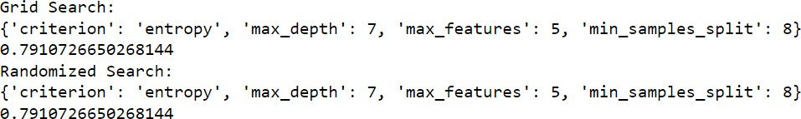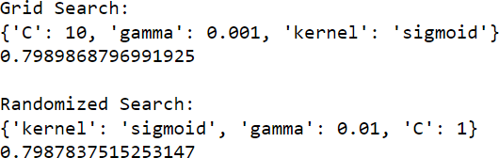

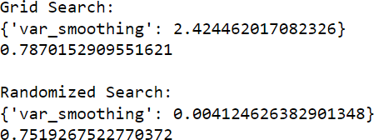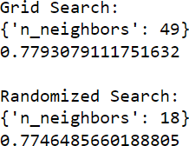

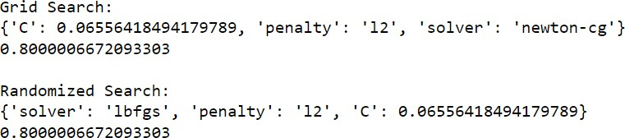

**Result:**

Hence, parameters for each classification model are selected using Grid Search and Random Search.

|  |  |
| --- | --- |
| **Ex. No: 5** | **Ensemble methods** |
| **Date: 27-01-2023** |

# Aim:

To build an ensemble of classification models.

# Algorithm:

* Import the necessary modules and the csv file.
* Fill the null values present in the data and pre-process the data.
* Split the data into train and test data using train test split.
* Create 5 bags consisting of Logistic regression, K-Nearest Neighbours, Naïve bayes, Decision Tree and Support Vector Machines and predict the classes.
* Create a separate data frame consisting of the predicted values for each model and use max voting to predict the appropriate final class.

# Program:

import numpy as np import pandas as pd import warnings

warnings.filterwarnings('ignore') df=pd.read_csv('telecom_customer_churn.csv') df.head()

df.info()

df.drop(['Churn Category','Churn Reason'],axis=1,inplace=True) df.drop(['Customer ID','City'],axis=1,inplace=True) df['Offer'].value_counts().index[0]

obj_col=df.select_dtypes(include='object') for i in obj_col:

df[i].fillna(method='ffill',inplace=True)

for i in obj_col: print(i,":",df[i].unique())

df_obj=pd.DataFrame()

from sklearn.preprocessing import LabelEncoder le=LabelEncoder()

for i in obj_col: df[i]=le.fit_transform(obj_col[i])

df.drop(['Latitude','Longitude','Zip Code'],inplace=True,axis=1) df['Avg Monthly GB Download']=df['Avg Monthly GB

Download'].fillna(value=df['Avg Monthly GB Download'].mean()) df['Avg Monthly Long Distance Charges']=df['Avg Monthly Long Distance

Charges'].fillna(value=df['Avg Monthly Long Distance Charges'].mean())

x=df.iloc[:,:-1]

y=df.iloc[:,-1]

from sklearn.model_selection import train_test_split x_train,x_test,y_train,y_test=train_test_split(x,y,test_size=0.3)

x_train.reset_index(inplace=True,drop=True) y_train.reset_index(inplace=True,drop=True)

x_train.columns x_train.info()

b1_x_train=x_train.sample(n=992) b1_y_train=y_train[b1_x_train.index]

b2_x_train=x_train.sample(n=992) b2_y_train=y_train[b2_x_train.index]

b3_x_train=x_train.sample(n=992) b3_y_train=y_train[b3_x_train.index]

b4_x_train=x_train.sample(n=992) b4_y_train=y_train[b4_x_train.index]

b5_x_train=x_train.sample(n=644) b5_y_train=y_train[b5_x_train.index]

## Logistic Regression -Bag 1

from sklearn.linear_model import LogisticRegression from sklearn.model_selection import GridSearchCV

lr=LogisticRegression() lr.fit(b1_x_train,b1_y_train)

lr_params={'solver':['newton-cg','lbfgs','sag'],'C':np.logspace(-

10,2.45,10),'penalty':['l1','l2']}

print("Grid Search:") grid_lr=GridSearchCV(lr,lr_params,scoring='accuracy',cv=9,n_jobs=-1) grid_lr.fit(b1_x_train,b1_y_train)

print(grid_lr.best_score_)

## KNN-Bag 2

from sklearn.neighbors import KNeighborsClassifier

knn=KNeighborsClassifier() knn.fit(b2_x_train,b2_y_train)

knn_p={'n_neighbors':np.arange(1,50)}

grid_knn=GridSearchCV(knn,knn_p,scoring='accuracy',cv=9,n_jobs=-1) grid_knn.fit(b2_x_train,b2_y_train)

print(grid_knn.best_score_)

## Naive Bayes-Bag 3

from sklearn.naive_bayes import GaussianNB

gnb=GaussianNB() gnb.fit(b3_x_train,b3_y_train)

gnb_params={'var_smoothing':np.logspace(5,-7,79)}

grid_gnb=GridSearchCV(gnb,gnb_params,scoring='accuracy',cv=9,n_jobs=-1) grid_gnb.fit(b3_x_train,b3_y_train)

print(grid_gnb.best_score_)

## Decision Tree-Bag 4

from sklearn.tree import DecisionTreeClassifier dtc=DecisionTreeClassifier() dtc.fit(b4_x_train,b4_y_train)

dtc_params={'criterion':['gini','entropy'],'max_depth':np.arange(1,20),'m in_samples_split':np.arange(1,10)

,'max_features':np.arange(1,7)} grid_dtc=GridSearchCV(dtc,dtc_params,scoring='accuracy',cv=9,n_jobs=-1)

grid_dtc.fit(b4_x_train,b4_y_train) print(grid_dtc.best_score_)

## Support Vector Machine-Bag 5 from sklearn.svm import SVC

from sklearn.metrics import accuracy_score svc=SVC()

svc.fit(b5_x_train,b5_y_train) print(accuracy_score(svc.predict(x_test),y_test)) print()

predicted_data=pd.DataFrame()

predicted_data['Logistic Regression']=grid_lr.predict(x_test) predicted_data['KNN']=grid_knn.predict(x_test) predicted_data['Naive Bayes']=grid_gnb.predict(x_test) predicted_data['Decision Tree']=grid_dtc.predict(x_test) predicted_data['Support Vector Machines']=svc.predict(x_test)

predicted_data

for i in predicted_data: print(i)

df1=predicted_data.iloc[0] l=[]

for i in range(0,len(predicted_data)):

c=d=0 pred=0

for i in predicted_data.iloc[i]: if i==0:

c+=1

elif i==1:

d+=1

if c>d:

pred=0 elif d>c:

pred=1 l.append(pred)

predicted_data predicted_data['Final']=l

from sklearn.metrics import accuracy_score print(accuracy_score(predicted_data['Final'],y_test))

# Output Screenshot:

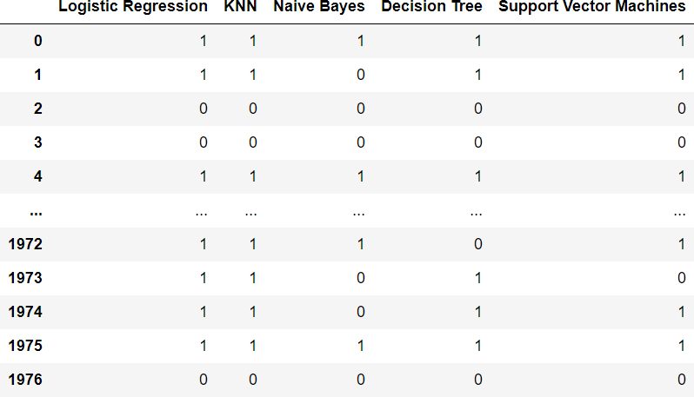

**Result:**

Hence, using ensemble methods of 5 classification models, churn is classified.

|  |  |
| --- | --- |
| **Ex. No: 6** | **K Means Clustering** |
| **Date: 03-02-2023** |

# Aim:

To build a clustering model using K-Means algorithm.

# Algorithm:

* Import the necessary modules and the csv file.
* Fill the null values present in the data and pre-process the data.
* Find the optimal number of clusters using WCSS graph.
* Retrain the model with the optimal number of clusters and predict the labels of each data point.
* Visualize the clusters in 3-dimensional using mpl_toolkits and print the silhouette score.

# Program:

import numpy as np import pandas as pd import seaborn as sns import warnings

import matplotlib.pyplot as plt warnings.filterwarnings('ignore') ### IRIS dataset df=sns.load_dataset('iris') df.head()

sns.pairplot(df) dataset=df.iloc[:,[1,2,3]].values from sklearn.cluster import KMeans wcss=[]

for i in range(1,15): km=KMeans(n_clusters=i,random_state=42) km.fit(dataset) wcss.append(km.inertia_)

plt.plot(range(1,15),wcss) km=KMeans(n_clusters=3,random_state=42) y=km.fit_predict(dataset)

y

%matplotlib widget

from mpl_toolkits.mplot3d import Axes3D

fig=plt.figure() #ax=fig.add_subplot(111,projection='3d') ax=Axes3D(fig)

ax.scatter(dataset[y==0,0],dataset[y==0,1],dataset[y==0,2],c='red',label= 'Cluster-1')

ax.scatter(dataset[y==1,0],dataset[y==1,1],dataset[y==1,2],c='green',labe l='Cluster-2')

ax.scatter(dataset[y==2,0],dataset[y==2,1],dataset[y==2,2],c='blue',label

='Cluster-3')

ax.scatter(km.cluster_centers_[:,0],km.cluster_centers_[:,1],km.cluster_c enters_[:,2],c='black',s=100,depthshade=False)

ax.set_xlabel('sepal_width') ax.set_ylabel('petal_length') ax.set_zlabel('petal_width') plt.legend(bbox_to_anchor=(1.05, 1), loc=2)

from sklearn.metrics import silhouette_score score=silhouette_score(dataset,y) print(score)

### data.csv df1=pd.read_csv('data.csv') df1.head() dataset1=df1.iloc[:,[2,3,4]].values from sklearn.cluster import KMeans wcss=[]

for i in range(1,15): km=KMeans(n_clusters=i,random_state=42) km.fit(dataset1) wcss.append(km.inertia_)

%matplotlib inline plt.plot(range(1,15),wcss) km1=KMeans(n_clusters=6,random_state=42) y1=km1.fit_predict(dataset1)

y1

%matplotlib widget

from mpl_toolkits.mplot3d import Axes3D

fig1=plt.figure() #ax=fig.add_subplot(111,projection='3d') ax=Axes3D(fig1)

ax.scatter(dataset1[y1==0,0],dataset1[y1==0,1],dataset1[y1==0,2],c='red', label='Cluster-1')

ax.scatter(dataset1[y1==1,0],dataset1[y1==1,1],dataset1[y1==1,2],c='green ',label='Cluster-2')

ax.scatter(dataset1[y1==2,0],dataset1[y1==2,1],dataset1[y1==2,2],c='blue'

,label='Cluster-3') ax.scatter(dataset1[y1==3,0],dataset1[y1==3,1],dataset1[y1==3,2],c='yello

w',label='Cluster-4') ax.scatter(dataset1[y1==4,0],dataset1[y1==4,1],dataset1[y1==4,2],c='magen

ta',label='Cluster-5') ax.scatter(dataset1[y1==5,0],dataset1[y1==5,1],dataset1[y1==5,2],c='orang

e',label='Cluster-6')

ax.scatter(km1.cluster_centers_[:,0],km1.cluster_centers_[:,1],km1.cluste r_centers_[:,2],c='black',s=100,depthshade=False)

ax.set_xlabel('Age') ax.set_ylabel('Annual Income') ax.set_zlabel('Spending Score')

plt.legend(bbox_to_anchor=(1.05, 1), loc=2)

from sklearn.metrics import silhouette_score score=silhouette_score(dataset1,y1)

print(score)

# Output Screenshot:

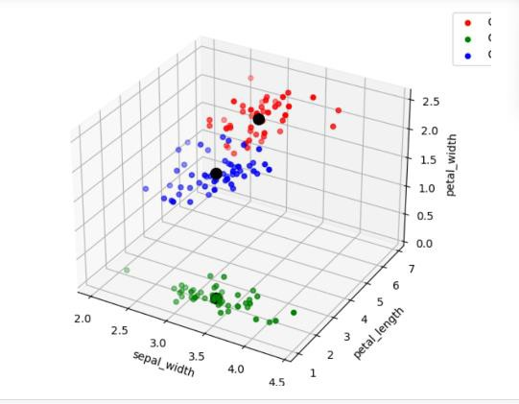

**Result:**

Hence, cluster classification model using K-Means is built and the labels of the data points are predicted.

|  |  |
| --- | --- |
| **Ex. No: 7** | **Principal Component Analysis** |
| **Date: 17-02-2023** |

# Aim:

To build a principal component analysis from scratch.

# Algorithm:

* Import the necessary modules and the necessary datasets.
* Fill the null values present in the data and pre-process the data.
* Normalize the data and compute the covariance matrix.
* Calculate the eigen values and eigen vectors of the covariance matrix.
* Reproject the data by scalar dot operation between the highest eigen vector and the normalized data i.e., mean is subtracted from all the data points.
* Calculate the variance and plot it using scree plot and select the number of features.

# Program:

import numpy as np import pandas as pd

from sklearn.datasets import load_digits

digit=load_digits() df=pd.DataFrame(digit.data) df.columns=digit.feature_names df

x=df mean_l=np.mean(x.T,axis=1) mean_l

x_center=x-mean_l x_center

q=[]

for i in df:

w=np.array(df[i]) q.append(w)

cov=np.cov(q,bias=False) cov

cov.shape eigen=np.linalg.eig(cov) eigen_values=eigen[0] eigen_vectors=eigen[1]

print("Eigen values:",eigen_values) print("Eigen vectors:",eigen_vectors) pca_x=eigen_vectors.T.dot(x_center.T) pca_x.T

df_pca=pd.DataFrame(pca_x.T)

df_pca eigen_value_max=np.sort(eigen_values)[-1] eigen_value_max eigen_vector_max=np.sort(eigen_vectors)[-1] eigen_vector_max pca1_x=eigen_vector_max.T.dot(x_center.T) pca1_x

df1_pca=pd.DataFrame(pca1_x) df1_pca

np.cumsum(pca1_x) np.cumsum(df_pca.iloc[:,:1])

# Output Screenshot:

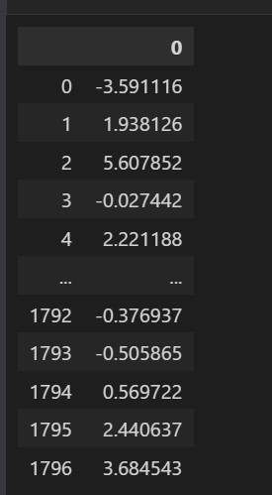

**Result:**

Hence, principal component analysis is built from scratch and the feature are selected.

|  |  |
| --- | --- |
| **Ex. No: 8** | **Recommendation System** |
| **Date: 3-03-2023** |

# Aim:

To build a content based and collaborative filter-based recommendation system.

# Algorithm:

* Import the necessary modules and the csv file.
* Fill the null values present in the data and pre-process the data.

# Content based recommendation system:

* Create a tfidf sparse matrix using TfidfVectorizer from sklearn library.
* Create a cosine similarity matrix using linear kernel function and store the keywords in a data frame.
* Create a user defined recommendation function to check if the keyword is present and sort the cosine similarity values and return the top recommended the top n items.

# Collaborative filter-based recommendation system:

* Create a csr matrix using the scipy module and use the nearest neighbours algorithm to fit the csr matrix.
* Find similar users using the nearest neighbour model trained with the csr matrix.
* Predict the rating a user would give to the item and recommend the top n-items.

# Program:

import numpy as np import pandas as pd

## Content based recommendation system df=pd.read_csv('result_final.csv') df.head()

df.info()

df.drop(columns=['Unnamed: 0.1','link','date'],axis=1,inplace=True) def string(x):

x=x[1:-1] s=''

for i in x.split(','): s+=i+','

return s df.fillna(method='ffill',inplace=True) df['keywords']=df['keywords'].agg(string)

from sklearn.feature_extraction.text import TfidfVectorizer tfidf=TfidfVectorizer(stop_words='english')

tfidf_mat=tfidf.fit_transform(df['keywords']) tfidf_mat

from sklearn.metrics.pairwise import linear_kernel

cosine_sim=linear_kernel(tfidf_mat,tfidf_mat) cosine_sim

df1=pd.DataFrame(pd.Series(df['keywords'],index=df.index)) df1

import re

def recomendation(x):

ind=df1[df1['keywords'].str.contains(x,flags=re.IGNORECASE,regex=True)

].index[0] sim_score=list(enumerate(cosine_sim[ind]))

sim_score=sorted(sim_score,key=lambda a:a[1],reverse=True) sim_score=sim_score[1:8]

final_ind=[i[0] for i in sim_score] return final_ind

r=input('Enter keyword for news title:') ind=recomendation(r)

print('Recommended news are:') for i in ind:

print('>>',df['title'][i],'\n \t>>>',df['title_summary'][i])

## Collaborative filtering recommendation system

df2=pd.read_csv('Netflix_Dataset_Movie.csv') df3=pd.read_csv('Netflix_Dataset_Rating.csv') df3.head() users=df3['User_ID'].unique().shape[0] movie=df3['Movie_ID'].unique().shape[0] df3.sort_values('User_ID',inplace=True) user_uni

df3

from sklearn.preprocessing import LabelEncoder

le=LabelEncoder() df3['User_ID']=le.fit_transform(df3['User_ID']) df3.sort_values('Movie_ID',inplace=True) df3['Movie_id']=le.fit_transform(df3['Movie_ID']) a=np.zeros((users,movie))

for i in df3.itertuples(): a[i[1]-1,i[4]-1]=i[2]

a

from scipy.sparse import csr_matrix sparse_matrix=csr_matrix(a)

from sklearn.neighbors import NearestNeighbors

nn=NearestNeighbors(n_neighbors=5,algorithm='brute',metric='cosine',n_job s=-1)

nn.fit(sparse_matrix) df3

data=df3.sort_values('User_ID',ascending=True) colab_filter=data[data['User_ID']==69].Movie_ID colab_filter=colab_filter.tolist() len(colab_filter)

item_id=[]

for i in colab_filter: dist,ind=nn.kneighbors(sparse_matrix[i],n_neighbors=5) ind=ind.flatten()

ind=ind[:1] item_id.extend(ind)

item_id=item_id[:10] item_id

df2

print("Movies recommended by User 69:") for i in item_id:

print(">>>>",df2['Name'][i-1])

# Output Screenshot:

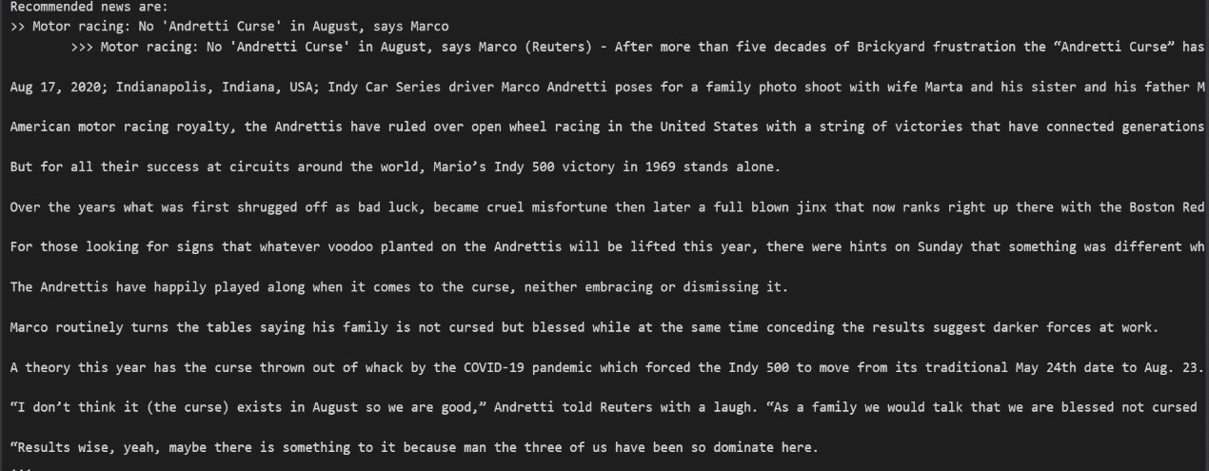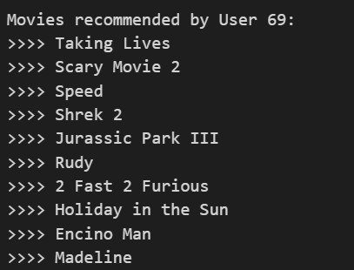

**Result:**

Hence, for the given keyword input the items are content based recommendations are recommended to the user and according to the given user collaborative filter-based recommendations are recommended.

|  |  |
| --- | --- |
| **Ex. No: 9** | **Neural Network** |
| **Date: 17-03-2023** |

# Aim:

To build a neural network using tensorflow and pytorch modules.

# Algorithm:

* Import the necessary modules and the csv file.
* Fill the null values present in the data and pre-process the data.
* Standardize the data using Standard Scalar from skleran.preprocessing module.

# Tensorflow neural network:

* Create the neural network by adding the layers and the activation functions of each layer.
* Compile the neural network and declare early stopping to avoid overtraining of the model.
* Fit the neural network and predict the values using validation data and print the classification report and confusion matrix.

# Pytorch neural network:

* Change the datatype of the train, test data and to torch datatypes and concert too tensor dataset.
* Create the neural network by adding the hidden layers and declare the optimizer and loss functions and train the network.
* Predict the values and print the accuracy of the network.

# Program:

import numpy as np import pandas as pd import seaborn as sns

import matplotlib.pyplot as plt df=pd.read_csv('Bank_Personal_Loan_Modelling.csv') df.head()

df.info() df.isnull().sum() df.duplicated().sum()

sns.countplot(x='Personal Loan',data=df) df.describe() df['Experience']=abs(df['Experience']) df['Annual_CCAvg']=df['CCAvg']*12

df.drop(['ID','ZIP Code','CCAvg'],axis=1,inplace=True) x=df.drop('Personal Loan',axis=1).values y=df['Personal Loan'].values.reshape(-1,1)

from sklearn.model_selection import train_test_split

x_train,x_test,y_train,y_test=train_test_split(x,y,test_size=0.3,random_s tate=42)

from sklearn.preprocessing import StandardScaler sc=StandardScaler() x_train=sc.fit_transform(x_train) x_test=sc.fit_transform(x_test)

from sklearn.decomposition import PCA

pca=PCA() x_train=pca.fit_transform(x_train) x_test=pca.fit_transform(x_test) np.cumsum(pca.explained_variance_ratio_) from sklearn.decomposition import PCA

pca=PCA(n_components=10) x_train=pca.fit_transform(x_train) x_test=pca.fit_transform(x_test) x_train.shape

## Using keras classification import tensorflow.keras

from tensorflow.keras.models import Sequential from tensorflow.keras.layers import Dense model=Sequential()

model.add(Dense(9,activation='relu')) model.add(Dense(5,activation='relu')) model.add(Dense(1,activation='sigmoid'))

model.compile(optimizer='adam',loss='categorical_crossentropy',metrics=[' accuracy']) model.fit(x_train,y_train,epochs=10,validation_data=(x_test,y_test),verbo se=1)

model_loss=pd.DataFrame(model.history.history) model_loss.plot()

model=Sequential()

model.add(Dense(9,activation='relu')) model.add(Dense(5,activation='relu')) model.add(Dense(1,activation='sigmoid'))

model.compile(optimizer='adam',loss='categorical_crossentropy',metrics=[' accuracy'])

from tensorflow.keras.callbacks import EarlyStopping early_stop=EarlyStopping(monitor='val_loss',mode='min',verbose=1,patience

=25)

model.fit(x_train,y_train,epochs=100,validation_data=(x_test,y_test),verb ose=1,callbacks=[early_stop]) model_loss=pd.DataFrame(model.history.history)

model_loss.plot() pred=model.predict(x_test)

threshold=0.5

pred=np.where(pred>threshold,1,0)

from sklearn.metrics import classification_report,confusion_matrix

print(confusion_matrix(y_test,pred)) print('\n') print(classification_report(y_test,pred)) ## Using PyTorch classification

import torch

import torch.nn as nn

from torch.optim import SGD

from torch.utils.data import TensorDataset,DataLoader x=df.drop('Personal Loan',axis=1).values y=df['Personal Loan'].values.reshape(-1,1)

from sklearn.model_selection import train_test_split x_train,x_test,y_train,y_test=train_test_split(x,y,test_size=0.3,random_s tate=42)

from sklearn.preprocessing import StandardScaler sc=StandardScaler() x_train=sc.fit_transform(x_train) x_test=sc.fit_transform(x_test) x_train=torch.tensor(x_train).to(torch.float32) x_test=torch.tensor(x_test).to(torch.float32) y_train=torch.tensor(y_train).to(torch.float32) y_test=torch.tensor(y_test).to(torch.float32) dataset=TensorDataset(x_train,y_train) data=DataLoader(dataset,batch_size=24,shuffle=True)

model=nn.Sequential(nn.Linear(11,8),nn.ReLU(),nn.Linear(8,4),nn.ReLU(),nn

.Linear(4,1),nn.Sigmoid()) model fn_loss=nn.BCELoss()

optimr=SGD(model.parameters(),lr=0.001) def train(model,epoch,data):

train_loss=[0]*epoch train_acc=[0]*epoch

for i in range(epoch):

for x_batch,y_batch in data:

pred=model(x_batch) loss=fn_loss(pred,y_batch)

loss.backward()

optimizer.step() optimizer.zero_grad()

train_loss[i]+=loss.item()*x_batch.size(0)

crt=(torch.where(model(x_batch)>=0.5,1,0)==y_batch).sum() train_acc[i]+=crt

train_loss[i] = train_loss[i]/len(data.dataset) train_acc[i]=train_acc[i]/len(data.dataset)

print(f'Epoch:{i+1}|Loss:{train_loss[i]}|Accuracy:{train_acc[i]}') return train_loss,train_acc

train_loss,train_acc=train(model,20,data) testdata=TensorDataset(x_test,y_test) tdata=DataLoader(testdata,batch_size=1500) with torch.no_grad():

for x_whole,y_whole in tdata: pred=model(x_whole)

crt_cnt=(torch.where(pred>=0.5,1,0)==y_whole).sum() print(f'Accuracy:{crt_cnt/len(tdata.dataset)}')

# Output Screenshot:

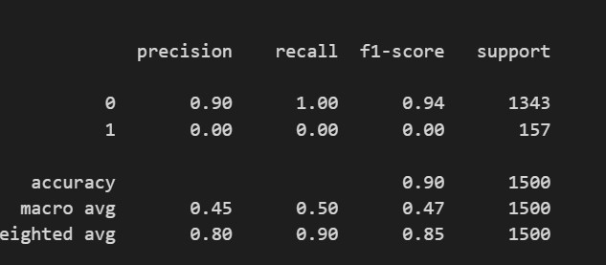

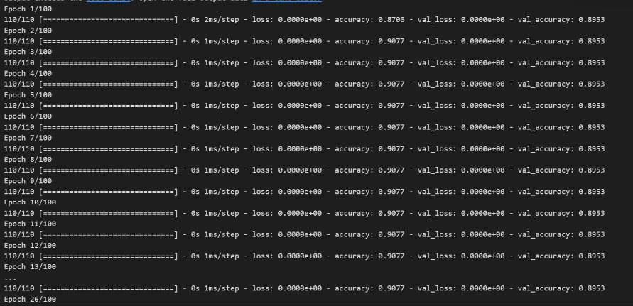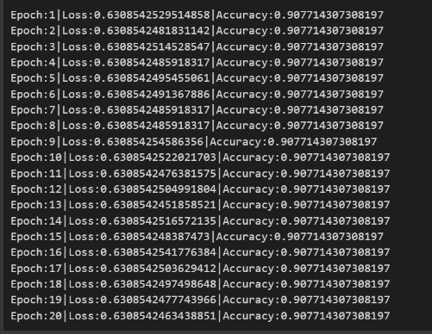

**Result:**

Hence, neural networks are built using tensorflow and pytorch and the data is classsified.

|  |  |
| --- | --- |
| **Ex. No: 10** | **Convolutional Neural Network** |
| **Date: 24-03-2023** |

# Aim:

To build a convolutional neural network using tensorflow for image classification.

# Algorithm:

* Import the necessary modules and the database.
* Label the images of each class and spilt the data into train and test data.
* Create the convolutional neural network by adding the layers of Conv2D and MaxPooling2D and the activation functions of each layer.
* Create an early stop to avoid overtraining of the model and compile the model and fit the model with training data.
* Predict the accuracy of the model using the test data and print the accuracy.

# Program:

import numpy as np import pandas as pd

import matplotlib.pyplot as plt import tensorflow as tf

from tensorflow.keras import datasets,layers,models (train_images,train_labels),(test_images,test_labels)=datasets.cifar10.lo ad_data()

train_images,test_images=train_images/255.0,test_images/255.0 class_names=['airplane','automobile','bird','cat','deer','dog','frog','ho rse','ship','truck']

plt.figure(figsize=(10,10)) for i in range(10):

plt.subplot(5,5,i+1)

plt.xticks([])

plt.yticks([]) plt.grid(False) plt.imshow(train_images[i])

plt.xlabel(class_names[train_labels[i][0]]) plt.show()

from keras.layers.core import Dense,Activation,Dropout,Flatten from tensorflow.keras.models import Sequential

from keras.layers.convolutional import Conv2D,MaxPooling2D model=Sequential()

model.add(Conv2D(32,(3,3),activation='relu',input_shape=(32,32,3)))

model.add(MaxPooling2D(2,2)) model.add(Conv2D(64,(3,3),activation='relu')) model.add(MaxPooling2D(2,2)) model.add(Conv2D(64,(3,3),activation='relu')) model.add(layers.Flatten()) model.add(Dense(128,activation='relu')) model.add(Dense(10))

model.summary()

from keras.callbacks import EarlyStopping early_stop=EarlyStopping(monitor='val_loss',mode='min',verbose=1,patience

=25)

model.compile(optimizer='adam',loss=tf.keras.losses.SparseCategoricalCros sentropy(from_logits=True),metrics=['accuracy']) history=model.fit(train_images,train_labels,epochs=30,validation_data=(te st_images,test_labels),callbacks=[early_stop]) plt.plot(history.history['accuracy'], label='accuracy') plt.plot(history.history['val_accuracy'], label='val_accuracy') plt.xlabel(['Epoch'])

plt.ylabel(['Accuracy']) plt.ylim([.5,1]) plt.legend(loc='lower right') **Output Screenshot:**

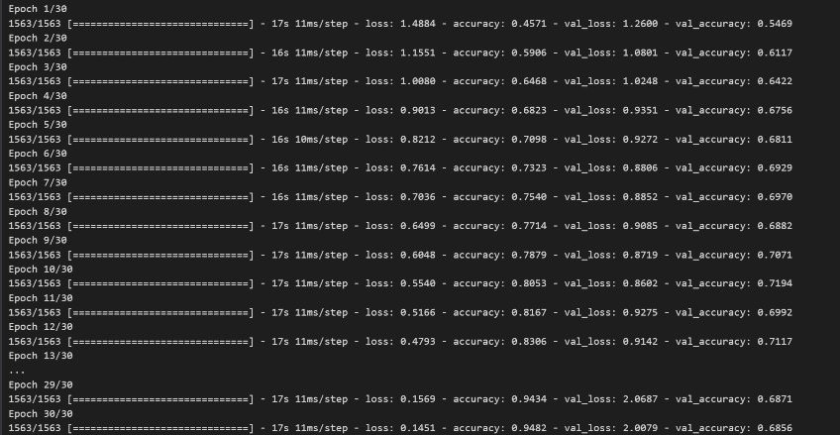

# Result:

Hence, the convolutional neural network is built, and the images are classified.

|  |  |
| --- | --- |
| **Ex. No: 11** | **MLOps-Using Flask** |
| **Date: 23-03-2023** |

# Aim:

To build a flask model that implements a recommendation system.

# Algorithm:

* Import the necessary modules and the necessary datasets.
* Fill the null values present in the data and pre-process the data.
* Create a recommendation model that receives user and input and recommends items and rename the file as model.py.
* Connect mysql using pymysql library to verify the login credentials.
* Create html page to display the output, receive input and a login page and render all the html pages using appropriate functions.
* Pass the input values to python from html to check the login credentials using sql.
* Pass the input for recommendation and print the recommendations in the html page.

# Program:

from flask import Flask,render_template,request import pickle

from model import Recommendation import pymysql as sql

app= Flask( name )

from flask import Flask, render_template, request

import numpy as np

import pickle

app = Flask(__name__)

model = pickle.load(open('model.pkl', 'rb'))

@app.route('/')

def index():

    return render_template('index.html')

@app.route('/predict', methods=['GET', 'POST'])

def predict():

    val1 = request.form['bedrooms']

    val2 = request.form['bathrooms']

    val3 = request.form['floors']

    val4 = request.form['yr_built']

    arr = np.array([val1, val2, val3, val4])

    arr = arr.astype(np.float64)

    pred = model.predict([arr])

    return render_template('index.html', data=int(pred))

if __name__ == '__main__':

    app.run(debug=True)

## Recommendation system:

import pandas as pd

from sklearn.model_selection import train_test_split

from sklearn.linear_model import LinearRegression

import pickle

df = pd.read_csv(r"C:\Users\rysha\Downloads\house_data.csv")

columns = ['bedrooms', 'bathrooms', 'floors', 'yr_built', 'price']

df = df[columns]

X = df.iloc[:, 0:4]

y = df.iloc[:, 4:]

X_train, X_test, y_train, y_test = train_test_split(X, y, test_size=0.25)

lr = LinearRegression()

lr.fit(X_train, y_train)

pickle.dump(lr, open('model.pkl', 'wb'))

import pickle rec=Recommendation()

pickle.dump(rec,open('model.pkl','wb'))

# Output Screenshot:

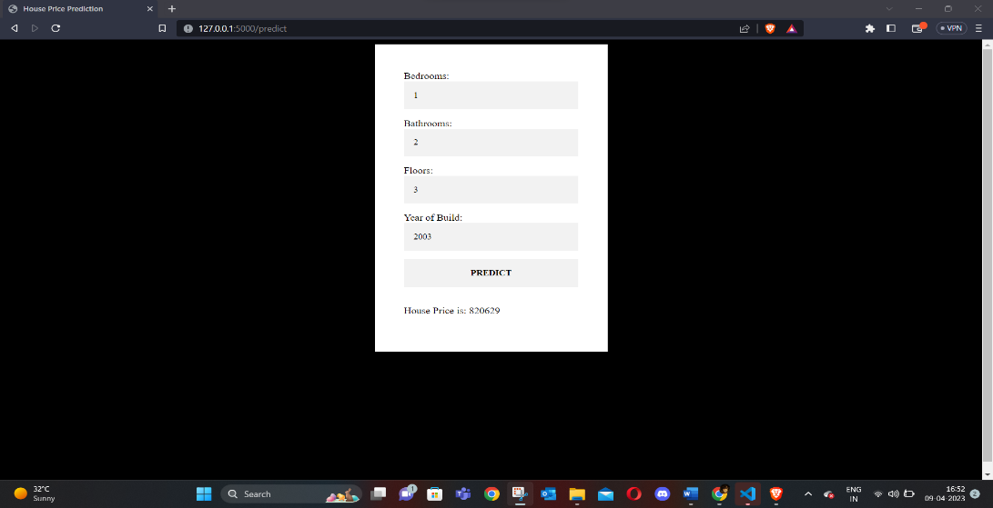

**Result:**

Hence, the recommendation system is built and implemented using flask.