PIE
PATENT INFORMATION EXTRACTION FORM
TOPIC: Smart IoT-Based Water Leakage Detection and Automatic Control System
SCHOOL: Chitkara University, Rajpura, Punjab
INVENTOR'S DETAIL WHO UPLOADED THE PATENT ON CHALKPAD
NAME: Prof. (Dr.) Darpan Anand
EMPLOYEE CODE: --
MOBILE NO: 70608 74708
MAIL ID (UNIVERSITY): darpan.anand@chitkara.edu.in
MAIL ID (PERSONAL): --

OTHER INVENTORS DETAIL
NAME | EMP CODE/ROLL | ADDRESS WITH EMAIL AND MOBILE NO.
Rythem Bangia | 2210990752 | House Number:- 1321 Sector:- 25 Panchkula , rythembangia2004@gmail.com  7533007700
Prof. (Dr.) Darpan Anand | -- | darpan.anand@chitkara.edu.in  7060874708

DESCRIPTION OF THE INVENTION
Q1. What was the problem?
Water leakage in residential and commercial buildings often remains undetected until significant damage has occurred — leading to water wastage, structural deterioration, electrical hazards, mold growth, and escalating maintenance costs. Traditional manual inspection methods are labour-intensive, unreliable, and cannot provide continuous monitoring. Basic alarm systems may sound an alert but lack automatic shutoff, remote access, and intelligent analysis. Industrial-grade leak detection solutions, while capable, are prohibitively expensive and complex for everyday residential use, creating a gap in affordable, fully automated water-leak protection.
Q2. How did you solve it (Inventive Step)?
We designed and implemented an end-to-end IoT Water Leak Detection and Automatic Response System that integrates three layers:
1. **Edge Layer (Raspberry Pi + Sensors + Actuators)** — Capacitive moisture sensors placed in critical zones continuously feed readings into a Raspberry Pi microcontroller. The Pi runs on-device AI (anomaly detection via rolling Z-score, trend prediction via linear regression, stuck-sensor detection, and a composite risk score) that operates entirely without internet. When moisture exceeds the configurable threshold, the Pi immediately closes a solenoid valve via a relay module, activates a piezo buzzer and status LED, and uploads the event to the cloud.
2. **Cloud Layer (Supabase Backend + Edge Functions)** — A PostgreSQL database (via Supabase) stores zones, devices, sensor readings (both physical and virtual), and leak events with millisecond-precision response times. A serverless Edge Function (`ai-hub`) provides multi-provider AI analysis (Gemini, Groq, or Puter — all free-tier LLMs) for incident briefs, risk prediction, emergency checklists, sensor health checks, threshold suggestions, and physical-vs-virtual data comparison. A separate Edge Function (`send-leak-alert`) dispatches email notifications via Resend.
3. **Application Layer (Expo React Native Mobile App)** — A cross-platform mobile app with four tabs (Monitor, Simulate, History, Settings) provides real-time zone monitoring, a full visual simulation of the leak detection pipeline (Flow → Detect → MCU → Cloud → Valve → Alarm → Email → AI → Done), historical event browsing with AI-powered summaries, and complete system configuration. A live Raspberry Pi status panel shows hardware connectivity, physical readings, and pipeline state in real time.
The inventive step lies in combining on-device edge AI for sub-second local response with cloud-based multi-provider AI for deeper analysis, a full virtual simulation mode for testing without hardware, and seamless bridging between physical and virtual sensor data through a single unified backend — all at residential-affordable cost.
Q3. What were the other possible solutions and why they could not be done?
Various alternative approaches to water leak detection exist, but each has significant limitations. Manual inspection methods are unreliable, time-consuming, and fail to provide continuous 24/7 monitoring, allowing leaks—especially during nighttime or absence—to go unnoticed. Basic alarm systems, such as buzzer-only setups, can alert occupants but lack automatic water shutoff capabilities, meaning damage continues until manual intervention occurs, and they typically do not support remote notifications. Industrial leak detection systems offered by companies like Honeywell and Siemens are highly effective but prohibitively expensive, often costing between $500 and $5,000 per zone, and require professional installation, proprietary protocols, and ongoing maintenance, making them impractical for residential use. Flow-meter-based systems can detect abnormal water usage but cannot accurately pinpoint the location of a leak and are prone to false alarms during normal high-consumption activities such as showers or laundry. Smart home hubs using technologies like Z-Wave sensors integrated with platforms such as Google Home can detect and notify users of leaks but still rely on human intervention to shut off water and lack advanced features like automated valve control, AI-driven analysis, and simulation capabilities. Lastly, cloud-only AI solutions depend entirely on internet connectivity, meaning that any network outage during a leak event can result in complete system failure with no local intelligence or response capability.

Q4. What are the advantages of the solution proposed by you?
The proposed system offers several significant advantages over existing solutions. It enables a sub-second local response through on-device AI running on the Raspberry Pi, which detects anomalies and triggers valve closure in under one second without relying on cloud communication. The system ensures automatic water shutoff using a solenoid valve, thereby preventing damage without requiring human intervention. Its dual AI architecture combines edge AI—responsible for anomaly detection, trend prediction, and risk scoring even in offline conditions—with cloud-based AI that provides advanced incident analysis, risk assessment, and emergency response guidance when connectivity is available.

Additionally, the system supports multi-zone monitoring, allowing deployment across multiple rooms or areas with independent thresholds and valve controls. A cross-platform mobile application provides real-time remote monitoring, displaying live moisture levels, valve status, leak history, and hardware connectivity. The solution also integrates push notifications and email alerts, ensuring immediate communication of leak events with critical details such as location, moisture level, and response time.

A key innovation is the inclusion of a full virtual simulation mode, enabling users to test the complete detection pipeline without requiring physical hardware. The system also bridges physical and virtual data through a unified cloud backend, allowing consistent processing and AI-based comparison of both data sources. From a cost perspective, it is highly economical, utilizing affordable commodity hardware to keep the total cost under $100 per zone—significantly lower than industrial alternatives.
Furthermore, the solution is energy efficient, with minimal power consumption, and is designed for easy installation without the need for soldering or specialized technical skills. It maintains comprehensive historical records of all events, including timestamps, moisture readings, response times, and notification status, which are analyzed using AI to identify patterns and recurring issues. Finally, the system is open and extensible, built on an open-source technology stack, making it adaptable for future enhancements, additional sensors, and custom integrations.

Q5. Explain the stepwise working of the innovation (components and specific functions)

Step 1 — Sensing

- Capacitive moisture sensors installed in critical zones (kitchen, bathroom, basement, laundry, etc.)
- Sensors connected to ADS1115 16-bit ADC module
- ADC interfaces with Raspberry Pi via I2C
- Continuous moisture measurement (0–100%)
- Calibration using dry-air and submerged baselines
- Mock sensor driver generates synthetic test data (drift + spike simulation)
Step 2 — On-Device AI Processing (Edge AI)

- All readings processed locally on Raspberry Pi (local_ai.py)
- Anomaly detection using rolling Z-score (default window: 60 readings)
- Flags values greater than 2.5 standard deviations from mean
- Trend prediction using linear regression (last 30 readings, % per minute)
- Trend classification: rising_fast, rising, stable, falling, falling_fast
- Stuck sensor detection for 20 or more identical consecutive readings
- Composite risk score (0–100) based on:
  - Threshold proximity (40 points)
  - Anomaly status (20 points)
  - Trend direction (15 points)
  - Sensor health (15 points)
- Risk levels mapped to low, medium, high, critical

Step 3 — Local Alarm
- Triggered immediately when moisture exceeds threshold
- Piezo buzzer (GPIO 27) beeps at 3 Hz for 5 seconds
- Status LED (GPIO 22) fast blinks (150 ms) for 10 seconds
- LED returns to steady ON after alert
- Activation occurs within milliseconds before cloud interaction
Step 4 — Automatic Valve Shutoff
- GPIO 17 sends LOW signal to relay module
- Relay controls 12V solenoid valve
- Valve switches from normally open to closed
- Water flow stops immediately in affected zone
- Valve remains closed until manually reset via app
Step 5 — Cloud Sync and Leak Event Logging
- Raspberry Pi calls Supabase submit_sensor_reading RPC
- Reading stored in sensor_readings table
- Zone state updated (moisture and valve status)
- Leak event created if threshold exceeded and valve was open
- Event logs include moisture_at_trigger, valve_closed_at, response_ms
- Authentication via user JWT or device UUID secret
Step 6 — Email Notification
- send-leak-alert Edge Function triggered on leak event
- Email sent via Resend API
- Includes:
  - Zone name and location
  - Moisture level
  - Response time
  - Inspection and reset instructions
Step 7 — Cloud AI Analysis
- ai-hub Edge Function with multi-provider fallback (Gemini, Groq, Puter)
- Generates:
  - Incident brief
  - Risk prediction (low to critical)
  - Estimated damage and recurrence likelihood
  - Emergency checklist (5–8 steps)
  - Sensor health analysis
  - Threshold recommendations
  - Physical vs virtual data comparison
Step 8 — Mobile App Monitoring and Control
- Built using Expo React Native
- Monitor tab:
  - Real-time moisture, threshold, valve state
  - Room selection and AI-based tips
- Simulate tab:
  - Full 8-step pipeline visualization
  - Animated flow and AI analysis
  - Raspberry Pi hardware status panel
- History tab:
  - Leak event timeline
  - Moisture, response time, email status
  - AI-powered summaries and pattern detection
- Settings tab:
  - Email configuration
  - AI setup
  - System validation
Step 9 — Reset and Return to Normal
- User taps “Reset valve” in mobile app
- Calls reset_zone_valve RPC
- Solenoid valve reopens
- Moisture state cleared
- System resumes continuous monitoring mode

Summary:
These components collectively perform the sequence:
Sense → Edge AI → Alarm → Valve Shutoff → Cloud Sync → Email → Cloud AI → App Monitor → Reset

Q6. Drawing (computer-made) — all main components
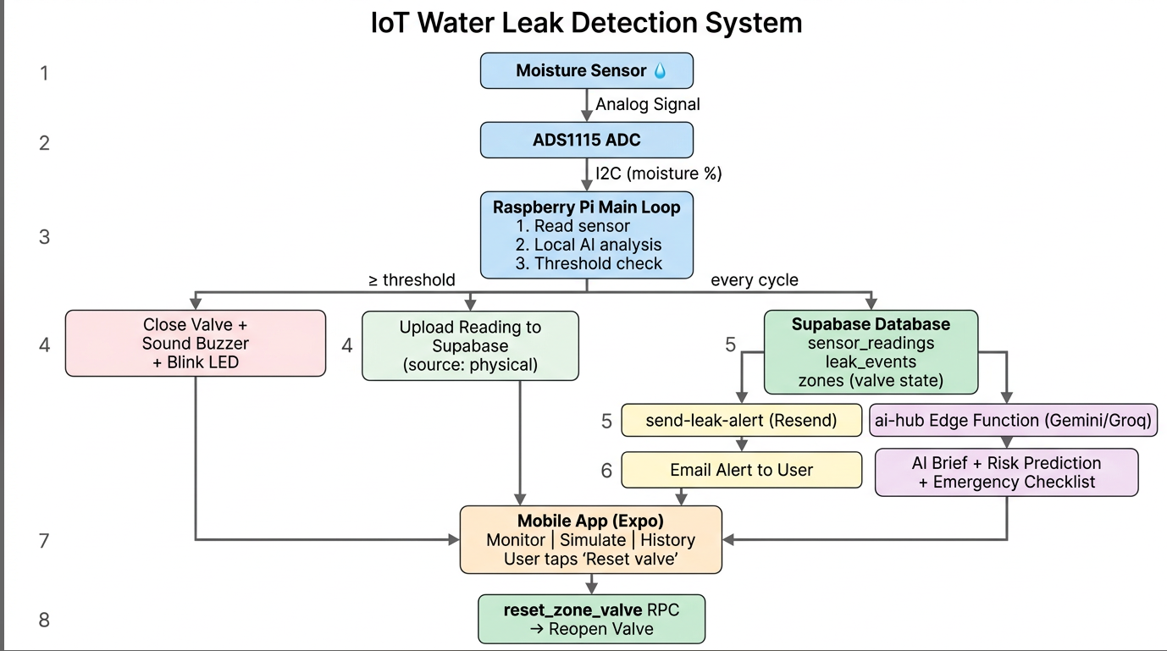
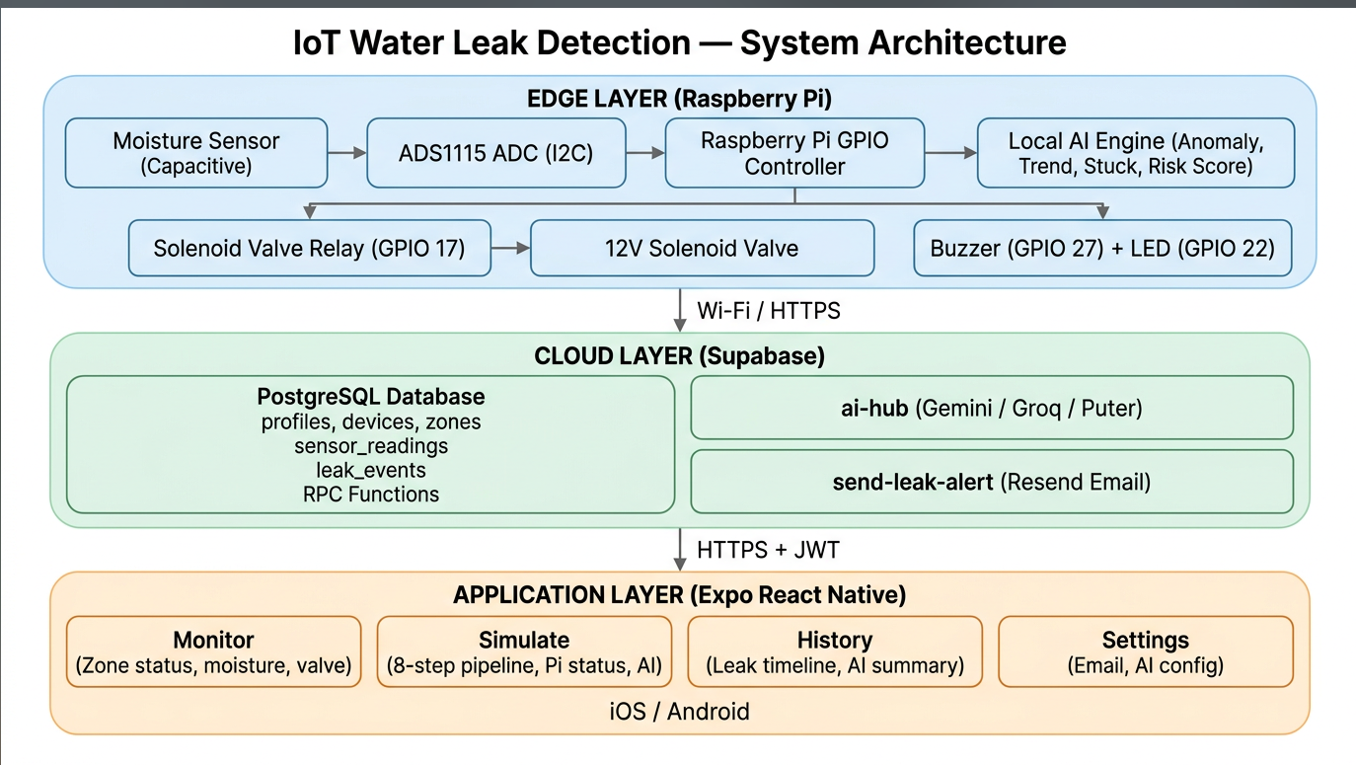

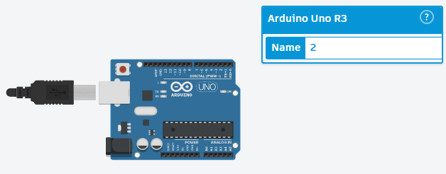
Arduino Uno R3

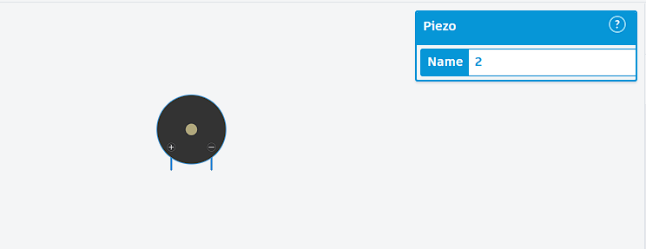
Piezo

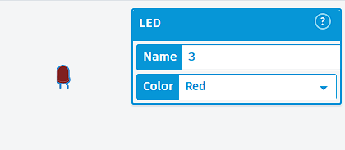
Led * 3
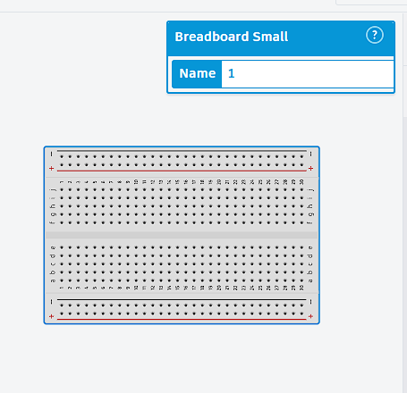
Breadboard

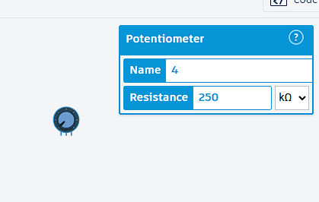
Potentiometer

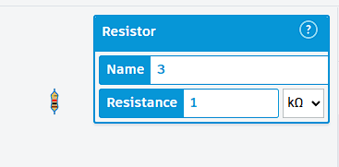
Resistor
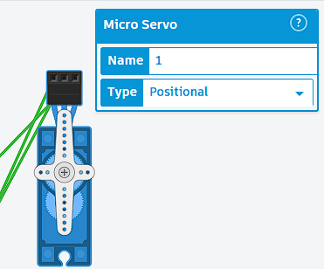
Solenoid Value
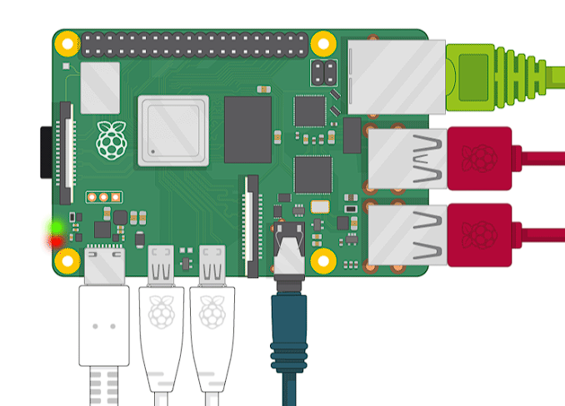
Raspberry Pi

Relevant Key phrases relating to your invention

S.No. |  |  |  | Key Phrase
1 |  |  |  | Automated water leak detection system
2 |  |  |  | Moisture-sensor-based multi-zone monitoring
3 |  |  |  | Microcontroller-controlled solenoid valve shutoff
4 |  |  |  | Real-time IoT alert to mobile device
5 |  |  |  | Sub-3-second emergency response time
6 |  |  |  | Residential affordable leak protection
7 |  |  |  | False-alarm reduction / intelligent verification
8 |  |  |  | Remote cloud monitoring and event logging
9 |  |  |  | Audio-visual local alarm on leak detection

