vi:

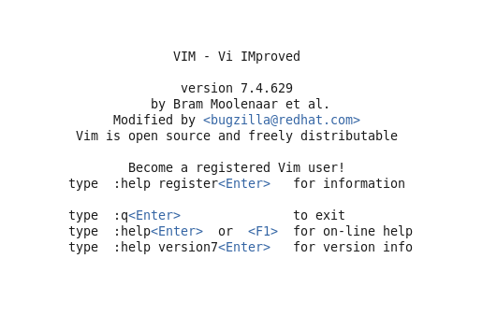

pwd:



ls

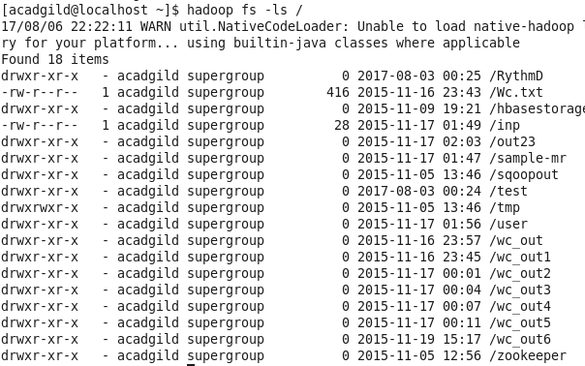

mkdir:



ls:

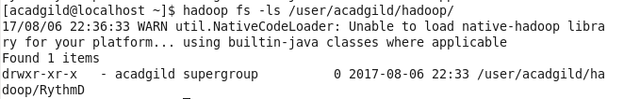

touchz:



cat:

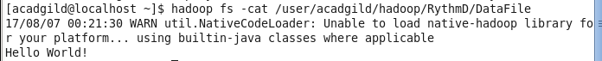

rm:

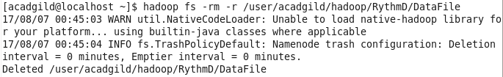

echo:



mv:

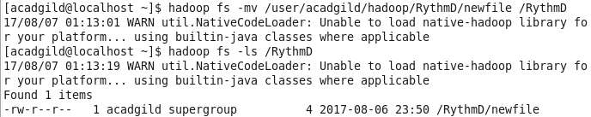

cp:

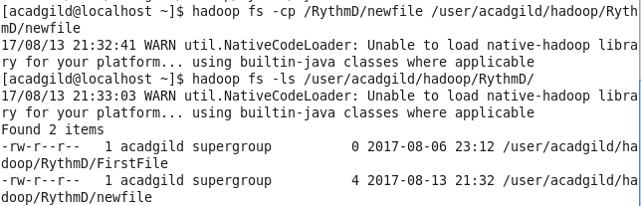

who:



which:

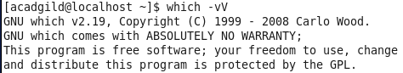

date:



cal:

