**Enter the text on screen and write on file:**

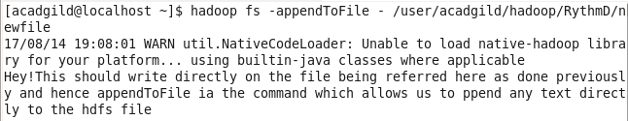

**Create a new file word-count.txt and write text:**

