

CSE470
Fall 2025
Assignment - 01

Instructor: Fardin Zubair Nafis
Name: Mehedi Hasan
ID: 22299331
Section: 05

Submitted on behalf of Group 5

Doctor–Patient Consultation System – Assignment 01

We will describe the software requirements and design overview for our Doctor–Patient Consultation System. The system supports online appointment booking, real-time consultation, digital prescriptions, payments, and administrative management with three main user roles: Patient, Doctor, and Admin.

1. Class Diagram
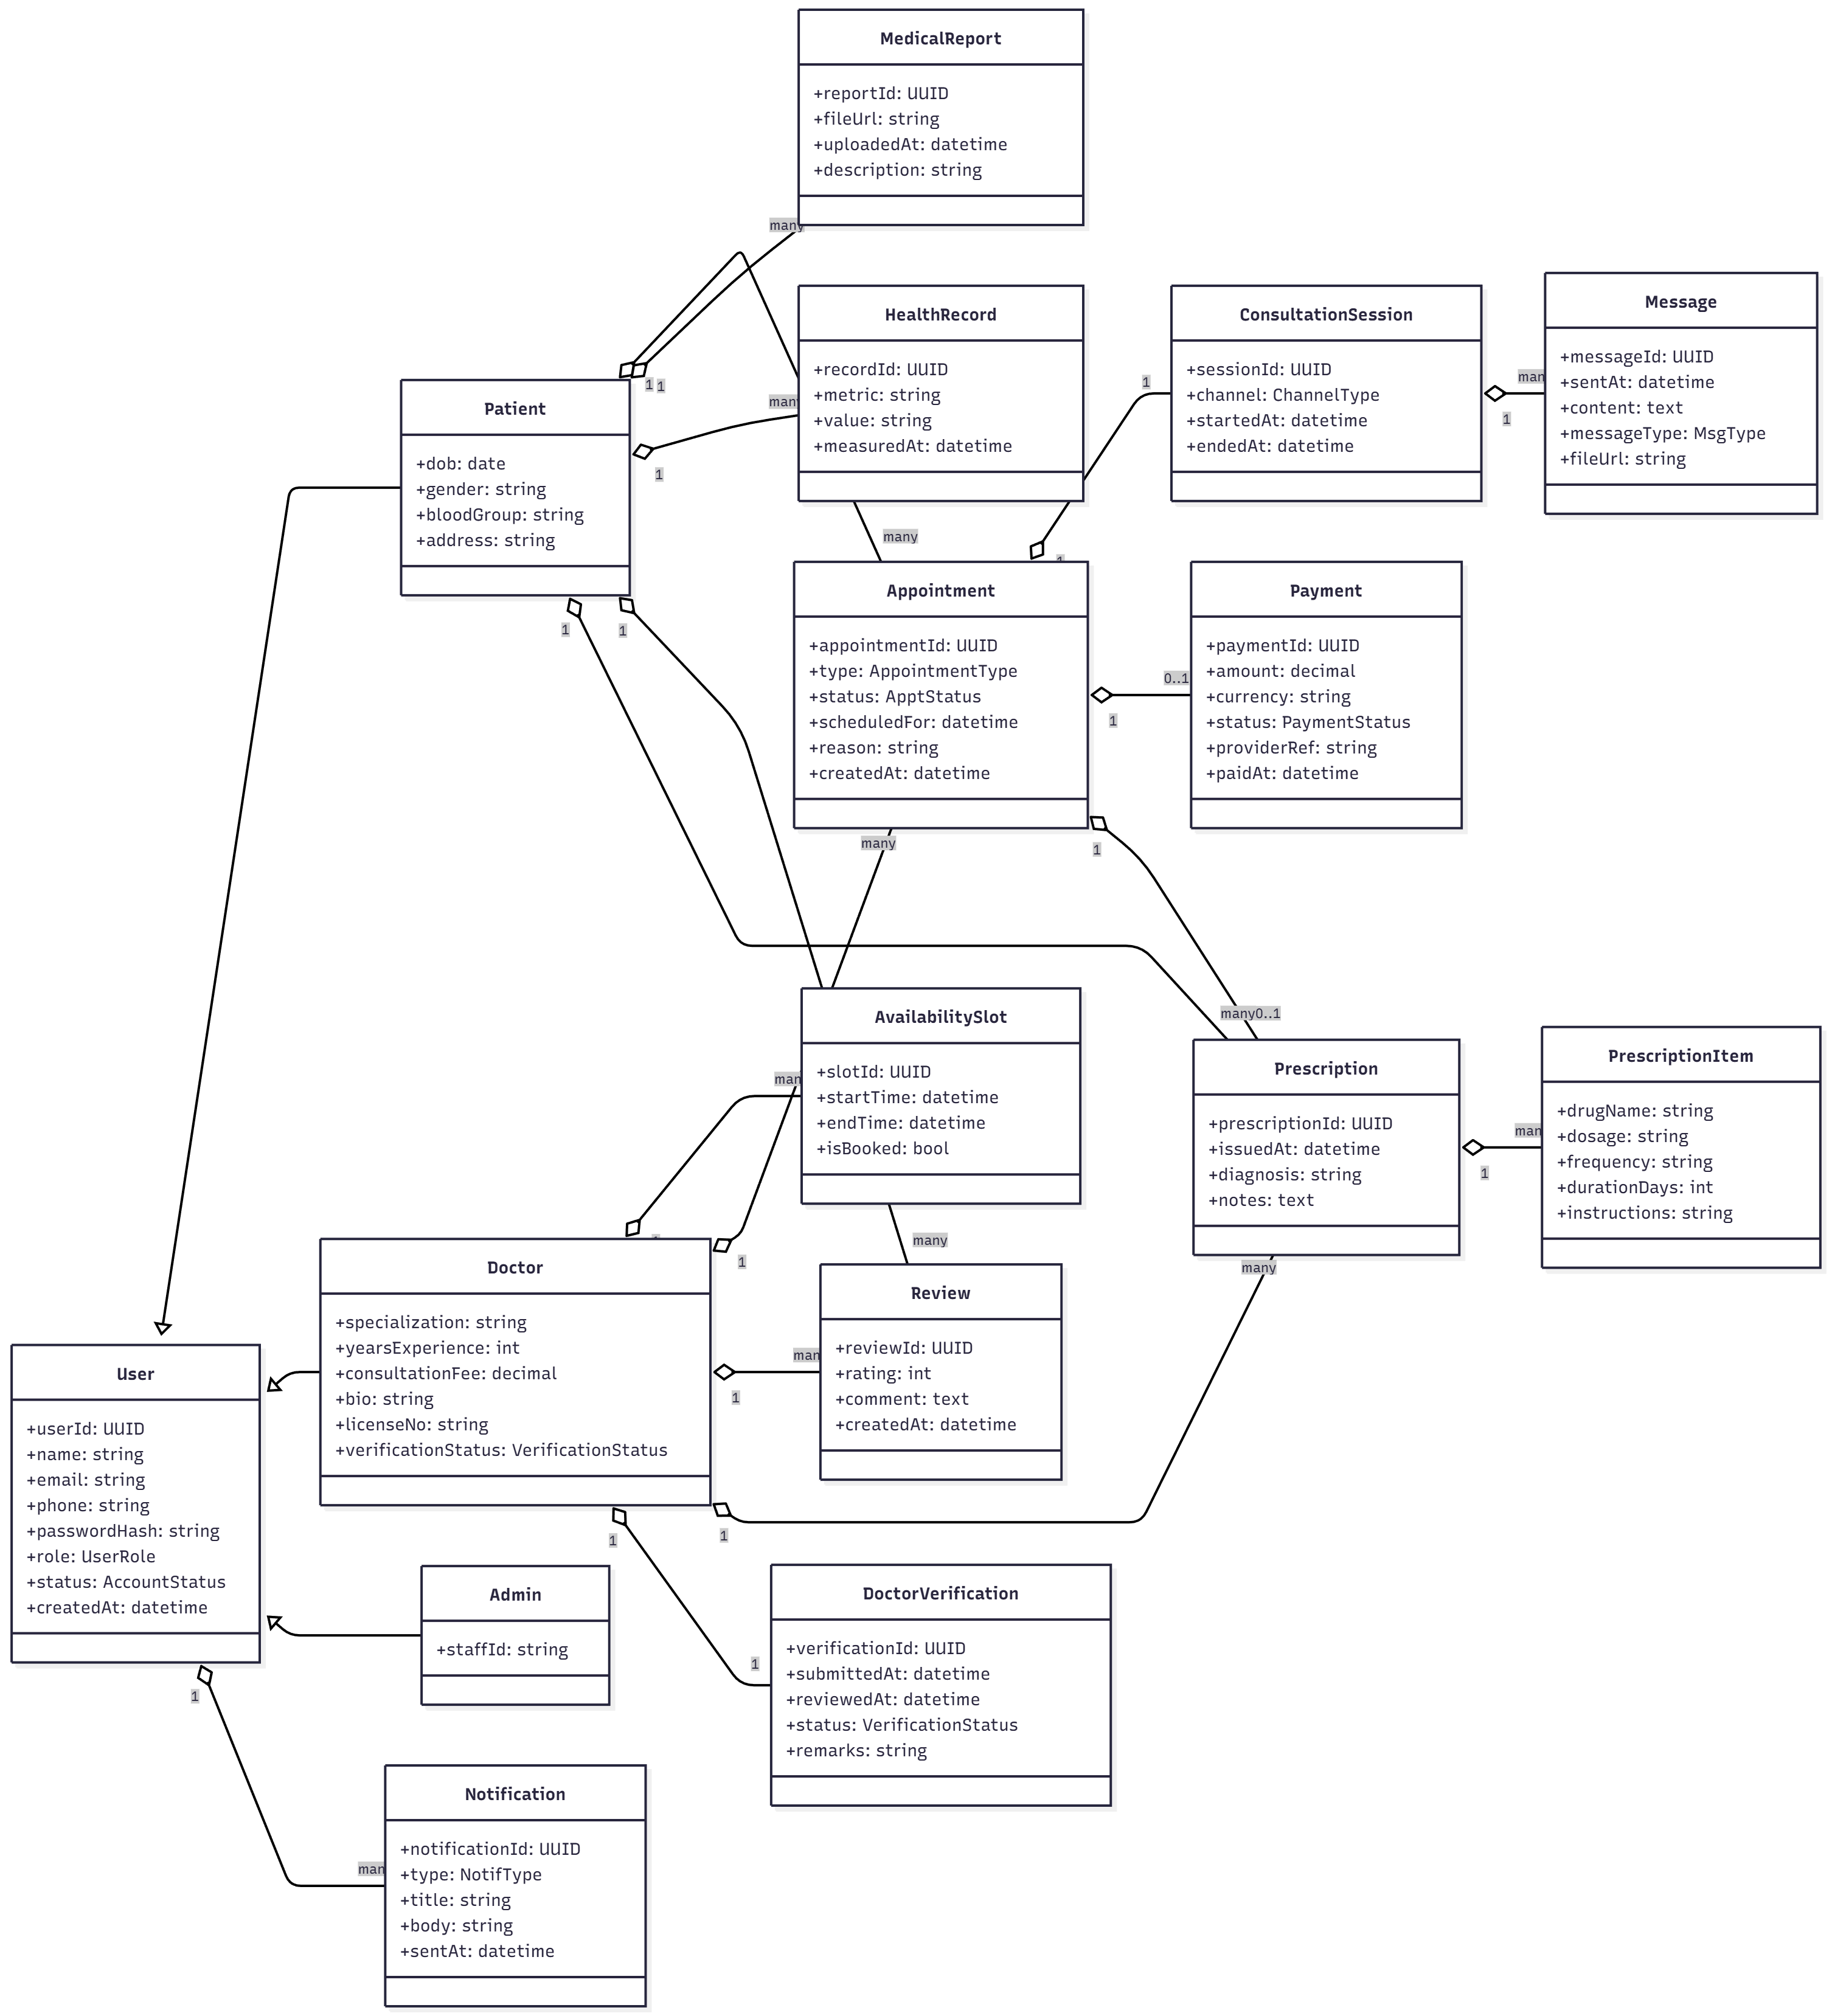
The following UML class diagram represents the core entities and relationships in the system.

2. Functional Requirements
The system’s functional requirements are grouped into five core requirement areas with a total of 20 key features, plus additional Login/Registration features and optional extra features.

2.1 FR1 – Appointment Booking Requirements
- FR1.1 The system shall allow patients to search for doctors based on specialization and availability.
- FR1.2 The system shall allow patients to book appointments using predefined availability time slots.
- FR1.3 The system shall allow patients to reschedule or cancel appointments according to system policies.
- FR1.4 The system shall send confirmation and reminder notifications for upcoming appointments to patients and doctors.

2.2 FR2 – Online Consultation Requirements
- FR2.1 The system shall provide a chat-based consultation interface for doctors and patients linked to a specific appointment.
- FR2.2 The system shall allow users to send and receive text messages in real-time during a consultation session.
- FR2.3 The system shall allow patients to upload and share medical files (such as reports or images) during a consultation.
- FR2.4 The system shall automatically close or mark the consultation session as completed after the doctor ends the session.

2.3 FR3 – Prescription & Health Record Requirements
- FR3.1 The system shall allow doctors to issue a digital prescription for each completed or confirmed appointment.
- FR3.2 The system shall support multiple prescription items, each with drug name, dosage, frequency, and duration.
- FR3.3 The system shall allow patients to view and download their prescription history.
- FR3.4 The system shall allow patients to record and maintain basic health records (e.g., blood pressure, blood sugar, weight).

2.4 FR4 – Payment & Billing Requirements
- FR4.1 The system shall require patients to complete online payment in order to confirm an appointment.
- FR4.2 The system shall record payment details including amount, currency, status, and transaction reference.
- FR4.3 The system shall process full or partial refunds automatically based on the defined cancellation policy.
- FR4.4 The system shall generate and send digital payment receipts to patients via email after successful payment.

2.5 FR5 – Doctor Management & Review Requirements
- FR5.1 The system shall require doctors to complete a verification process before their profiles become visible for booking.
- FR5.2 The system shall allow users to view doctor profiles including specialization, years of experience, consultation fee, and average rating.
- FR5.3 The system shall allow patients to submit reviews and star ratings for a doctor after a completed appointment.
- FR5.4 The system shall allow doctors to create, update, and delete their availability time slots for accepting appointments.

3. Login & Registration Functional Requirements
- LR.1 The system shall allow new users to register as either a Patient or a Doctor account.
- LR.2 The system shall require doctors to provide license information and upload verification documents during registration.
- LR.3 The system shall require users to verify their email address before gaining full access to the system’s features.
- LR.4 The system shall allow users to securely log in using their registered email and password.
- LR.5 The system shall allow logged-in users to update their personal and profile information at any time.

4. Optional Extra Functional Features (Phase 2 / Nice-to-Have)
The following features are not strictly required for the initial assignment but are realistic, useful enhancements that align well with the overall system design. They can be mentioned as future work or extended scope.

4.1 Symptom Checker
Patients can select one or more common symptoms from a predefined list, and the system suggests a suitable department or specialization (for example, Dermatology, Cardiology, or General Physician). This improves usability and helps new patients choose an appropriate doctor. This feature is good to mention as an extension but does not change the core class diagram.

4.2 Favourite / Saved Doctors
Patients can mark certain doctors as favourites in order to quickly view their profiles or rebook future appointments. This can be implemented with an additional mapping table (Patient–Doctor favourites) but is not required for the minimum system. It is a user-experience improvement and safe to include as an extra feature.

4.3 Health Tips & Blog Section
Admins or verified doctors can create and publish health tips and blog posts, such as preventive care advice or explanations of common conditions. Patients can browse these articles inside the system. This increases user engagement and can be added later without affecting core flows like booking or consultation.

4.4 Dark Mode and Accessibility Options
The system can offer a UI toggle for dark mode and larger text size to support accessibility and user comfort. This is mainly a front-end concern and is considered a non-functional/usability enhancement rather than a core functional requirement, but it is a very good feature to mention.

4.5 Doctor Leave Management System
Doctors can mark leave days or specific time ranges during which they are unavailable. The system then automatically disables or hides availability slots for those dates, preventing bookings when the doctor is on leave. This feature fits naturally with the existing AvailabilitySlot and Appointment design and is a strong candidate for inclusion in a later version of the system.

5. Non-Functional Requirements (NFRs)

5.1 Security Requirements
- The system shall securely store user passwords using strong hashing algorithms (e.g., bcrypt).
- The system shall restrict access to patient medical data using role-based access control for Patient, Doctor, and Admin.
- The system shall protect data in transit using secure communication protocols (e.g., HTTPS).

5.2 Performance Requirements
- The system shall return doctor search results within 1–2 seconds under normal load.
- The system shall support real-time chat such that message delivery latency is typically below 200 ms.
- The system shall handle concurrent access from multiple users without significant degradation in response time.

5.3 Reliability Requirements
- The system shall target an uptime of at least 99% over a one-month period.
- The system shall perform regular automated backups of critical data (e.g., once per day).
- The system shall ensure that an appointment slot cannot be double-booked, even under concurrent requests.

5.4 Usability Requirements
- The system user interface shall be simple, clean, and responsive on desktop and mobile devices.
- The system shall use clear navigation so that new users can perform key tasks (e.g., booking an appointment) without training.
- The system shall provide meaningful error and success messages to guide users when actions fail or succeed.
- Optional: The system should provide a dark mode and larger text size settings to enhance user comfort and accessibility.

5.5 Scalability Requirements
- The system shall be designed so that the number of supported doctors and patients can grow without major redesign.
- The system shall support horizontal scaling of the backend (e.g., running multiple instances) if user traffic increases.

5.6 Maintainability Requirements
- The system shall use a modular architecture (separate modules for authentication, booking, consultation, payments, etc.) to ease maintenance.
- The source code shall follow consistent naming conventions and documentation standards so that future developers can extend the system.

5.7 Availability Requirements
- The system shall be accessible to patients and doctors 24/7, except during planned maintenance windows.
- Planned maintenance windows shall be communicated to users in advance when possible.

