Problem：
Now, we have installed the Ryu Controller and the Linc Switch.Also we solved the last problem, but when Linc Switch connect to the Ryu controller, we have other problem. This is the last step to display the error when we enter commands to connect at the terminal.

First, open the “LINC Switch” file, then run the command at the terminal: sudo rel/linc/bin/linc console. We got the error, just like in the picture. An error indicating a similar version of the message is displayed.
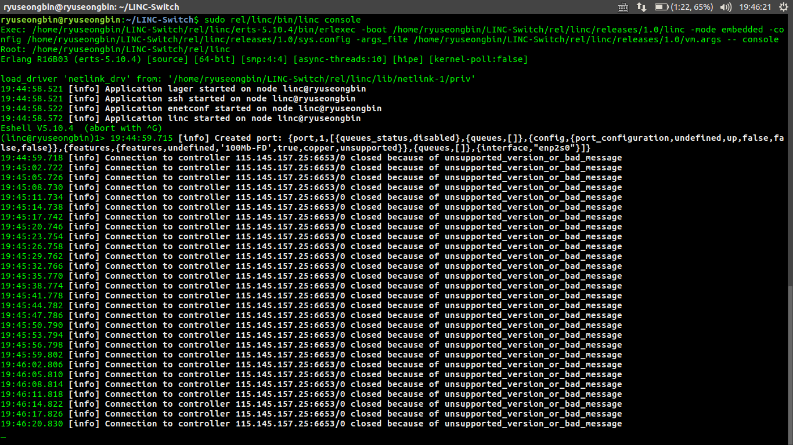

After, we looked at some information on the Google, but there is not much information about it.
Our think of the causes of errors has the following
- The version of RYU controller and LINC Switch does not match and incompatible.
- The function of the port in the sys.config file in LINC Switch is not configured properly.
- We Just installed the Ryu controller, not installed other features.

solution：
1. Restudy the configuration of the associated port configuration.
2. install other features for the Ryu controller.
3. If still can't solve this problem, we will use OpenDayLight and Linc Switch to simulate SDN network.

