## Problem：

when Linc Switch connect to the Ryu controller, we have problem. This is the last step to display the error when we enter commands to connect at the terminal. In last week, we looked at some information on the Google, and we tired to solve the problem, but we failed. We have replaced the Linc switch version and Ryu controller version and we re-configured the sys.config file in LINC Switch, but we still can’t solve the problem.

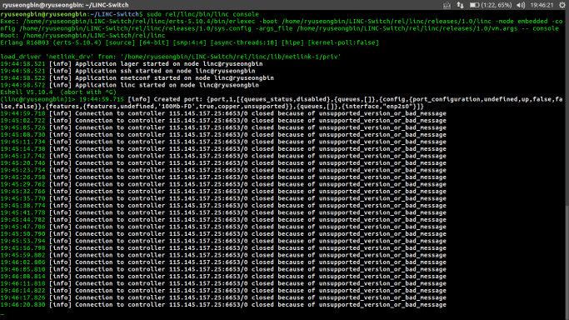

**Plan:**

1. We will replace the controller with Opendaylight. First, we will install the components of the Opendaylight to the computer, according to the guidance, the Linc switch connect to the Opendaylight controller.

2. According to the information on the Google, we will install Linc switch and Ryu controller on a single computer. We will try the Linc switch connect to the Ryu controller on a single computer.