2017.0.7.24

Liu Chengbin

SDN network

* **Topic**

I have successfully connected the switch and controller and made them to send and receive data from each other. And tries to connect the physical port and the virtual port of the switch.

Use *“mn –nat –topo single,3 –conntroller=remote,ip=115.145.157.23,port=6633”* command to create a topology and connected to the Opendaylight Controller, and “*ip=115.145.157.23,port=6633”* is Ip and port of my controller.

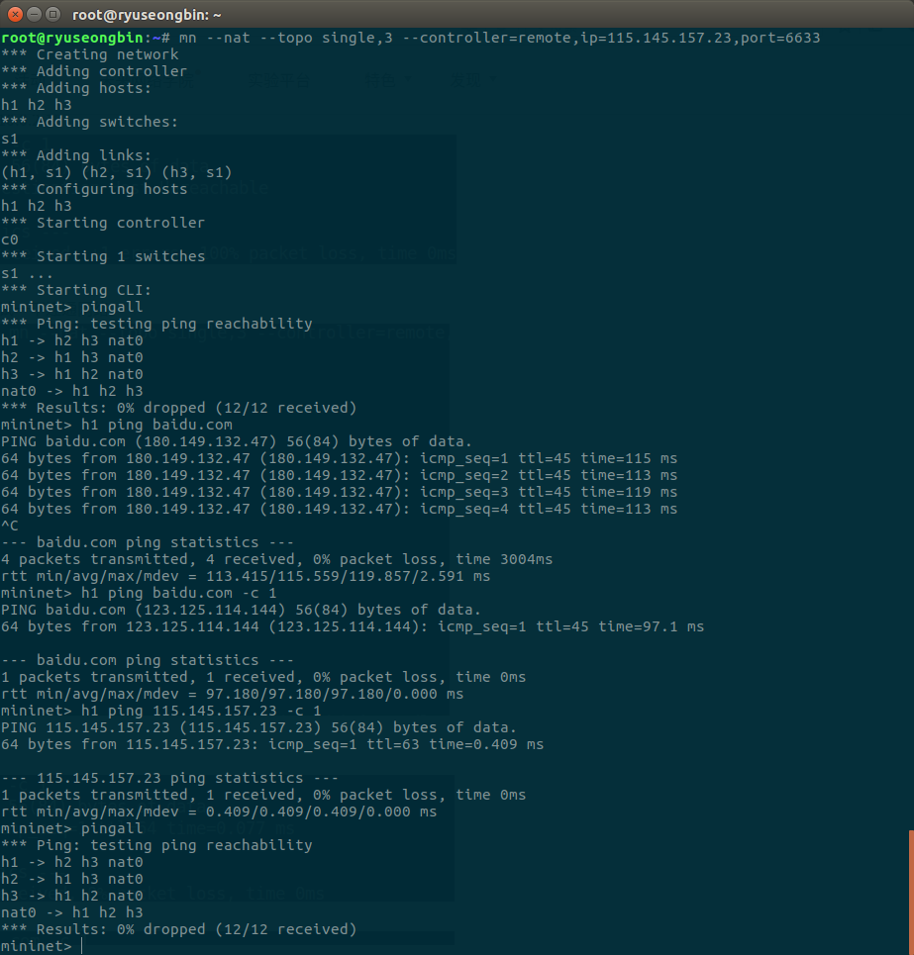

* **Problem**

I have not found the connection method between the physical port of the host under the switch and the virtual port inside of the switch.

* **Solution**

1. Learn and use the command of the Open vswitch to create a bridge for achieve the purpose of the connection.
2. Modify mininet internal related python file to achieve port creation and connection.