2017.08.03

Liu Chengbin

* **State**

Last week we have established a virtual port on the switch, and made the virtual port and physical PC connected. Then the switch and PC can ping each other, and through the controller we can see the switch connected the PC successful.

Problem is PC can`t access the external network.

* **Ping test**
  + **Ping from PC to the Switch**

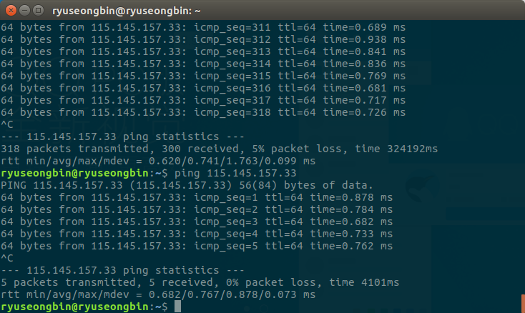

* **Ping from Switch to PC**

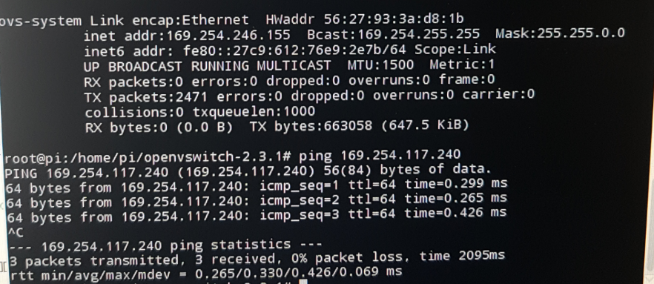

* **Topology in OpenDayLight controller**

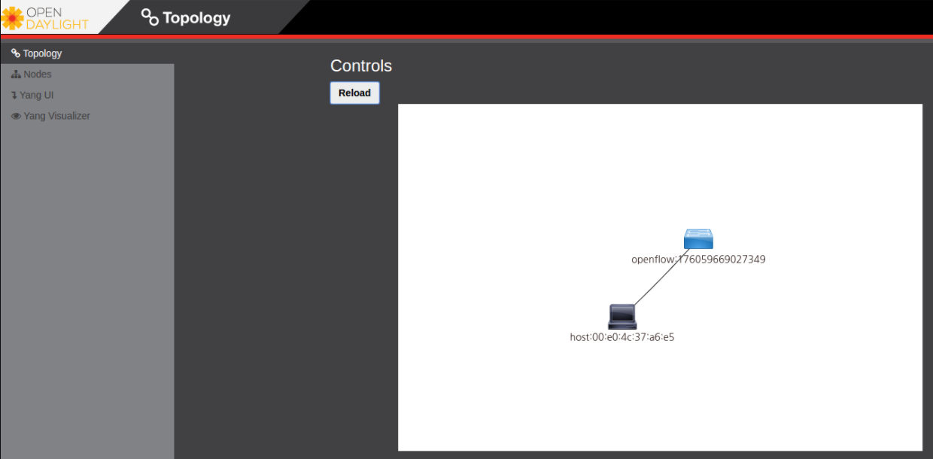

* **Problem**

Until now we have solved the problem of PC can`t access the external network. But when the PC successfully access the external network, we found a new problem, that is the switch can`t access the external network now.

.

* **Ping test of PC access the external network**

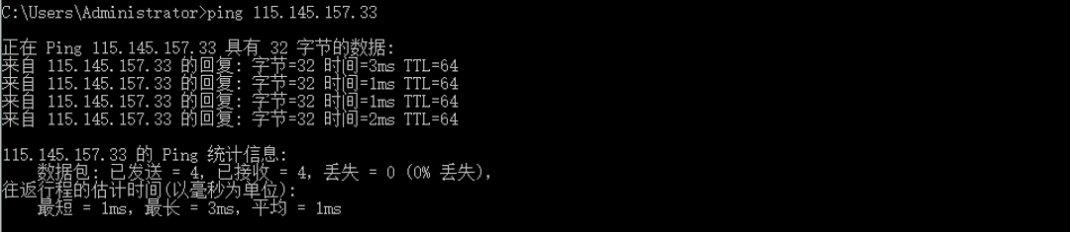

* **Future work**

Keep study about the Openvswitch.