2017.08.10

Liu Chengbin

## The main function of OpenvSwitch

OpenvSwitch is a virtual switching software. In a virtualized environment of a machine, a virtual switch (vswitch) has two main functions: to pass the traffic between the virtual machine and the host, and to achieve the host and the external network communication.

## OpenvSwitch environmental overview

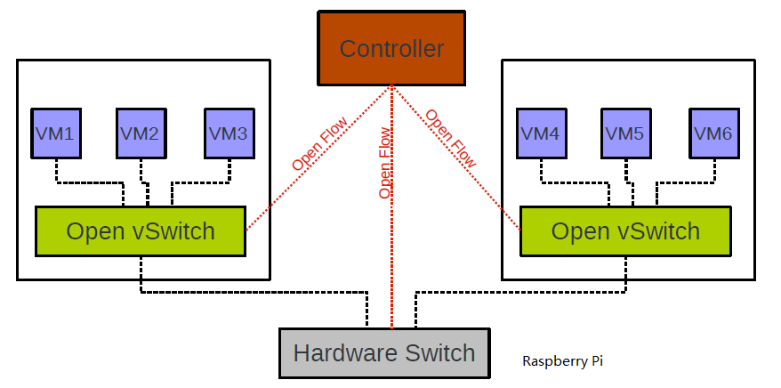

## Problem:

Until now the controller and switch and host can be connected to each other in the local area network, and the host can also access the external network, but the problem is that the switch can`t access the external network.

Because we may need to exchange date between the switch and external network, so we want to solve this problem.

## The solution (tried):

1. Change the switch's gateway through the OpenvSwitch command line, but this is not useful.

## The solution (intended to try):

1. Modify the configuration files which related to the network in the Raspberry Pi system.