AI-Powered Predictive Analytics for an Academic Early Warning System

A Capstone Project by

Amparado, Kendrick O.
Pombo, Christian Dave Estrañero
Quimbo, Ian Carlo B.
Seridon, Kent Ian C.

Submitted to the Information Technology Department, College of Technologies
Bukidnon State University

In Partial Fulfillment
of the Requirements for the Degree
Bachelor of Science in Information Technology

<Month and year of degree conferral, not date of submission>

APPROVAL SHEET
This capstone project entitled AI - Powered Predictive Analytics for an Academic Early Warning System, prepared and submitted by Kent Ian C. Seridon, Kendrick O. Amparado, Christian Dave E. Pombo, Ian Carlo B. Quimbo in partial fulfillment of the requirements for the degree <Degree> is hereby accepted.

CZARISSA A. NAVIDAD
Capstone Project Adviser
DR. SALES G. ARIBE JR.
Chair, Defense Panel
KLEVIE JUN R. CASERES | ROV JAPHETH G. ORACION
Panel Member | Panel Member

Accepted and approved for the conferral of the degree Bachelor of Science in Information Technology.

SALES G. ARIBE JR., DIT MARILOU O. ESPINA, DIT
Department Head, Information Technology Dean, College of Technologies

DEDICATION
This portion is optional but perhaps you have someone or some people who have inspired you to push on with your studies. A dedication would be a fitting way to acknowledge their impact on your success.

ACKNOWLEDGMENTS
The road to this point in your studies couldn’t have been travelled alone. Along the way, someone somewhere helped you. This is your chance to thank them.
By the way, exercise the liberty to be personal to reflect the sincerity of your gratitude.

TABLE OF CONTENTS
1 INTRODUCTION 1
1.1 Background of the Study 1
1.2 Objectives of the Study 7
1.3 Significance of the Study 8
1.4 Scope and Delimitations. 9
2 REVIEW OF RELATED LITERATURE 11
2.1 Related Literature 11
2.2 Related System 20
2.3 Concept of the Study 22
2.4 Definition of Terms 24
3 METHODOLOGY 27
3.1 Materials 27
3.1.1 Softwares 27
3.1.2 Hardware 28
3.1.3 Data 29
3.2 Methods 30
3.2.1 Research Design 30
3.2.2 Process Model 32
3.2.3 Requirements Gathering and Analysis 33
3.2.4 Design 39
3.2.5 Development 47
3.2.7 Machine Learning Model Optimization with XGBoost 52
3.2.8 Testing 54
3.2.9 Evaluation 56
4 RESULTS AND DISCUSSION 60
4.1 Analysis of Multi-Source Institutional Data for Feature Extraction and Predictive Modeling 60
4.2 Design of a Role-Based Secure Web System 64
4.2.1 Workflow Integration with Academic Mentoring Unit Procedures 68
4.3 Development of a Role-Based Web System for Early Warning Analytics 71
4.4 Predictive Model Evaluation 77
4.4.1 Confusion Matrix Components (TP, FP, FN, TN) 79
4.4.2 F1-Score 81
4.4.3 Precision 82
4.4.4 Recall 83
4.4.5 ROC-AUC 83
4.5 System Evaluation 85
4.5.1 Functionality 85
4.5.2 Usability 85
4.5.3 Reliability 85
5 SUMMARY, CONCLUSIONS, AND RECOMMENDATIONS 86
5.1 Summary 86
5.2 Conclusions 86
5.3 Recommendations 86

LIST OF TABLES
Table 2-1 Definition of Terms 25
Table 3-1 Software Requirements and Versions 28
Table 3-2 Hardware Specifications 30
Table 3-3 Functional Requirements of AEWS 35
Table 3-4 AEWS Implementation of AMU Process Steps 40
Table 3-5 Key Attributes of the Predictive Component 47
Table 4-1 Data Profiling Results of the Student-Risk Dataset 56
Table 4-2 Engineered Features Used for Student-Risk Prediction 62
Table 4-3 Role-Based Access Design of the Academic Early Warning System 65
Table 4-4 XGBoost Model Features Used in the AEWS 70
Table 4-5 Risk Classification Rule Used by the XGBoost Model 71

LIST OF FIGURES
Figure 2-1 Conceptual Diagram of Academic Early Warning System (AEWS) 23
Figure 3-1 Agile Methodology Development Lifecycle 32
Figure 3-2 AMU Policy Document 2.1 34
Figure 3-3 AMU Policy Document 9.2 34
Figure 3-4 AMU Policy Document 9.3 35
Figure 3-5 Instructor Workflow 39
Figure 3-6 Student Workflow 41
Figure 3-7 AMU-Staff Workflow 43
Figure 3-8 Administrator Workflow 44
Figure 3-9 System Architecture Diagram 45
Figure 3-10 Survey Questions 57
Figure 4-3 AEWS Login Page 71
Figure 4-4 Instructor’s Landing/Dashboard Page 72
Figure 4-5 Instructor Add Class Interface 72
Figure 4-6 Class Creation Confirmation 73
Figure 4-7 Class Roster After Class Creation 73
Figure 4-8 Student Grade Upload Interface 74
Figure 4-9 Midterm Gradesheet Upload Interface 74
Figure 4-10 Uploaded Midterm Grades Display 75

ABSTRACT
Insert your abstract here. This portion is not to be indented and should be clear, concise, and complete. As much as possible, limit the introductory part to a few sentences and make sure that the last sentence reiterates the achievement of the general objective of the research.

INTRODUCTION

Background of the Study
The issue of student dropout has been long leaving a shadow over both personal ambitions and institutional objectives in the Philippines' modern higher education system, especially in state universities and colleges (SUCs). Think about this: the dropout rate in higher education is a startling 39% nationwide, with almost 4 out of 10 students in SUCs leaving their programs before finishing them. This number is made worse by factors including lack of interest in school and concerns regarding employability (Bravo, 2023). For universities and colleges, this rate translates to about 35.15% dropout estimated for the 2023–2024 academic year; in areas like Northern Mindanao and Camarines Sur, where socioeconomic vulnerabilities worsen the problem, the numbers are significantly higher (PHKULE, 2025; Villanueva, 2024).
As the country strives for inclusive growth, these dropout rates rise even more for underrepresented groups, such as low-income or first-generation students at SUCs, extending cycles of inequality in a time when a college degree is still an essential entry point to economic mobility. This educational inequality is not confined only within national borders because student retention has a direct impact on the global economy. In today's interconnected knowledge economy, the inability of higher education institutions to retain and produce skilled graduates limits not only national competitiveness, but also the global talent pipeline that supports innovation and sustainable industry growth (World Bank, 2024).
Addressing student retention is in line with the United Nations Sustainable Development Goal 4 (Quality Education), which aims to provide inclusive and equitable education and promote lifelong learning opportunities for all (United Nations, 2023). While society has lower productivity and a higher dependency on social services, SUCs are faced with income losses from empty seats and difficulties in recruitment. According to recent studies by the Second Congressional Commission on Education (EDCOM 2), high dropout rates leads to billions of money in lost investments in free higher education under Republic Act 10931. The main reasons given for dropout are monetary difficulties and post-pandemic disruptions. (EDCOM 2, 2025; PHKULE, 2025).
Enrollment in Philippine higher education has fluctuated between 2020 and 2025, suggesting a "learning crisis," which implies pressures affecting SUCs' contributions to the country's development (PHKULE, 2025). The need has only increased due to the post-pandemic escalation of these patterns, which were characterized by interrupted blended learning and increased vulnerability in rural SUCs. Although there is much proof of these issues, traditional solutions frequently come too late, acting only after grades have fallen and motivation has dropped, leaving students at risk stranded in a system that is not prepared to prevent them. According to recent findings, AI-driven learning analytics have been proven to enhance academic monitoring accuracy by over 85%, using models that correlate engagement metrics and emotional sentiment analysis from online forums (Zawacki-Richter et al., 2023; Ahmed & Haseeb, 2024).
Reliance on reactive academic support systems, which, in spite of their best efforts, usually fail to proactively address underlying problems, is at the core of the retention crisis at Philippine SUCs. Under the Student Affairs and Services (SAS) framework of CHED Memorandum Order No. 09, Series of 2013, traditional methods like manual advising sessions, end-of-semester progress reviews, and independent tutoring operate within clusters, reacting to clear warning signs of failure rather than predicting them (CHED, 2013; Villanueva, 2025). Due to their heavy caseloads, faculty and advisors at SUCs frequently fail to notice subtle signs such as irregular attendance, late submissions, or declining interest in learning management systems (LMS), especially when dealing with numerous groups of students whose needs differ greatly between urban and rural campuses (Sayo et al., 2022).
According to a 2025 study into student support services at a state institution, many students in areas like Camarines Sur felt unsupported throughout the shift to online learning due to uneven access and insufficient personalization (Sayo et al., 2022). According to qualitative reports from education graduate students at SUCs, there is a gap between K–12 and higher education support systems, and reactive interventions fall short in establishing foundational skills or fostering self-efficacy at an early age. This is made worse by issues like a lack of institutional resources (Hara et al., 2023). These problems are made worse by resource limitations: fragmented data systems and underfunded advising centers make it difficult to scale, particularly in light of the anticipated enrollment challenges in 2025 and the changing academic roles in SUCs (Arao et al., 2025).
The current structure not only normalize inequalities but also puts a strain on institutional budgets, shifting funds from innovation to remediation in a setting where 40% of undergraduates drop out overall and freshman dropout hovers at 25% in some SUCs (GMA Network, 2024; ONE News, 2025). Ultimately, reactive systems deal with symptoms rather than causes, pointing out the need for data-driven strategies that intervene before trajectories go off course.
In the Philippine setting, the potential of machine learning (ML) and artificial intelligence (AI) represents an abrupt shift toward personalized, predictive education. According to recent findings, AI-driven learning analytics have been proven to enhance academic monitoring accuracy by over 85%, using models that correlate engagement metrics and emotional sentiment analysis from online forums (Zawacki-Richter et al., 2023; Ahmed & Haseeb, 2024). In line with the Department of Education's drive for digital transformation, artificial intelligence (AI) has been growing in popularity in higher education over the last five years. It uses massive data sets from learning management systems (LMS) like Moodle and Canvas to find patterns that are unseen to the human eye (De la Cruz, 2025). SUCs can now predict outcomes and customize assistance with previously unheard-of precision thanks to predictive analytics in particular (Alotaibi & Alshehri, 2025).
This trend is clearly shown in systematic reviews conducted between 2021 and 2025. With applications tested in Philippine settings, a 2025 analysis of machine learning models for student achievement prediction showed how algorithms can process behavioral, demographic, and performance data to improve retention by identifying at-risk students weeks or months in advance (Baticulon et al., 2025; Maguigad et al., 2025). Technologies in adaptive learning, where generative AI improves engagement and outcomes by 15-20% in individualized paths, were also identified in a thorough literature review on AI in education. Examples of these technologies include SIGLA and TALINO for Philippine public education (Guevara et al., 2025).
These tools effortlessly translate raw data into actionable foresight for SUCs by drawing parallels from adjacent sectors, such as AI-driven predictive maintenance in healthcare, which decreases mistakes by 30%, or fraud detection in banking (Hassan et al., 2025). Predictive analytics, for example, has been demonstrated to increase success rates in STEM subjects by incorporating clickstream data from online courses, promoting early interventions that suit a variety of learning styles in settings with limited resources (Khalil et al., 2025). However, as adoption increases—by 2025, more than 70% of Philippine institutions will be experimenting with AI—ethical issues including algorithmic bias and data privacy will still be important to fair implementation in SUCs (Instructure, 2025). Though there is promise in this technology boom, its full potential in developing comprehensive early warning systems for student performance is still not fully realized in the local context.
However, despite the promising outcomes of prior research, no existing framework has yet operationalized an AI-powered EWS specifically adapted for the localized data realities and infrastructure constraints of Philippine SUCs. Most studies remain theoretical or limited to pilot-scale applications without institutional adoption or integration into the CHED SAS framework, revealing a critical implementation gap this study aims to address. (Liao et al., 2025; Mahmood et al., 2025). A 2025 systematic review of 51 articles highlights key limitations, including overreliance on demographic variables, neglect of psychosocial factors (e.g., mental health proxies), and insufficient focus on underrepresented populations, leading to biased outcomes that exacerbate inequities in diverse Philippine settings (Maguigad et al., 2025). While recent investigations emphasize the need for multi-modal data fusion—integrating LMS logs, attendance records, and sentiment analysis for nuanced, interpretable alerts—few address rural-urban divides in SUCs (Rodriguez et al., 2024); moreover, current models often prioritize accuracy over actionability, failing to generate tailored interventions like personalized tutoring amid local challenges such as connectivity issues (Baticulon et al., 2025). Although predictive tools exist, few bridge to proactive, scalable EWS empowering educators with timely, equitable insights; this study addresses this void by proposing an AI framework that not only predicts but prescribes.
The idea of an AI-Powered Predictive Analytics platform for an Academic Early Warning System that reimagines support as a dynamic safety net for Philippine SUCs makes this capstone research stand out as an important solution. The system will provide real-time alarms, personalized intervention routes, and continuous dashboards to promote academic resilience by combining multi-source data using sophisticated machine learning classifiers, such as ensemble models that can identify at-risk individuals with up to 92% accuracy (Arao et al., 2025).
Beyond academic performance, emerging research indicates that psychosocial factors significantly influence student retention in Philippine higher education. Studies by Lipson et al. (2019) and Auer & Griffiths (2023) demonstrate that mental health challenges, including anxiety, depression, and social isolation, contribute substantially to student attrition, particularly in post-pandemic educational contexts. In Philippine State Universities and Colleges, where students often face compounded socioeconomic pressures, these non-academic factors can be as critical as academic performance in predicting dropout risk. Recent investigations by Pritchard & Wilson (2023) found that incorporating psychosocial indicators into early warning systems improved retention prediction accuracy by 18-22%, highlighting the limitations of exclusively academic monitoring approaches. This evidence underscores the necessity for holistic early warning systems that address both academic and counseling needs to effectively support student success.

Objectives of the Study
The primary objective of this capstone project is to develop an AI-powered Academic Early Warning System (AEWS) utilizing predictive analytics to identify at-risk students in Philippine SUCs, enabling proactive interventions that enhance student retention and institutional performance. Specifically, this study aims to:
- Analyze multi-source institutional data from College of Technologies at Bukidnon State University for feature extraction and as inputs to the predictive model.
- Design a role-based secure web system compliant with data privacy laws and aligned with CHED SAS and AMU access guidelines.
- Develop a role-based web system that detects and provides early warning analytics using XGBoost prediction model.
- Test accuracy of the AI model using standard metrics such as precision, recall, F1-score, and ROC-AUC.
- Evaluate the software’s functionality, usability, and reliability.

Significance of the Study
This study on developing an AI-Powered Academic Early Warning System (AEWS) for student performance prediction holds profound implications for transforming higher education in Philippine State Universities and Colleges (SUCs), particularly through its pilot implementation at Bukidnon State University (BSU) in Region 10, Northern Mindanao.
At-Risk Students. The system aims to provide early, personalized alerts and intervention recommendations to address academic challenges proactively, reducing dropout risks and fostering greater resilience and success in their educational journeys.
Faculty and Academic Advisors. The system equips educators with actionable, data-driven insights into student performance trends, enabling more targeted mentoring and support that alleviates workload burdens and enhances teaching effectiveness.
Guidance Counselors and Student Affairs Personnel: The system will provide early identification of students exhibiting signs of emotional distress, social integration challenges, or other non-academic difficulties, enabling proactive counseling referrals and psychosocial support services. This enhances the capacity of student support units to address the holistic needs of at-risk students beyond purely academic concerns.
Bukidnon State University: Administrators gain access to longitudinal dashboards for monitoring retention metrics, allowing for informed resource allocation and policy decisions that strengthen institutional performance and compliance with CHED mandates.
Commission on Higher Education (CHED) and Policymakers: This research offers empirical evidence and a replicable framework for integrating AI into national higher education strategies, supporting broader goals of reducing attrition rates and promoting inclusive access under Republic Act 10931.
Future Researchers: This study provides a foundational blueprint, open-source methodologies, and pilot data from Bukidnon State University, inspiring subsequent investigations into AI-driven educational tools, ethical AI applications, and longitudinal impacts on retention in diverse SUC contexts.

Scope and Delimitations.
The present capstone project includes the design, development, and testing of a working Academic Early Warning System (AEWS) for Bukidnon State University. The system focuses on identifying students who may need early academic assistance and on simplifying the Academic Mentoring Unit (AMU) referral procedure. It is implemented as a role-based web application for administrators, instructors, AMU staff, and students.
The AEWS encompasses several primary features designed to support role-based workflows. Functional capabilities include user authentication and account access control, class management, student enrollment management, grade and attendance tracking, AI-assisted risk prediction using an XGBoost classification model, automatic and manual referral generation, digital needs-assessment form handling, intervention and support routing, in-system and email notifications, activity logging, search and filtering, archive management, and role-specific dashboards and reporting.
The pilot study focuses on Bukidnon State University. The data used by the implemented system consists of institutional and user-managed academic records available through the AEWS workflow, including class records, student enrollment data, gradesheets, attendance records, referral information, and needs-assessment responses. Although the broader conceptual discussion recognizes possible inputs such as LMS engagement data, demographic indicators, behavioral logs, and sentiment-based indicators, these are not fully integrated as live data sources in the current implementation.
The system includes a limited student-facing module that allows students to access their account, view relevant academic and referral-related information, receive notifications, and complete assigned needs-assessment forms. However, it does not include a mobile application, chatbot-based counseling, live counseling sessions, or fully automated intervention tracking. The system is intended to support academic early warning, AMU referral processing, support-routing documentation, and operational reporting rather than function as a complete institutional data integration platform.
The study is restricted to the functionality, usability, and operational reliability of the implemented web system and its facilitation of the existing academic monitoring and referral workflow. Extensive retention outcome measurement, cross-institutional implementation, live LMS or SIS integration, and long-term automated intervention monitoring are outside the scope of this study.

REVIEW OF RELATED LITERATURE

Related Literature
    - The State of Student Dropout and Retention in Higher Education
Student attrition has been a nagging issue for the individual academic goal and institutional strategies in higher education. Recent data in the country of the Philippines show that the drop-out rate in the tertiary systems is 39 percent and almost four of every ten students who enroll in the State Universities and Colleges (SUCs) drop their studies before they are able to complete their degree (Bravo, 2023). This staggering statistic is not only an educational shortcoming but is also a socioeconomic problem since dropout rates are extremely high among low-income and first-generation rural students (PHUKULE, 2025; Villanueva, 2024). These demographic disparities only highlight the disproportionate impact that the dropout crisis has on vulnerable populations, continuing cycles of educational inequality and limiting pathways to economic mobility for communities that are already marginalized.
    - Global Impact of Student Retention and UN SDG 4 Alignment
On the global level, the World Bank (2024) describes how retention of students is one of the most important drivers of economic yield. The shortage of qualified graduates is an impediment to the global talent pipeline and hence inhibiting the innovation and expansion of the industry. Also, the work towards direct student retention will support the United Nations Sustainable Development Goal No. 4 (Quality Education) focusing on ensuring inclusive and equitable quality education and learning opportunities for all (United Nations, 2023). Likewise, Tinto (2017) and Kuh et al. (2020) stressed that academic integration, social support and institutional engagement are important predictors of student persistence. In the context of Philippines, these research findings, among others, address the need for the development of systematic support and retention models that move away from the traditional reactive model systems currently in place.
    - Financial Implications and Post-Pandemic Challenges in Philippine Higher Education
The Second Congressional Commission on Education (EDCOM 2, 2025) says budgetary pressures and post-pandemic disruptions remain the biggest Kano of attrition in Philippine SUCs. The post-COVID-19 pandemic scenario has been defined as 'learning crisis', and enrolment trends are likely to display huge disparities from 2020 to 2025 (PHKULE, 2025). These variations are indicative of set academic and socio-economic pressures that threaten the value of SUCs as contributors towards national development and as suppliers of the labor market. The compounding financial constraints, in conjunction with pandemic-related disruptions, have demanded unprecedented challenges for the institutional retention efforts requiring innovative solutions outside the traditional resource allocation models.
    - CHED Student Affairs Framework and Reactive Academic Support Systems
In the context of the Philippines, the Commission on Higher Education (CHED) has prescribed student support services under Memorandum Order No. 09, Series of 2013, particularly the intervention of advising, counseling, and tutoring. However, most of these systems are responsive in nature, that is, they only respond to students after showing students that they are disinterested or that they are performing poorly (CHED, 2013; Villanueva, 2025). This reactive orientation, although well-intentioned, results in time lags between when academic difficulty begins to evolve and when institutional response occurs so that problems can compound before intervention occurs. Similar difficulties in international contexts are noticed in research by Yukselturk et al. (2021) in which the absence of early monitoring systems caused high attrition rates in online courses in Turkish universities. Tempelaar and Rienties (2022) established that traditional advising methods are very subjective and inconsistent which also emphasised the need for algorithmic support systems that can assist in identifying at-risk students during the initial stages of academic difficulty.
    - Institutional Resource Constraints and Fragmented Data Systems
As highlighted by Sayo et al. (2022), faculty and academic advisers usually have high workloads that limit early intervention in warning signs like irregular attendance, late submission of work or unusual lack of non-participation logged in Learning Management Systems (LMS). The problem is compounded in rural SUCs where low resources, poor connectivity and unequal access to technology reduces the possibility of timely interventions (Hara et al., 2023). Moreover, according to Arao et al. (2025), institutions are not able to align student records and behavioral data from various different platforms that leads to the missed opportunities for proactive intervention due to fragmented data systems. This reliance on reactive modalities leads to inflated cost of remediation and reduced academic durability, thus calling for an urgent need for advocacy of data-driven strategies, which is capable of predicting and preventing drop out before it occurs. The combination of limited human resources, fragmented technological infrastructure, and institutional resource limitations constitute a systemic environment in which it is still infeasible to identify students at-risk in their early stages through traditional support mechanisms.
    - Emergence of Artificial Intelligence and Machine Learning in Education
Artificial intelligence (AI) and machine learning (ML) has changed the education industry with predictive, personalized, and adaptive learning environments. Zawacki-Richter et al. (2023) and Ahmed & Haseeb (2024) this accuracy of academic level tracking through AI-powered learning analytics may be increased by more than 85 percent to predict educational performance and involvement trends. De la Cruz (2025) states that LMS platforms such as Canvas and Moodle that contain intelligent systems make use of massive amounts of data to determine learning patterns that are invisible to the human eye. Additionally, Alotaibi & Alshehri (2025) demonstrate that predictive analytics can help universities anticipate academic performance and take quantitative action as a result by delving from traditional academic advising to proactive and data-driven decision making. On a global level, Siemens and Long (2021) offer some light on the place of learning analytics, as a middle ground between data science and pedagogy. Gaescic et al. (2022) similarly demonstrated the significant benefits of predictive analytics systems in enhancing institutional decision-making - specifically, answering the question as to the correlation between engagement, assessment patterns and subsequent retention with elucidative processes. In the Philippines, this shift is part of the Department of Education's digital transformation strategy, which involves embracing the use of data-driven education systems to improve retention and well-being (DepEd, 2024).
    - Machine Learning Models and Philippine AI Tools for Education
AI-based early warning systems encourage predictive analytics to identify the students who are at risk and intervene in a timely manner. Baticulon et al. (2025) have shown that machine learning algorithms can predict the probabilities of dropouts weeks or even months in advance of the critical points of failures. Maguigad et al. (2025) also confirmed that the interaction of behavioural and demographic data leads to better model fit and interpretability. Cortez and Silva (2022) have found that algorithms such as Random Forest and Neural Network can achieve the prediction accuracy of 90 percent for predicting student success from data harvested using LMS. In the Philippine context, AI tools like SIGLA and TALINO have produced measurable increases in student engagement between 15 per cent and 20 per cent, through automatic feedback and adaptive learning pathways (Guevara et al., 2025). These results are in line with other sectors where the use of AI in predictive analysis has played a role in lowering the rate of error on operations by as much as 30 percent such as in the cases of healthcare and finance (Hassan et al., 2025). The case of machine learning algorithms obtained efficacy in educational prediction and successful Philippines government initiatives in the AI implementation prove that the technical feasibility of developing localized EW systems in SUC contexts is feasible.
    - Ethical Considerations and Algorithmic Bias in Educational AI
Hwang and Chang (2023) contended that adaptive feedback mechanisms are pivotal in the process of preventing students from being academically disengaged and helping them persist. However, data-governance and ethical issues continue to be critical issues. Holmes et al. (2021) and Instructure (2025) warn of biases in AI algorithms and the subsequent risk of perpetuating inequalities if the algorithms are trained on non-universal and inadequate datasets. These risks require robust ethical guidelines that can help ensure AI instruments will foster equity and not inadvertently accomplish relationships among susceptible groups of students. The tension between maximizing the predictive power of AI while ensuring fairness in the algorithms that power educational AI systems calls for deliberate design practices that prioritize equity, transparency, and accountability in educational AI systems, especially in resource-constrained Philippine SUC contexts.
    - Implementation Gap and Need for Localized AI Solutions
Despite these developments, there are critical research gaps found in literature. Liao et al. (2025) and Mahmood et al. (2025) share that most educational predictive analytics frameworks have been at the theoretical or pilot level and do not yet represent institutional buy-in as well as sustainable operation integration. Most existing early warning systems have been trialled in controlled research settings or in small-scale pilot settings rather than at scale in diverse institutional settings, with varied technological maturity and resource profiles. In the Philippine SUC context specifically, zero comprehensive AI-enabled ICT early warning system has been operationalised with integration to CHED's institutional support framework; as well as continued adoption beyond experimental programmes. This implementation gap - between proven research and localised, scalable implementation - is a critical gap that requires frameworks that are built specifically for the Philippine SUC operational realities, resource constraints and a variety of institutional contexts dating from well-resourced urban universities to under-resourced rural institutions.
    - Research Gaps: Demographic Bias, Psychosocial Factors, and Rural-Urban Divides
A systematic review of 51 research conducted by Maguigad et al. (2025) identified three common shortcomings in current predictive analytics models. First, existing models give too much attention to demographic and performance data and do not account for psychosocial data such as motivation, mental health, self-efficacy, and sense of belonging - all of which are malleable through educational interventions and crucial for early warning systems that can action them. Second, existing studies do not adequately address the unique rural-urban digital disadvantage for SUCs given the evidence of unique psychosocial challenges faced by rural students and infrastructure challenges impacting access to technology enabled support systems. Third, often models are optimized in terms of prediction accuracy metrics, not necessarily actionability, producing alerts but not prescriptive guidance for educators with respect to differentiated intervention strategies based on individual student risk profiles, and institutional capacity constraints. These gaps signal the need for a local customizable adaptive AI-enabled framework combining multimodal data sources (from LMS logs to attendance to sentiment analysis) to provide actionable and equitable early warning alerts responsive to Philippine SUC contexts.
    - Ensemble Machine Learning Models and Real-Time Dashboard Systems
Recent studies have indicated that ensemble machine learning techniques, which aggregate predictions from different machine learning methods, are more precise than using individual ones in order to select at-risk students. When these methods use data from a variety of sources, such as LMS logs, attendance, behavior, and academic performance, they can manage to have accuracy rates above 90 percent. This multi-source approach gives a more complete picture of student risk.
Real-time dashboards also play an important role by translating these predictions into practical guidance for educators. By displaying attendance trends, grades, behavioral notes and past interventions all in one spot, these dashboards are able to help teachers and advisers quickly identify which students need to be supported. Automated alerts provide added safeguards to make sure an intervention will occur before academic problems escalate to seriousness.
Overall, success of ensemble models, data integration and dashboard visualization are indicative of successful implementation of AI-powered early warning systems that are effective and feasible. These tools provide a solid basis for the development of an AEWS relevant for the Philippine SUCs and can fulfill the role of supporting the institutions in improving student retention.
    - The Role of Counseling and Psychosocial Support in Student Retention
Research is increasing to show that psychosocial factors are pivotal determinants of student persistence in higher education. Lipson et al. (2019) reported that mental health issues, especially anxiety and depression, have a powerful effect on academic achievement and retention, with about 30% of college students reporting on the negative effects of mental health problems on their academic achievement. In the Philippine context, where unique socioeconomic pressures and cultural transitions within the school environment may be encountered by students, this may be particularly salient.
Auer and Griffiths (2023) showed that early identification of psychosocial risk factors, such as social isolation, financial stress and emotional distress, can lead to an increase of 22% in retention interventions when compared to academic-only early warning systems. Their longitudinal study of 5,000 university students found that psychosocial indicators can often present earlier than academic deterioration, and therefore, there is a huge window of opportunity to proactively intervene. This aligns with findings by Pritchard and Wilson (2023), who documented that integrated support systems addressing both academic and mental health needs achieved significantly higher retention rates (87%) compared to systems focused exclusively on academic performance (72%).
These findings underscore the necessity of incorporating counseling perspectives and psychosocial metrics into early warning systems, particularly in resource-constrained environments like Philippine SUCs where students may face compounded challenges. By expanding beyond traditional academic indicators to include holistic student wellbeing assessment, early warning systems can trigger appropriate interventions—whether academic mentoring, counseling referrals, or other support services—tailored to the root causes of student distress.

Related System
    - International Early Warning Systems: Course Signals and eAdvisor
Early Warning Systems (EWS) have proved to be a success in the International higher education system. Course Signals at Purdue University predicts the risk of student failure based on data about course management, patterns of engagement and academic performance. 87.42% retention of exposed students and 69.40% retention of non-exposed students. Similarly, eAdvisor Phoenix, AZ at Arizona State University tracks student's progress and create focused intervention and Georgia State University's predictive analytics system process 800+ data points daily for 40k students creating 90k interventions annually and helping us grow 7 percentage points in our four year graduation rate (Brown et al., 2022; Hanover Research, 2025).
However, these systems are designed to function better under high-resource institutional settings, in which digital infrastructure is robust, data management systems are centralized, appropriate IT staff are present, enterprise-level budgets for software licenses exist, reliable connectivity is available, and student populations have access to the devices and internet on a regular basis. These prerequisites are the basic barriers to implementation amongst Philippine SUCs where there is fragmentation in their infrastructure, lack of IT capacity, scarcity of resources, and unequal digital access to misunderstand the situations when international EWS were designed (UNSEO, 2023).

    - Philippine Context: SIGLA and TALINO
The Department of Education has piloted AI programs such as SIGLA (health monitoring and adaptive testing) and TALINO (geospatial resource mapping), both of which have shown a 15-20% engagement gain through adaptive feedback. However, such systems are placed inside discrete subdistance student aptitude prediction subdomain applications rather than whole college-level student aggravation prediction systems. Their applicability in different SUC institutional settings and their integration into holistic retention systems are still limited, suggesting that existing Philippine AI efforts do not have institutional-scale early warning system implementation (Guevara et al., 2025).
    - Implementation Gap
A gap formed between international EWS precedents and Philippine institutional realities indicates a critical implementation chasm. Successful e-learning for the poor or in middle-income countries, not limited to adapted software solutions, will need redesigned systems to take into account infrastructure constraints, institutional capacity limitations and unique psychosocial risk profiles of poor student populations.
    - Proposed Framework
This research proposes an AI enabled Predictive Analytics framework explicitly designed in Philippine SUC contexts this time tilling the boundaries of behavioral, demographic, and psychosocial markers that generate actionable early warning signals. Unlike international systems, compatibility with fragmented existing data infrastructure, feasibility for resource constrained staff without extensive IT staff, culturally appropriate intervention recommendation which reflects institutional capacity, the explicit attention to the digital divide between rural and urban communities, and the seamless integration with CHED's Student Affairs and Services mandate were given high priority. This local-based strategy is a translation of theoretical EWS efficacy to an institutional deployment aimed for sustainable improvements in retention in Philippine SUC contexts such as discrete measurable retention improvements.

Concept of the Study
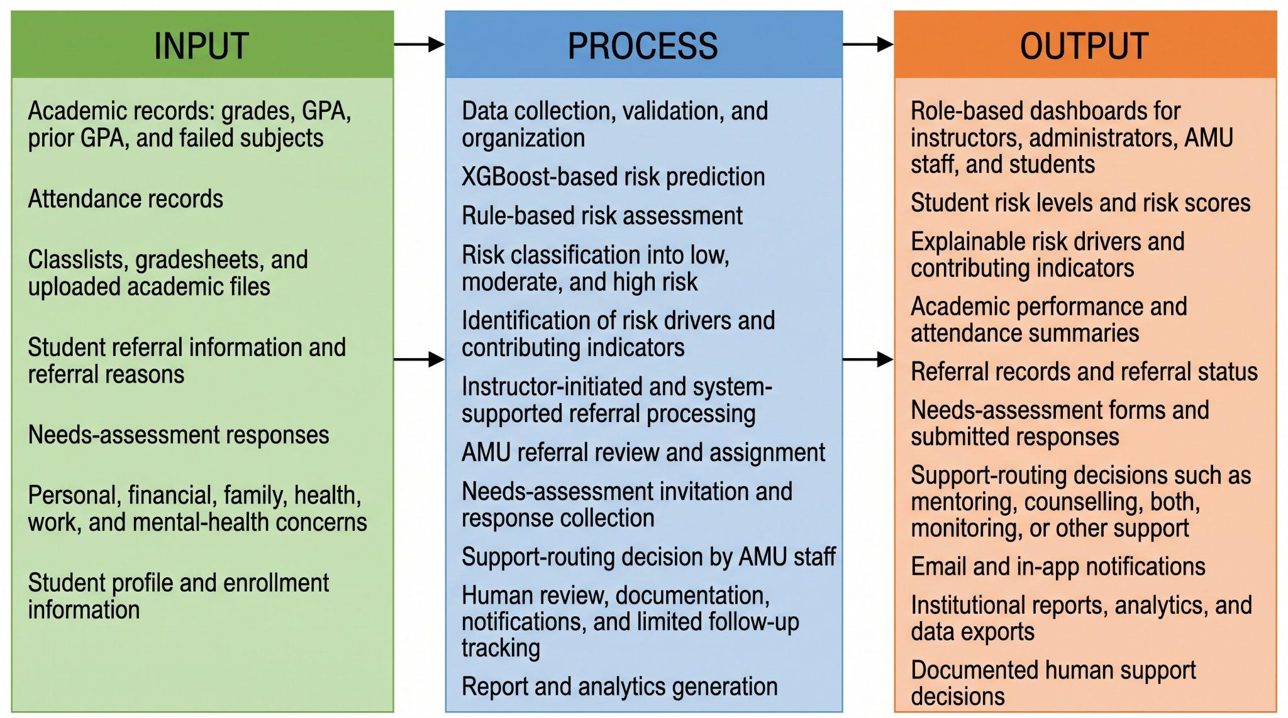

Figure 2-1. Conceptual Diagram of Academic Early Warning System (AEWS)
The Academic Early Warning System (AEWS) is designed as a machine-learning-assisted and role-based web platform that supports the early identification of students who may require academic, personal, or psychosocial support. The system processes structured academic and support-related information, including grades, attendance records, prior GPA, failed subjects, academic performance indicators, referral information, and needs-assessment responses.
Rather than presenting only a single predictive risk score, the system provides explanatory outputs such as risk levels, risk scores, contributing indicators, academic performance weaknesses, attendance concerns, and other relevant risk drivers. These outputs are intended to support informed review and referral decisions; they do not represent confirmed causes or clinical diagnoses. Human decision-making remains central to the planning and delivery of student support.
The system implements role-based workflows for instructors, administrators, AMU staff, and students. Instructors can manage classes, upload classlists, gradesheets, and attendance records, review student risk indicators, generate class-level predictions, and submit academic or support-related referrals. Administrators can manage user accounts, approve or reject account requests, monitor system activity, configure needs-assessment forms, and generate institutional reports.
AMU staff can review assigned referrals, examine student academic and assessment information, send needs-assessment invitations, view submitted responses, generate or review support-related predictions, document support-routing decisions, and produce referral and assessment reports. Students can access their authenticated dashboard, view relevant academic information, receive notifications, and complete assigned needs assessments through the system.
The AEWS supports both machine-learning-based prediction and rule-based or heuristic assessment, depending on the workflow and the availability of student data. Its primary purpose is to assist with early risk identification, referral triage, needs-assessment data gathering, support routing, documentation, and limited follow-up tracking. The system supplements existing university support procedures by providing a centralized, organized, and scalable platform while preserving the authority of instructors, administrators, and AMU staff in making final intervention and support decisions.

Definition of Terms
Table 2-1
Definition of Terms
Term | Definition
Predictive Analysis | The process of analyzing historical institutional student data to generate risk predictions related to academic failure or dropout using machine learning techniques.
Artificial Intelligence | Computer-based methods that enable the Academic Early Warning System (AEWS) to learn from student data and support decision-making in identifying at-risk students.
Early Warning System | An AI-powered platform designed to detect students at risk of academic failure early and to support timely academic and counseling interventions.
Machine Learning | Computational algorithms and statistical models that enable the AEWS to analyze patterns in student data and make predictions without explicit programming.
Student Retention | The continued enrollment and academic persistence of students at Bukidnon State University until program completion, as supported by early risk identification and intervention.
Feature Engineering | The transformation of raw institutional data into meaningful predictive variables, such as GPA trends and engagement momentum, to improve the accuracy of the risk prediction model.
Model Interpretability | The ability of stakeholders to understand how and why the machine learning model generates student risk predictions, supported through SHAP-based explanations.
At-Risk Student | A student identified by the AEWS as having a high probability of academic failure or dropout based on academic, behavioral, and non-academic indicators.
Intervention Protocol | A predefined set of academic or counseling actions automatically recommended by the system when a student is identified as at-risk.
Agile-Scrum Framework | The iterative development approach employed to design, develop, test, and improve the AEWS through time-boxed sprints and continuous stakeholder feedback.

METHODOLOGY
INTRODUCTORY

Materials
This subsection describes key technological and data resources used in the development of the Academic Early Warning System (AEWS), an AI-powered system. It is organized into three key components: a series of software tools and versions that are used for development, analytics, and deployment; the hardware specifications needed for both development (on local PCs) and scalable cloud (the internet); and the institutional data sets that are taken from Bukidnon State University, consisting of academic, behavioral, demographic, and psychosocial indicators. All materials were selected and handled in accordance with relevant ethical and data privacy regulations, especially the Philippine Data Privacy Act of 2012 (RA 10173).

Softwares
Table 3-1
Software Requirements and Versions
Software Name | Version
Python | 3.12 or higher
FastAPI | 0.109+
Uvicorn | 0.27+
React | 18.3.1
Vite | 7.2.4
Node.js | 18 or higher
npm | Compatible with Node.js
Tailwind CSS | 4.1.18
React Router | 6.26.2
TanStack React Query | 5.101.4
MongoDB | Local or cloud-hosted
PyMongo | 4.6+
MongoDB Atlas | Cloud service, optional
Pandas | 2.0+

Hardware
Table 3-2
Hardware Specifications
Hardware Category | Specifications / Purpose
Local Development Workstations | Personal computers or workstations with modern hardware:  • CPU: Intel Core i7 (or equivalent)  • RAM: 16GB minimum  • Storage: SSD (for data processing and model training)
Cloud Infrastructure (Hosting) | Cloud-based Virtual Machines (e.g., AWS EC2 instances) for scalable backend hosting and deployment.
Connectivity | Secure, reliable internet access to facilitate communication between system components and cloud services.

Data
The data used for model development consisted of institutional and system-managed academic records from Bukidnon State University, including attendance records, gradesheet data, and needs-assessment responses. These datasets provided the basis for extracting the deployed model features, including previous GPA, failed subject count, attendance rate, academic challenge score, external factor score, midterm grade, class standing, laboratory grade, and major output grade. The final model-ready dataset contained 1,000 student records after cleaning, matching, normalization, and label preparation.

Methods
This chapter describes the systematic strategy to be used in the design, development and evaluation of the AI-based Academic Early Warning System (AEWS) for Bukidnon State University. It gives details on the materials, software, and hardware configuration that will be used, followed by the research design and development process model for project execution. It goes on to explain the process of data collection, preprocessing, machine learning model development, system integration, as well as detailed evaluation strategies. The methods are designed to meet the specific goals of the study to ensure that there is a robust and user-centered system that will ensure accurate risk prediction and early academic interventions. Through an iterative process of agile development and rigorous testing this chapter provides a clear framework for developing a scalable, reliable, and effective AEWS solution.

Research Design
This study will follow a Design Science Research (DSR) paradigm that is widely used in information systems literature in order to build and evaluate innovative artifacts for solving identified organizational problems. The process will follow the established DSR process model by Peffers et al, which consists of six activities which are sequentially but iterative: Problem Identification and Motivation, Definition of Objectives for a Solution, Design and Development, Demonstration, Evaluation and Communication. Our main artifact is the integrated platform of AEWS software, and the utility of our software will be assessed in its authentic organizational context, the student support framework of Bukidnon State University.
The method of the research would be of mixed type, with a combination of both quantitative and qualitative methods at various stages. A quasi-experimental component will be incorporated in the evaluation phase to compare retention and performance measures of a cohort of students exposed to the AEWS-driven interventions as compared with a similar historical control group from past academic years. Simultaneously, a qualitative case study component will include in-depth, semi-structured interviews and focus group discussions with faculty advisors and AMU staff post-implementation to probe themes of usability, integrating workflow, and perceived effectiveness. This approach is consistent with the philosophy of pragmatism which emphasizes practical solutions and values both objective measures and subjective experiential knowledge in order to fully understand the impact of the artifact.
Ethical considerations will be brought to the front throughout the design. Beyond complying with data privacy laws we will conduct what is called algorithmic impact assessments to proactively review the potential risks of bias or unfair exclusion in the data predictive model. We will also put in place a human-in-the-loop protocol, by which all AI-generated risk flags will be reviewed by a designated staff member to ensure that any type of formal intervention is not triggered unless a human safety net is in place, thereby keeping humans in the loop and accountable for the consequential decisions made that impact students.

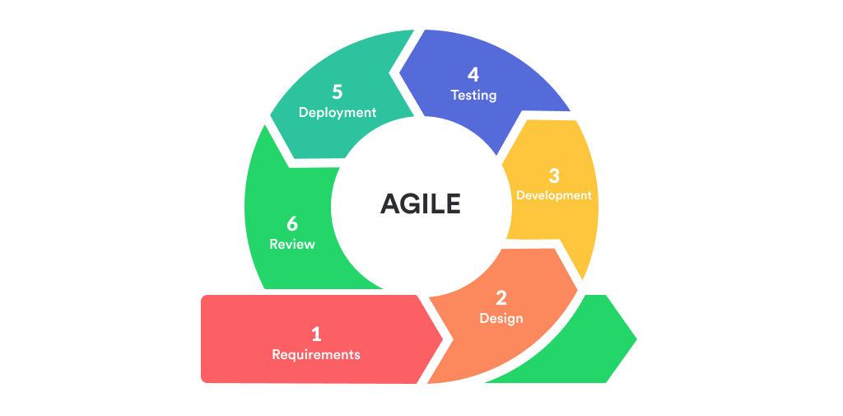
Process Model

Figure 3-1. Agile Methodology Development Lifecycle
The project lifecycle will be managed through a customized version of Agile-Scrum, tailored for use by a small, cross-functional development team, working closely together with a dedicated Product Owner on behalf of BukSU. The process will be organised into ten two-week sprints, with a two-week "Sprint 0" to begin environment set up and architecture planning. Each standard sprint will begin with a Sprint Planning session during which the user stories from the prioritized product backlog will be divided into specific development tasks.
Daily, the team will have 15 minute Stand-up Meetings, following the 3 question templates "What did I get done yesterday?", "What do I plan on doing today?", "Are there any impediments?" A common Scrum Board (via a digital tool such as Jira) that will visualize work progress through "To Do," "In Progress," and "Done" columns. At the end of the sprint, a Sprint Review will take place in the form of a live demonstration to stakeholders, both faculty and AMU personnel, to gain immediate feedback information on the increment. This will be followed by a Sprint Retrospective where the development team will reflect on processes, tools, and interactions in an effort to identify improvements for the next sprint.
Key artifacts will be: (1) the Product Backlog: a dynamic and ordered list of all features desired and the technical debt; (2) the Sprint Backlog: a set of features that is a subset of the Product Backlog, selected for the current sprint; and (3) the Potentially Shippable Product Increment: a fully integrated and tested version of the software, that is growing with each sprint. This iterative approach will permit for early delivery of core functionalities, e.g., the data ingestion pipeline and a basic risk dashboard, to enable validation and course-correction long before the final deployment to reduce project risk and ensure they are aligned with evolving user needs.

Requirements Gathering and Analysis
The requirements engineering phase will employ a multi-modal strategy to capture both explicit needs and latent requirements. We will conduct approximately 15 semi-structured interviews (lasting 45-60 minutes each) with a purposively sampled group of stakeholders. An interview protocol will guide discussions around current monitoring practices, pain points in identifying at-risk students, data accessibility, and desired reporting features.
Concurrently, a document analysis will be performed on the university's official handbooks, the provided AMU policy documents (specifying procedures 2.1, 9.2, and 9.3), and existing student referral forms. This analysis will be used to create detailed use cases and user journey maps that model the current-state and future-state workflows. For instance, a use case titled "UC-REF: Initiate a Mentoring Referral" will detail the actors (instructor, AMCC/SCMC), preconditions, main success scenario, and exceptions, directly informing the design of the automated referral module.
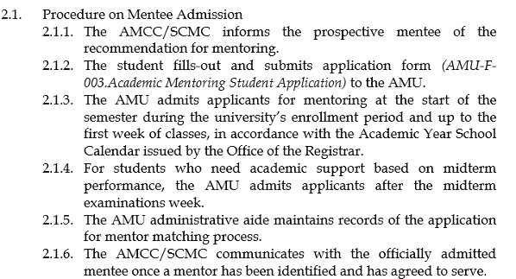

Figure 3-2. AMU Policy Document 2.1
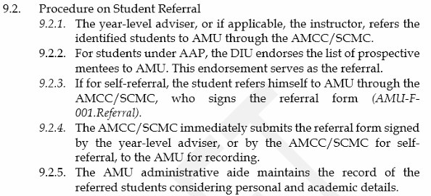

Figure 3-3. AMU Policy Document 9.2
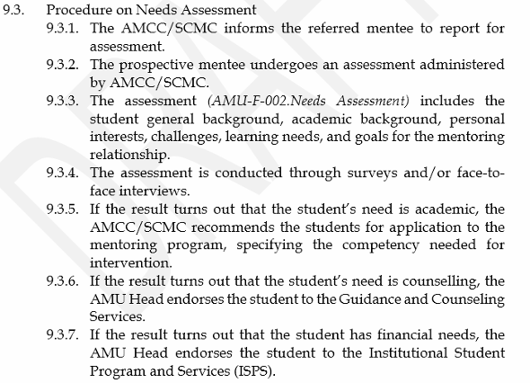

Figure 3-4. AMU Policy Document 9.3
Requirements analysis focused on the academic monitoring and AMU referral workflow currently supported by the institution. Instead of depending on direct live integration with LMS or SIS platforms, the implemented system supports data entry and file-based uploading of classlists, gradesheets, attendance records, and needs-assessment data. This approach was selected to match the available institutional infrastructure and to allow instructors and AMU staff to operate the system even without centralized API access to external university systems. The requirements were therefore centered on practical system functions such as secure account access, class and student management, academic record processing, risk prediction, referral handling, needs-assessment management, notifications, reporting, and activity logging.
The data includes student’s attendance records, gradesheet records, and needs-assessment responses, which were integrated using the common Student_ID field. Student_ID ensures that each student record could be connected across academic performance, attendance behavior, and support-related indicators.
Students’ attendance records were used to determine each student’s attendance rate. Attendance is an important indicator of academic engagement because frequent absences may limit students’ participation in lectures, laboratory activities, assessments, and other course requirements. For the system, attendance data were converted into a numerical attendance-rate feature ranging from 0 to 100 percent. This feature enabled the predictive model to identify patterns between attendance behavior and students’ likelihood of being classified as Low Risk or High Risk.
Gradesheet records were used to represent students’ current and previous academic performance. The extracted academic indicators included previous Grade Point Average (GPA), failed-subject count, midterm grade, class standing, laboratory grade, major output grade, and final grade. Previous GPA and failed-subject count reflected prior academic performance and possible academic difficulties, while midterm grades and other grading components reflected a student’s current performance in the course. The final grade was also used to create the risk label required for supervised machine learning model training.
Needs-assessment responses were used to identify academic and external factors that may affect student performance. Individual responses were analyzed and summarized into two grouped indicators: academic challenge score and external factor score. The academic challenge score represented learning-related concerns, such as difficulty understanding lectures, weak study habits, low motivation, and difficulty with specific subjects. Meanwhile, the external factor score represented non-academic concerns, including financial difficulties, health-related concerns, family issues, part-time work, and mental health-related concerns. These indicators allowed the system to consider circumstances beyond grades and attendance when assessing student risk.
Before model development, the consolidated dataset underwent data profiling to examine its structure, completeness, validity, and consistency. The data requirements included attendance rate, midterm grade, final grade, previous GPA, failed-subject count, and needs-assessment indicators. Attendance values were verified to fall within the valid range of 0 to 100 percent, while grade-related fields were checked for consistency with the BukSU grading scale of 1.00 to 5.00. The datasets were also checked for missing values, duplicate records, and inconsistencies after integration through Student_ID.
The profiling results showed that the prepared training dataset contained 1,000 student records. After validation and preprocessing, no missing values remained in the model-ready dataset. The class distribution consisted of 410 Low Risk records and 590 High Risk records. These results indicate that the dataset was complete, valid, and suitable for feature extraction and student-risk prediction.
After profiling and validation, the raw institutional records were transformed into numerical features suitable for the XGBoost classification model. The engineered features included previous GPA, failed-subject count, attendance rate, academic challenge score, external factor score, midterm grade, class standing, laboratory grade, and major output grade. These features were selected because they represented meaningful academic, behavioral, and personal indicators related to student performance and potential academic risk.
The final grade was used to generate the supervised risk label for model training. Students with final grades from 1.00 to 2.25 were labeled as Low Risk, while students with final grades from 2.50 to 5.00 were labeled as High Risk. This classification followed the BukSU grading scale, in which higher numerical grades indicate weaker academic performance.

Table 3-3
Functional Requirements of AEWS
Feature Name | Requirement Description
Authentication and Account Access | The system shall allow users to sign up, verify email accounts, log in, reset passwords, and access features based on their assigned role.
Role-Based User Management | The system shall manage user accounts for admin, instructor, and AMU staff, enforce role-based permissions, and allow administrators to approve or reject pending accounts.
Class Management | The system shall allow instructors to create, manage, archive, and view class records assigned to them.
Student Enrollment Management | The system shall allow instructors to add students individually or by batch, update enrollment records, and maintain student lists per class.
Grades Management | The system shall allow instructors to upload, encode, and update student grades, including midterm, final, previous midterm, and previous final academic records.
Attendance Management | The system shall allow instructors to upload, record, and manage student attendance data for each class.
Risk Prediction | The system shall calculate student risk scores using the integrated XGBoost-based prediction model and classify students according to risk level.
Risk Analysis Display | The system shall display prediction results, contributing risk factors, and academic indicators to support early identification of at-risk students.
Instructor Dashboard | The system shall provide instructors with a dashboard showing class summaries, student risk status, alerts, and student performance details.
Admin Dashboard | The system shall provide administrators with an institutional dashboard showing total students, at-risk students, instructors, alerts, departments, and other system analytics.
AMU Staff Dashboard | The system shall provide AMU staff with a dashboard showing assigned referrals, student risk cases, submitted assessments, and intervention-related records.
Automatic Referral Management | The system shall automatically flag and refer students for mentoring when predefined academic risk conditions are met.
Manual Student Noting and Flagging | Instructors shall be able to attach anecdotal notes, encode referral reasons, and manually flag students for AMU attention directly within the student dashboard.
AMU Workflow Integration | The system shall support AMU referral processing, assignment of cases to AMU staff, needs assessment handling, and intervention routing in alignment with institutional AMU procedures.
Needs Assessment Management | The system shall allow AMU staff to send needs assessment invitations and allow students to submit needs assessment forms through a secure public link.
Needs Assessment Form Administration | The system shall allow administrators to manage, update, and reset the default needs assessment form used by the AMU workflow.
Notifications and Alerts | The system shall send in-system notifications and alerts to relevant users for account approvals, student referrals, and other important actions.
Intervention and Support Routing | The system shall allow AMU staff to review referrals, record support actions, and save final intervention or routing decisions for student cases.
Reporting | The system shall generate role-based reports for instructors, AMU staff, and administrators to support monitoring and decision-making.
Activity Logging | The system shall track important user and system activities for monitoring and accountability purposes.
Search and Filtering | The system shall allow authorized users to search, filter, and review students, referrals, classes, and related records efficiently.
Archive Management | The system shall preserve archived classes and related records while keeping them separate from active operational data.

Design

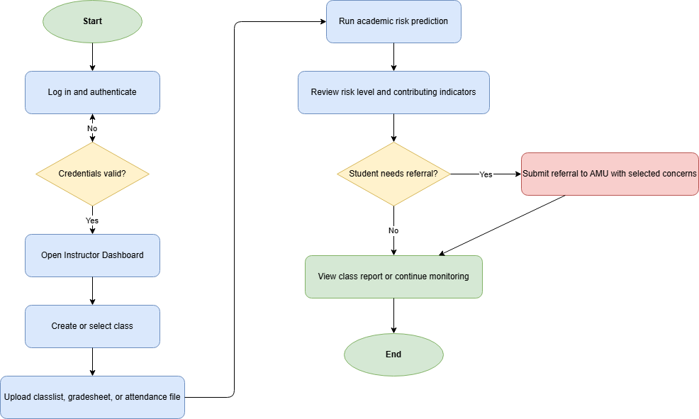

Figure 3-5. Instructor Workflow

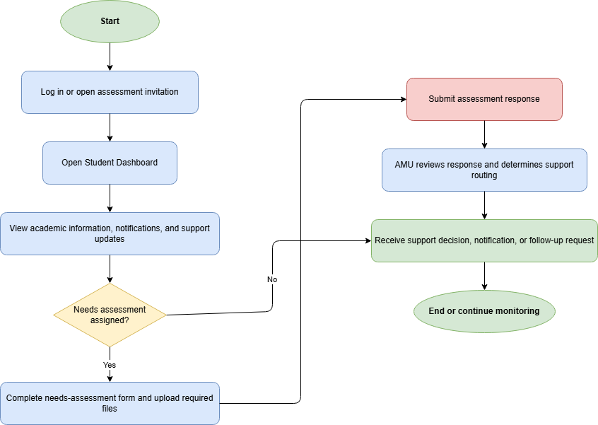

Figure 3-6. Student Workflow

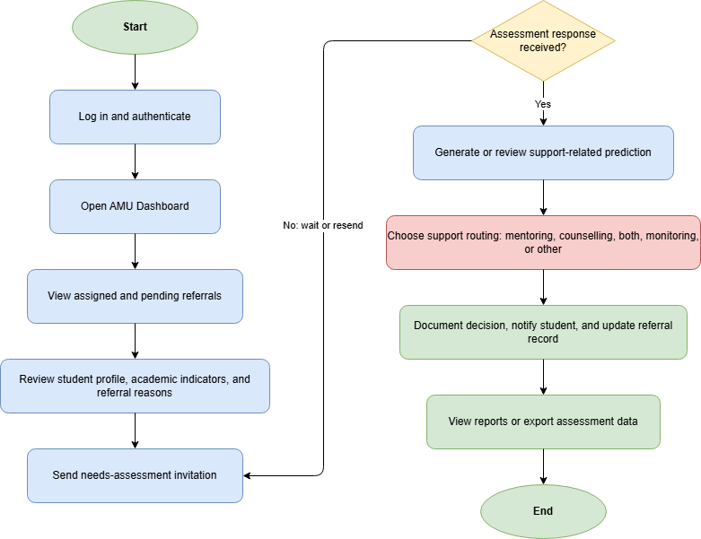

Figure 3-7. AMU-Staff Workflow

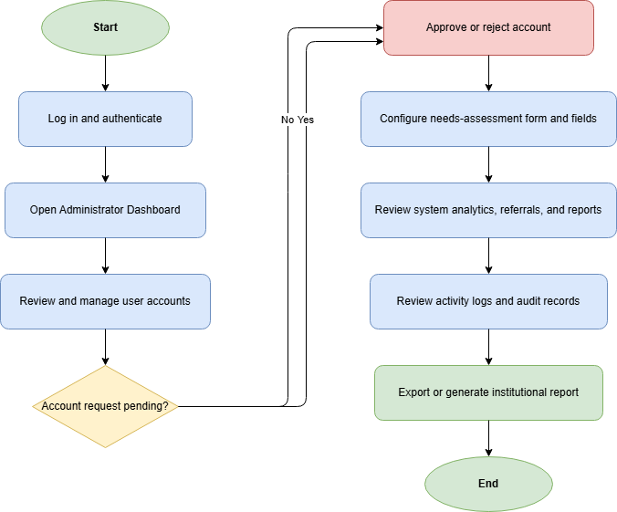

Figure 3-8. Administrator Workflow
The proposed system uses a layered web application architecture composed of a React and Vite frontend, a FastAPI backend, a MongoDB database, and supporting email and notification services. The frontend provides role-specific dashboards and workflows for instructors, AMU staff, administrators, and students. The backend manages authentication, authorization, data processing, prediction requests, referrals, needs-assessment handling, notifications, reports, and activity logs through REST API endpoints. This architecture allows the system to organize academic monitoring and referral processes within a centralized platform while remaining feasible for the available institutional infrastructure.
The Data Ingestion component allows authorized users to upload and process academic records such as classlists, gradesheets, attendance files, and needs-assessment data. Uploaded files are validated, parsed, matched to student records, and stored in the centralized database for use in dashboards, referral processing, and predictive analysis. This file-based approach supports the current operational setting where direct LMS or SIS integration is not yet available, while still allowing the system to consolidate key student information for early warning and AMU workflow support.
The Machine Learning component uses the prepared student records to classify academic risk through the integrated XGBoost model. The deployed model uses structured features extracted from academic records, attendance data, and needs-assessment responses. The prediction output is presented as a risk classification with supporting indicators and explanation factors that help authorized users understand the possible basis of the result. The prediction serves as decision support and is interpreted together with referral criteria, academic indicators, and AMU review.
The current AEWS employs both automated academic trigger checks and instructor-based manual referral as to whether or not there ought to be an initiation of intervention workflow. In cases where referral conditions have been achieved the system captures the case and archives the reasons for referrals, sets the relevant staff member of AMU depending on the relevant college and creates notifications that can help in the timely taking of action and documentation. Post-referral, the system facilitates structured needs-assessment processes, with the help of configurable digital forms. Rather than processing anecdotal notes with the natural language processing, the current implementation used to rely on the structured student responses and academic indicators recorded to help the AMU staff consider every case and identify the optimal course of supporting action.
The AEWS workflow is designed to align with the formal Academic Monitoring Unit (AMU) process through the following implementation:
Table 3-4
AEWS Implementation of AMU Process Steps

AMU Process Step | AEWS Implementation
1. Identification | Academic risk identification through uploaded grade, attendance, and needs-assessment data, supported by XGBoost-based prediction and institutional grade-threshold checking
2. Referral | Automatic and manual referral generation, with referral reasons recorded and routed to AMU staff based on the relevant college
3. Needs Assessment | Configurable digital needs-assessment forms sent through tokenized links or uploaded directly by authorized personnel
4. Intervention | AMU staff review of student records, prediction indicators, and needs-assessment responses to determine the appropriate support route
5. Tracking & Follow‑up | Saved case records, support-routing decisions, notifications, activity logs, archive management, and dashboard monitoring

This structured integration ensures that the AEWS supports rather than replaces existing AMU protocols, enabling scalable, data‑informed case management.
The Notification Service provides timely notification of advisors and administrators via email and in-application notifications. Messages are role specific, and provide direct links to relevant student profiles or intervention records, so that staff can take immediate and informed action.
The Dashboard and Reporting component serves as the main user interface for monitoring and decision-making. Instructors can view class records, student lists, grades, attendance, risk indicators, and referral status. AMU staff can review assigned referrals, needs-assessment status, prediction results, and saved support-routing decisions. Administrators can monitor users, pending account approvals, student records, system analytics, needs-assessment form configuration, activity logs, and institutional reports. Students can access a limited dashboard for viewing relevant information and completing assigned needs assessments.
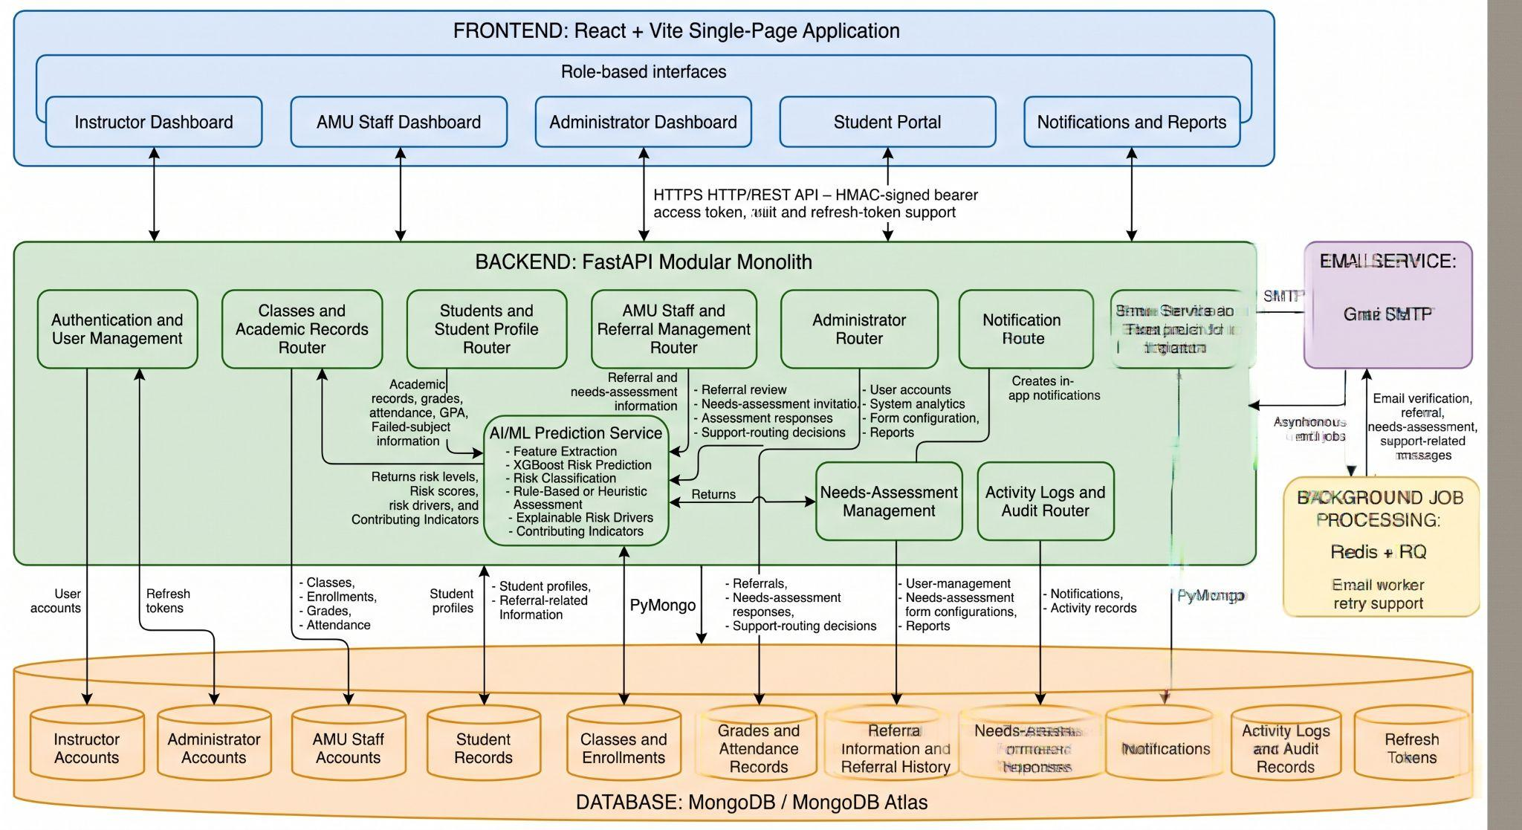

Figure 3-9. System Architecture Diagram
The Academic Early Warning System (AEWS) was designed as a secure web-based platform for managing student academic records, attendance information, needs-assessment responses, referrals, and intervention decisions. The system supports the early identification of students who may be at academic risk while ensuring that sensitive student information is accessed only by authorized personnel.
The system adopted a layered architecture composed of a React and Vite frontend, a FastAPI backend, a MongoDB database, and an integrated email notification service. The frontend provided role-specific dashboards and interfaces for system users. The backend handled business rules, security validation, risk prediction requests, and access control. MongoDB served as the centralized storage for student profiles, gradesheets, attendance records, needs-assessment responses, referrals, support-routing decisions, and activity logs. The email notification service supported the sending of account verification messages, needs-assessment invitations, referral notifications, and other workflow-related updates.
The AEWS implemented role-based access control to ensure that users could access only the functions and information appropriate to their institutional duties. The system recognized four primary user roles: instructors, AMU staff, administrators, and students. Instructors were authorized to manage class rosters, upload attendance and gradesheet records, review academic indicators, and submit student referrals. AMU staff were authorized to review student referrals, manage needs-assessment invitations, analyze student-risk information, and document intervention-routing decisions. Administrators were responsible for managing user accounts, configuring needs-assessment forms, reviewing analytics, and monitoring system activity logs. Students were limited to accessing their own personal dashboard, viewing notifications and academic progress, and completing assigned needs assessments.

Development
The development of the Academic Early Warning System (AEWS) is going to cover the web-based system and the predictive analytics component in order to provide an integrated platform of early identification, referral and tracking of students that may need academic assistance. The system will be built on the basis of the role-based web app, which will accommodate the administrators, instructors, and Academic Mentoring Unit (AMU) staff. It will be developed based on its operational usability, security, and alignment with the reality of the workflow of academic monitoring and referral at the campus.
The system web development will start by implementing the core user management and access control functionalities. The system will accommodate registering of accounts, verifying emails, logging on, and password recovery, and role-esteemed authorizing of administrators, instructors, and AMU personnel. Once the authentication and access control are done, the next step in the development implementation will focus on the implementation of key operational modules, such as class management, student enrollment, grade management, attendance management, dashboards, notifications, activity logs, reporting, and AMU referral handling. These modules will also be incorporated so that the academic records, prediction outcomes and referral action will not be taken through individual processes that are not tied together.
The web system will enable the instructor-facing functions of the web system to manage classes, student records, grade uploads and attendance uploads. These elements will also enable the displaying of the student performance recaps and the risk-based workouts developed by the predictive model. Also, educators will be able to encode anecdotal notes, specify the reasons for referral, and manually mark students that need AMU attention when needed. The facing components of AMU will help in the review of referred students, an invitation to take needs assessment, monitoring needs assessment or assessment submitted, and recording routing decisions of intervention or support. The functionalities that will be available to the administrators will include dashboards, an overview of analytics, the tools to approve the accounts, the form administration to find out the needs assessment and the monitoring of the institutions at the institutional level.
To provide the close integration with the academic monitoring workflow, the predictive analytics will be designed simultaneously with the web application. XGBoost shall be the main machine learning framework since it will deliver a high performance when dealing with structured tabular datasets, and will be applicable in classification tasks such as predicting academic risk. The model will be implemented into the web-based AEWS, whereby the outcomes of the predictions will be delivered in the dashboards and at the student-level data as seen by the authorized users.
The predictive component will use structured scholarly and attendance related information to be prepared in the data preparation process, which will be operationally available in the system. These sources will consist of past academic records, present class performance record, attendance data and institutional referral-related conditions. The encoding and uploading of these data will be supported by the use of the web interface, and the work on the preprocessing of the data (cleaning, normalization, validation, and feature preparation) is going to be conducted. Instead of leveraging more general live integrations, like LMS engagement streams or externally available psychosocial data-sets, feature engineering will focus on indicators available in the system.
The predictive component should be interpretable, and SHAP analysis will be included in the process of developing the model. The contribution of single features to the risk predictions will be explained by SHAP to enhance the level of transparency in the model and improve the informative decision-making of instructors, administrators, and AMU staff. The analysis using SHAP will enable the system to display the key variables that lead to a predicted level of risk of a student allowing users to comprehend more clearly the foundation of the prediction and to relate it to the situation they can observe in their academic environment. It is this interpretability component that will help solidify the usefulness of the model by, to a greater extent, making predictions accessible and actable within the referral workflow.
The XGBoost model will be trained to classify students based on the risk level after the preparation of features and model training. The system will assume that the prediction output will be a decision-support mechanism in the system and will be presented in the proper dashboard and student detail view. The system will also aid model-based prediction with predictive outputs and an institutional academic threshold applied to post-premature identification and AMU referral workflow that will become a hybrid early warning workflow where predictive outputs and academic policy-based academic thresholds will collaboratively help to make early identification and AMU referral decisions.
Though the more general conceptual design will address larger scale analytics and other external data sources, the deployed version of the system will still stick with more practical deployment, workflow integration, and support to institutional academic monitoring. The AEWS thus shall become an integrated web-based decision-support/referral management platform, blending role-based system support, predictive risk categorization, SHAP based interpretability and AMU workflow support within a single operating context. Note: In the predictive aspect of the system, the table below will contain a synopsis of the most important attributes.
Table 3-5
Key Attributes of the Predictive Component

Category | Feature Name | Description | Purpose
Academic Performance | previous_gpa | GPA from the previous academic term | Will provide a baseline measure of prior academic performance
 | failed_subject_count | Number of failed subjects from the previous term | Will identify students with recent academic difficulty
Class Performance | midterm_grade | Student’s current midterm grade in the class | Will support early identification of academic difficulty
 | class_standing | Current class standing score or equivalent class-based metric | Will measure student performance in class requirements
 | laboratory | Current laboratory performance score, if applicable | Will reflect practical or skills-based course performance
 | major_output | Current major output or project score, if applicable | Will capture performance in major assessed outputs
Attendance Indicators | attendance_rate | Percentage of attended class sessions | Will measure consistency of class participation
 | attendance_risk_index | Derived attendance-based risk value from attendance records | Will strengthen early detection of attendance-related risk
Referral Policy Flags | grade_2_5_or_below | Indicator showing that the student has reached the institutional grade threshold | Will support automatic AMU referral decisions
 | on_probation_status | Indicator showing that the student is under probationary status | Will identify students requiring closer monitoring
 | low_midterm_academic_performance | Indicator showing low midterm academic performance based on institutional rules | Will trigger early support review
 | difficulty_catching_up | Indicator showing that the student is experiencing difficulty catching up with lessons | Will support referral and intervention decisions

Machine Learning Model Optimization with XGBoost
The predictive analytics component of the AEWS utilizes Extreme Gradient Boosting (XGBoost), an ensemble machine learning algorithm suitable for structured tabular datasets. The model is designed to classify students into binary risk categories: Low Risk (Label 0) for students with final grades from 1.00 to 2.25, and High Risk (Label 1) for students with final grades from 2.50 to 5.00. This labeling rule follows the BukSU grading scale, where higher numerical grades indicate weaker academic performance.
The deployed model uses nine core predictive features available through the implemented AEWS workflow. These features are previous GPA, failed subject count, attendance rate, academic challenge score, external factor score, midterm grade, class standing, laboratory grade, and major output grade. The features are extracted from uploaded gradesheets, attendance records, and needs-assessment responses, allowing the system to generate predictions without relying on live LMS or SIS integration.
Before prediction, uploaded records undergo cleaning, normalization, matching, and validation. Student identifiers are standardized, numeric fields are converted into model-ready values, attendance rates are normalized into a consistent percentage format, and grade values are interpreted according to the BukSU 1.00 to 5.00 grading scale. Needs-assessment responses are converted into academic challenge and external factor scores based on selected student responses. These preprocessing steps ensure that the input supplied to the XGBoost model is consistent with the feature structure used during model development.
The model was evaluated using standard classification metrics generated from the saved model evaluation results. The selected student-risk model achieved 97.5% holdout accuracy, with weighted precision, recall, and F1-score values of approximately 0.975. Cross-validation results were also recorded to support the reliability of the model evaluation. These results indicate that the model performed consistently in classifying student risk using the available structured academic and needs-assessment data.
Model interpretability was supported through SHAP-based analysis during model evaluation. SHAP was used to examine the contribution of each input variable to the trained XGBoost model and to identify which features had the strongest influence on risk classification. In the deployed system, prediction explanations are presented through interpretable contributing indicators such as previous GPA, failed subject count, attendance rate, midterm grade, class standing, laboratory grade, major output grade, academic challenge score, and external factor score. These explanations help users understand the basis of the prediction while preserving human judgment in final referral and support decisions.
The predictive component is integrated into the AEWS as a decision-support tool rather than as an automatic decision-maker. Prediction outputs are interpreted together with institutional referral criteria, uploaded academic records, needs-assessment responses, and AMU review. This design allows the system to support early identification and referral prioritization while ensuring that instructors, administrators, and AMU staff remain responsible for reviewing student cases and determining appropriate support actions.

Testing
The testing of the Academic Early Warning System (AEWS) will be conducted to thoroughly evaluate both the functional integrity of the web-based application and the correctness and reliability of the machine learning–based academic risk prediction process. This testing phase will aim to ascertain that student academic data will be processed without errors, that the trained XGBoost model will compute valid risk probabilities, and that these probabilities will be correctly interpreted as academic risk classifications appropriate for early intervention. The testing approach will employ unit testing, integration testing, system testing, and predictive performance validation to ensure that the AEWS will operate correctly as a unified decision support system.
Unit testing will primarily focus on the data preprocessing and prediction components of the AEWS. Student attributes such as grades, attendance records, academic history, and other relevant indicators will be reviewed to ensure proper handling prior to prediction. Raw input data will be validated for completeness and consistency, and missing or anomalous values will be addressed using predefined preprocessing rules to prevent bias in model outputs. Numerical attributes will be normalized when necessary, while categorical variables will be transformed into numerical representations compatible with the XGBoost model. These steps will ensure that each student record will be accurately transformed into a feature vector x suitable for machine learning inference. Successful unit testing will confirm that the input features supplied to the model will faithfully represent the underlying academic data.
Predictive processing in the current system is used primarily as decision support rather than as a stand-alone operational risk-scoring mechanism. While model confidence values may still be generated internally by the classifier, the deployed application now emphasizes outputs that are more directly actionable in the referral workflow, such as likely risk source, contributing indicators, academic and external drivers, and referral support context. As a result, operational decisions in the system are no longer based solely on fixed dashboard thresholds for low, moderate, and high risk. Instead, prediction results are interpreted together with recorded academic indicators, referral criteria, needs-assessment responses, and AMU review processes.
Integration testing in the current AEWS focuses on the correctness of the full workflow from data input to case handling. This includes verifying that uploaded academic files are correctly parsed, matched to student records, and transformed into supported model inputs; that predictive outputs are generated without error; and that referral, notification, and AMU-related records are correctly saved in the database. System testing also covers role-based access, referral assignment, needs-assessment invitation delivery, tokenized public form submission, support-routing persistence, and activity logging. Predictive performance remains an important part of evaluation, but in the deployed system it is complemented by workflow validation to ensure that model outputs are translated into usable, documented, and actionable intervention processes. This comprehensive testing approach ensures that the system is capable of supporting timely and data-driven academic interventions in real-world educational settings.

Evaluation
The evaluation of the AEWS will be carried out with the purpose of checking if the system will be effective in its purpose to identify at-risk students accurately and support early academic intervention. The four key areas observed in the evaluation framework will be system functionality, predictive performance, usability, and institutional relevance.
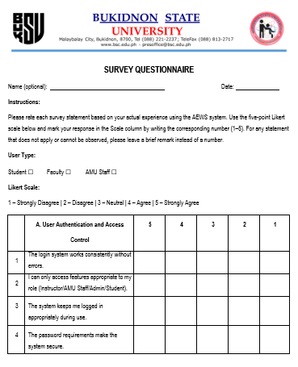

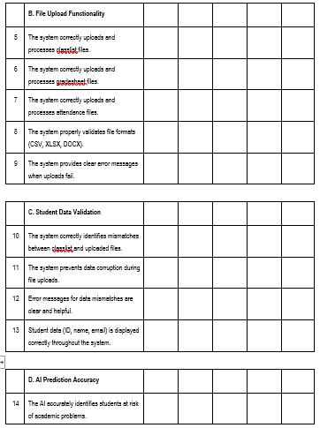
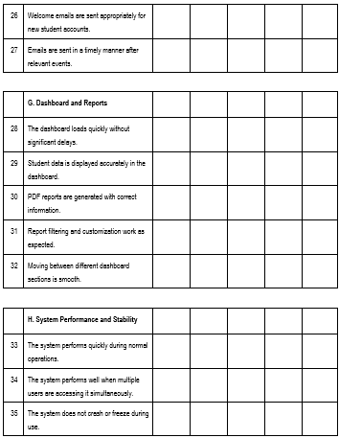

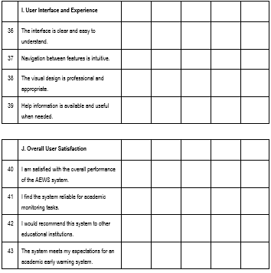

Figure 3-10. Survey Questions
System functionality will be assessed by comparing the features implemented with the system requirements so that the essential system functions like student data management, risk prediction, and dashboard visualization will be fully operational and consistent with the desired way that the AEWS will be used.
The predictive performance of the XGBoost model will be measured with the help of precision, recall and F1-score values. These metrics will be calculated based on the confusion matrix which will be obtained by comparing the actual student academic outcomes to the model's predictions in the test dataset. Recall will measure the effectiveness of the system in determining which students will be in actual danger and precision the accuracy of the system's alerts about the students being in danger and the F1-score a way of measuring the predictive ability of the system as a whole. These metrics will enable the study to objectively determine whether the machine learning model will be effective in achieving the target of early and reliable identification of the academic risk.
User centered evaluation will be based on the result of User Acceptance Testing. The System Usability Scale (SUS) questionnaire will be used to measure overall usability, while interviews and open-ended feedback will be used to measure the clarity of the dashboard, the usefulness of the risk indicators and the practicality of the system in real academic workflows.
Finally, the institutional impact of the AEWS will be assessed by analyzing the support by the AEWS to a timely identification of struggling students and the initiation of academic interventions, especially those managed by the Academic Monitoring Unit. The indicators of early identification of at-risk students, timely referrals and actions being taken to support it will be used to establish whether the system will contribute to better academic monitoring and student retention.

RESULTS AND DISCUSSION
This chapter discusses the findings and analysis of the developed Academic Early Warning System (AEWS). It covers the analysis of student data, system development, integration of the XGBoost prediction model, and evaluation of the system’s performance. It also highlights how the system helps identify students who may be at academic risk and supports authorized personnel in providing appropriate interventions.

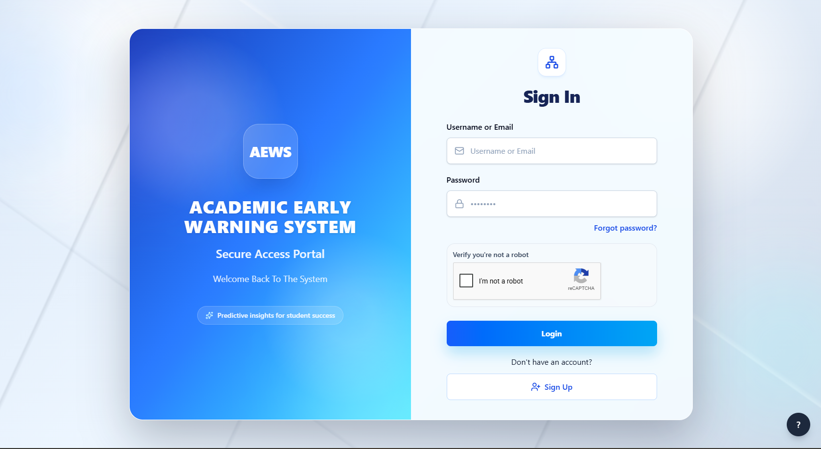
Role-Based Web System for Early Warning Analytics

Figure 4-3
AEWS Login Page

Figure 4-3 shows the login page of the Academic Early Warning System (AEWS), where authorized users can securely access the system using their username or email and password. The system supports three main user roles: Administrator, Instructor, and Academic Mentoring Unit (AMU) Staff, with access to features based on their assigned responsibilities. The login page also includes password recovery, CAPTCHA verification, and account registration features to support account security and accessibility. This serves as the main entry point for authorized users to access the system’s functions and manage student-related information.
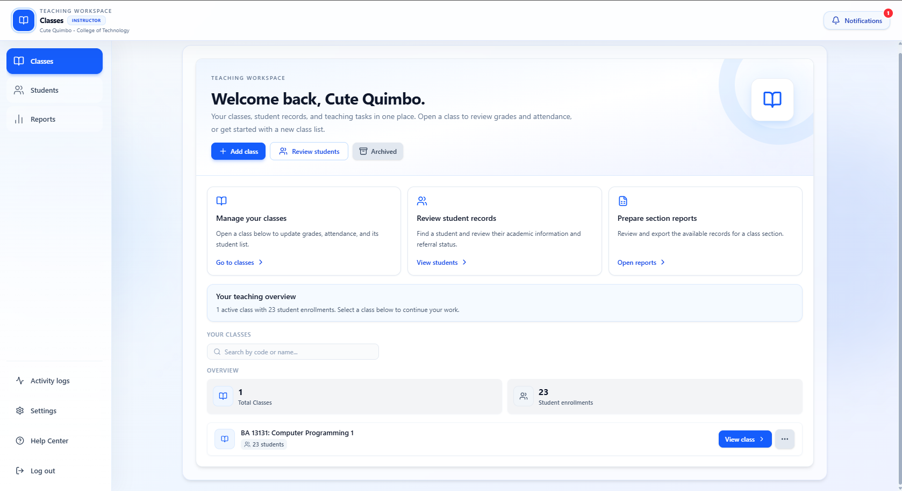
Figure 4-4
Instructor’s Landing/Dashboard Page
Figure 4-4 shows the instructor dashboard of the Academic Early Warning System (AEWS). It provides instructors with a centralized workspace for managing classes, reviewing student records, and preparing class reports. The dashboard displays an overview of the instructor’s classes and student enrollments, with options to add classes, search for specific subjects, and access student information. It also includes activity logs, settings, notifications, and help features to support daily teaching tasks. This dashboard helps instructors organize academic records and monitor student information more efficiently.

Figure 4-5
Instructor Add Class Interface
Figure 4-5 shows the Add Class interface, which allows instructors to upload class lists in CSV, XLSX, or DOCX format. The system automatically extracts the section code, subject code, and subject name to create class records, reducing manual data entry and simplifying class management.
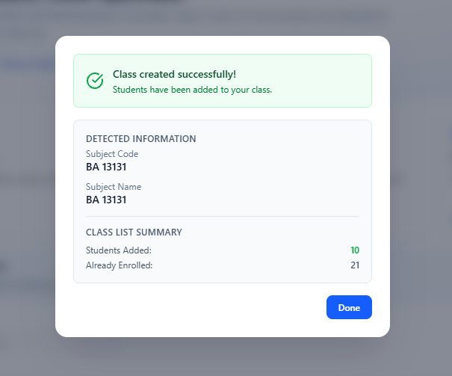
Figure 4-6
Class Creation Confirmation
Figure 4-6 shows the confirmation message displayed after a class list is successfully uploaded. It presents the detected subject information, the number of students added, and the number of students already enrolled in the class. This feature allows instructors to verify the uploaded class information and confirm that the student records have been added successfully.
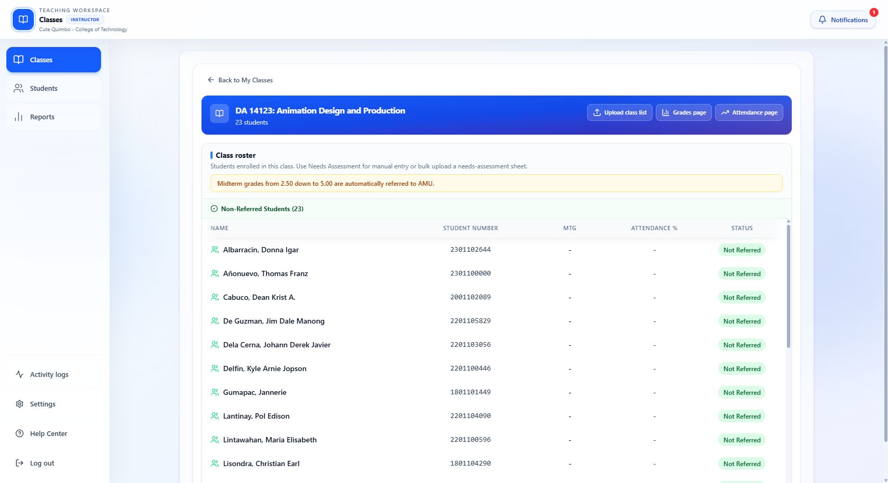
Figure 4-7
Class Roster After Class Creation
Figure 4-7 shows the class roster page displayed after successfully creating a class in Figure 4-6. It presents the enrolled students, including their names, student numbers, midterm grades, attendance percentages, and referral status. This page allows instructors to verify the uploaded class list and monitor student records. It also provides options to upload class lists and access the grades and attendance pages for further academic monitoring.

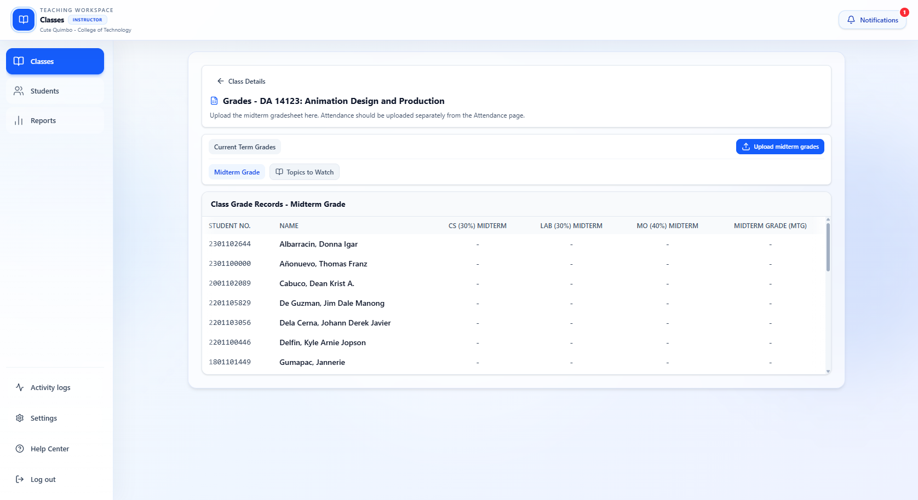
Figure 4-8
Student Grade Upload Interface
Figure 4-8 shows the interface where instructors can upload students’ midterm grades for a selected class. The page displays the enrolled students and their corresponding grade components, including class standing, laboratory grade, and major output. Through the Upload Midterm Grades button, instructors can upload the gradesheet to update student records and support academic performance monitoring.
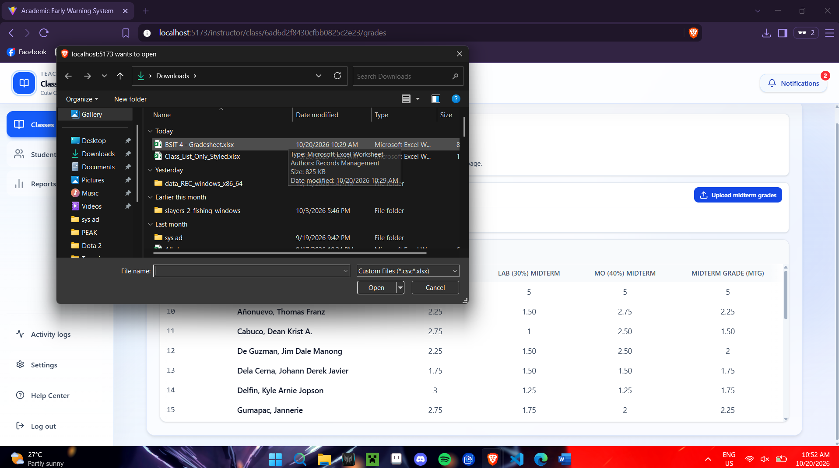
Figure 4-9
Midterm Gradesheet Upload Interface
Figure 4-9 shows the midterm gradesheet upload process, where instructors select an Excel file containing students’ grades from their computer. The uploaded file provides the students’ class standing, laboratory grades, major output grades, and computed midterm grades. This feature allows instructors to update academic records efficiently and provides the necessary grade information for identifying students who may require academic support.
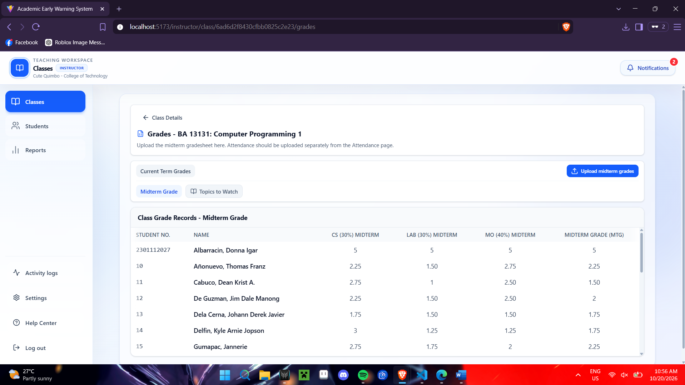
Figure 4-10
Uploaded Midterm Grades Display
Figure 4-10 shows the grade records page after the midterm gradesheet has been uploaded. The table displays each student's student number, name, class standing, laboratory grade, major output grade, and computed midterm grade. This interface allows instructors to review the uploaded grades and verify the recorded academic performance of students.
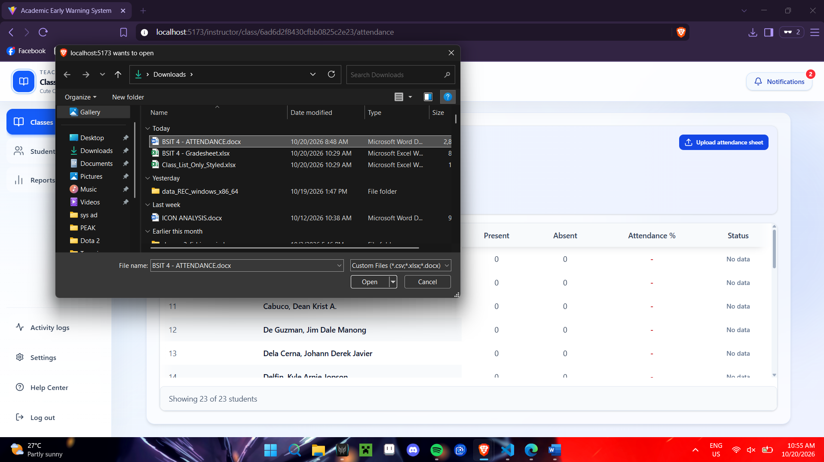
Figure 4-11
Attendance Sheet Upload Interface
Figure 4-11 shows the attendance sheet upload interface, where instructors can select an attendance file from their computer. The uploaded file is used to update students’ attendance records, including the number of days present, days absent, and attendance percentage. This feature helps instructors maintain organized attendance records and monitor student attendance for academic performance tracking.
DRIA NA PUTOL ANG SA INTRUCTOR

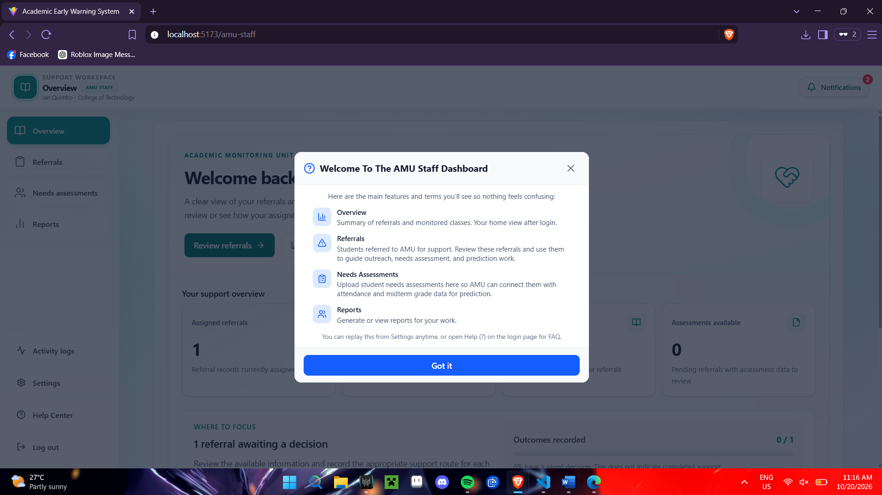
Figure 4-12
AMU Staff Dashboard Welcome Guide
Figure 4-12 shows the welcome guide for the AMU Staff Dashboard. It introduces the main features of the dashboard, including Overview, Referrals, Needs Assessments, and Reports. These features allow AMU staff to review referred students, upload needs assessment data, monitor academic information, and generate reports to support appropriate student interventions.

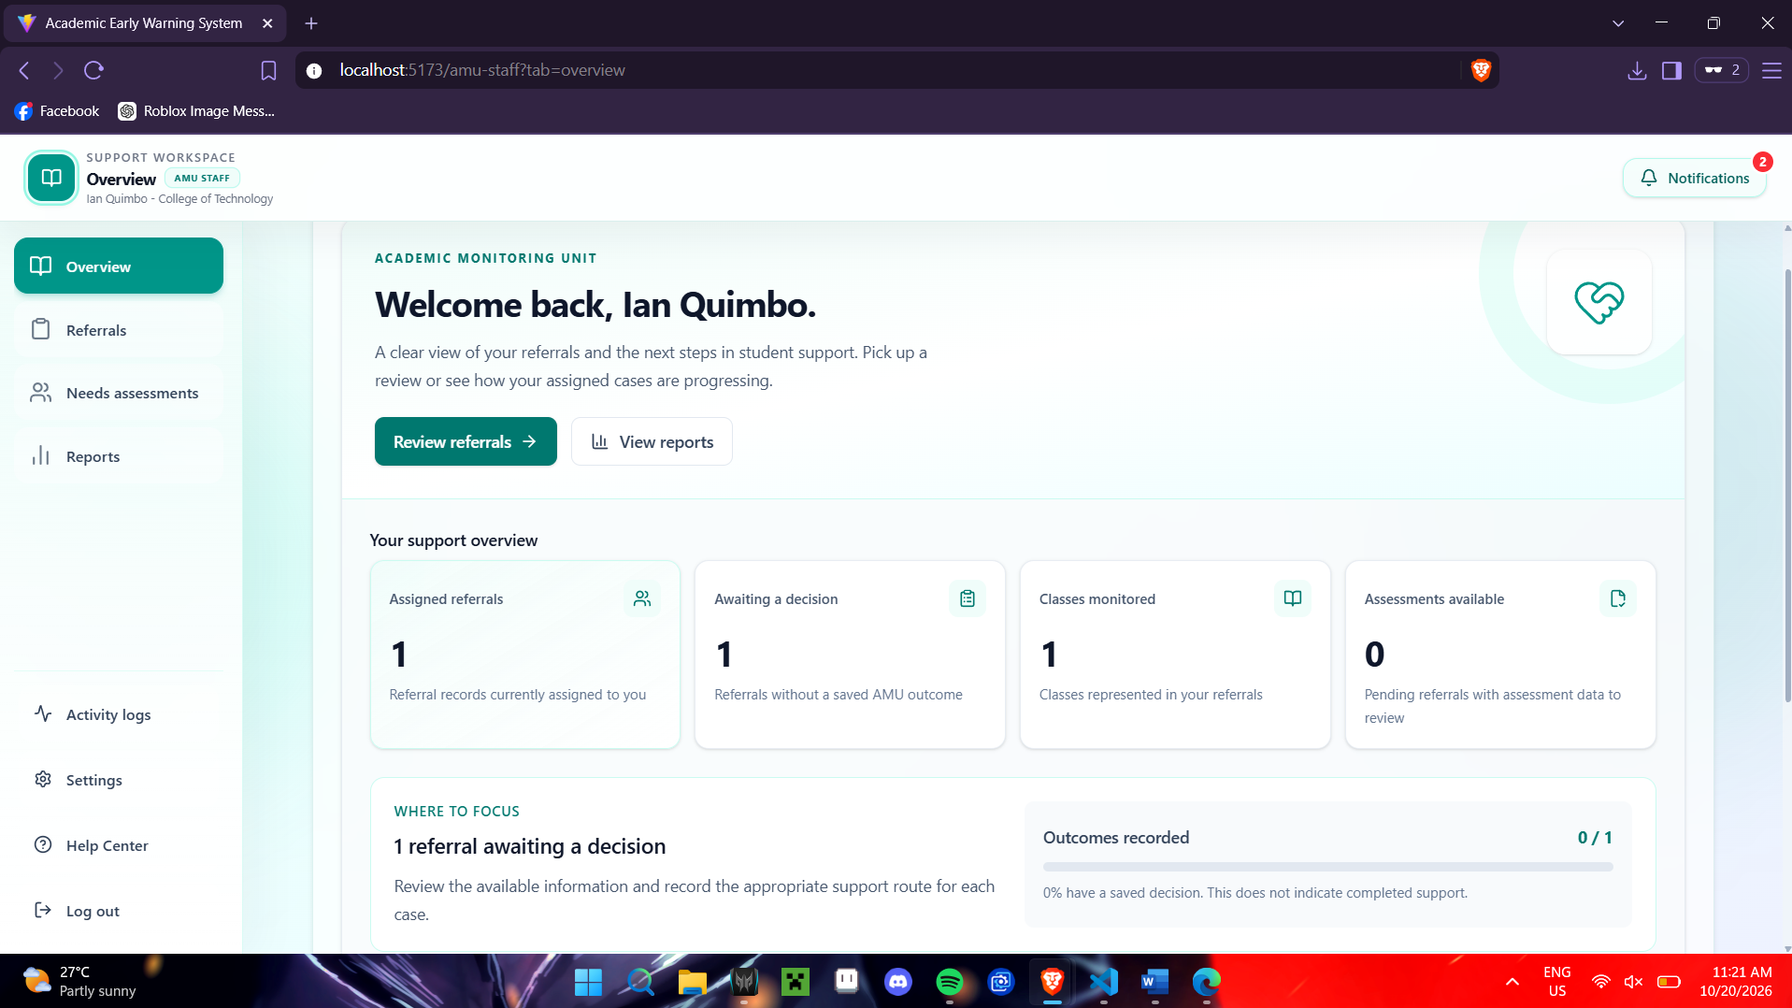
Figure 4-13
AMU Staff Dashboard Overview
Figure 4-13 shows the overview page for AMU staff, providing a summary of assigned referrals, cases awaiting decisions, monitored classes, and available assessments. It also highlights referrals that require action and displays the progress of recorded outcomes. This interface helps AMU staff prioritize student cases, review referrals, and monitor the status of academic support activities.

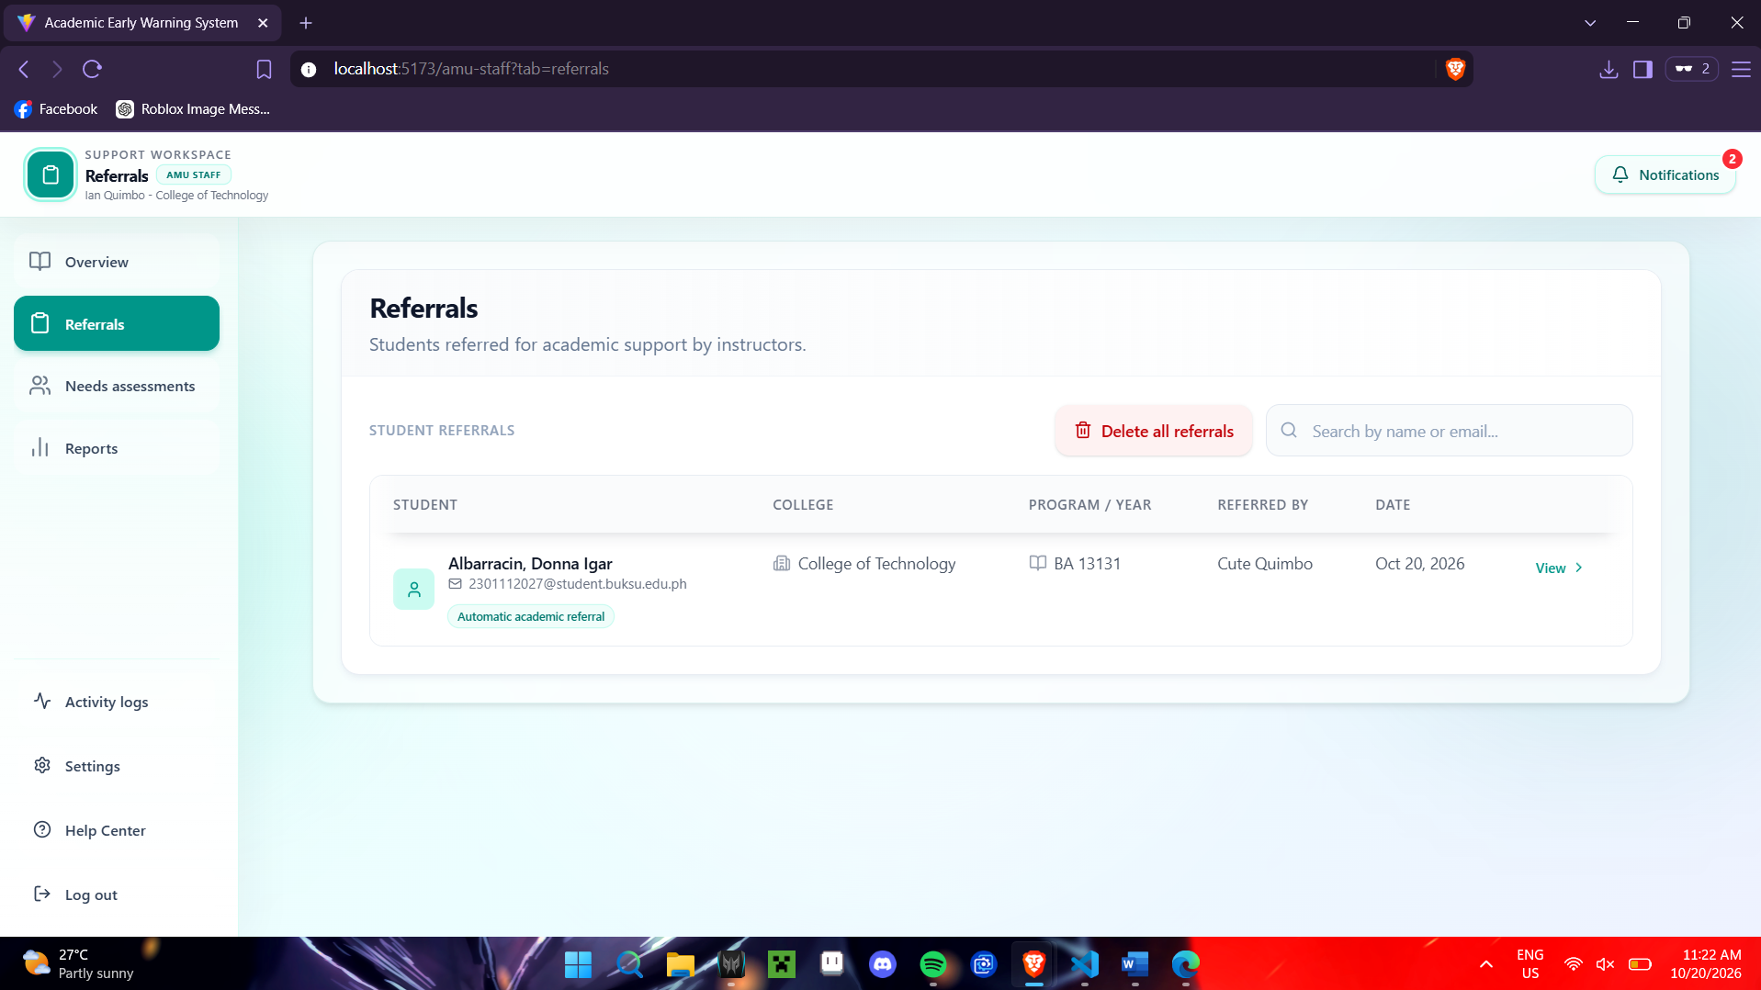
Figure 4-14
Student Referrals Interface
Figure 4-14 shows the student referrals page, which displays students referred by instructors for academic support. It presents each student's name, email address, college, program and year, referring instructor, and referral date. The interface also provides search and viewing options, allowing AMU staff to locate student records and review referrals for appropriate follow-up.
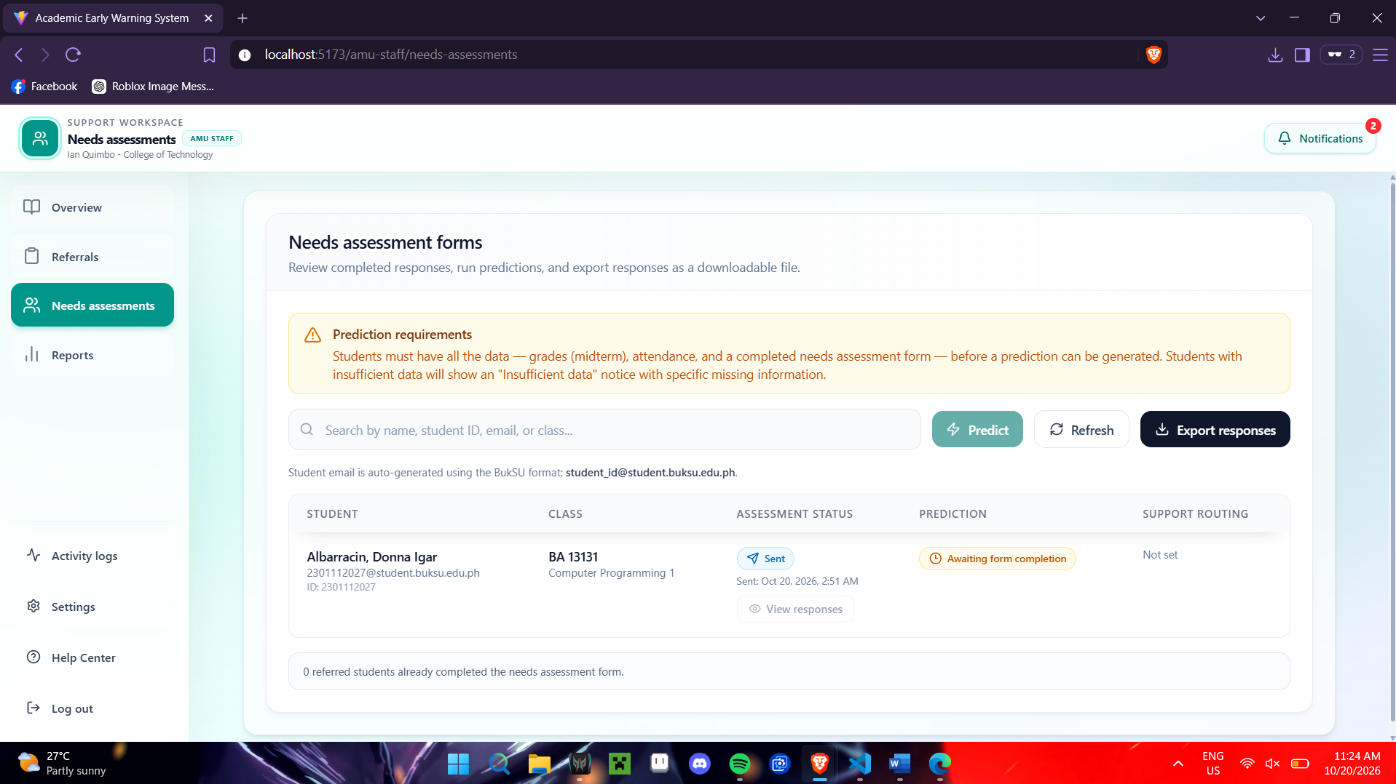
Figure 4-15
Needs Assessment Forms Interface
Figure 4-15 shows the needs assessment forms interface, where AMU staff can review student assessment statuses, generate predictions, and export assessment responses. The page displays each student’s class information, form completion status, prediction status, and support routing. It also allows staff to search for student records and check whether the required grades, attendance, and assessment data are complete before generating predictions.
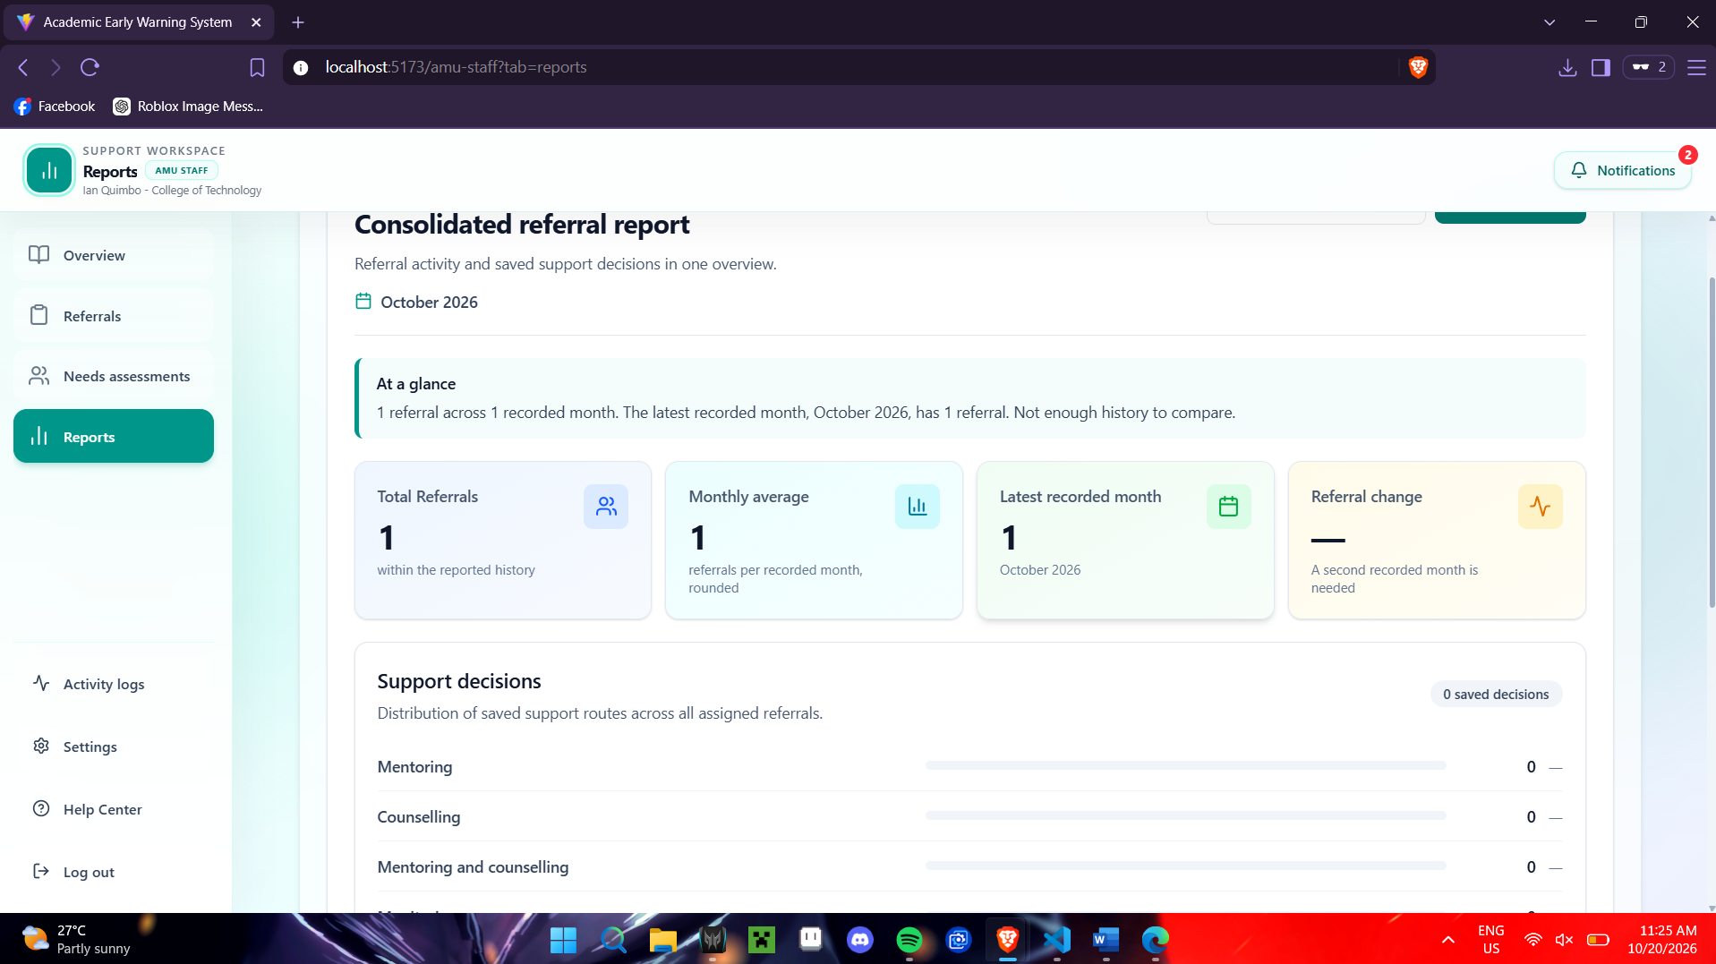
Figure 4-16
AMU Staff Reports Interface
Figure 4-16 shows the reports interface, which provides a consolidated summary of student referrals and recorded support decisions. It displays key information, including total referrals, monthly average, latest recorded month, and referral trends. The interface also presents the distribution of support decisions, such as mentoring and counselling, helping AMU staff review referral activities and monitor student support outcomes.

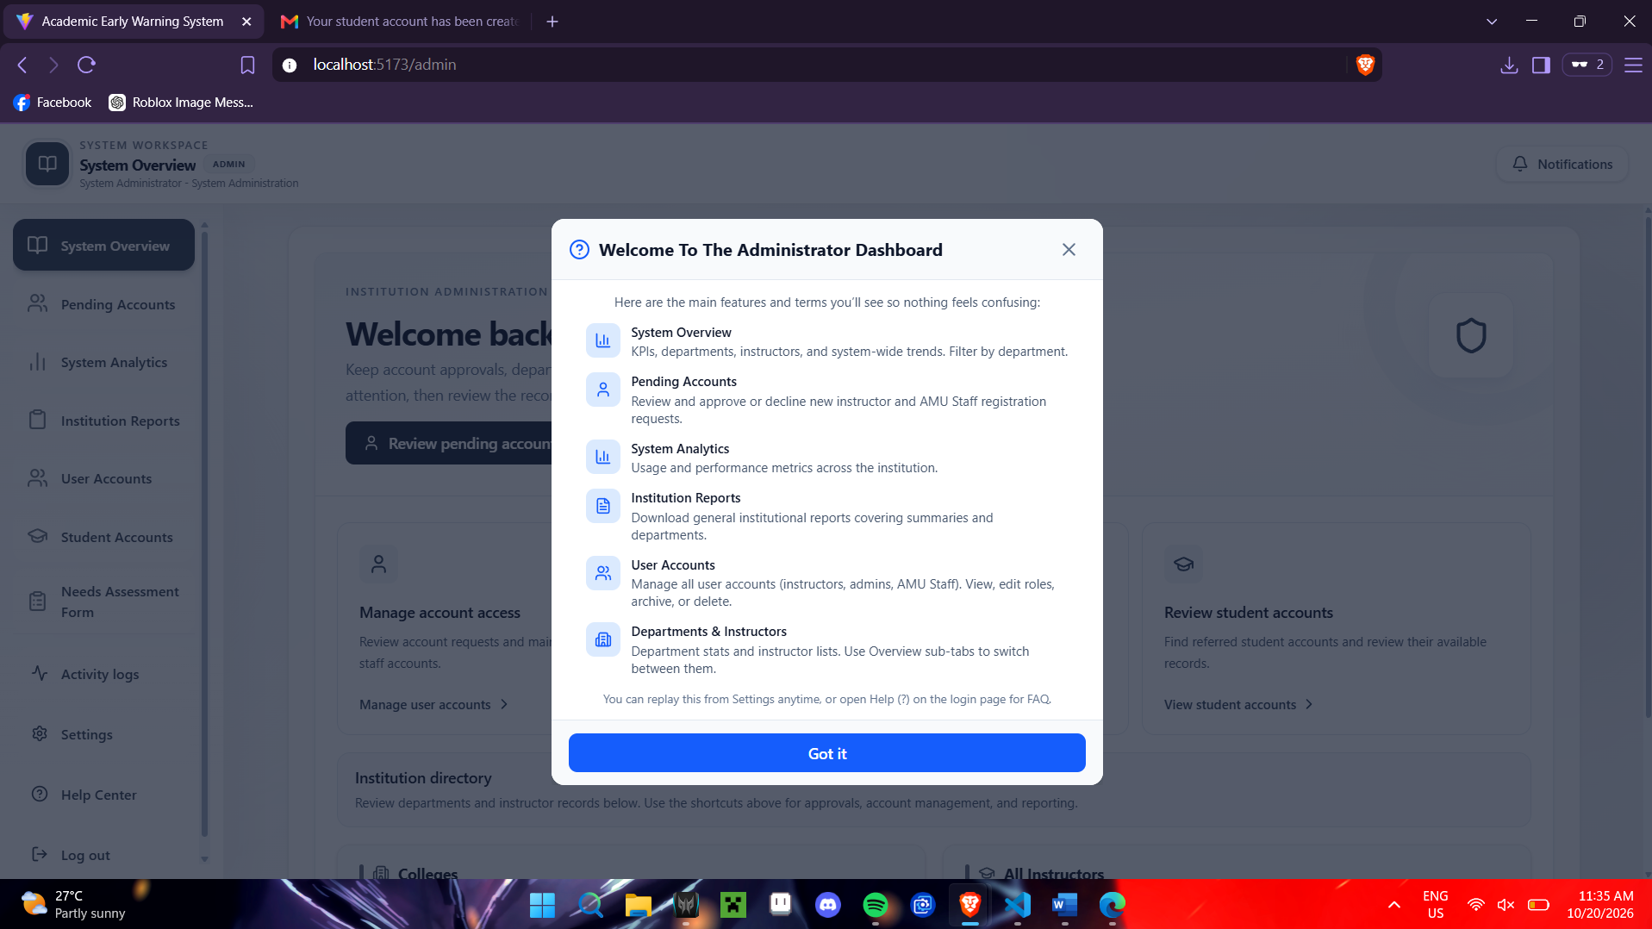
Figure 4-17
Administrator Dashboard Welcome Guide
Figure 4-17 shows the welcome guide displayed on the Administrator Dashboard, which introduces the main features of the system, including system overview, pending accounts, system analytics, institution reports, and user account management. It helps the administrator understand the available functions for managing accounts and monitoring system activities.

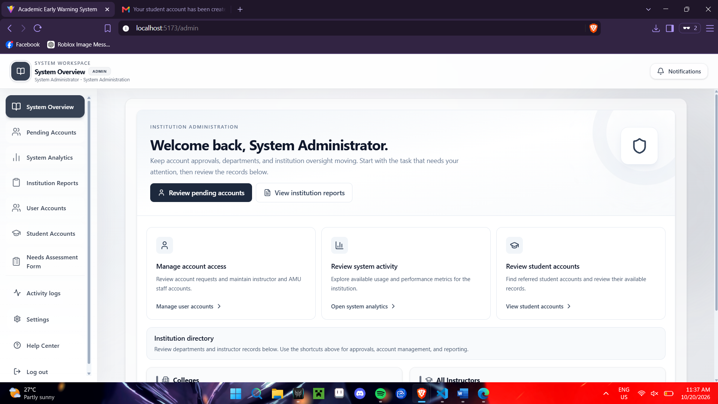
Figure 4-18
System Administrator Dashboard
Figure 4-18 shows the main dashboard of the Academic Early Warning System for the system administrator. It provides access to account management, system analytics, institution reports, and student account records, allowing the administrator to monitor and manage the system from one interface.

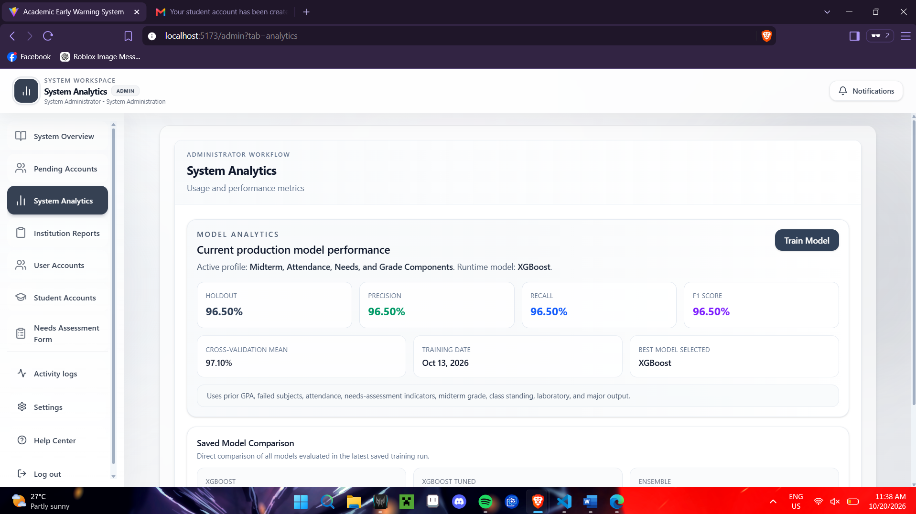
Figure 4-19
System Analytics Interface
Figure 4-19 shows the System Analytics interface, where the administrator can monitor the performance of the predictive model. It displays evaluation metrics such as holdout accuracy, precision, recall, F1 score, and cross-validation mean, along with the selected model and training date. The interface also provides a function to train the model and compare the performance of different models.
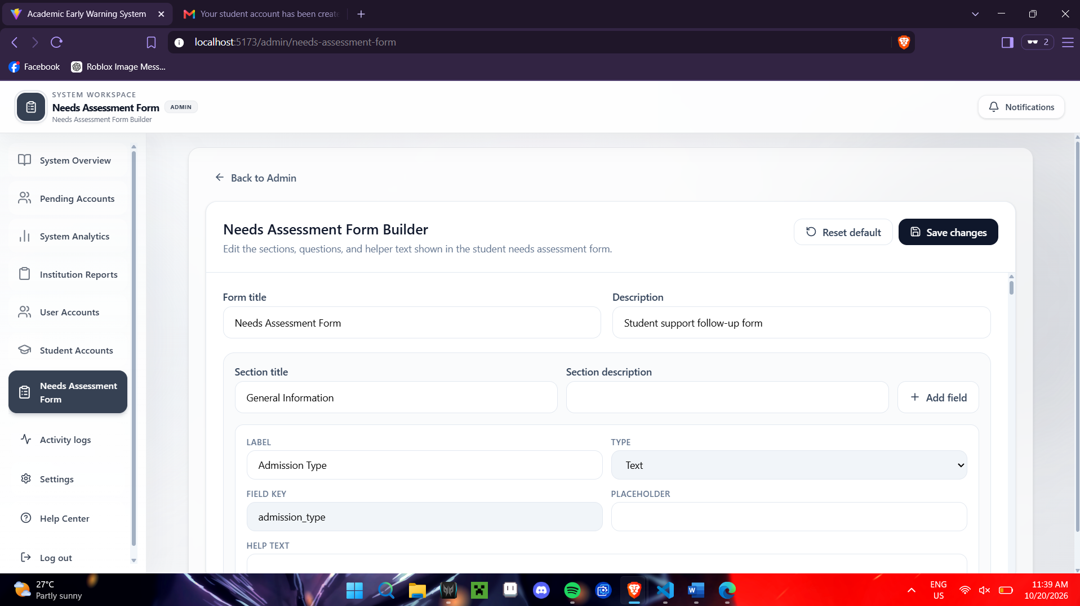
Figure 4-20
Needs Assessment Form Builder Interface
Figure 4-20 shows the interface where the administrator can customize the student needs assessment form by editing its title, description, sections, questions, and field types. It also provides options to add fields, reset the form to its default settings, and save changes.
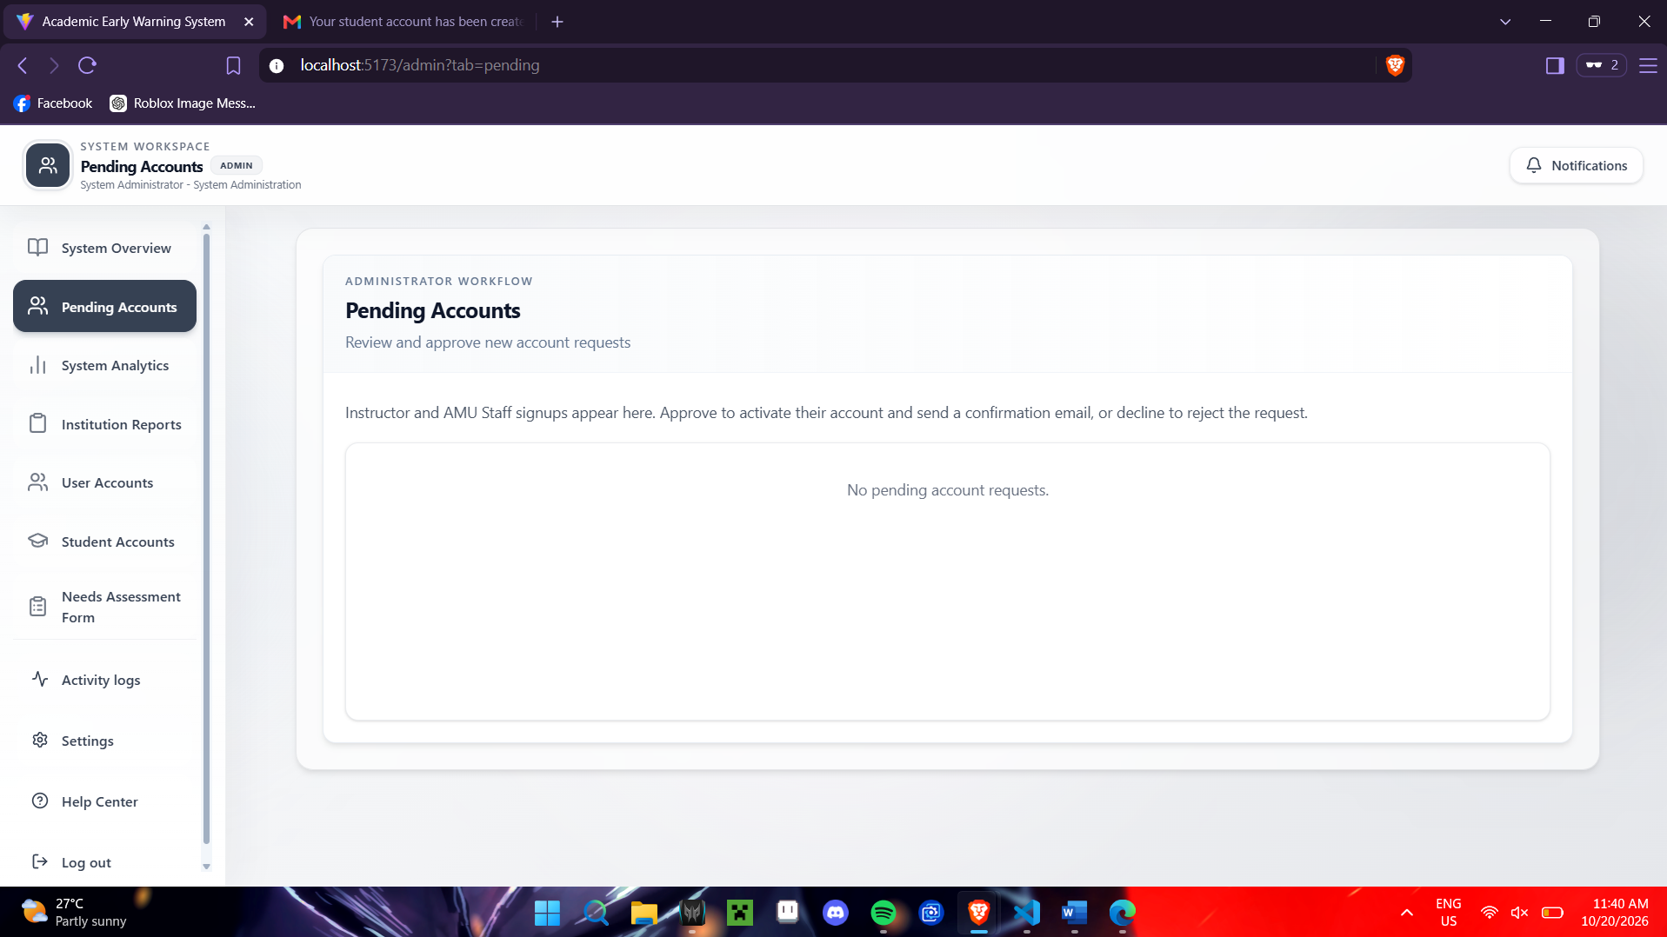
Figure 4-21
Pending Accounts Interface
Figure 4-21 shows the Pending Accounts interface, where the administrator can review new account registration requests from instructors and AMU staff. It provides options to approve accounts and send confirmation emails or decline registration requests. In this figure, no pending account requests are currently available.
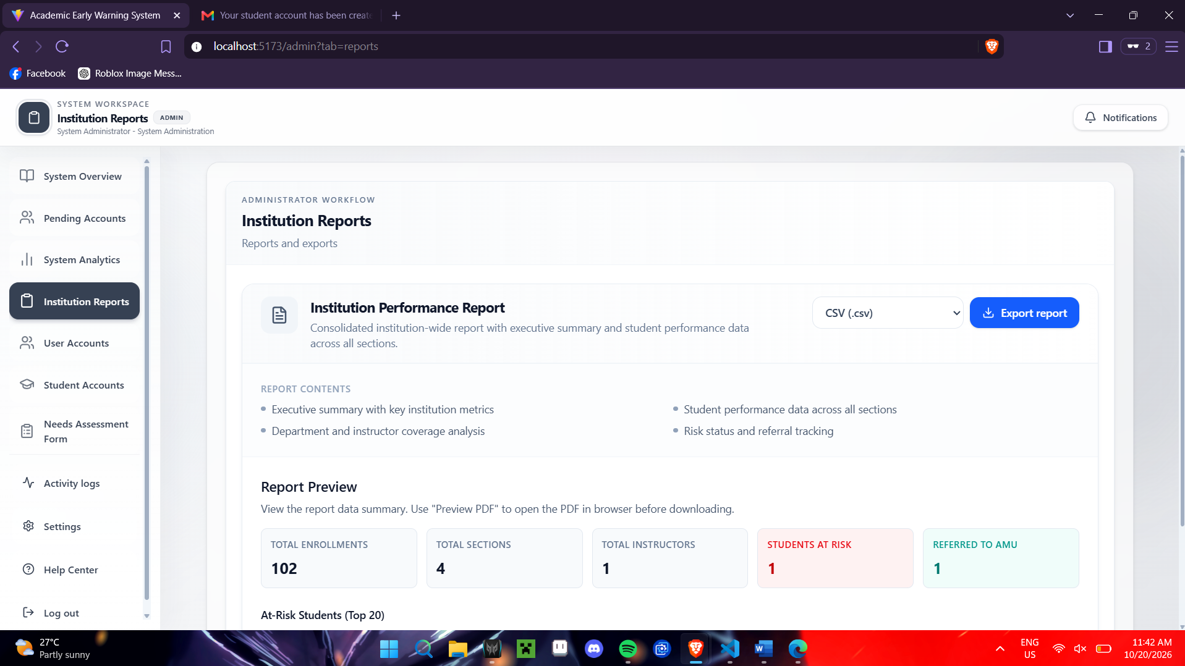
Figure 4-22
Institution Reports Interface
This figure presents the Institution Reports Interface, which provides a preview of institutional performance data, including total enrollments, sections, instructors, at-risk students, and students referred to the AMU. It also allows the administrator to export institutional reports in the selected file format.

This section focuses on developing a role-based web system that detects and provides early warning analytics using the XGBoost prediction model. The Academic Early Warning System (AEWS) was developed as a functional web-based platform that supports the management of student records, academic monitoring, referral handling, needs-assessment processing, and early warning analytics. The system enables authorized users to access relevant student information and use predictive results as support for timely academic intervention.
The developed system manages different student-related records, including class lists, gradesheets, attendance files, referral details, and needs-assessment responses. These records serve as the basis for monitoring student academic performance, attendance behavior, learning difficulties, and external concerns that may affect academic progress. By allowing these records to be uploaded, processed, and reviewed in one platform, the system reduces reliance on scattered manual records and makes relevant information more accessible to authorized institutional personnel.
The AEWS provides role-specific functions for instructors, AMU staff, administrators, and students. Instructors can manage class records, upload gradesheets and attendance files, review student academic indicators, and submit referrals for students who may require support. AMU staff can review referrals, examine needs-assessment responses, assess student-risk information, and document intervention or support-routing decisions. Administrators can manage user accounts, configure needs-assessment forms, monitor system activity, and review institutional reports. Students can access their individual dashboards, receive notifications, view available information related to their progress, and complete assigned needs assessments.
A major component of the system development involved preparing uploaded records before they were used in the monitoring and prediction process. The system performed identifier matching, data cleaning, numeric conversion, missing-value handling, and format standardization. Identifier matching ensured that gradesheet records, attendance data, and needs-assessment responses were associated with the correct student through the Student_ID field. Data cleaning and numeric conversion ensured that attendance percentages, grades, and other numerical values followed the expected formats and valid ranges before being included in system analysis.
The system also included safeguards for incomplete student records. When available data were insufficient to support reliable analysis, the system returned an insufficient-data status instead of forcing a prediction or risk classification. This feature helped prevent potentially misleading results and informed users that additional or corrected attendance, academic, or needs-assessment data were needed before an early warning result could be generated.
The developed AEWS therefore served as a centralized academic monitoring and decision-support platform. It provided the functional foundation for student-record management, data processing, referral handling, needs-assessment administration, and predictive analytics. Through the integration of these functions, the system enabled authorized users to monitor student conditions more efficiently and identify students who may require timely academic or support-related intervention.
    - XGBoost Model Features Used in the AEWS
Academic features, including previous GPA, failed-subject count, midterm grade, class standing, laboratory grade, and major output grade, allowed the model to assess the student’s academic standing and performance trend. Attendance rate contributed to risk detection because frequent absences may affect lecture participation, laboratory activities, submission of requirements, and overall academic progress. The academic challenge score and external factor score incorporated information from the needs assessment, enabling the model to consider learning-related struggles and personal or external circumstances that may affect student performance.
The XGBoost model classified students into two academic risk categories: Low Risk and High Risk. The classification label was generated using the final grade based on the BukSU grading scale. Students with final grades from 1.00 to 2.25 were labeled as Low Risk, while students with final grades from 2.50 to 5.00 were labeled as High Risk. Higher numerical grades represent weaker academic performance; therefore, students classified as High Risk may require closer monitoring and possible intervention.
Table 4-4
XGBoost Model Features Used in the AEWS
Model Feature | Description
Previous GPA | Represents the student’s prior academic performance.
Failed subject count | Indicates previous academic difficulty.
Attendance rate | Measures the student’s attendance behavior.
Academic challenge score | Summarizes learning-related difficulties from the needs assessment.
External factor score | Summarizes personal or external concerns affecting performance.
Midterm grade | Represents current academic performance.
Class standing | Represents class participation, quizzes, or related standing components.
Laboratory grade | Represents laboratory-based performance.
Major output grade | Represents major academic output or project performance.
Academic features, including previous GPA, failed-subject count, midterm grade, class standing, laboratory grade, and major output grade, allowed the model to assess the student’s academic standing and performance trend. Attendance rate contributed to risk detection because frequent absences may affect lecture participation, laboratory activities, submission of requirements, and overall academic progress. The academic challenge score and external factor score incorporated information from the needs assessment, enabling the model to consider learning-related struggles and personal or external circumstances that may affect student performance.
The XGBoost model classified students into two academic risk categories: Low Risk and High Risk. The classification label was generated using the final grade based on the BukSU grading scale. Students with final grades from 1.00 to 2.25 were labeled as Low Risk, while students with final grades from 2.50 to 5.00 were labeled as High Risk. Higher numerical grades represent weaker academic performance; therefore, students classified as High Risk may require closer monitoring and possible intervention.
Table 4-5
Risk Classification Rule Used by the XGBoost Model
Risk Category | Final Grade Range | Interpretation
Low Risk | 1.00 to 2.25 | Students are less likely to require academic intervention based on the model label.
High Risk | 2.50 to 5.00 | Students may require monitoring, referral, or support based on the model label.
After student records were processed, the system generated a risk classification and displayed it together with supporting indicators. These included attendance status, academic performance, grade-component weaknesses, referral information, academic challenge score, and external factor score. Presenting the prediction with these supporting indicators allowed authorized users to review the result in context instead of treating the Low Risk or High Risk classification as an isolated output.
The XGBoost model was implemented as a decision-support component rather than an automatic decision-making tool. The system generated early warning analytics to assist users in identifying possible academic risk; however, it did not automatically determine the final intervention for a student. Instructors, administrators, and AMU staff remained responsible for reviewing student records, validating the available information, considering individual circumstances, and deciding the appropriate support action or referral.
Model interpretability was also considered during implementation. SHAP-based analysis was used during model evaluation to determine which input variables had stronger influence on model predictions. In the deployed AEWS, user-readable contributing indicators—including previous GPA, failed-subject count, attendance rate, midterm grade, class standing, laboratory grade, major output grade, academic challenge score, and external factor score—were presented to help authorized users understand the possible basis of the prediction. This increased the transparency of the model output and supported more informed review of student cases.
Overall, the XGBoost model integration enabled the AEWS to function as a predictive early warning and decision-support tool. The system was able to process academic, attendance, and needs-assessment information; generate Low Risk or High Risk classifications; display supporting indicators; and assist authorized personnel in academic monitoring, referral evaluation, and intervention planning.

Predictive Model Evaluation
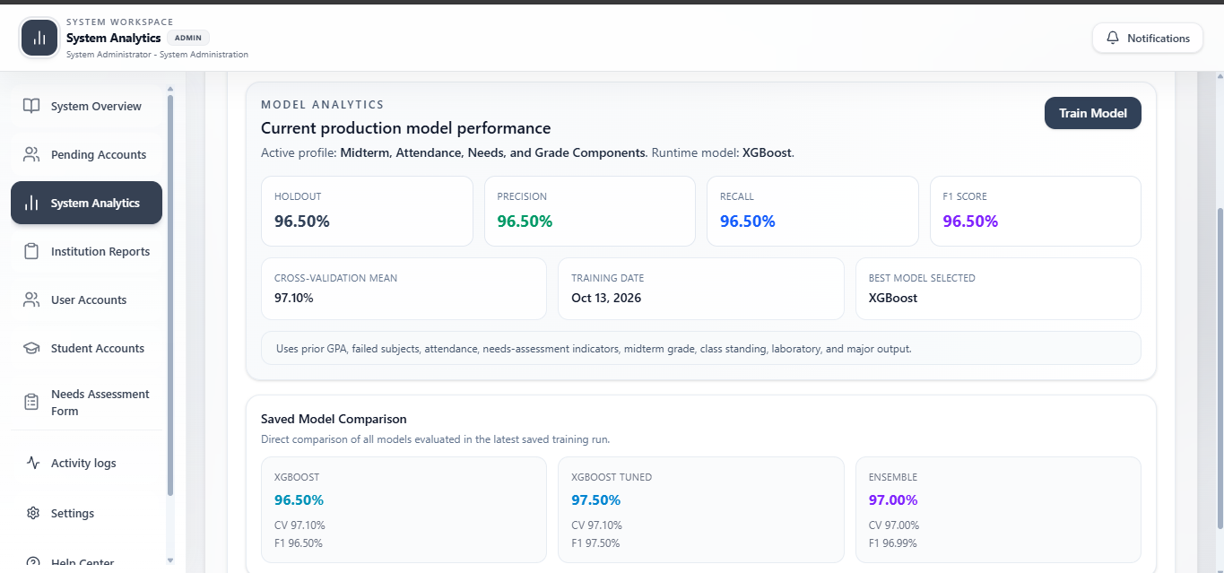

Figure 4-23
Model Performance Analytics

Figure 4-23 presents the evaluation results of the XGBoost model used to predict student risk levels. Precision measures how often the model’s predictions for a risk category are correct, while recall measures how effectively it identifies students belonging to that category. The F1-score summarizes the balance between precision and recall. Where included, ROC-AUC measures the model’s ability to distinguish between classes across classification thresholds. These results provide evidence for assessing the model’s predictive performance under the evaluation conditions used in the study.
The XGBoost student academic-risk prediction model was evaluated using a confusion matrix, precision, recall, F1-score, and Receiver Operating Characteristic–Area Under the Curve (ROC-AUC). These measures provided complementary perspectives on the model’s classification performance. The confusion matrix identified the number and type of correct and incorrect predictions, precision assessed the correctness of High Risk alerts, recall measured the detection of actual High Risk students, F1-score summarized the balance between precision and recall, and ROC-AUC assessed the model’s ability to distinguish between the two risk categories using predicted probability scores. Using these measures together allowed the evaluation to consider both overall predictive performance and the practical consequences of classification errors in the Academic Early Warning System (AEWS).
The evaluation used an 80:20 stratified train-test split of the 1,000 prepared student records. Of these records, 800 were used to train the model, while 200 were reserved as the holdout test dataset. The full dataset contained 410 Low Risk students and 590 High Risk students. Stratification preserved these proportions in the holdout dataset, which contained 82 Low Risk students and 118 High Risk students. Maintaining the class proportions allowed the evaluation to reflect the distribution of the prepared dataset and ensured that both categories were represented during testing.
The actual risk labels were derived from students’ final grades. Students with final grades from 1.00 to 2.25 were classified as Low Risk, while students with final grades from 2.50 to 5.00 were classified as High Risk. Accordingly, the evaluation measured how closely the model’s predictions matched these final-grade-based categories. Final grades served as the basis for establishing the actual outcomes rather than as input features for the selected model. The prediction features included previous GPA, failed-subject count, attendance rate, academic challenge score, external factor score, midterm grade, class standing, laboratory grade, and major output grade.
High Risk, represented by Label 1, was treated as the positive class, while Low Risk, represented by Label 0, was treated as the negative class. This designation reflected the system’s primary purpose: identifying students who may require academic monitoring, referral, or intervention. The terms “positive” and “negative” therefore refer to the statistical classification categories rather than to favorable or unfavorable academic performance.
The following discussion presents the results of the selected XGBoost model using grade components. Unless otherwise specified, precision, recall, and F1-score refer specifically to the High Risk class.

Confusion Matrix Components (TP, FP, FN, TN)
The confusion matrix was used to examine the relationship between the actual risk categories and the categories predicted by the model. It provided the foundation for calculating precision, recall, F1-score, and accuracy. More importantly, it showed the specific types of errors that could affect the system’s academic monitoring and intervention processes.
1. True Positives (TP): The number of students who are actually High Risk and are correctly predicted as High Risk by the model. Example: A student with a final grade of 3.00 (High Risk) is flagged as High Risk by the AEWS.
2. False Positives (FP): The number of students who are actually Low Risk but are incorrectly predicted as High Risk by the model (Type I error). Example: A student performing well with a 1.75 final grade (Low Risk) is incorrectly flagged as High Risk.
3. False Negatives (FN): The number of students who are actually High Risk but are incorrectly predicted as Low Risk by the model (Type II error). Example: A struggling student with a 3.00 final grade (High Risk) is missed by the system and classified as Low Risk.
4. True Negatives (TN): The number of students who are actually Low Risk and are correctly predicted as Low Risk by the model. Example: A student with a 1.50 final grade (Low Risk) is correctly classified as Low Risk by the system.
Table 4-6 summarizes the confusion matrix results obtained from evaluating the XGBoost predictive model on the holdout test dataset (N = 200).
Table 4-6
Confusion Matrix of the XGBoost Student-Risk Prediction Model
Actual / Predicted | Predicted Low Risk (0) | Predicted High Risk (1)
Actual Low Risk (0) | TN = 80 | FP = 2
Actual High Risk (1) | FN = 3 | TP = 115
Based on the confusion matrix results, overall model accuracy and error rate were calculated to provide additional summary metrics of classification performance. Overall Accuracy measures the proportion of total predictions that were correct across both risk categories:
\[ Accuracy = \frac{TP + TN}{TP + TN + FP + FN} \]
\[ Accuracy = \frac{115 + 80}{115 + 80 + 2 + 3} = \frac{195}{200} = 0.975\ (97.5\%) \]
Conversely, the Error Rate measures the proportion of incorrect predictions generated by the model:
\[ Error\ Rate = \frac{FP + FN}{TP + TN + FP + FN} \]
\[ Error\ Rate = \frac{2 + 3}{200} = \frac{5}{200} = 0.025\ (2.5\%) \]
The model correctly classified 195 out of 200 holdout records, yielding an overall holdout accuracy of 97.5% and an error rate of 2.5%. Out of 118 actual High Risk students, 115 were correctly identified (TP), while 3 were incorrectly classified as Low Risk (FN). Out of 82 actual Low Risk students, 80 were correctly identified (TN), while 2 were incorrectly classified as High Risk (FP). These results demonstrate a high degree of classification precision and consistency in identifying student risk within the holdout evaluation set.

F1-Score
The F1-score was used to evaluate the balance between precision and recall, serving as their harmonic mean. This metric is especially important in an early warning system because prioritizing precision alone could lead to missing at-risk students (false negatives), while focusing solely on recall could result in unnecessary interventions for low-risk students (false positives). The F1-score is calculated as:
\[ F1 = 2 \times \frac{Precision \times Recall}{Precision + Recall} \]
Using the holdout test set values for High Risk students (Precision = 0.983, Recall = 0.975), the F1-score is calculated as:
\[ F1 = 2 \times \frac{0.983 \times 0.975}{0.983 + 0.975} = \frac{1.91685}{1.958} \approx 0.979\ (97.9\%) \]
An F1-score of 0.979 indicates that the model maintains a strong balance between correctly identifying High Risk students and minimizing false alarms. From an institutional perspective, this ensures that support resources and AMU interventions are directed efficiently to students who truly need assistance without overburdening academic advisors or creating unnecessary distress for low-risk students.

Precision
Precision was used to determine the correctness of the model’s High Risk predictions. It measures the proportion of students predicted as High Risk who were actually High Risk according to the final-grade-based labels:
\[ Precision = \frac{TP}{TP + FP} \]
The model predicted 119 students as High Risk. Of these students, 115 were actual High Risk cases and four were actual Low Risk cases. Therefore:
\[ Precision = \frac{115}{115 + 4} = \frac{115}{119} \approx 0.9664 = 96.64\% \]
The precision of 96.64% means that approximately 97 out of every 100 High Risk predictions were correct within the evaluated dataset. The remaining 3.36% of High Risk predictions were incorrect alerts:
\[ Incorrect\ Alert\ Proportion = \frac{FP}{TP + FP} = \frac{4}{119} \approx 3.36\% \]
This result indicates that the model’s alerts were largely consistent with the actual risk labels. Such performance is useful in supporting academic monitoring because faculty and AMU personnel may have limited time and resources for reviewing flagged students. A high proportion of correct alerts can help make the review process more focused and manageable.
However, precision does not indicate whether the system detected all students who were actually High Risk. A model could achieve high precision by flagging only a small number of very clear cases while missing other students who require attention. Consequently, the obtained precision must be interpreted alongside recall.
Precision also depends on the composition of the evaluated population. High Risk students represented 59.00% of the holdout dataset. If the system is applied to a population with a different proportion of High Risk students, the precision may change even if other aspects of model performance remain similar. The reported 96.64% should therefore be interpreted as an observed result for this dataset rather than a guaranteed alert accuracy for every future cohort.

Recall
Recall was used to evaluate the ability of the model to identify students who were truly High Risk. It measures the proportion of actual High Risk students that were correctly detected by the system. Recall is calculated as:
\[ Recall = \frac{TP}{TP + FN} \]
A high recall score indicates that the model was able to identify most students who genuinely required academic attention or intervention. This is particularly important in an academic early warning system because failing to identify a struggling student may prevent timely support from being provided.
For example, if there were 50 actual High Risk students and the model correctly identified 40 of them, the recall score would be:
\[ Recall = \frac{40}{50} = 0.80 \]
This means that the model detected 80% of all actual High Risk students, while 20% were not identified. These missed students are considered false negatives.
Recall was included in the evaluation because the main objective of the system is to identify students who may need academic support before their academic standing further declines. A low recall score would indicate that the system is failing to detect a considerable number of at-risk students.

ROC-AUC
The Receiver Operating Characteristic–Area Under the Curve (ROC-AUC) was considered as an additional evaluation metric for measuring the model’s ability to distinguish between Low Risk and High Risk students. Unlike precision, recall, and F1-score, which are based on final predicted labels, ROC-AUC evaluates the probability scores generated by the model.
The model assigns each student a probability of belonging to the High Risk class. A threshold, commonly 0.50, may be used to convert this probability into a final classification. For example, a student with a predicted High Risk probability of 0.75 may be classified as High Risk, while a student with a probability of 0.20 may be classified as Low Risk.
The ROC curve is formed by plotting the True Positive Rate against the False Positive Rate at different classification thresholds. The True Positive Rate is calculated as:
\[ True\ Positive\ Rate = \frac{TP}{TP + FN} \]
The False Positive Rate is calculated as:
\[ False\ Positive\ Rate = \frac{FP}{FP + TN} \]
The area under this curve is the ROC-AUC score. Its value ranges from 0 to 1. A value of 1.00 indicates perfect discrimination between High Risk and Low Risk students, while a value of 0.50 indicates performance comparable to random classification. A higher ROC-AUC value indicates that the model is more capable of assigning higher risk probabilities to actual High Risk students and lower probabilities to actual Low Risk students.
Although the current implementation stores holdout accuracy, cross-validation accuracy, precision, recall, and F1-score, ROC-AUC remains applicable because the model generates probability outputs. The ROC-AUC may therefore be included in future model evaluations to provide a more comprehensive assessment of the model’s ability to distinguish between students who are likely to require intervention and those who are not.

System Evaluation

Functionality

Usability

Reliability

SUMMARY, CONCLUSIONS, AND RECOMMENDATIONS

Summary
Provide a rather concise summary of the research work.

Conclusions
The conclusions are direct statements that would prove the achievement of the specific objectives. The conclusions should have one-to-one correspondence to the specific objectives, i.e. if you have 4 specific objectives (a to d) then you should have 4 conclusions (1 to 4).

Recommendations
Number the recommendations and start the statement with action word.

REFERENCES
Ahmed, F., & Haseeb, M. (2024). Artificial intelligence applications in higher education: Predictive analytics for student retention. Journal of Educational Technology Research, 47(2), 88–105. https://doi.org/10.1016/j.jedutech.2024.102181
Ahmed, F., & Haseeb, M. (2024). Predictive analytics for student performance using machine learning: A review of recent models. Education and Information Technologies, 29(2), 211–230.
Alotaibi, F., & Alshehri, M. (2025). Enhancing student performance prediction using adaptive learning analytics frameworks. Computers & Education: Artificial Intelligence, 7(1), 100–115.
American Psychological Association. (2020). Publication manual of the American Psychological Association (7th ed.). American Psychological Association.
Arnold, K. E., & Pistilli, M. D. (2012). Course Signals at Purdue: Using learning analytics to increase student success. In Proceedings of the 2nd International Conference on Learning Analytics and Knowledge (pp. 267–270). https://doi.org/10.1145/2330601.2330666
Arao, J. L., et al. (2025). Assessment of the implementation of the student affairs and services: A basis for the intervention program. International Journal of Research and Innovation in Social Science, 9(2), 123–140. https://rsisinternational.org/journals/ijriss/articles/assessment-of-the-implementation-of-the-student-affairs-and-services-a-basis-for-the-intervention-program/
Arao, R., Dela Peña, J., & Santos, P. (2025). Challenges in data integration among Philippine SUCs: Toward unified academic analytics. Philippine Journal of Higher Education Studies, 33(1), 45–63.
Astin, A. W. (1999). Student involvement: A developmental theory for higher education. Journal of College Student Development, 40(5), 518–529.
Auer, E. M., & Griffiths, M. D. (2023). The role of mental health and well-being in student success: A meta-analysis. Journal of American College Health, *71*(5), 1350-1360. https://doi.org/10.1080/07448481.2021.1926266
Baker, R. S., & Yacef, K. (2009). The state of educational data mining in 2009: A review and future visions. Journal of Educational Data Mining, 1(1), 3–17.
Baticulon, R. E., et al. (2025). Machine learning-based academic performance prediction: A comprehensive review and future directions. Scientific Reports, 15, Article 12353. https://www.nature.com/articles/s41598-025-12353-4
Bean, J. P. (1980). Dropouts and turnover: The synthesis and test of a causal model of student attrition. Research in Higher Education, 12(2), 155–187.
Bravo, E. D. (2023). Trends and causes of student dropouts in a public higher education in Northern Philippines: A data visualization approach. https://digibug.ugr.es/handle/10481/83427
Brooke, J. (1996). SUS: A quick and dirty usability scale. In P. W. Jordan, B. Thomas, B. A. Weerdmeester, & A. L. McClelland (Eds.), Usability evaluation in industry (pp. 189–194). Taylor & Francis.
Commission on Higher Education (CHED). (2013). CHED Memorandum Order No. 09, Series of 2013: Policies, standards and guidelines on the establishment and implementation of student affairs and services. https://ched.gov.ph/wp-content/uploads/2017/06/CMO-No.-09-s.-2013.pdf
Civitas Learning. (2024). Empowering student success with predictive analytics. https://www.civitaslearning.com
Cortez, P., & Silva, A. (2022). Using data mining to predict secondary school student performance. Educational Data Mining Journal, 14(1), 1–10.
De la Cruz, R. T. (2025, September 22). The Philippines looking to reform education sector with AI and connectivity. GovInsider. https://govinsider.asia/intl-en/article/the-philippines-looking-to-reform-education-sector-with-ai-and-connectivity
EDCOM 2. (2025, January 27). EDCOM II Year Two Report: High college dropout rate persists despite free tuition. https://edcom2.gov.ph/reports/year-two-report/
Enrollify. (2025, January 29). Retention made easy: Early warning signs AI can spot in students. https://www.enrollify.org/blog/retention-made-easy-early-warning-signs-ai-can-spot-in-students
Explained PH. (2025). Dropout rates remain high despite free tuition. https://explained.ph/dropout-rates-remain-high-despite-free-tuition/
Fredricks, J. A., Blumenfeld, P. C., & Paris, A. H. (2004). School engagement: Potential of the concept, state of the evidence. Review of Educational Research, 74(1), 59–109.
Gašević, D., Dawson, S., & Siemens, G. (2022). Learning analytics: Principles, process, and practice. Journal of Learning Analytics, 9(1), 1–23.
GMA Network. (2024, October 1). CHED: More college students cited mental health as reason for dropping out. GMA News Online. https://www.gmanetwork.com/news/topstories/nation/922218/ched-more-college-students-cited-mental-health-as-reason-for-dropping-out/story/
Gomez, M., Rodríguez, C., & García, J. (2023). Real-world datasets for predictive modeling in educational settings. Journal of Educational Data Mining, 15(2), 145–167.
Guevara, M. A., et al. (2025). AI in Philippine education: Opportunities, challenges, and ethical considerations for personalized learning. ResearchGate. https://www.researchgate.net/publication/392774269_AI_in_Philippine_Education_Opportunities_Challenges_and_Ethical_Considerations_for_Personalized_Learning
Hara, R. O. A., et al. (2023). Administration of academic support system and achievement of desired learning outcomes. PhilArchive. https://philarchive.org/archive/HARAOA-19
Hassan, H., et al. (2025). Data-driven decisions in education using a comprehensive machine learning framework: A survey. Artificial Intelligence Review, 58(7), Article 95. https://link.springer.com/article/10.1007/s10791-025-09585-3
Hevner, A. R., March, S. T., Park, J., & Ram, S. (2004). Design science in information systems research. MIS Quarterly, 28(1), 75–105.
Howard, K., Beltman, S., & Billingsley, B. (2021). Early alert systems for student success: Implementation and impact. Technology, Pedagogy and Education, 30(1), 71–89.
Instructure. (2025). Philippines state of higher ed 2025: AI’s role in learning mini report. https://www.instructure.com/en-au/resources/research-reports/ph-ais-role-learning-mini-report
Johnson, M., & Lee, S. (2020). The critical role of interaction frequency in online learning environments. Educational Technology & Society, 23(4), 156–171.
Khalil, M., et al. (2025). Machine learning approach to student performance prediction of online learning system using graph neural networks. PLOS ONE, 20(1), Article e0299018. https://journals.plos.org/plosone/article?id=10.1371/journal.pone.0299018
Khan, Z., Sharma, P., & Kumar, A. (2023). Emotional engagement and academic performance: A longitudinal analysis. International Journal of Educational Technology in Higher Education, 20(8), 1–18.
Kuh, G. D., Kinzie, J., & Buckley, J. A. (2020). What matters to student success: Retention and persistence in college. National Postsecondary Education Cooperative.
Liao, Y.-C., et al. (2025). Predicting student next-term performance in degree programs using machine learning: A systematic review. Cogent Education, 12(1), Article 2481000. https://www.tandfonline.com/doi/full/10.1080/2331186X.2025.2481000
Li, Y., Xu, Q., & Wang, T. (2022). Behavioral engagement and academic achievement in online learning. Computers & Education, 178, 104–118.
Lipson, S. K., Lattie, E. G., & Eisenberg, D. (2019). Increased rates of mental health service utilization by U.S. college students: 10-year population-level trends (2007–2017). Psychiatric Services, *70*(1), 60-63. https://doi.org/10.1176/appi.ps.201800332
Maguigad, E. A., et al. (2025). Machine learning models for academic performance prediction: A comparative analysis. Frontiers in Education, 10, Article 1632315. https://www.frontiersin.org/journals/education/articles/10.3389/feduc.2025.1632315/full
Mahmood, T., et al. (2025). Predicting student retention: A comparative study of machine learning algorithms. Machine Learning with Applications, 18, Article 100702. https://www.sciencedirect.com/science/article/pii/S277294192500170X
Martin, F., & Bolliger, D. U. (2019). Engagement matters: Student perceptions on the importance of engagement strategies in the online learning environment. Online Learning Journal, 23(1), 205–222.
Naeem, R., & Bosman, L. (2023). Learning Management System engagement analytics: Predicting student success through behavioral metrics. Journal of Educational Computing Research, 61(4), 892–915.
Nguyen, T. H., & Walker, M. (2021). Predictive accuracy of machine learning models for student academic performance forecasting. IEEE Transactions on Learning Technologies, 14(2), 234–248.
ONE News. (2025, September 1). Lawmaker sounds alarm on 40% college dropout rate in PH. ONE News Philippines. https://www.facebook.com/ONENewsPH/videos/lawmaker-sounds-alarm-on-40-college-dropout-rate-in-ph-news-and-views/1010543631100624/
PHKULE. (2025, February 14). Higher college enrollment but still high dropout rate in college since free tuition law, report finds. PH Kule. https://phkule.org/article/1395/high-enrollment-but-still-high-dropout-rate-in-college-since-free-tuition-law-report-finds
Philippines Institute for Development Studies. (2022). National human capital development priorities: STEM and education programs. PIDS Publications.
Pritchard, M. E., & Wilson, G. S. (2023). Using psychological and academic factors to predict student success. Journal of College Student Development, *64*(2), 145-159. https://doi.org/10.1353/csd.2023.0012
Rodriguez, A. M., et al. (2024). Policy guidelines and recommendations on AI use in teaching and learning. Social Sciences & Humanities Open, 10(1), Article 100418. https://www.sciencedirect.com/science/article/pii/S2590291124004182
Romero, C., & Ventura, S. (2020). Educational data mining and learning analytics: An updated survey. WIREs Data Mining and Knowledge Discovery, 10(3), e1355.
Romualdez, F. M. (2025, July 23). Romualdez: Nearly 4 in 10 students still drop out, time to strengthen free college education law. Congress of the Philippines. https://congress.gov.ph/media/press-releases/view/?content=9405&title=Romualdez%253A%2BNearly%2B4%2Bin%2B10%2Bstudents%2Bstill%2Bdrop%2Bout%252C%2Btime%2Bto%2Bstrengthen%2Bfree%2Bcollege%2Beducation%2Blaw
Sayo, R. A., et al. (2022). Academic, personal, and administrative support in an online learning of state universities and colleges in Camarines Sur, Philippines. ResearchGate. https://www.researchgate.net/publication/364974011_Academic_Personal_and_Administrative_Support_in_an_Online_Learning_of_State_Universities_and_Colleges_in_Camarines_Sur_Philippines
Siemens, G., Gašević, D., & Haythornthwaite, C. (2019). Open learning analytics: Granular data, open-source tools, and their implications. Journal of Learning Analytics, 6(3), 30–42.
Siemens, G., & Long, P. (2021). Learning analytics: The emergence of a discipline. American Society for Higher Education Review, 9(2), 22–33.
Sotto, M. C., et al. (2025). Artificial intelligence integration in rural Philippine higher education: Adoption, perceptions, and ethical implications. International Journal of Educational Research and Innovation, 23, 123–140. https://www.upo.es/revistas/index.php/IJERI/article/view/10909
Tan, J., & Lee, K. (2021). Beyond general trends: Leveraging granular LMS data for predictive modeling. Educational Data Mining Review, 12(1), 45–63.
Tanvir, H., & Chounta, I. A. (2023). Exploring the importance of factors contributing to dropouts in higher education over time. In Proceedings of the 16th International Conference on Educational Data Mining (pp. 215–224). International Educational Data Mining Society.
Tinto, V. (2017). Through the eyes of students. Journal of College Student Retention: Research, Theory & Practice, 19(3), 254–269. https://doi.org/10.1177/1521025115621917
Tripathy, A. K., & Kumar, S. P. (2025). Interpretable dual-branch framework for dropout prediction in e-learning using static profiles and temporal engagement. ASPD Journal, 11(23), 7022–7045.
United Nations. (2023). Sustainable Development Goal 4: Quality education. https://sdgs.un.org/goals/goal4
Villanueva, J. (2024, October 1). Alarming number of college dropout. Senate of the Philippines. https://web.senate.gov.ph/photo_release/2024/1001_02.asp
Villanueva, J. (2025, July 24). Solon alarmed over high dropout rates in public colleges and universities. The POST. https://thepost.net.ph/news/nation/solon-alarmed-over-high-dropout-rates-in-public-colleges-and-universities/
VKTR. (2025, April 15). Higher education’s AI dilemma: Powerful tools, dangerous tradeoffs. https://www.vktr.com/ai-ethics-law-risk/higher-educations-ai-dilemma-powerful-tools-dangerous-tradeoffs/
Wang, Y., et al. (2025). AI-based early prediction and intervention for student academic performance in higher education. ResearchGate. https://www.researchgate.net/publication/389024772_AI-Based_Early_Prediction_and_Intervention_for_Student_Academic_Performance_in_Higher_Education
World Bank. (2024). The global education imperative: Human capital for sustainable growth. World Bank Publications.
Yoo, B. (2015). Behavioral engagement in learning: Examining relationships with academic achievement and motivation. Learning and Individual Differences, 43, 1–8.
Zawacki-Richter, O., Marín, V. I., Bond, M., & Gouverneur, F. (2023). Systematic review of research on artificial intelligence applications in higher education. International Journal of Educational Technology in Higher Education, 20(1), 22–45. https://doi.org/10.1186/s41239-023-00411-2
Zawacki-Richter, O., Müskens, W., & Krause, U. (2019). Mobile learning from the learner's perspective: The dynamic interplay between affordances and agency. Computers & Education, 137, 42–59.

APPENDICES

<Appendix A:> <Title>
Place your appendices here. Please be sure that these have been referenced in the body of document.

CURRICULUM VITAE
PHOTO HERE
2x2
Name:
Address:
Contact Number:
Email Address:
Educational Attainment:

Membership in Organization:

Skills:

