**ELEMENTARY DATA ORGANIZATION**

**DATA**

▪ Data represents a single value or a set of values assigned to

entities. Data item refers a single or group of values with in the data.

Eg:10 , 18/08/1990,A,Raju ….

**ENTITY**

▪ An entity is a thing that has some properties or attributes which can take values.

Eg: Student

Attributes : Name , Roll.No. , D.O.B

Values : Raju , 78255 , 22/05/2005

**INFORMATION**

▪ Processed or meaning full data is called information. This is

used for taking some action.

Eg: 10 ml of water , D.O.B of raju is 22/05/2005

**DIFFERENCE BETWEEN DATA AND INFORMATION**

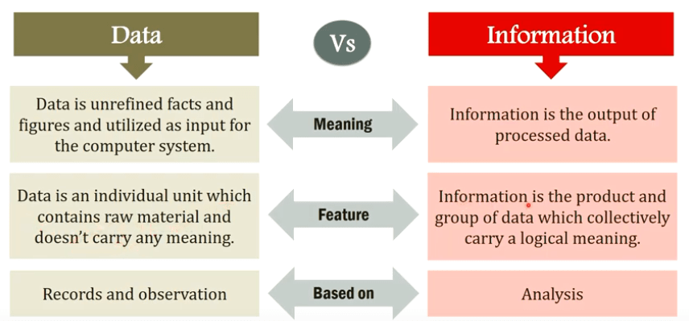

**DATA TYPE**

A data type is a term which refers to the kind of data that may appear in computation. Real, boolean, character, complex, etc .. are also some more frequently used data types.

**1.Bultt-ln data type**

With every programming language, there is a set of data types called built-in data types. For

example, in C,

c : int. float, char, double, enum etc

**2.Abstract data type**

When an application requires a special kind of data which is 001 available as built-in data type then it is the programmer's burden to implement his own kind of data. Programmers' own data type is termed as abstract data type, Abstract data type is also alternatively termed as user-defined data type.