**CHRIST COLLEGE (AUTONOMOUS),**

**IRINJALAKUDA**

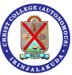

**PRACTICAL RECORD**

**BSC COMPUTER SCIENCE**

**CC19UBCS2B03:Programming Laboratory-I:HTML & Programming in C**

**2019-2020**