**VIEW OF DATA IN DBMS**

Abstraction is one of the main features of database systems. Hiding irrelevant details from user and providing abstract view of data to users, helps in easy and efficient user-database interaction. In the previous tutorial, we discussed the three level of DBMS architecture, The top level of that architecture is “view level”. The view level provides the “view of data” to the users and hides the irrelevant details such as data relationship, database schema, constraints, security etc from the user.

**Data Abstraction in DBMS**

Database systems are made-up of complex data structures. To ease the user interaction with database, the developers hide internal irrelevant details from users. This process of hiding irrelevant details from user is called data abstraction.

3 levels of abstraction

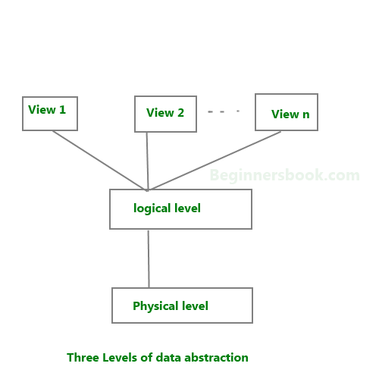

We have three levels of abstraction:

Physical level: This is the lowest level of data abstraction. It describes how data is actually stored in database. You can get the complex data structure details at this level.

Logical level: This is the middle level of 3-level data abstraction architecture. It describes what data is stored in database.

View level: Highest level of data abstraction. This level describes the user interaction with database system.

Example: Let’s say we are storing customer information in a customer table.

At physical level these records can be described as blocks of storage (bytes, gigabytes, terabytes etc.) in memory. These details are often hidden from the programmers.

At the logical level these records can be described as fields and attributes along with their data types, their relationship among each other can be logically implemented. The programmers generally work at this level because they are aware of such things about database systems.

At view level, user just interact with system with the help of GUI and enter the details at the screen, they are not aware of how the data is stored and what data is stored; such details are hidden from them.