A Smart Parking System

IOT102-SE2045, GROUP 7

Nguyen Sy Minh Man, Do Thanh Triet, Tran Dang Khoa, and Bui Dinh Long
FPT University, Ho Chi Minh Campus, Vietnam
{syminhman01, thanhtriet1007, khoavainoi2398, buidinhlongwork}@gmail.com

Abstract—This project presents a Smart Parking System with vehicle detection, barrier control, and web-based monitoring. The system integrates Arduino UNO R3 boards, ultrasonic sensors, an ESP32-CAM, a servo-based barrier, an IR remote, a backend server, and a web dashboard. The ultrasonic sensors are used to detect vehicle presence near the parking gate, while the Arduino UNO boards handle sensor communication and barrier control. When a vehicle is detected, the ESP32-CAM captures an image and sends it to the backend server for vehicle detection or license plate recognition. Based on the detection result, the system determines whether the barrier should be opened or remain closed. The IR remote provides manual override functions, allowing the operator to open, close, or reset the barrier when necessary. The web dashboard displays gate status, sensor readings, captured images, detection results, and vehicle entry or exit history. The proposed system demonstrates an IoT-based parking management solution that improves automation, monitoring, and control compared with traditional manual parking systems.

Keywords: Internet of Things, IoT, Smart Parking, Arduino UNO, ESP32-CAM, Ultrasonic Sensor, Barrier Control, Web Dashboard, Vehicle Detection.

VERSION HISTORY
Date | Description | Note | Version
##/##/## |  |  | v#.#.#
08/06/26 | Initialize Document |  | v0.1.0
 | + Introduction | Background and problem statement | v0.1.1
10/06/26 | Review Introduction |  | v0.1.2
 | Revise Introduction |  | v0.1.3
 | Hardware Design |  | v0.2.0
24/06/26 | Hardware Redesign | Remove Ir reciver and Ir remote & HC- SRF05 | v0.2.1
 | Circuit Diagram and Schematic | Add ciruit image and connection tables

I. INTRODUCTION
A. Background
With the rapid increase in number of private vehicles has made parking management in urban areas, campuses, office, and public facilities a significant issue. In conventional parking, drivers have to look for available parking lots, which waste valuable time, increase fuel consumption, and contribute to surrounding traffic congestion. Previous studies on smart parking systems have shown that IoT-based solutions can improve parking management by detecting vehicle presence, monitoring parking availability, and providing real-time information to users through web or mobile applications [1], [2].
IoT-based smart parking systems commonly use sensors, microcontrollers, and network communication to collect and process parking data. Ultrasonic sensors are frequently used to detect whether a vehicle is present in a parking slot or near a gate because they can measure the distance between the sensor and an object. Several studies have applied ultrasonic sensors with microcontrollers such as Arduino, NodeMCU, ESP8266, or ESP32 to detect vehicle presence and update parking information to a server or cloud platform in real time [2], [3], [4]. These approaches demonstrate that sensor-based detection is suitable for small-scale parking prototypes because it is low-cost, simple to implement, and effective for basic vehicle presence monitoring.
However, sensor-based detection alone has limitations. An ultrasonic sensor can detect an object, but it cannot confirm whether the object is actually a vehicle or identify the vehicle information. To address this limitation, recent smart parking systems have integrated camera modules and image processing techniques. Studies using ESP32-CAM, web cameras, Automatic Number Plate Recognition (ANPR), Optical Character Recognition (OCR), and machine learning show that image-based detection can support vehicle verification, license plate recognition, and automatic entry or exit recording [5], [6]. Moreover, deep learning models such as YOLO have been applied in smart parking systems to improve vehicle detection accuracy and support real-time parking monitoring [7].
Based on these existing approaches, this project proposes a smart parking system that combines ultrasonic sensing, image capture, barrier control, and web dashboard monitoring. The proposed prototype uses Arduino UNO R3 to read sensor data and control the servo-based barrier gate, while the ESP32-CAM captures vehicle images for detection or future license plate recognition. The system also includes a web dashboard to display vehicle detection results, gate status, and parking activity history. This integration of IoT sensors, embedded control, camera-based detection, and dashboard monitoring provides a practical foundation for a small-scale smart parking system.

B. Problem Statement
Traditional parking management systems still depend heavily on manual operation, especially in small and medium-sized parking areas such as campuses, offices, and residential buildings. In these systems, vehicle entry and exit are often controlled by a human operator or a basic gate mechanism without automatic detection, verification, or data recording. This can lead to several problems, including slow vehicle processing, inaccurate parking records, limited monitoring ability, and difficulty in reviewing entry and exit history.
Existing low-cost parking systems that use only sensors also have technical limitations. Ultrasonic sensors can detect the presence of an object near the gate, but they cannot determine whether the object is a valid vehicle. As a result, the barrier may be triggered by non-vehicle objects, or the system may fail to provide reliable evidence for each vehicle event. Without a camera module and image-based detection, the system cannot support vehicle verification, license plate recognition, or visual record keeping. This reduces the reliability of the parking management process.
Another problem is the lack of real-time monitoring and centralized data management. If the parking system only controls the gate locally, administrators cannot easily monitor gate status, sensor readings, vehicle entry and exit events, or detection results from a dashboard. Previous studies show that smart parking systems become more useful when sensor data, camera data, and parking records are stored and displayed through a web or mobile interface [1], [2], [6]. Therefore, a parking system should not only open and close the gate, but also record and present system information clearly for monitoring and future analysis.
Therefore, this project aims to develop a smart parking system that integrates vehicle presence detection, image capture, barrier control, and web dashboard monitoring. The system uses ultrasonic sensors to detect vehicles near the gate, an ESP32-CAM to capture vehicle images, Arduino UNO R3 to control the servo barrier, and a web dashboard to display parking-related information. The expected result is a low-cost IoT prototype that reduces manual operation, improves vehicle monitoring, and provides a more reliable parking management process for small-scale applications.

II. SYSTEM DESIGN
A. Hardware Design
A.1. System Model and Block Diagram
The system is designed with a modular architecture. It is divided into three main parts, the Logic Control and LCD system, the Sensor-Camera Module, and the IoT Server (fig.).
[fig.]
The Logic Control and LCD System used an Arduino Master as the central controller. The Arduino Master is responsible for controlling local output devices such as the servo motor, LED indicator, and LCD display. The servo motor is used to open or close the parking barrier, while the LED and LCD provide visual status information to the user.
The sensing and camera functions are handled by a Sensor-Camera Module. Each module is designed as an independent module that can be connected to the Arduino Master. A module includes an Arduino Slave, an ultrasonic sensor, and an ESP32-CAM. The ultrasonic sensor detects the presence of a vehicle near the gate. When a vehicle is detected, the Arduino Slave processes the sensor signal and coordinates with the ESP32-CAM to capture an image. The Arduino Slave communicates with the Arduino Master for local control decisions, while the ESP32-CAM communicates with the IoT Server through Wi-Fi.
The IoT Server side contains the AI Compute Module, Database, and Web Dashboard. The ESP32-CAM sends captured images to the AI Compute Module through the Internet. The AI Compute Module analyzes the image to detect vehicles or parking-related information. After processing, the result is sent back to the ESP32-CAM, and then stored in the database and can be displayed on the dashboard. The dashboard allows users or administrators to monitor vehicle detection results, gate status, and system activity.
A.2. Components and Peripheral Devices
Arduino Uno R3: The Arduino Uno R3 is a microcontroller development board based on the ATmega328P microcontroller. It provides digital input/output pins, analog input pins, power pins, USB programming support, and serial communication capability. This project use a wide range of Arduino from ATmega16U2 to ATmega328PB.
[fig.]
ESP32-CAM: The ESP32-CAM is a compact camera development module based on the ESP32 microcontroller. It includes a camera interface, Wi-Fi capability, Bluetooth capability, GPIO pins, and support for image capture. In this project ESP32-CAM modules use an OV3360 camera sensor.
[fig.]
Ultrasonic Sensor: An ultrasonic sensor is a distance-measuring sensor that works by transmitting ultrasonic sound waves and receiving the reflected echo. The sensor calculates distance based on the time taken for the sound wave to return. An ultrasonic sensor used in this project is the HC-SR04, which includes a trigger pin, echo pin, power pin, and ground pin.
[fig.]
Servo Motor: A servo motor is a rotary actuator that can rotate to a specific angle based on a control signal. It usually has three wires: power, ground, and signal. Small servo motors is used in this prototype systems because it can provide controlled angular movement, usually within a range such as 0 to 180 degrees.
[fig.]
LCD display: An LCD, or Liquid Crystal Display, is a display device used to show text or simple symbols. A common type used in Arduino projects is the 16x2 LCD, which can display 16 characters per row and 2 rows of text.
[fig.]

A.3. Circuit Diagram and Schematic
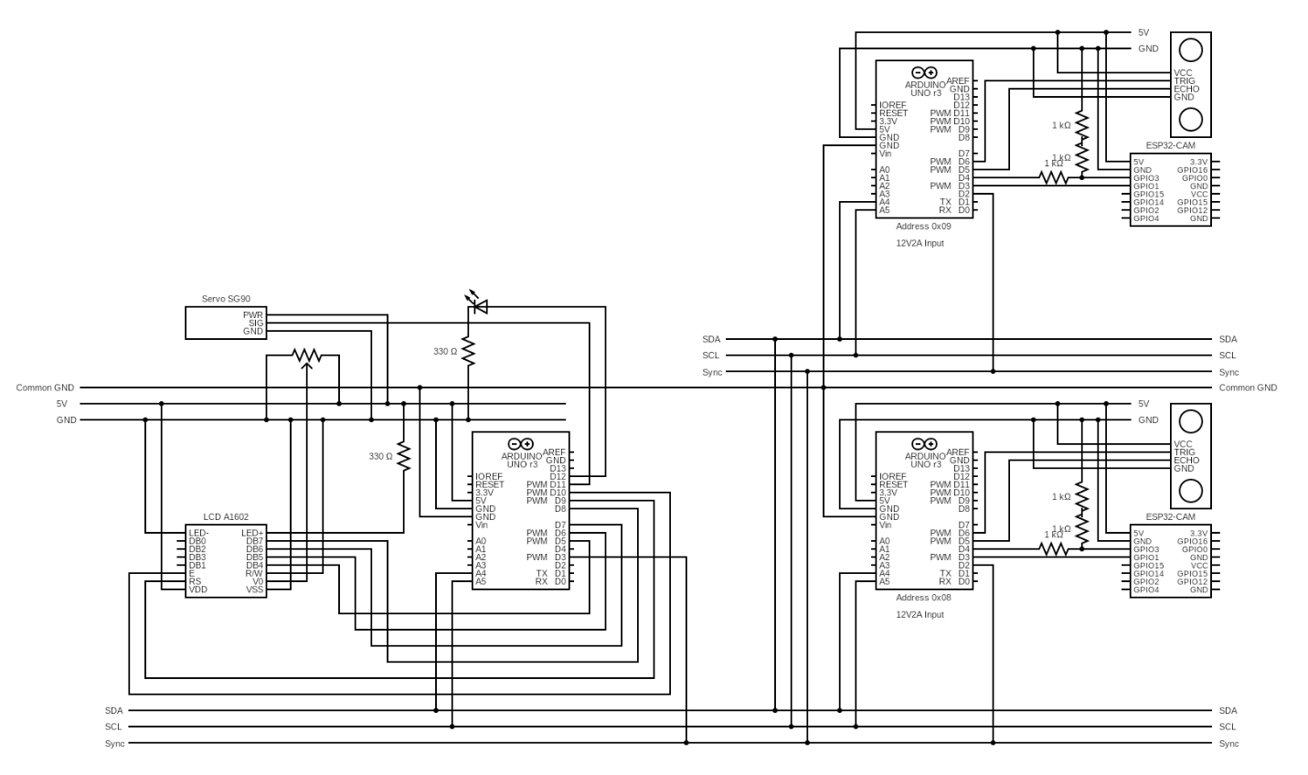
Image 2 Circuit diagram showing the complete wiring of Arduino controllers, sensors, cameras, LCD, LED, and servo gate.
The circuit is designed as a distributed smart parking control system. The central Arduino Uno acts as the master controller, managing the LCD display, LED indicator, and SG90 servo barrier. Two additional Arduino Uno boards are configured as I2C slave modules with addresses 0x08 and 0x09. Each slave module is connected to an ultrasonic sensor for vehicle presence detection and an ESP32-CAM module for image capture. The master and slave boards communicate through the shared SDA and SCL I2C lines, while a synchronization line is used to coordinate system operations. All modules share a common ground to ensure stable signal reference. When a vehicle is detected, the corresponding slave module collects sensor and camera data, sends the result to the master controller, and the master Arduino controls the servo gate and updates the display accordingly.
Table 1 Interfacing between Arduino Master and Arduino Slaves
Arduino Master | Arduino Slave 0x08 / 0x09 | Function | Note
GND | GND | Common ground | Required for stable I2C and signal reference.
A4 | A4 | I2C SDA | Data line for master-slave communication.
A5 | A5 | I2C SCL | Clock line for master-slave communication.
D3 | D2 | Sync signal | Used to synchronize detection/control between master and slaves.

Table 2 Interfacing between Master Arduino and Output Devices
Arduino Master | Device Pin | Device | Function | Note
D11 | SIG | Servo SG90 | PWM gate control | Servo opens/closes the barrier. Use stable 5V supply.
5V | PWR | Servo SG90 | Power | Servo may draw high current; external 5V is recommended.
GND | GND | Servo SG90 | Ground
D12 | LED anode | LED 3mm | Status indicator | Uses 330Ω resistor to limit current.
GND | LED cathode | LED 3mm | Ground

Image 3 Interfacing between Master Arduino and LCD1602
Arduino Master | LCD1602 Pin | Function | Note
5V | VDD | LCD power | LCD1602 operates at 5V.
GND | VSS | Ground | Common ground connection.
Potentiometer output | VO | Contrast control | Adjusts LCD text visibility.
D9 | RS | Register select | Selects command/data mode.
GND | R/W | Read/write control | Grounded for write-only mode.
D10 | E | Enable | Enables LCD data transfer.
D5 | DB4 | Data bit 4 | 4-bit LCD communication mode.
D6 | DB5 | Data bit 5 | 4-bit LCD communication mode.
D7 | DB6 | Data bit 6 | 4-bit LCD communication mode.
D8 | DB7 | Data bit 7 | 4-bit LCD communication mode.
5V | LED+ | Backlight power | Usually connected through suitable resistance/module design.

Image 4 Interfacing between Slave Arduino and HC-SR04 Sensor
Arduino Slave 0x08 / 0x09 | HC-SR04 Pin | Function | Note
5V | VCC | Sensor power | HC-SR04 works with 5V.
GND | GND | Ground | Must share common ground.
D6 | TRIG | Trigger signal | Arduino sends pulse to start distance measurement.
D5 | ECHO | Echo signal | Arduino receives reflected pulse duration.

Image 5 Interfacing between Slave Arduino and ESP32-CAM
Arduino Slave 0x08 / 0x09 | ESP32-CAM Pin | Function | Note
5V | 5V | Camera power | ESP32-CAM requires stable 5V input.
GND | GND | Ground
D3 | GPIO1 / TX | UART receive line | ESP32-CAM sends data to Arduino slave.
D4 | GPIO3 / RX | UART transmit line | Arduino sends data to ESP32-CAM through voltage divider.
5V Arduino signal | 3.3V ESP32 signal | Logic conversion | Arduino Uno is 5V logic; ESP32-CAM is 3.3V logic, so voltage reduction is needed.

Image 6 Power and Ground Distribution
Source / Rail | Connected Devices | Function | Note
5V rail | Arduino modules, HC-SR04, LCD, servo, ESP32-CAM | Main low-voltage supply | Use enough current for servo and ESP32-CAM.
Common GND | All Arduino boards, sensors, LCD, servo, ESP32-CAM | Shared reference ground | Required for I2C, UART, PWM, and sensor signals.
12V/2A input | Arduino VIN / regulated supply path | Main external input | Do not connect 12V directly to ESP32-CAM, HC-SR04, LCD, or servo 5V pins.
Voltage divider | Arduino TX to ESP32-CAM RX | Logic-level protection | Reduces 5V UART signal to safer 3.3V range.

B. Software Design
C. System Workflow
III. IMPLEMENTATION
IV. RESULTS AND DISCUSSION
V. CONCLUSION

REFERENCES

[1] | A. Z. M. T. Kabir, A. M. Mizan, P. K. Saha, M. S. Hasan and M. Pramanik, "An IoT Based Intelligent Parking System for the Unutilized Parking Area With Real-Time Monitoring Using Mobile and Web Application," Asian Journal of Convergence in Technology, 2021.
[2] | I. Jung, "An IoT-based smart parking management system," International Journal of Computational Vision and Robotics, 2020.
[3] | S. Y. C. Hong, C. C. Kang, J. D. Tan and M. Ariannejad, "Smart Parking System Using IoT Sensors," Journal of Engineering Technology and Applied Physics, 2023.
[4] | Y. Allbadi, J. N. Shehab and M. M. Jasim, "The Smart Parking System Using Ultrasonic Control Sensors," IOP Conference Series: Materials Science and Engineering, 2021.
[5] | V. A. Kusuma, H. Arof, S. S. Suprapto, B. Suharto, R. A. Sinulingga and F. Ama, "An internet of things-based touchless parking system using ESP32-CAM," International Journal of Reconfigurable and Embedded Systems, 2023.
[6] | E. Saputra, N. P. IS, E. Fitriani, T. Ariyadi and A. H. A. Tarecha, "Car Parking Monitoring System Based on Location Plate Detection Using Web Camera," Circuit: Jurnal Ilmiah Pendidikan Teknik Elektro, 2026.
[7] | G. P. C. P. d. Luz, G. M. Sato, L. F. G. Gonzalez and J. F. Borin, "Smart Parking with Pixel-Wise ROI Selection for Vehicle Detection Using YOLOv8, YOLOv9, YOLOv10, and YOLOv11," arXiv, 2024.

