7. BUSINESS PROCESSES AND ACTIVITY DIAGRAMS
The diagrams and step tables in this section describe the primary successful path. Validation failures are handled according to the screen-level rules in Sections 10–13; a separate exception-message catalogue is outside this baseline.

7.1 User Account Registration
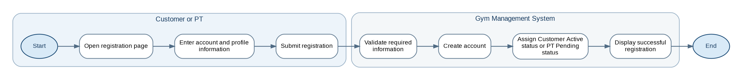
Figure 1. User Account Registration

Process Step Specification
Step | Source | Business Operation | Description | Result / Status
1 | Customer or PT | Open registration | The actor opens the registration function for the applicable role. | Registration form displayed
2 | Customer or PT | Enter registration data | The actor enters account and role-specific profile information. | Registration data prepared
3 | Customer or PT | Submit registration | The actor submits the completed form. | Request sent to GMS
4 | GMS | Validate registration | The system checks required fields, formats, and account-identifier uniqueness. | Valid registration request
5 | GMS | Create account | The system stores the account and profile information. | Account record created
6 | GMS | Assign initial status | A Customer account becomes Active; a PT account request becomes Pending. | Active Customer or Pending PT
7 | GMS | Confirm registration | The system displays the registration result. | Process completed

7.2 User Login
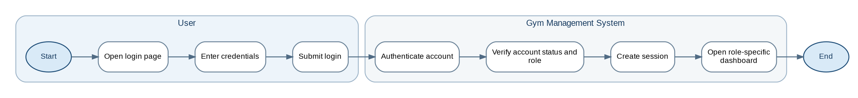
Figure 2. User Login

Process Step Specification
Step | Source | Business Operation | Description | Result / Status
1 | User | Open login | The user opens the shared login page. | Login form displayed
2 | User | Enter credentials | The user enters the registered login identifier and password. | Credentials prepared
3 | User | Select role login | The user selects Customer, PT, or Gym Owner login. | Login request submitted
4 | GMS | Authenticate account | The system validates the credentials. | Account identified
5 | GMS | Verify access | The system verifies role and current account status. | Authorized role confirmed
6 | GMS | Create session | The system creates an authenticated session. | Active session
7 | GMS | Open dashboard | The system redirects the user to the authorized dashboard. | Process completed

7.3 Membership Package Management
Figure 3. Membership Package Management

Process Step Specification
Step | Source | Business Operation | Description | Result / Status
1 | Gym Owner | Open package administration | The Gym Owner opens membership-package administration. | Package list displayed
2 | Gym Owner | Select operation | The Gym Owner creates a package or selects an existing package. | Editable package form displayed
3 | Gym Owner | Enter package data | Name, duration, unit, description, display price, and status are entered. | Package data prepared
4 | Gym Owner | Save package | The Gym Owner submits the package form. | Save request sent
5 | GMS | Validate package | The system validates required fields and numeric values. | Valid package data
6 | GMS | Persist package | The system creates or updates the package and status. | Active or Inactive package
7 | GMS | Refresh list | The updated package list is displayed. | Process completed

7.4 Membership Registration at Counter
Figure 4. Membership Registration at Counter

Process Step Specification
Step | Source | Business Operation | Description | Result / Status
1 | Gym Owner | Open counter registration | The Gym Owner opens the counter membership function. | Registration form displayed
2 | Gym Owner | Find Customer | The Gym Owner searches for and selects an existing Customer account. | Customer selected
3 | Gym Owner | Select package | The Gym Owner selects an Active membership package. | Package selected
4 | Gym Owner | Enter activation date | The Gym Owner supplies the membership start date. | Activation input prepared
5 | GMS | Load and validate data | The system loads Customer/package data and checks that membership periods do not overlap. | Eligible registration
6 | GMS | Calculate validity | The system calculates the end date from the package duration. | Validity period calculated
7 | Gym Owner | Confirm registration | The Gym Owner confirms the counter registration. | Activation authorized
8 | GMS | Create membership | The system creates the membership in Active status. | Active membership

7.5 Membership Activation and QR Generation
Figure 5. Membership Activation and QR Generation

Process Step Specification
Step | Source | Business Operation | Description | Result / Status
1 | Gym Owner | Confirm activation | The Gym Owner confirms the valid counter-registration request. | Activation request accepted
2 | GMS | Activate membership | The system stores the membership with its calculated validity period. | Membership Active
3 | GMS | Generate membership code | A unique membership code is assigned. | Membership code created
4 | GMS | Generate QR | A stable QR is generated from or associated with the membership code. | QR available
5 | GMS | Store activation result | Membership and QR information are committed to D1. | Membership/QR persisted
6 | GMS | Create notifications | The system creates a System Notification and, when enabled, an SMS request. | Notification records created
7 | SMS Service | Process SMS | SMS Service processes the activation message and returns a delivery status. | Pending, Sent, or Failed

7.6 PT Account Registration and Approval
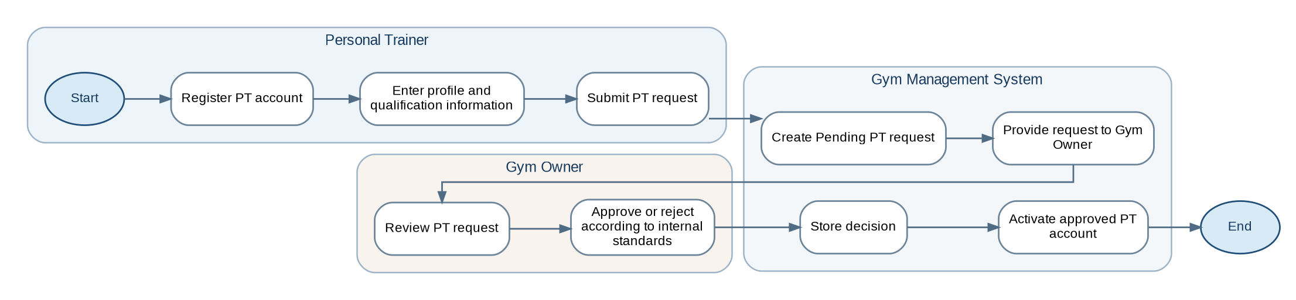
Figure 6. PT Account Registration and Approval

Process Step Specification
Step | Source | Business Operation | Description | Result / Status
1 | PT | Enter registration data | The applicant enters account, profile, experience, specialization, and qualification information. | PT request prepared
2 | PT | Submit request | The PT submits the account request. | Request sent to GMS
3 | GMS | Create PT request | The system stores the account with Pending status. | PT Pending
4 | GMS | Present request | The request becomes available to the Gym Owner. | Review item available
5 | Gym Owner | Review request | The Gym Owner reviews the applicant and qualification data. | Decision prepared
6 | Gym Owner | Approve or reject | The Gym Owner records the decision according to internal standards. | Approved or Rejected decision
7 | GMS | Apply decision | Approved requests become Active; rejected requests become Rejected. | Active or Rejected PT

7.7 PT Package Management
Figure 7. PT Package Management

Process Step Specification
Step | Source | Business Operation | Description | Result / Status
1 | PT | Open package module | An approved Active PT opens their package-management function. | PT package list displayed
2 | PT | Create or select package | The PT starts a new package or selects their own existing package. | Editable package form displayed
3 | PT | Enter package data | The PT enters package description, duration/session information, display price, and status. | Package data prepared
4 | PT | Save package | The PT submits the package form. | Save request sent
5 | GMS | Validate ownership and data | The system verifies PT ownership, account status, required fields, and numeric values. | Valid package request
6 | GMS | Persist package | The package is created or updated as Active or Inactive. | Package stored
7 | GMS | Refresh list | The PT's updated package list is displayed. | Process completed

7.8 PT Package Booking and Confirmation
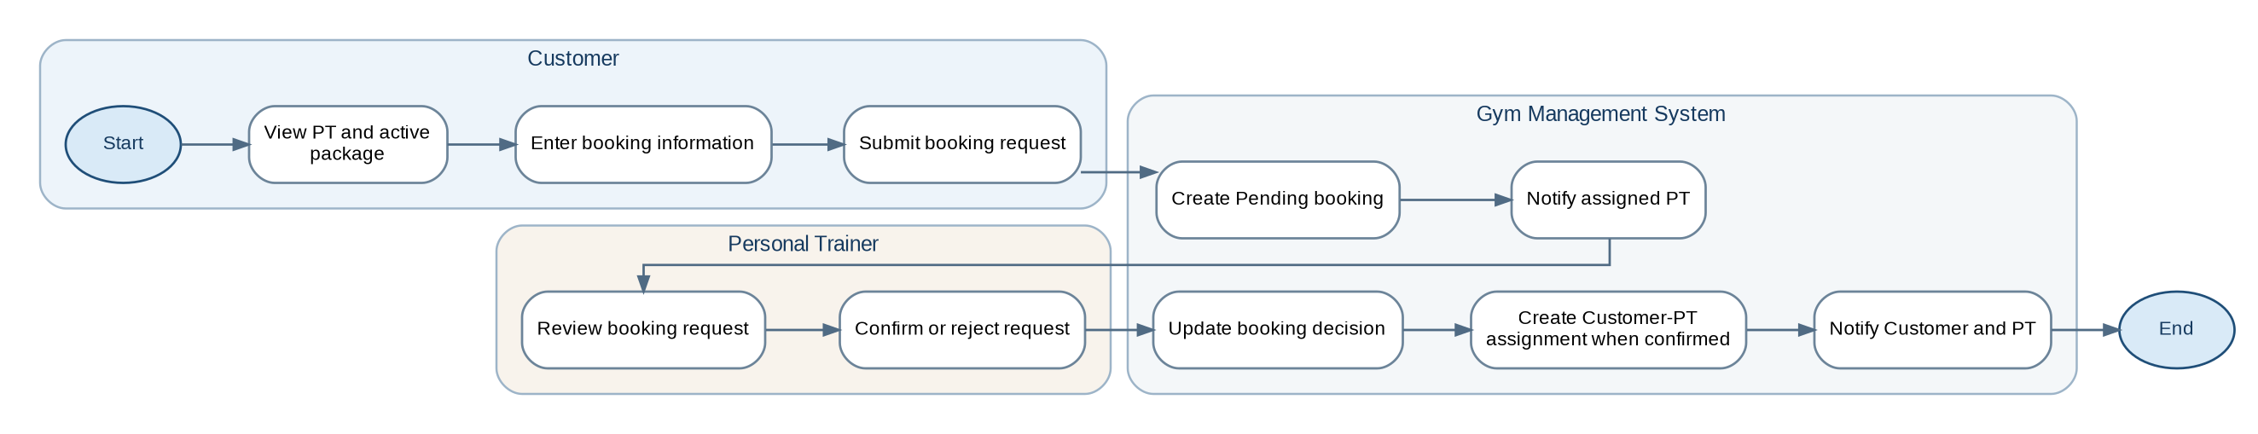
Figure 8. PT Package Booking and Confirmation

Process Step Specification
Step | Source | Business Operation | Description | Result / Status
1 | Customer | Select PT package | The Customer selects an approved PT and an Active package. | Booking target selected
2 | Customer | Enter booking information | Goal, preferred schedule, and optional note are entered. | Booking data prepared
3 | Customer | Submit request | The Customer submits the PT-package booking. | Request sent to GMS
4 | GMS | Create booking | The system stores the request with Pending status. | Booking Pending
5 | GMS | Notify PT | The assigned PT receives a booking notification. | Review requested
6 | PT | Review booking | The PT views the booking details. | Decision prepared
7 | PT | Confirm or reject | The PT records the booking decision. | Confirmed or Rejected
8 | GMS | Create assignment | For a Confirmed booking, the system creates the Customer–PT assignment. | Assignment created
9 | GMS | Notify result | The system notifies the Customer and PT of the result. | Process completed

7.9 Training Schedule Management
Figure 9. Training Schedule Management

Process Step Specification
Step | Source | Business Operation | Description | Result / Status
1 | PT | Open schedule creation | The PT opens the schedule form. | Schedule form displayed
2 | GMS | Load assigned Customers | The system lists Customers linked through Confirmed bookings. | Eligible Customer list
3 | PT | Select Customer | The PT selects the applicable assigned Customer. | Assignment selected
4 | PT | Enter schedule | The PT enters date, start time, end time, and session information. | Schedule data prepared
5 | PT | Submit schedule | The PT submits the schedule. | Request sent to GMS
6 | GMS | Validate assignment and time | The system verifies the assignment and basic date/time validity; it does not check schedule conflicts. | Valid schedule request
7 | GMS | Store schedule | The schedule is stored with Scheduled status. | Session Scheduled
8 | GMS | Publish schedule | The schedule becomes visible to the related PT and Customer. | Process completed

7.10 Training Session Recording
Figure 10. Training Session Recording

Process Step Specification
Step | Source | Business Operation | Description | Result / Status
1 | PT | Select assigned session | The PT opens a Scheduled session assigned to them. | Session detail displayed
2 | PT | Select result status | The PT selects Completed, Cancelled, or Missed. | Result status selected
3 | PT | Enter result information | The PT enters actual times and session notes as applicable. | Session result prepared
4 | PT | Save session | The PT submits the session record. | Update request sent
5 | GMS | Validate session | The system verifies PT ownership, allowed current status, and time consistency. | Valid update
6 | GMS | Store session result | The selected status and notes are stored. | Terminal session status
7 | GMS | Enforce immutability | A Completed session is locked against later modification. | Completed record immutable
8 | GMS | Update history | The training history is refreshed. | Process completed

7.11 Membership QR Check-in/Check-out
Figure 11. Membership QR Check-in/Check-out

Process Step Specification
Step | Source | Business Operation | Description | Result / Status
1 | Customer | Present QR | The Customer presents the QR associated with their membership code. | QR available to service
2 | QR Service | Read membership code | QR Service reads the code represented by the QR. | Membership code obtained
3 | QR Service | Determine event type | QR Service determines CHECK_IN or CHECK_OUT. | Event type assigned
4 | QR Service | Control duplicates | QR Service applies duplicate-event controls. | Accepted service event
5 | QR Service | Submit visit event | The service sends event ID, membership code, event type, and scan time. | Event sent to GMS
6 | GMS | Validate event payload | The system validates required event fields and event identifier. | Valid visit event
7 | GMS | Store visit event | CHECK_IN creates an Open visit; CHECK_OUT closes the related Open visit. | Open or Closed visit
8 | GMS | Auto-close when required | An Open visit is automatically closed after 24 hours without checkout. | Auto-closed visit

7.12 Notification Management
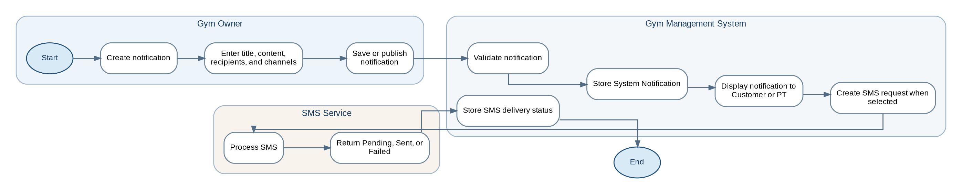
Figure 12. Notification Management

Process Step Specification
Step | Source | Business Operation | Description | Result / Status
1 | Gym Owner | Start notification | The Gym Owner creates a new notification or selects an existing notification. | Notification form displayed
2 | Gym Owner | Enter notification data | Title, content, recipient scope, and delivery channels are entered. | Notification data prepared
3 | Gym Owner | Save or publish | Save stores the content for later completion; Publish makes it available to recipients. | Draft or Published notification
4 | GMS | Validate notification | The system validates required content, recipients, and channel selection. | Valid notification
5 | GMS | Store System Notification | The system stores recipient records and displays Published notifications. | System notification available
6 | GMS | Create SMS request | If SMS is selected, the system creates a Pending SMS request. | SMS Pending
7 | SMS Service | Process SMS | SMS Service processes the request. | Provider result returned
8 | GMS | Store delivery result | The system records Pending, Sent, or Failed without removing the System Notification. | Delivery status stored

7.13 Report Generation
Figure 13. Report Generation

Process Step Specification
Step | Source | Business Operation | Description | Result / Status
1 | Gym Owner | Open reports | The Gym Owner opens the report module. | Report criteria displayed
2 | Gym Owner | Select report | Membership, Visit, or PT Booking report is selected. | Report type selected
3 | Gym Owner | Enter filters | Date range and report-specific filters are entered. | Filter set prepared
4 | Gym Owner | Generate report | The Gym Owner submits the criteria. | Report request sent
5 | GMS | Validate filters | The system validates the date range and filter values. | Valid report request
6 | GMS | Retrieve data | Relevant data is retrieved from D1–D5. | Result dataset prepared
7 | GMS | Calculate output | Summary values and result rows are calculated. | Report generated
8 | GMS | Display report | The report and current filter summary are displayed. | Process completed

7.14 Report Export
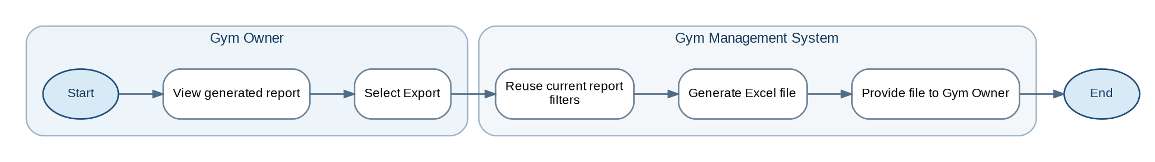
Figure 14. Report Export

Process Step Specification
Step | Source | Business Operation | Description | Result / Status
1 | Gym Owner | View report | The Gym Owner views a successfully generated report. | Current report available
2 | Gym Owner | Select Export | The Gym Owner requests an Excel export. | Export request sent
3 | GMS | Reuse report context | The system applies the current report type, filters, and result scope. | Export dataset fixed
4 | GMS | Generate file | The system generates an .xlsx file with title, filters, generation time, and rows. | Excel file created
5 | GMS | Provide file | The file is provided to the Gym Owner using the required naming convention. | Process completed

