Full Stack Assignment 1 Screenshots

By: Ryan Lee | Student Number: 101296633

# GraphQL Queries & Mutations

Create User

Get all Users

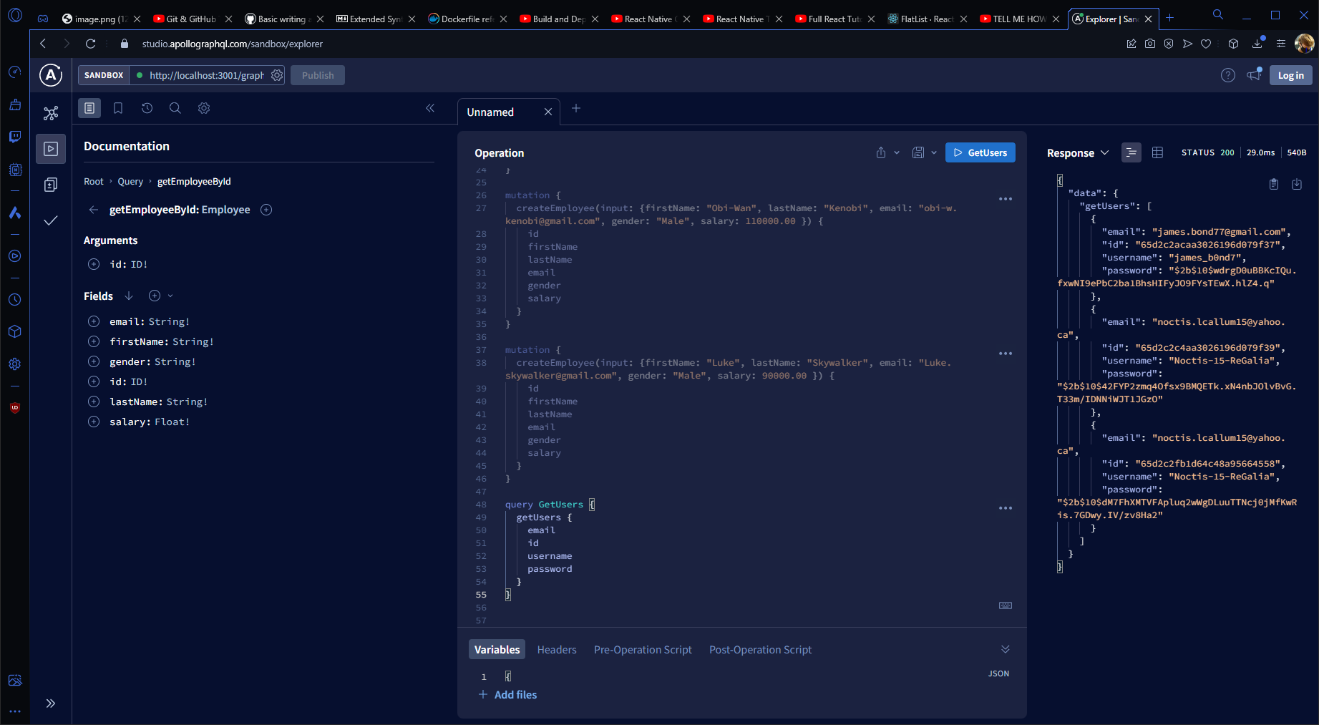

Create an employee

Get All Employees

Update Employee

Find Employee by ID

Delete Employee

# MongoDB Database & Collections

