**Câu 1:**

**Software Requirements**

**Specification**

for

**Koi Order System**Version 1.0 approved

Prepared by Phan Lê Thanh Hoàng - DE180633

FPT University Da Nang

Octorber 24th, 2024

**Câu 2:**

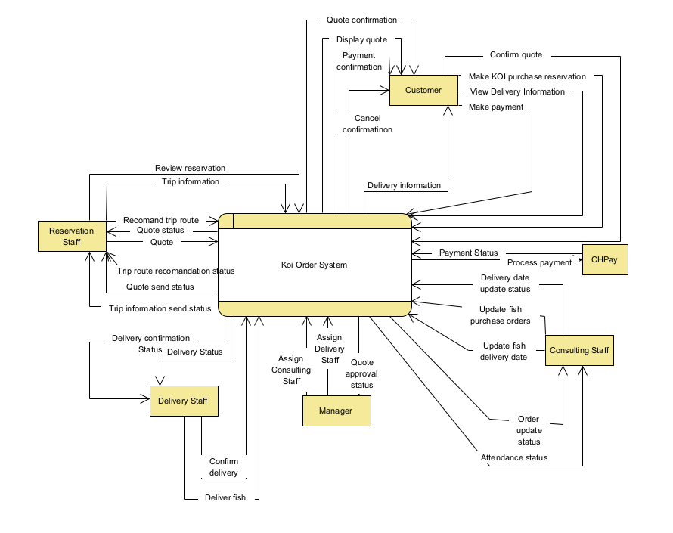  
External Entity:  
· **Customer**

* Makes KOI purchase reservations.
* Views delivery information.
* Receives/display quote.
* Confirms quote and payment.
* Cancels confirmation.
* Receives delivery information.

· **CHPay (Payment System)**

* Processes payment.
* Updates payment status.

· **Consulting Staff**

* Updates fish purchase orders.
* Updates fish delivery date.
* Provides order update status.
* Provides attendance status.

· **Manager**

* Assigns consulting staff.
* Assigns delivery staff.
* Approves quote.

· **Reservation Staff**

* Recommends trip route.
* Sends trip information and quote.
* Reviews reservations.
* Provides quote and trip route recommendation status.

· **Delivery Staff**

* Confirms delivery.
* Delivers fish.
* Provides delivery confirmation status.