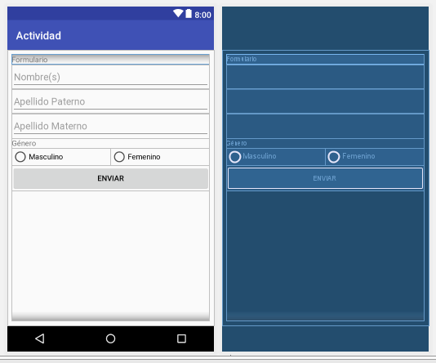

*<?***xml version="1.0" encoding="utf-8"***?>*<**android.support.constraint.ConstraintLayout xmlns:android="http://schemas.android.com/apk/res/android"  
 xmlns:app="http://schemas.android.com/apk/res-auto"  
 xmlns:tools="http://schemas.android.com/tools"  
 android:layout_width="match_parent"  
 android:layout_height="match_parent"  
 tools:context="com.example.axelcuevas.actividad.MainActivity"**>  
  
 <**LinearLayout  
 android:layout_width="368dp"  
 android:layout_height="495dp"  
 android:orientation="vertical"  
 tools:layout_editor_absoluteX="8dp"  
 tools:layout_editor_absoluteY="8dp"  
 tools:ignore="MissingConstraints"**>  
  
 <**TextView  
 android:id="@+id/textView"  
 android:layout_width="match_parent"  
 android:layout_height="wrap_content"  
 android:text="@string/formulario"** />  
  
 <**EditText  
 android:id="@+id/name"  
 android:layout_width="match_parent"  
 android:layout_height="wrap_content"  
 android:ems="10"  
 android:hint="@string/nombre_s"  
 android:inputType="textPersonName"** />  
  
 <**EditText  
 android:id="@+id/apellidop"  
 android:layout_width="match_parent"  
 android:layout_height="wrap_content"  
 android:ems="10"  
 android:hint="@string/apellido_paterno"  
 android:inputType="textPersonName"** />  
  
 <**EditText  
 android:id="@+id/apellidom"  
 android:layout_width="match_parent"  
 android:layout_height="wrap_content"  
 android:ems="10"  
 android:hint="@string/apellido_materno"  
 android:inputType="textPersonName"** />  
  
 <**TextView  
 android:id="@+id/textView2"  
 android:layout_width="match_parent"  
 android:layout_height="wrap_content"  
 android:text="@string/g_nero"** />  
  
 <**RadioGroup  
 android:id="@+id/gen"  
 android:layout_width="match_parent"  
 android:layout_height="wrap_content"  
 android:orientation="horizontal"**>  
  
 <**RadioButton  
 android:id="@+id/masculino"  
 android:layout_width="match_parent"  
 android:layout_height="wrap_content"  
 android:layout_weight="1"  
 android:text="@string/masculino"** />  
  
 <**RadioButton  
 android:id="@+id/femenino"  
 android:layout_width="match_parent"  
 android:layout_height="wrap_content"  
 android:layout_weight="1"  
 android:text="@string/femenino"** />  
 </**RadioGroup**>  
  
 <**Button  
 android:id="@+id/btn"  
 android:layout_width="match_parent"  
 android:layout_height="wrap_content"  
 android:text="@string/enviar"** />  
  
 </**LinearLayout**>  
</**android.support.constraint.ConstraintLayout**>

**package** com.example.axelcuevas.actividad;  
  
 **import** android.content.Intent;  
 **import** android.support.v7.app.AppCompatActivity;  
 **import** android.os.Bundle;  
 **import** android.view.View;  
 **import** android.widget.Button;  
 **import** android.widget.EditText;  
 **import** android.widget.RadioButton;  
 **import** android.widget.RadioGroup;  
  
**public class** MainActivity **extends** AppCompatActivity **implements** View.OnClickListener{  
  
 **private** Button **btn**;  
 **private** RadioGroup **gen**;  
 **private** RadioButton **typegen**;  
 **private** EditText **nombre**, **apaterno**, **amaterno**;  
  
 @Override  
 **protected void** onCreate(Bundle savedInstanceState) {  
 **super**.onCreate(savedInstanceState);  
 setContentView(R.layout.***activity_main***);  
  
 **nombre** = findViewById(R.id.***name***);  
 **apaterno** = findViewById(R.id.***apellidop***);  
 **amaterno** = findViewById(R.id.***apellidom***);  
 **gen** = findViewById(R.id.***gen***);  
 **btn** = findViewById(R.id.***btn***);  
  
 **btn**.setOnClickListener(**this**);  
 }  
  
 @Override  
 **public void** onClick(View v) {  
 **switch** (v.getId()){  
 **case** R.id.***btn***:  
 **int** selected = **gen**.getCheckedRadioButtonId();  
 **typegen** = findViewById(selected);  
  
 Intent screen = **new** Intent(**this**, screen2.**class**);  
 screen.putExtra(**"nombre"**, **nombre**.getText().toString());  
 screen.putExtra(**"apaterno"**, **apaterno**.getText().toString());  
 screen.putExtra(**"amaterno"**, **apaterno**.getText().toString());  
 screen.putExtra(**"gen"**, **typegen**.getText().toString());  
 startActivity(screen);  
 **break**;  
 }  
 }  
}

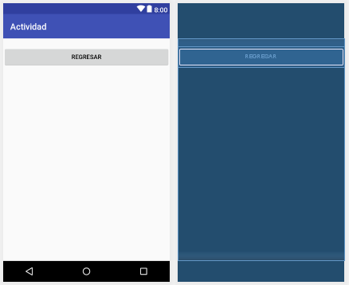

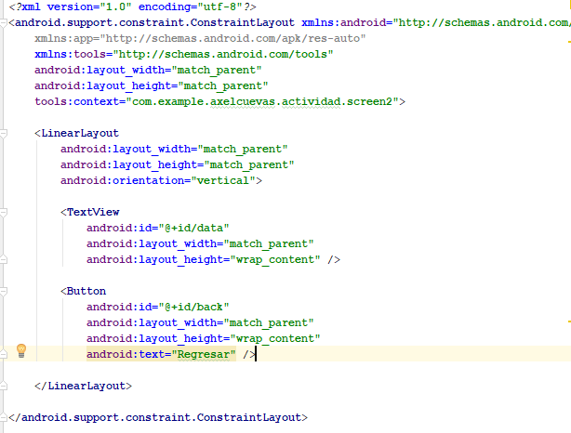

**package** com.example.axelcuevas.actividad;  
  
**import** android.content.Intent;  
**import** android.support.v7.app.AppCompatActivity;  
**import** android.os.Bundle;  
**import** android.view.View;  
**import** android.widget.Button;  
**import** android.widget.TextView;  
  
**public class** screen2 **extends** AppCompatActivity **implements** View.OnClickListener{  
  
 **private** TextView **data**;  
 **private** Button **back**;  
  
 @Override  
 **protected void** onCreate(Bundle savedInstanceState) {  
 **super**.onCreate(savedInstanceState);  
 setContentView(R.layout.***activity_screen2***);  
  
 **data** = findViewById(R.id.***data***);  
 **back** = findViewById(R.id.***back***);  
  
 Intent datos = getIntent();  
  
 String nombre = datos.getStringExtra(**"nombre"**);  
 String paterno = datos.getStringExtra(**"apaterno"**);  
 String materno = datos.getStringExtra(**"amaterno"**);  
 String gen = datos.getStringExtra(**"gen"**);  
  
 **data**.setText(**"Nombre: "** +nombre +  
 **"\nApellido Paterno: "** + paterno +  
 **"\nApellido Materno: "** + materno +  
 **"\nGénero: "** + gen);  
  
 **back**.setOnClickListener(**this**);  
  
 }  
  
 @Override  
 **public void** onClick(View view) {  
 **switch** (view.getId()){  
 **case** R.id.***back***:  
 Intent regreso = **new** Intent(**this**, MainActivity.**class**);  
 startActivity(regreso);  
 **break**;  
 }  
 }  
}