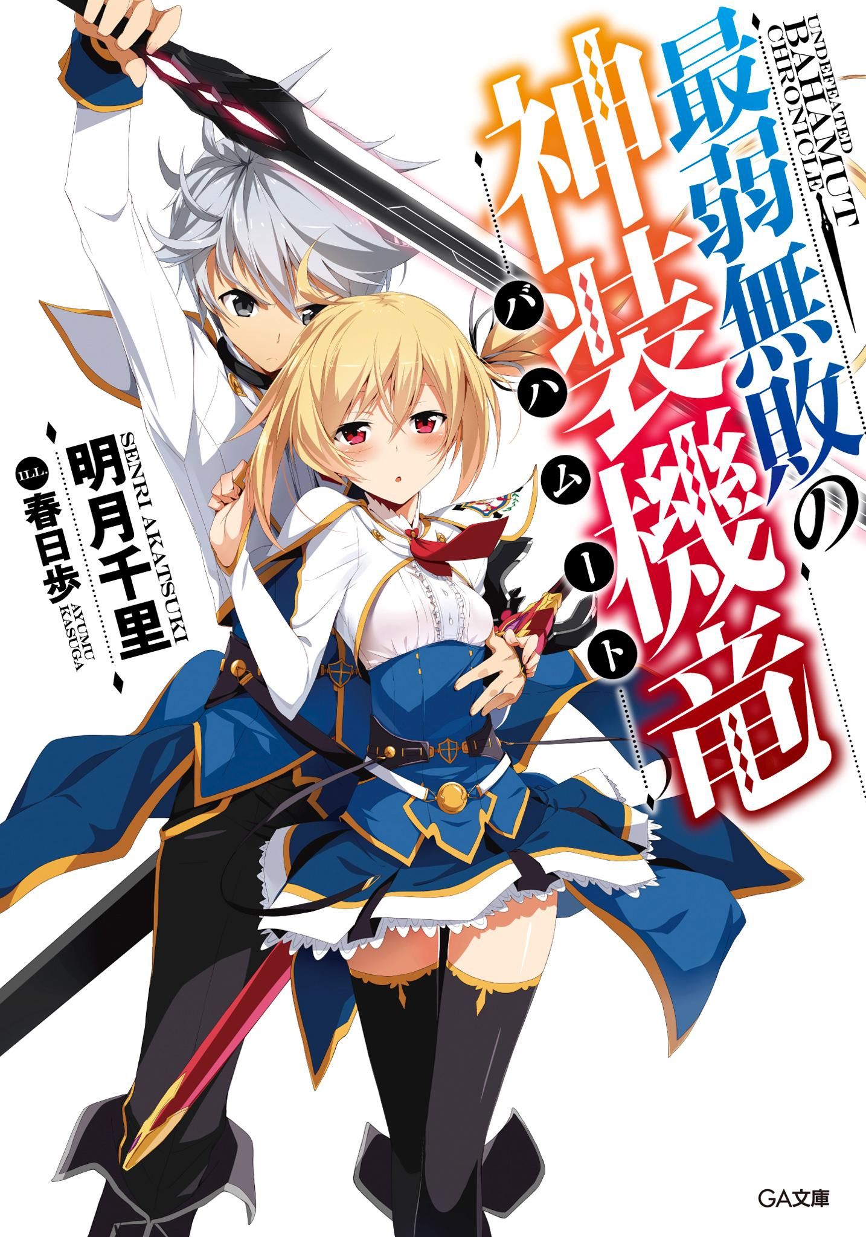

Table of Contents
Illustrations
Prologue – The Black Hero
Episode 1 – The Intruder at Midnight
Episode 2 – Academy for Noble Children
Episode 3 – The Scarlet Princess
Episode 4 – Assault, and…
Episode 5 – Reunion with a Childhood Friend
Episode 6 – Atelier of Machine Dragons and Enrollment Exams
Episode 7 – The Weakest Drag-Knight
Epilogue – Where The Prince belongs
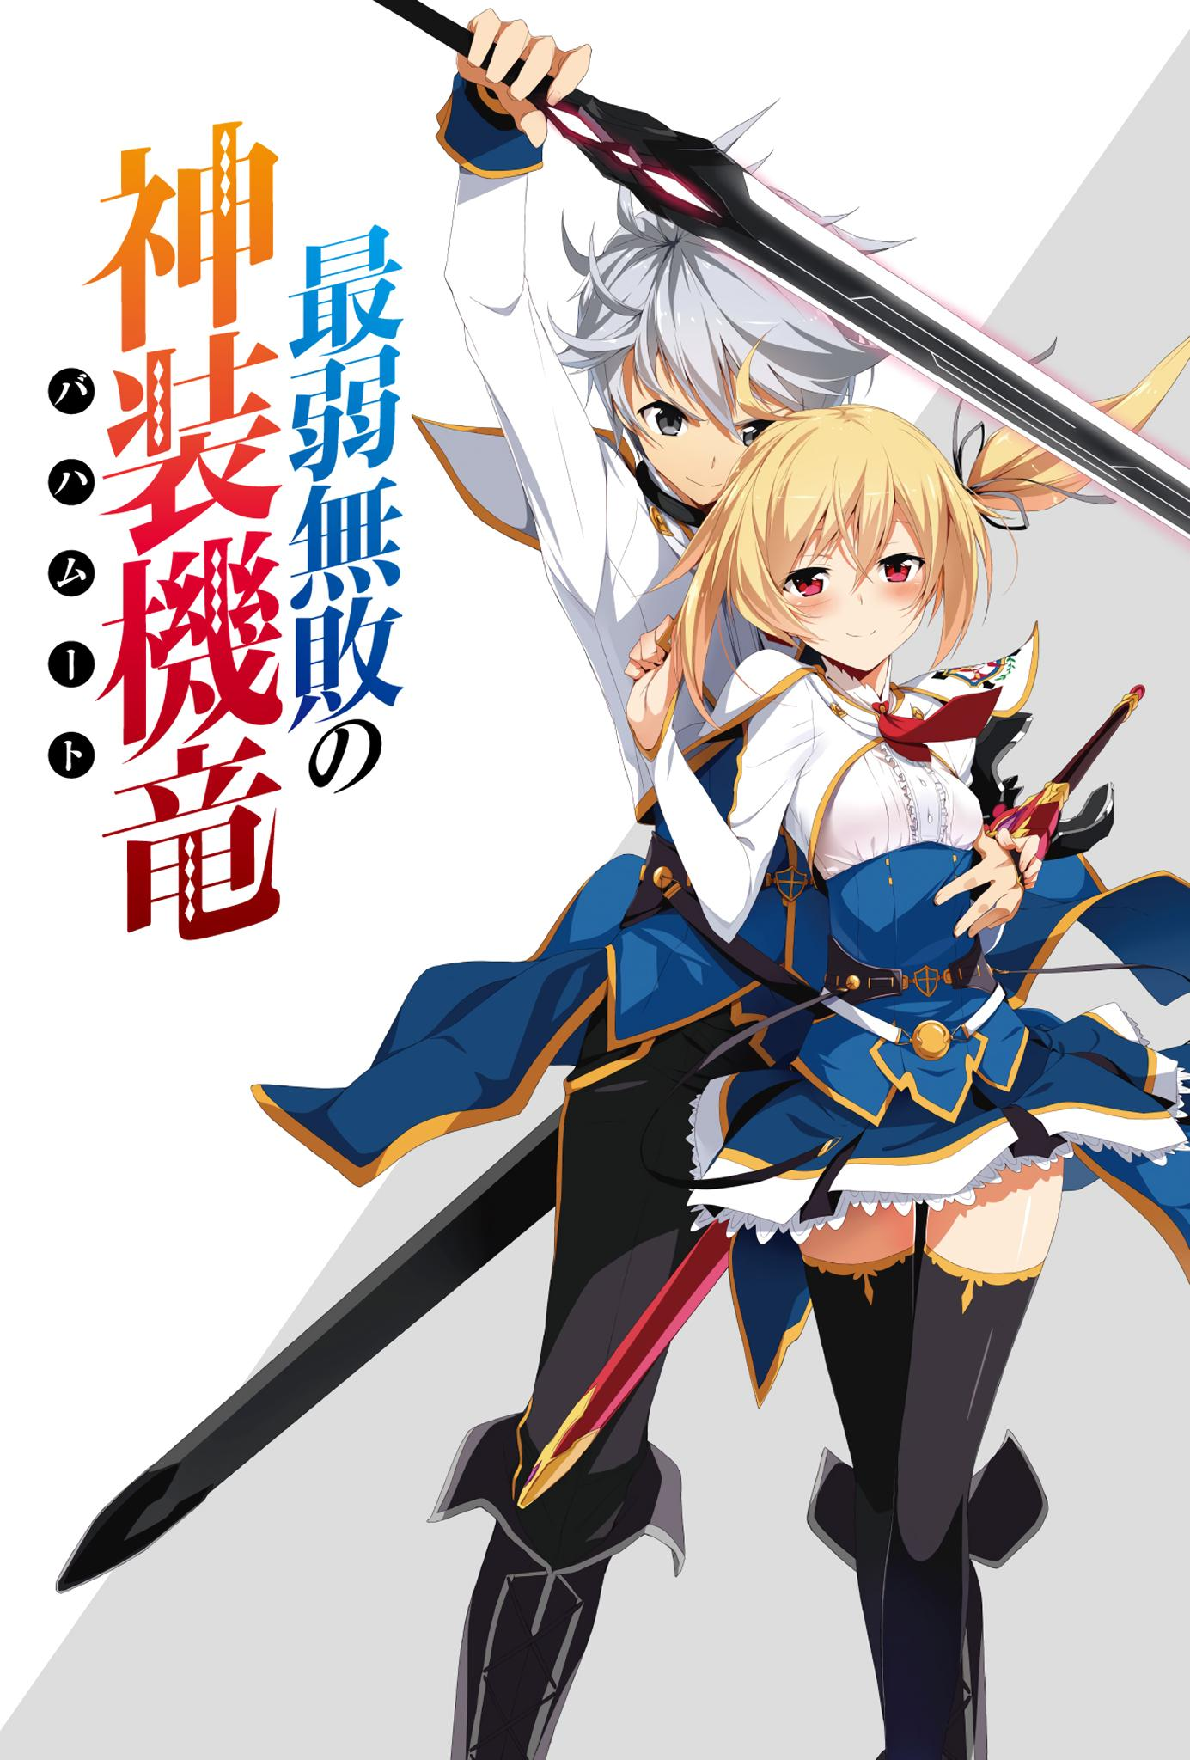
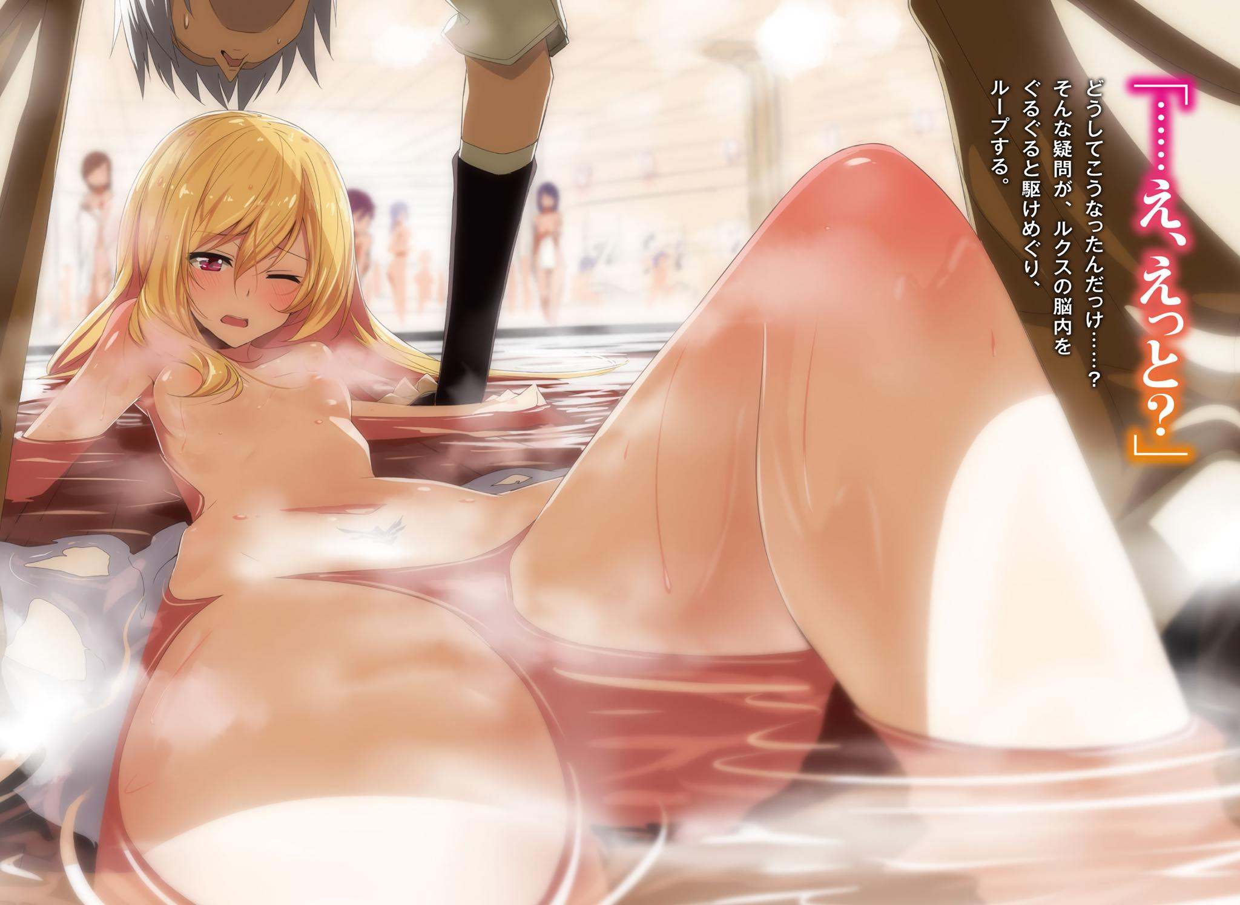
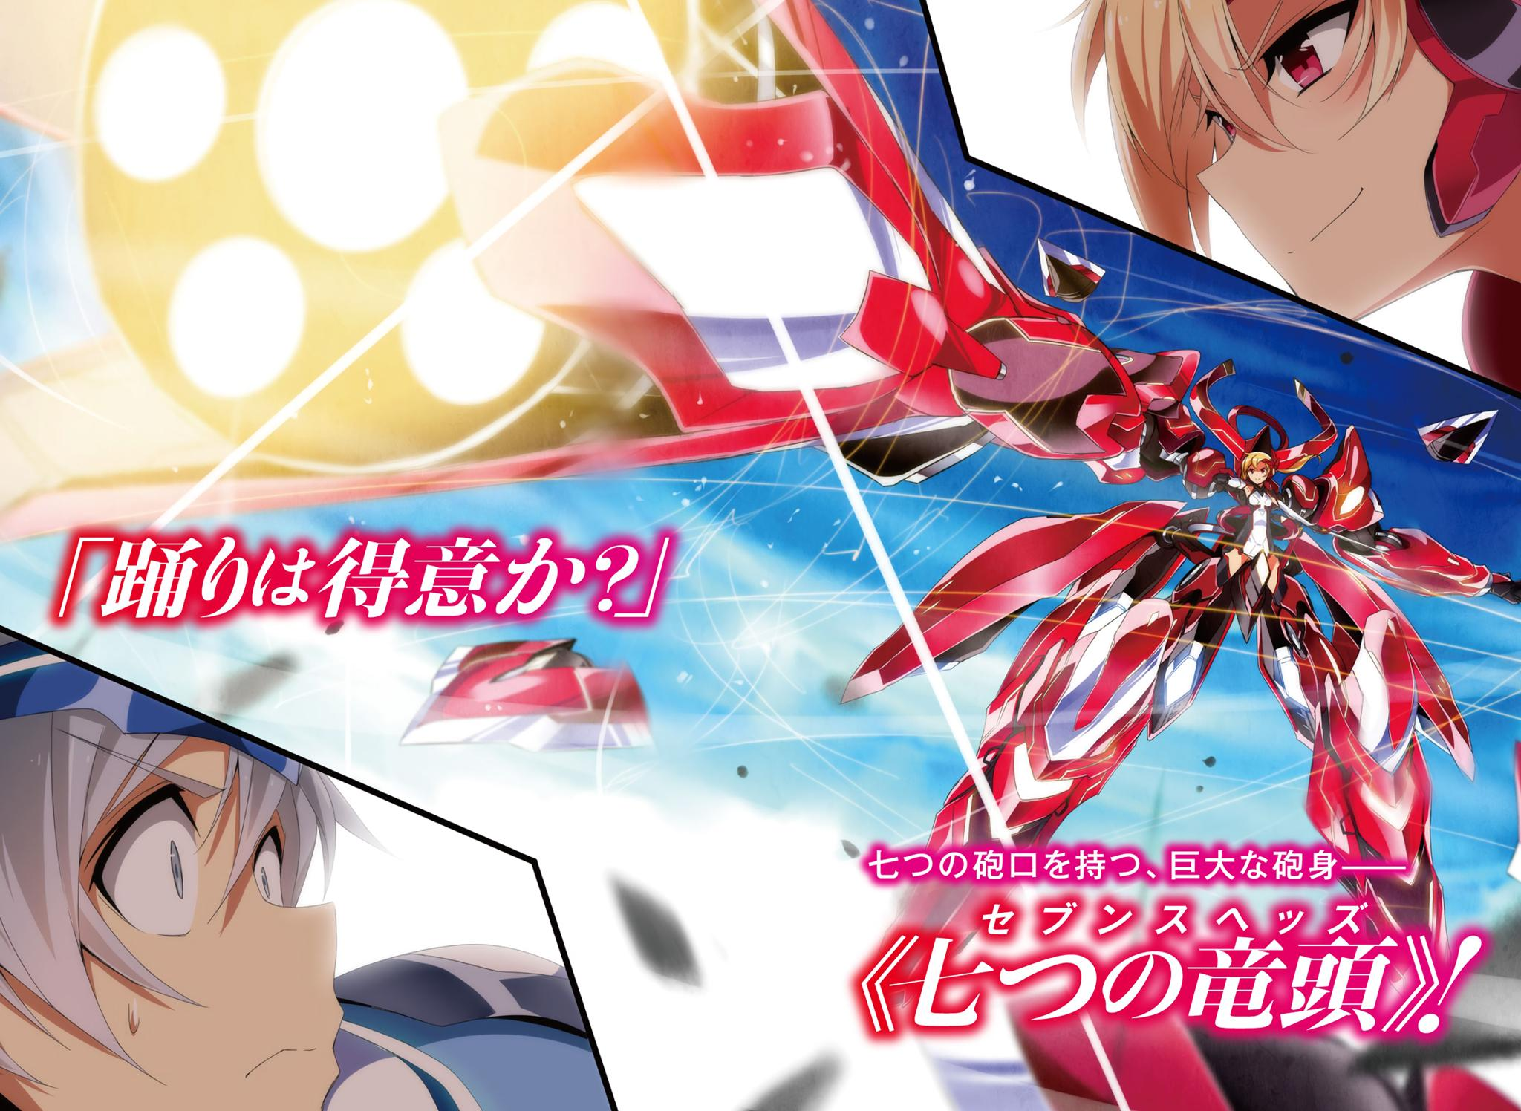
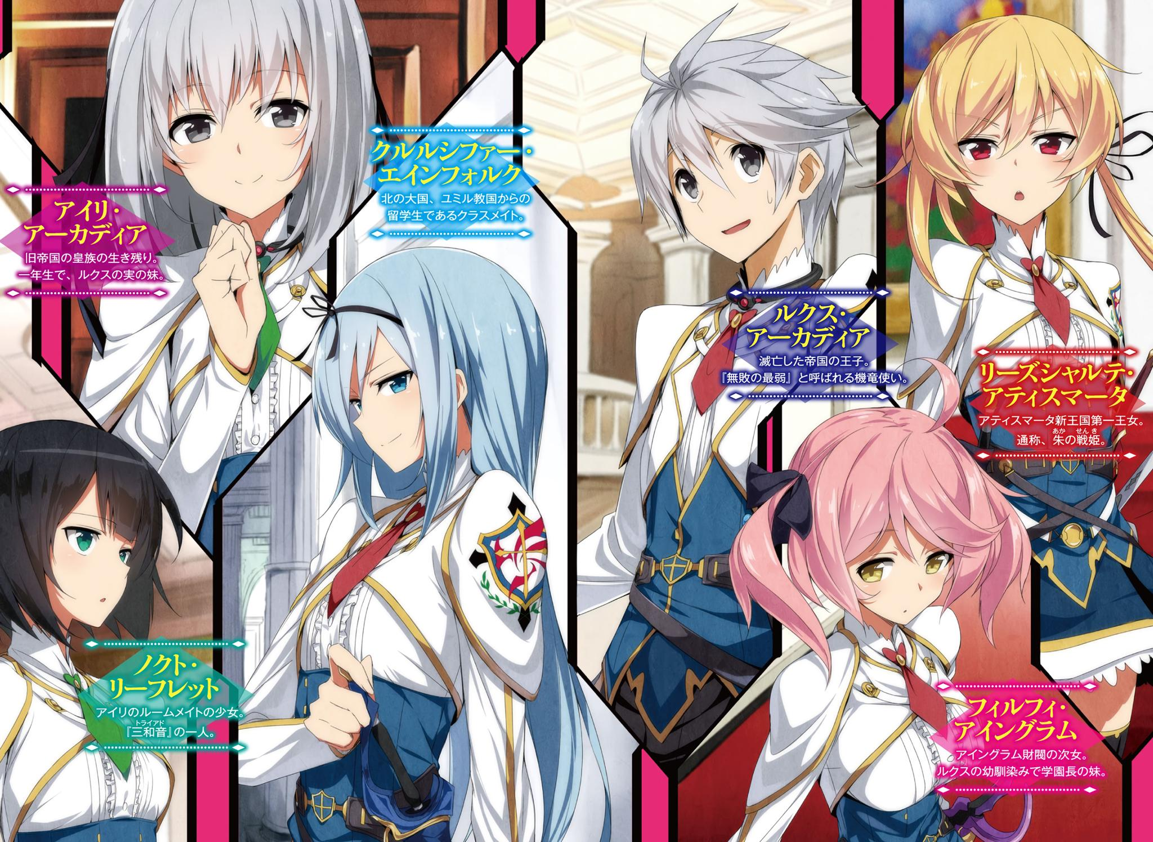
Contents
⬩··········⬩
■■■■  Prologue | The Black Hero
■■■■  Episode 1 | The Intruder at Midnight
■■■■  Episode 2 | Academy for Noble Children
■■■■  Episode 3 | The Scarlet Princess
■■■■  Episode 4 | Assault, and…
■■■■  Episode 5 | Reunion with a Childhood Friend
■■■■  Episode 6 | Atelier of Machine Dragons and Enrollment Exams
■■■■  Episode 7 | The Weakest Drag-Knight
■■■■  Epilogue | Where The Prince belongs
⬩··········⬩

最弱無敗の神装機竜《バハムート》
Saijaku Muhai no Bahamut

(Undefeated Bahamut Chronicle)
Volume 1

Author: Akatsuki Senri
Illustrator: Kasuga Ayumu
Translation: Setsuna86

Prologue

The Black Hero
The girl looked up to the sky.
As if being absorbed, the girl looked up to the deep, dark sky as though she was enchanted by it.
However, the lower region of the sky was red.
The red flames that were slowly wavering within the whole surface.
The powerful country that controlled one fifth of the world. The castle of the Acadia Empire was burning.
A castle made from thick rock that was built up high, as if trying to cut itself off from the outside world.
The girl simply looked up to the sky while being surrounded by sparks that fell down to the courtyard.

There were Dragons dancing in the sky.
The battle of the Drag-Knights with their lives on the line where they wore dark grey ancient weapons over their bodies.
Hundreds of Dragons danced in the sky that was lit by flames as they howled, had their wings torn off, and fell.

“Aren’t you going to run away, brat?”
The girl turned around; hearing a voice from behind her.
There was a youth standing there.
A handsome face with silver hair and ash colored eyes.
That man who wore a cape with a refined design imprinted on it acted in a manly manner like that of a noble, but he looked at the girl with sparkling eyes that made you think of a hungry beast.
However, the girl clad in a black dress who had no emotion in her eyes didn’t get scared and instead gazed at the youth with her eyes.
“……Were you the one that killed them? The people of this castle—”
“I did. …….If I say that, will you avenge them? Fine then, bring it.”
Instead of trembling at the question thrown at him, he drew his sword out with joy.
It was a beautiful blade that had multiple silver lines on its surface.
A divine weapon that was the key to activate the Drag-Ride and control them—the sword device.
“……If you did, then kill me right here as well.”
“What……?”
The youth twitched his eyebrows at what the girl muttered.
“If the Empire is going to fall, then I don’t have any other place left where I belong to—.”
“…………”
The youth made an uncanny look, and stared at the girl for a while.
“……Kuhahahaha! Oh I see! So you were that kind of girl! One of those people! This is a masterpiece! Hahahahaha! Hahahahahahahahahahahaha!”
He suddenly put his hand on his forehead and laughed as if he was mad.
Despite that, the girl did not show any response.
“This is boring…… I’m not going to kill you, idiot. What would I benefit from killing someone amusing like you?”
As the man said that, he took off the other sword that was hanging on his hip along with its sheath and threw towards the girl.
On the sheath that sunk down on the grass while it made a heavy sound, there were beautiful ornaments carved into it.
“I’ll give that to you. The “power” that will change fate—that sword device, that is. So flee while taking that with you. This castle will go down very soon, lady.”
The man said that while putting on a smile that didn't hold any of the insanity he'd shown till now.
“…………”
The girl picked up the sword silently.
She embraced the sword which was too big for a young, small body like hers along with the sheath.
After the youth smiled fearlessly seeing that, he turned around and walked into the castle.
“Wait.”
“What’s wrong?”
The silver haired youth stopped due to the girl’s voice, and he turned around reluctantly.
“What is that……?”
The girl pointed at the sky.
What was there was a devil that was destroying the Empire that was known as the absolute undefeated myth.
It flew in many directions in the sky where there were sparks. A single grey colored Dragon that was wreaking havoc by destroying Drag-Rides that belonged to the Empire one after another.
It was a giant jet-black Drag-Ride that had the same color as the sky.
“Kukuku. ……No idea. Except, for the majority of the people in this town, you can call it the great hero that took down the horrible Empire.”
“A hero……?”
The man disappeared during the time the girl looked up once again.
She didn’t get any answers.
That’s why, the girl wished to live on until she found the answer.
Even as the hot wind that came from inside the castle became violent, and caused the sparks that were falling down on the courtyard to swirl.
“…………”
The girl went inside the water well while embracing the sword that was given to her by the youth.
When she went down the well using the hanging rope, there was a blocked hole near the water surface.
She used the key she was hiding inside her pocket. The girl stopped right before entering the passage.

She looked up very high to the night sky which was a battlefield as if she was being absorbed by it.
“Father…… I—”

The girl muttered as if she was dead.

