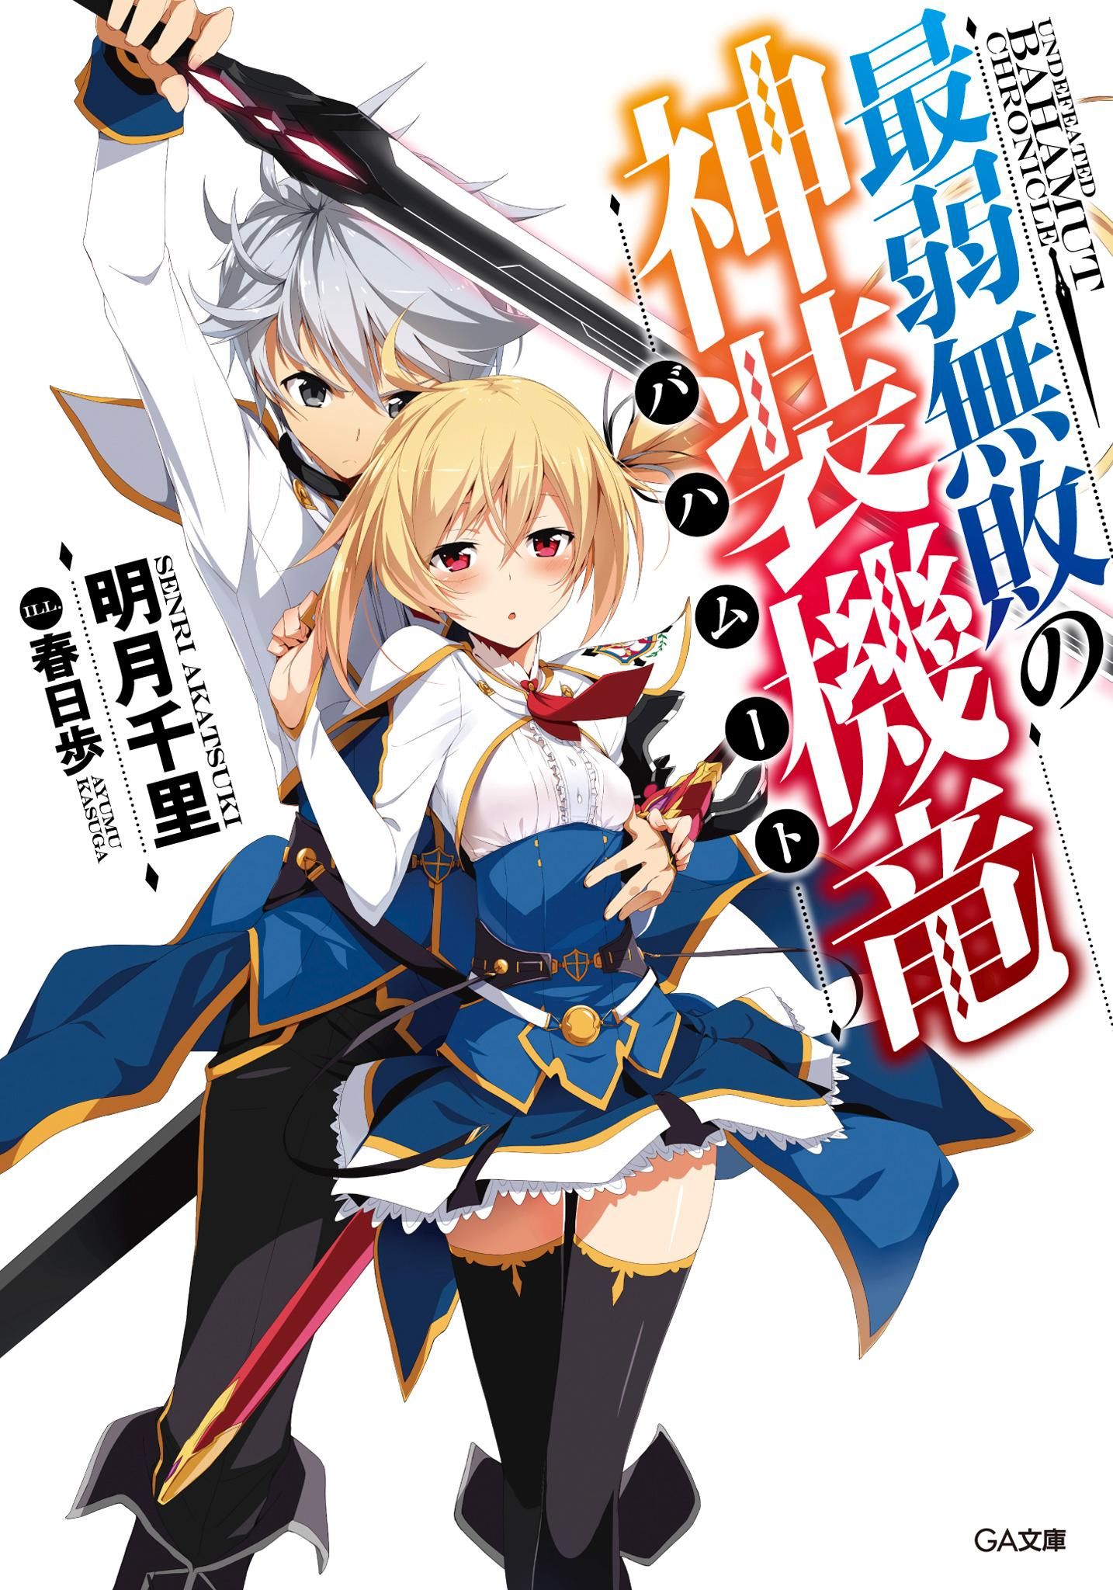

Table of Contents
Illustrations
Prologue – The Black Hero
Episode 1 – The Intruder at Midnight
Episode 2 – Academy for Noble Children
Episode 3 – The Scarlet Princess
Episode 4 – Assault, and…
Episode 5 – Reunion with a Childhood Friend
Episode 6 – Atelier of Machine Dragons and Enrollment Exams
Episode 7 – The Weakest Drag-Knight
Epilogue – Where The Prince belongs
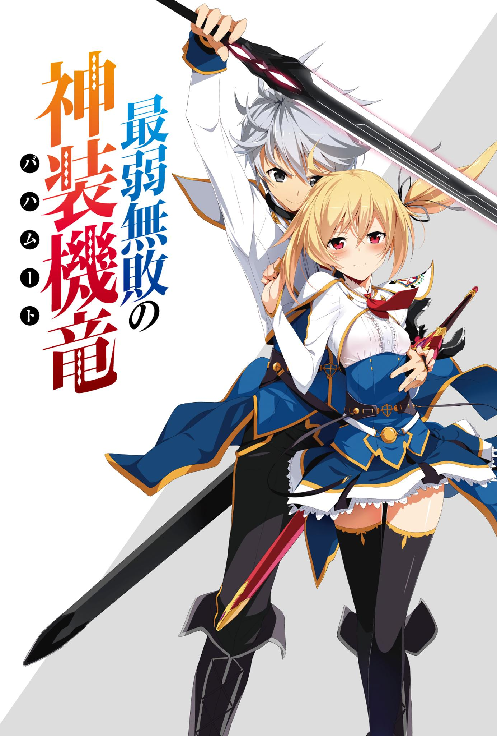
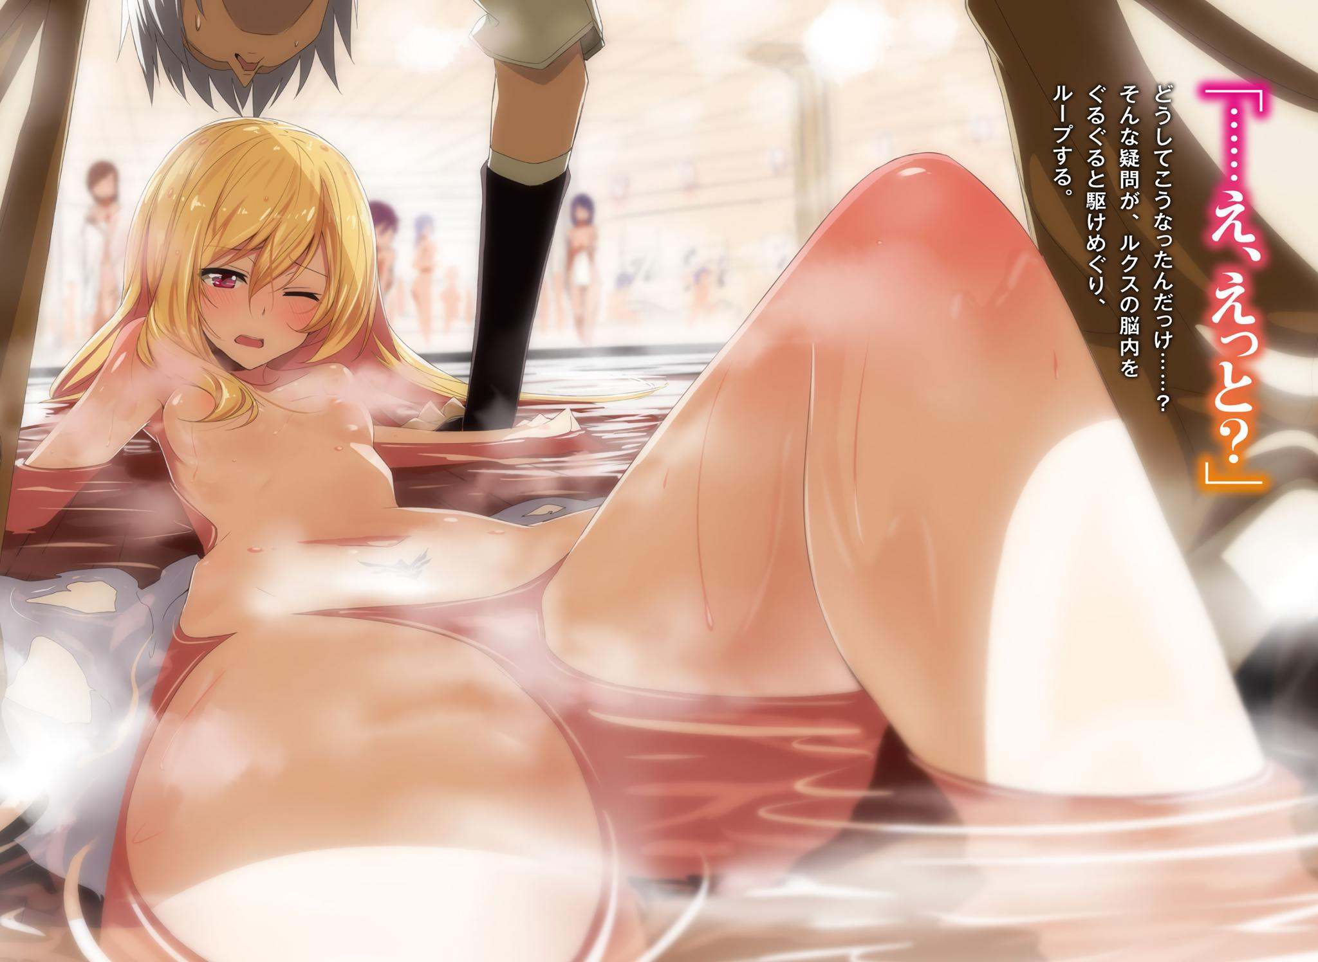
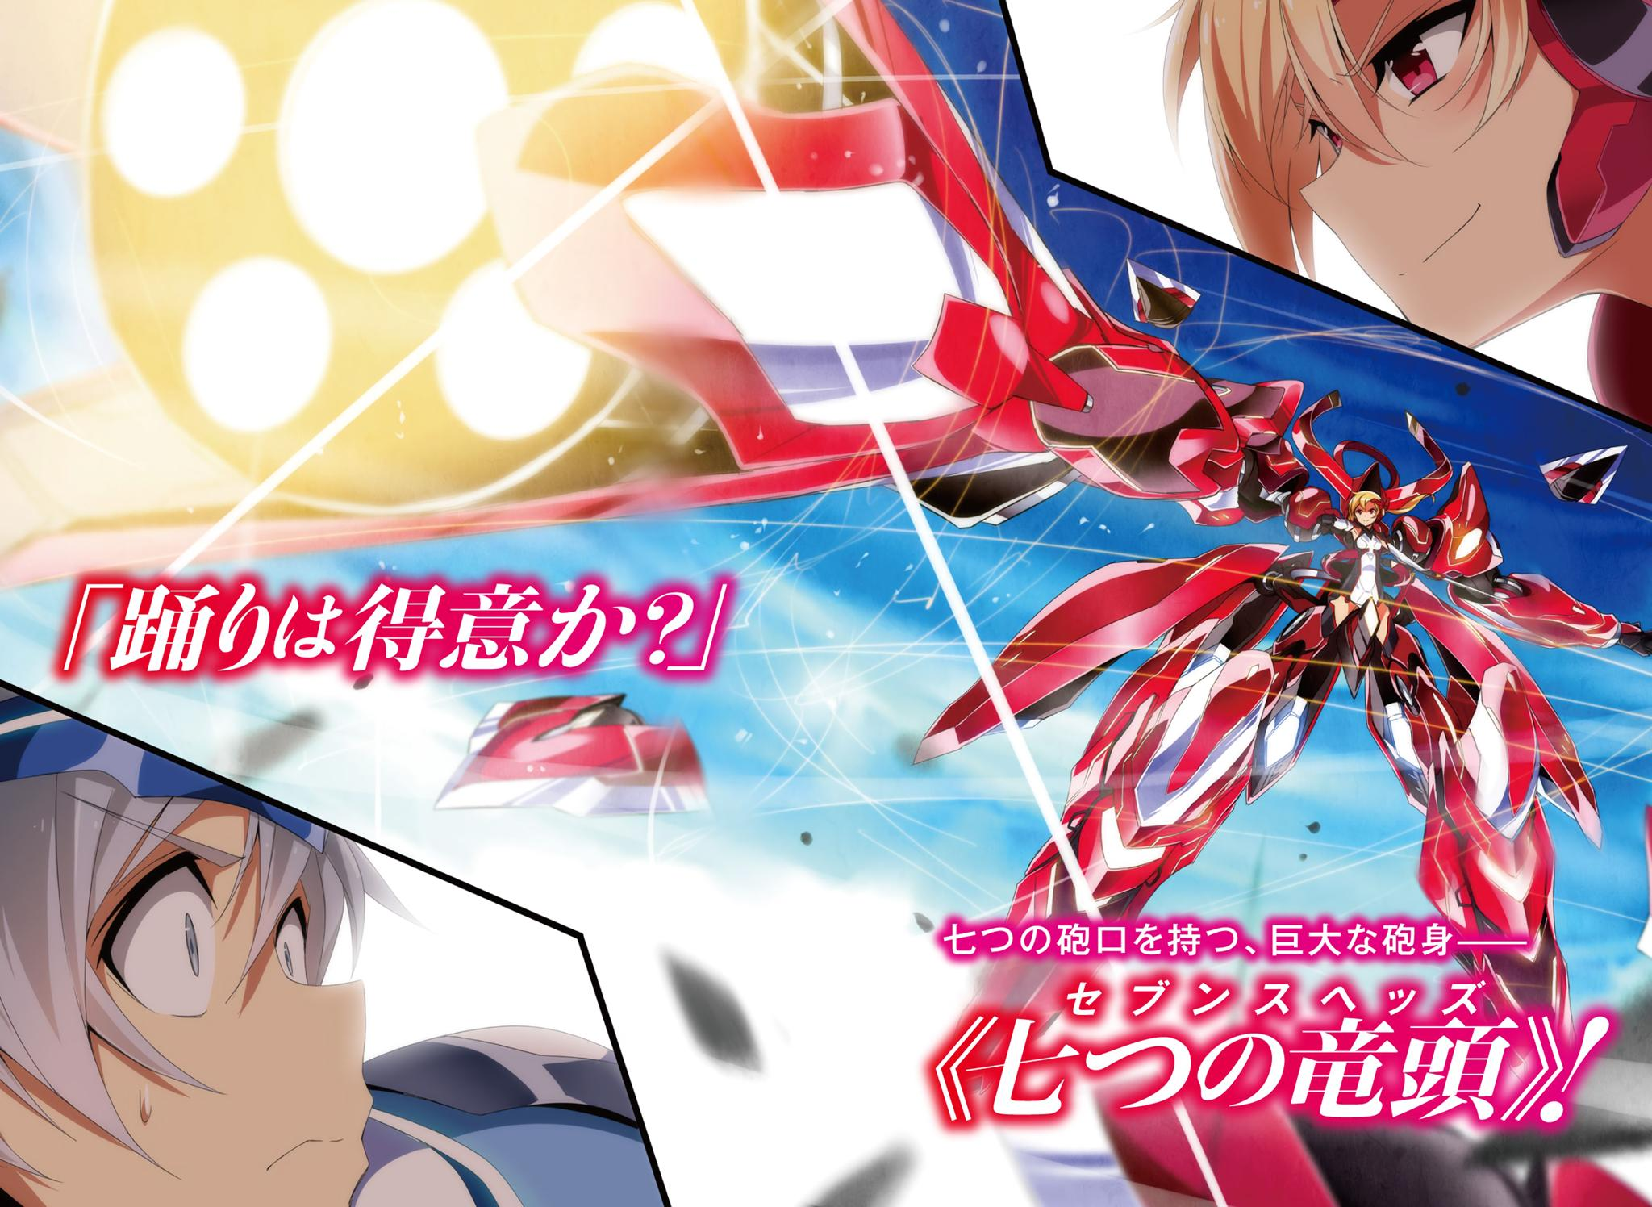
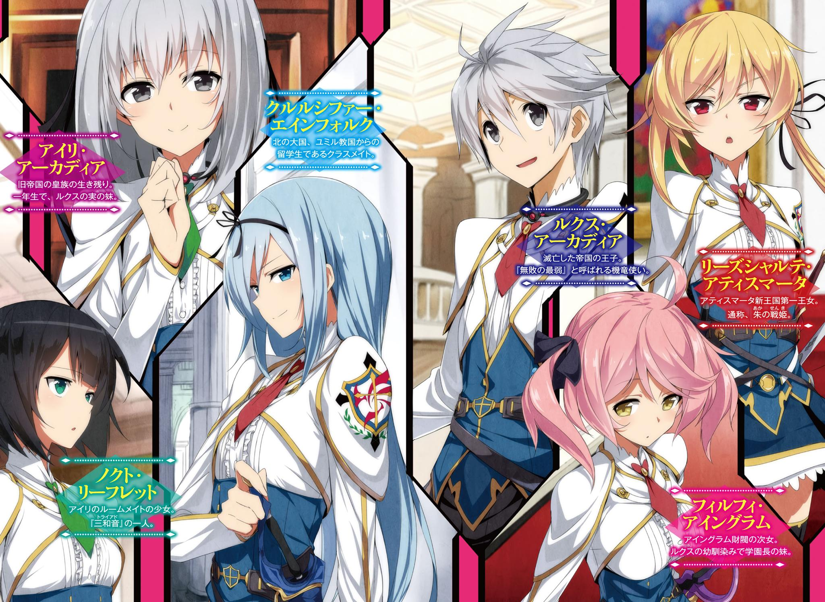
Contents
[TEXT TRANSLATED: ⬩··········⬩]
■■■■  Prologue | The Black Hero
■■■■  Episode 1 | The Intruder at Midnight
■■■■  Episode 2 | Academy for Noble Children
■■■■  Episode 3 | The Scarlet Princess
■■■■  Episode 4 | Assault, and…
■■■■  Episode 5 | Reunion with a Childhood Friend
■■■■  Episode 6 | Atelier of Machine Dragons and Enrollment Exams
■■■■  Episode 7 | The Weakest Drag-Knight
■■■■  Epilogue | Where The Prince belongs
[TEXT TRANSLATED: ⬩··········⬩]

[TEXT TRANSLATED: 最弱無敗の神装機竜《バハムート》]
[TEXT TRANSLATED: Saijaku Muhai no Bahamut]

[TEXT TRANSLATED: (Undefeated Bahamut Chronicle)]
[TEXT TRANSLATED: Volume 1]

[TEXT TRANSLATED: Author: Akatsuki Senri]
[TEXT TRANSLATED: Illustrator: Kasuga Ayumu]
Setsuna86[TEXT TRANSLATED: Translation: Setsuna86]

Prologue[TEXT TRANSLATED: Prologue]

[TEXT TRANSLATED: The Black Hero]
[TEXT TRANSLATED: The girl looked up to the sky.]
[TEXT TRANSLATED: As if being absorbed, the girl looked up to the deep, dark sky as though she was enchanted by it.]
[TEXT TRANSLATED: However, the lower region of the sky was red.]
[TEXT TRANSLATED: The red flames that were slowly wavering within the whole surface.]
[TEXT TRANSLATED: The powerful country that controlled one fifth of the world. The castle of the Acadia Empire was burning.]
[TEXT TRANSLATED: A castle made from thick rock that was built up high, as if trying to cut itself off from the outside world.]
[TEXT TRANSLATED: The girl simply looked up to the sky while being surrounded by sparks that fell down to the courtyard.]

[TEXT TRANSLATED: There were Dragons dancing in the sky.]
[TEXT TRANSLATED: The battle of the Drag-Knights with their lives on the line where they wore dark grey ancient weapons over their bodies.]
[TEXT TRANSLATED: Hundreds of Dragons danced in the sky that was lit by flames as they howled, had their wings torn off, and fell.]

[TEXT TRANSLATED: “Aren’t you going to run away, brat?”]
[TEXT TRANSLATED: The girl turned around; hearing a voice from behind her.]
[TEXT TRANSLATED: There was a youth standing there.]
[TEXT TRANSLATED: A handsome face with silver hair and ash colored eyes.]
[TEXT TRANSLATED: That man who wore a cape with a refined design imprinted on it acted in a manly manner like that of a noble, but he looked at the girl with sparkling eyes that made you think of a hungry beast.]
[TEXT TRANSLATED: However, the girl clad in a black dress who had no emotion in her eyes didn’t get scared and instead gazed at the youth with her eyes.]
[TEXT TRANSLATED: “……Were you the one that killed them? The people of this castle—”]
[TEXT TRANSLATED: “I did. …….If I say that, will you avenge them? Fine then, bring it.”]
[TEXT TRANSLATED: Instead of trembling at the question thrown at him, he drew his sword out with joy.]
[TEXT TRANSLATED: It was a beautiful blade that had multiple silver lines on its surface.]
[TEXT TRANSLATED: A divine weapon that was the key to activate the Drag-Ride and control them—the sword device.]
[TEXT TRANSLATED: “……If you did, then kill me right here as well.”]
[TEXT TRANSLATED: “What……?”]
[TEXT TRANSLATED: The youth twitched his eyebrows at what the girl muttered.]
[TEXT TRANSLATED: “If the Empire is going to fall, then I don’t have any other place left where I belong to—.”]
[TEXT TRANSLATED: “…………”]
[TEXT TRANSLATED: The youth made an uncanny look, and stared at the girl for a while.]
[TEXT TRANSLATED: “……Kuhahahaha! Oh I see! So you were that kind of girl! One of those people! This is a masterpiece! Hahahahaha! Hahahahahahahahahahahaha!”]
[TEXT TRANSLATED: He suddenly put his hand on his forehead and laughed as if he was mad.]
[TEXT TRANSLATED: Despite that, the girl did not show any response.]
[TEXT TRANSLATED: “This is boring…… I’m not going to kill you, idiot. What would I benefit from killing someone amusing like you?”]
[TEXT TRANSLATED: As the man said that, he took off the other sword that was hanging on his hip along with its sheath and threw towards the girl.]
[TEXT TRANSLATED: On the sheath that sunk down on the grass while it made a heavy sound, there were beautiful ornaments carved into it.]
[TEXT TRANSLATED: “I’ll give that to you. The “power” that will change fate—that sword device, that is. So flee while taking that with you. This castle will go down very soon, lady.”]
[TEXT TRANSLATED: The man said that while putting on a smile that didn't hold any of the insanity he'd shown till now.]
[TEXT TRANSLATED: “…………”]
[TEXT TRANSLATED: The girl picked up the sword silently.]
[TEXT TRANSLATED: She embraced the sword which was too big for a young, small body like hers along with the sheath.]
[TEXT TRANSLATED: After the youth smiled fearlessly seeing that, he turned around and walked into the castle.]
[TEXT TRANSLATED: “Wait.”]
[TEXT TRANSLATED: “What’s wrong?”]
[TEXT TRANSLATED: The silver haired youth stopped due to the girl’s voice, and he turned around reluctantly.]
[TEXT TRANSLATED: “What is that……?”]
[TEXT TRANSLATED: The girl pointed at the sky.]
[TEXT TRANSLATED: What was there was a devil that was destroying the Empire that was known as the absolute undefeated myth.]
[TEXT TRANSLATED: It flew in many directions in the sky where there were sparks. A single grey colored Dragon that was wreaking havoc by destroying Drag-Rides that belonged to the Empire one after another.]
[TEXT TRANSLATED: It was a giant jet-black Drag-Ride that had the same color as the sky.]
[TEXT TRANSLATED: “Kukuku. ……No idea. Except, for the majority of the people in this town, you can call it the great hero that took down the horrible Empire.”]
[TEXT TRANSLATED: “A hero……?”]
[TEXT TRANSLATED: The man disappeared during the time the girl looked up once again.]
[TEXT TRANSLATED: She didn’t get any answers.]
[TEXT TRANSLATED: That’s why, the girl wished to live on until she found the answer.]
[TEXT TRANSLATED: Even as the hot wind that came from inside the castle became violent, and caused the sparks that were falling down on the courtyard to swirl.]
[TEXT TRANSLATED: “…………”]
[TEXT TRANSLATED: The girl went inside the water well while embracing the sword that was given to her by the youth.]
[TEXT TRANSLATED: When she went down the well using the hanging rope, there was a blocked hole near the water surface.]
[TEXT TRANSLATED: She used the key she was hiding inside her pocket. The girl stopped right before entering the passage.]

[TEXT TRANSLATED: She looked up very high to the night sky which was a battlefield as if she was being absorbed by it.]
[TEXT TRANSLATED: “Father…… I—”]

[TEXT TRANSLATED: The girl muttered as if she was dead.]

