COM1102

Programming and Data Structures

Stacks
(Part A)

Data Structures

We now start learning about ‘Data Structures’, which can be used for organizing multiple data efficiently.

For example, an Array is a data structure.

69 | 12 | 11 | 72 | 9 | 15
Questions: what is a limitation of arrays?

Stacks
The first Data Structure (apart from arrays) that we learn is called a stack.
push

pop



Operations (Methods):
- Push: Put a new plate on top of the stack of plates.
- Pop: Take out a plate from the stack of plates.
- Peep: look at the top element without removing it.

What are Stacks

In computing, we use stacks to store values.
Stack of
Integers

Stack of
Integers

pop

23

1

10

5

23

1

10

5

27

23

1

10

5

27

4

63

45

2

4

63

45

4

63

45

2

push

What are Stacks

In computing, we use stacks to store values.
Stack of
characters

'm'

Stack of
characters

pop

'b'

'p'

'p'

'b'

'm'

'p'

'p'

's'

'b'

'm'

'p'

'p'

's'

'a'

'd'

'e'

'z'

'a'

'd'

'e'

'a'

'd'

'e'

'z'

push

What are Stacks

In computing, we use stacks to store values.
Stack of
floats

1.1

Stack of
floats

pop

0.8

4.3

0.6

0.8

1.1

4.3

0.6

7.8

0.8

1.1

4.3

0.6

7.8

0.5

0.7

2.4

0.1

0.5

0.7

2.4

0.5

0.7

2.4

0.1

push

What are Stacks

In computing, we use stacks to store values.
Stack of
shapes

Stack of
shapes

pop

push

Stack Operations

The push operation puts a new value on the top of a stack.

push

Stack Operations

The pop operation takes a value from the top of a stack.

pop

This value is returned by pop.

Usually ‘pop’ is seen as a function, which returns the value originally stored at the top of the stack.

Stack Operations

The peep operation return the value at the top of a stack without removing it.

peep

This value is returned by peep.

Stack unchanged

Stack Operations

A stack is a Last-In-First-Out (LIFO) structure.

pop

1
2

3

4

1

2

3

4

5

1

2

3

4

5

push

1

2

3

4

1

2

3

4

5

Stack Terminologies

top

stack depth = 4

bottom

a stack element

an empty stack

The Stack Class of Java

Java has a class called java.util.Stack.
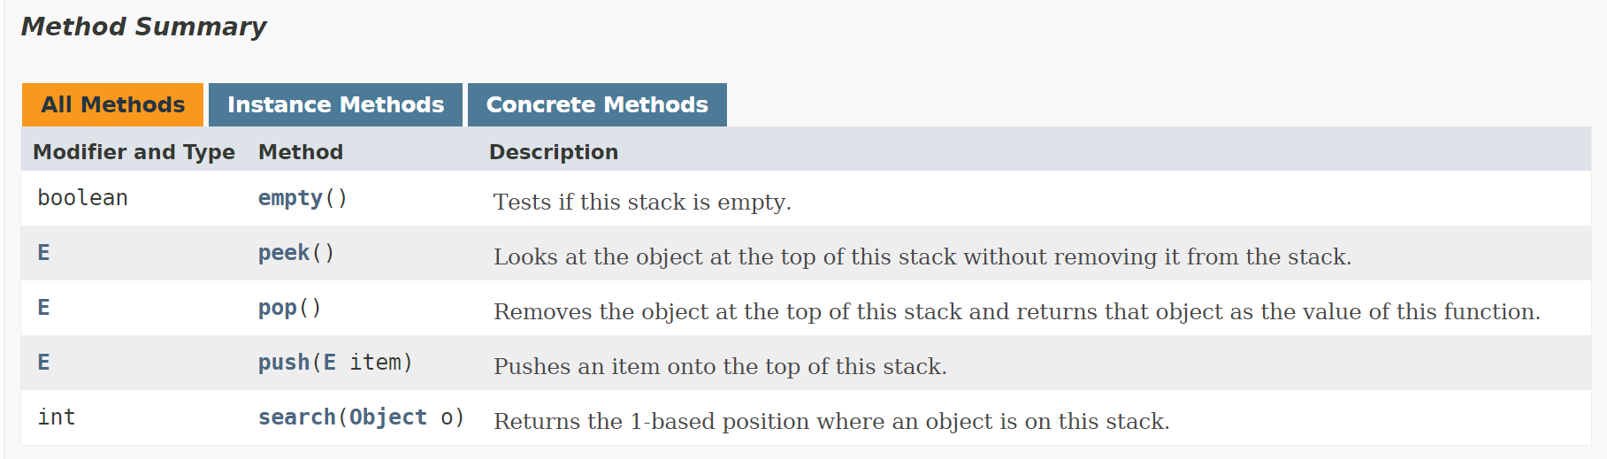

Stack and Java Generic

You can specify the type of objects to be stored when you create a Stack. E.g.,

Stack <Student> students = new Stack<Student>();
Stack <String> names= new Stack<String>();
Stack <Integer> names= new Stack<Integer>();

Here, the class of objects to be stored are indicated by the class name in < > notation. This approach is called Java Generic.

Stack and Java Generic

You can specify the type of objects to be stored when you create a Stack. E.g.,
Stack <Student> students = new Stack<Student>();
Stack <String> names= new Stack<String>();
Stack <Integer> names= new Stack<Integer>();
Note: Stacks are for storing objects. Primitive data types are first converted into their object equivalences before storing into the stack.

For example, int (primitive data type variables) are converted into Integer (objects) before storing

Simple Stack Example
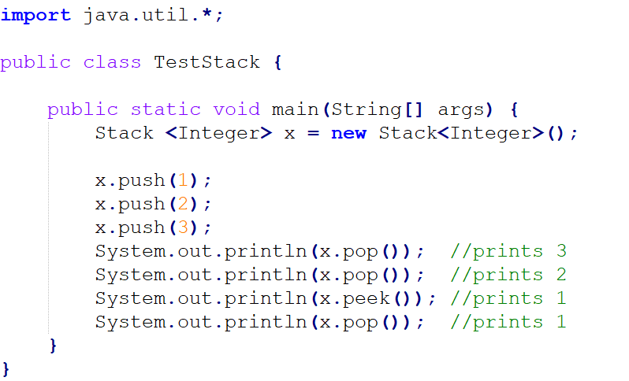

Stack Application: RPN Pocket Calculator

Suppose we need to calculate

50 * 15 + 38 / 20

We have a very special calculator that calculate this expression:

50 ENTER 15 X 38 ENTER 20 / +

Expressions in this form are said to be in the reverse Polish notation (RPN).
Another example:
4.99 * 1.06 + 5.99 + 6.99 * 1.06 ➔
4.99 1.06 * 5.99 + 6.99 1.06 * +

Question:
What is the RPN of (3 + 2) * (7 + 8 * 9)?

Question:
What is 6 5 2 3 + 8 * + 3 + *?

The ‘conventional’ form is also known as the ‘infix form.’ The RPN is also known as the ‘postfix form.’

Evaluating An Expression in RPN

50 * 15 + 38 / 20
50 15 * 38 20 / + =

50 ENTER
15 ENTER
50
50
15
750
750
38
750
38
20
750
1
751
50
15
*
38
20
/
+
=
* ENTER
38 ENTER
20 ENTER
/ ENTER
+ ENTER
= ENTER
import java.io.*;
import java.util.*;
*

public class RPNCalcCommand {

Static Stack<Integer> operandStack = new Stack<Integer>();

public static void main(String[] args) {

Scanner scanner = new Scanner(System.in);
char op;
String line;

char op; String line;
do {
*
line = scanner.next();
op = line.charAt(0);
switch (op) {
case '+' : case '-' : case '*' : case '/' :
ApplyOperator(op); break;
case '=' :
System.out.println(operandStack.pop()); break;
default :
operandStack.push(Integer.parseInt(line));
}
} while (op != '=');
}
static void ApplyOperator(char op) {
int lhs, rhs, result=0;
*

rhs = operandStack.pop();
lhs = operandStack.pop();
switch (op) {
case '+' : result = lhs + rhs; break;
case '-' : result = lhs - rhs; break;
case '*' : result = lhs * rhs; break;
case '/' : result = lhs / rhs;
}
operandStack.push(result);
}
}

Note:

- line = scanner.next(); op = line.charAt(0);
Now op contains the first character in the line.

- case '+' : case '-' : case '*' : case '/' :
ApplyOperator(op); break;
This performs operations: Pop->Pop->op->Push.
50
50
15
750
750
38
750
38
20
750
1
751
50
15
*
38
20
/
+
=

Note:

- case '=' :
System.out.println(operandStack.pop()); break;
When we see a '=', we shall print the answer.

- default :
operandStack.push(Integer.parseInt(line));
When we see an integer, we shall push it to the stack.

