Customer_Churn_Project
2026-03-24
library(ggplot2)
library(rpart)
library(rpart.plot)
library(caret)
## Loading required package: lattice
library(randomForest)
## randomForest 4.7-1.2
## Type rfNews() to see new features/changes/bug fixes.
##
## Attaching package: 'randomForest'
## The following object is masked from 'package:ggplot2':
##
## margin
unzip("archive.zip",list=TRUE)
## Name Length Date
## 1 Customer-Churn-Records.csv 837415 2023-04-28 16:32:00
df <-read.csv("CustomerChurn.csv")
View(df)
dim(df)
## [1] 10000 18
colnames(df)
## [1] "RowNumber" "CustomerId" "Surname"
## [4] "CreditScore" "Geography" "Gender"
## [7] "Age" "Tenure" "Balance"
## [10] "NumOfProducts" "HasCrCard" "IsActiveMember"
## [13] "EstimatedSalary" "Exited" "Complain"
## [16] "Satisfaction.Score" "Card.Type" "Point.Earned"
str(df)
## 'data.frame': 10000 obs. of 18 variables:
## $ RowNumber : int 1 2 3 4 5 6 7 8 9 10 ...
## $ CustomerId : int 15634602 15647311 15619304 15701354 15737888 15574012 15592531 15656148 15792365 15592389 ...
## $ Surname : chr "Hargrave" "Hill" "Onio" "Boni" ...
## $ CreditScore : int 619 608 502 699 850 645 822 376 501 684 ...
## $ Geography : chr "France" "Spain" "France" "France" ...
## $ Gender : chr "Female" "Female" "Female" "Female" ...
## $ Age : int 42 41 42 39 43 44 50 29 44 27 ...
## $ Tenure : int 2 1 8 1 2 8 7 4 4 2 ...
## $ Balance : num 0 83808 159661 0 125511 ...
## $ NumOfProducts : int 1 1 3 2 1 2 2 4 2 1 ...
## $ HasCrCard : int 1 0 1 0 1 1 1 1 0 1 ...
## $ IsActiveMember : int 1 1 0 0 1 0 1 0 1 1 ...
## $ EstimatedSalary : num 101349 112543 113932 93827 79084 ...
## $ Exited : int 1 0 1 0 0 1 0 1 0 0 ...
## $ Complain : int 1 1 1 0 0 1 0 1 0 0 ...
## $ Satisfaction.Score: int 2 3 3 5 5 5 2 2 3 3 ...
## $ Card.Type : chr "DIAMOND" "DIAMOND" "DIAMOND" "GOLD" ...
## $ Point.Earned : int 464 456 377 350 425 484 206 282 251 342 ...
summary(df)
## RowNumber CustomerId Surname CreditScore
## Min. : 1 Min. :15565701 Length:10000 Min. :350.0
## 1st Qu.: 2501 1st Qu.:15628528 Class :character 1st Qu.:584.0
## Median : 5000 Median :15690738 Mode :character Median :652.0
## Mean : 5000 Mean :15690941 Mean :650.5
## 3rd Qu.: 7500 3rd Qu.:15753234 3rd Qu.:718.0
## Max. :10000 Max. :15815690 Max. :850.0
## Geography Gender Age Tenure
## Length:10000 Length:10000 Min. :18.00 Min. : 0.000
## Class :character Class :character 1st Qu.:32.00 1st Qu.: 3.000
## Mode :character Mode :character Median :37.00 Median : 5.000
## Mean :38.92 Mean : 5.013
## 3rd Qu.:44.00 3rd Qu.: 7.000
## Max. :92.00 Max. :10.000
## Balance NumOfProducts HasCrCard IsActiveMember
## Min. : 0 Min. :1.00 Min. :0.0000 Min. :0.0000
## 1st Qu.: 0 1st Qu.:1.00 1st Qu.:0.0000 1st Qu.:0.0000
## Median : 97199 Median :1.00 Median :1.0000 Median :1.0000
## Mean : 76486 Mean :1.53 Mean :0.7055 Mean :0.5151
## 3rd Qu.:127644 3rd Qu.:2.00 3rd Qu.:1.0000 3rd Qu.:1.0000
## Max. :250898 Max. :4.00 Max. :1.0000 Max. :1.0000
## EstimatedSalary Exited Complain Satisfaction.Score
## Min. : 11.58 Min. :0.0000 Min. :0.0000 Min. :1.000
## 1st Qu.: 51002.11 1st Qu.:0.0000 1st Qu.:0.0000 1st Qu.:2.000
## Median :100193.91 Median :0.0000 Median :0.0000 Median :3.000
## Mean :100090.24 Mean :0.2038 Mean :0.2044 Mean :3.014
## 3rd Qu.:149388.25 3rd Qu.:0.0000 3rd Qu.:0.0000 3rd Qu.:4.000
## Max. :199992.48 Max. :1.0000 Max. :1.0000 Max. :5.000
## Card.Type Point.Earned
## Length:10000 Min. : 119.0
## Class :character 1st Qu.: 410.0
## Mode :character Median : 605.0
## Mean : 606.5
## 3rd Qu.: 801.0
## Max. :1000.0
sum(is.na(df))
## [1] 0
churn_df <- df[,c("CreditScore", "Geography", "Gender", "Age",
"Tenure", "Balance", "NumOfProducts",
"HasCrCard", "IsActiveMember",
"EstimatedSalary", "Card.Type",
"Point.Earned", "Exited")]
View(churn_df)
ggplot(churn_df,aes(x=factor(Exited)))+
geom_bar()+
labs(title="Customer Churn Count",
x="Exited",
y="Count")
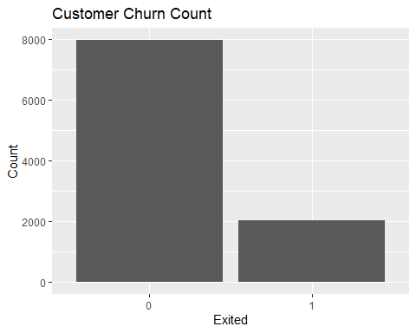
ggplot(churn_df,aes(x=Geography,fill=factor(Exited)))+
geom_bar(position = "dodge")+
labs(title = "Geography vs Churn",
x="Geography",
y="Churn",
fill="Exited")
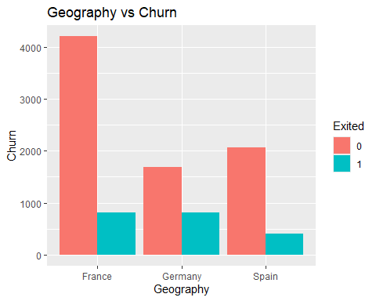
ggplot(churn_df,aes(x=factor(IsActiveMember),fill=factor(Exited)))+
geom_bar()
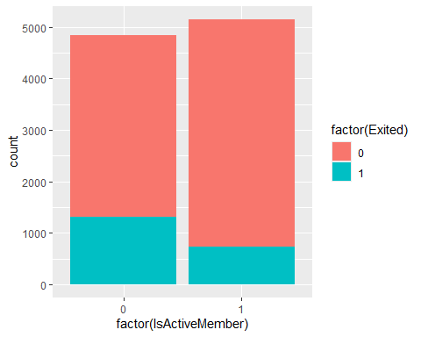
ggplot(churn_df,aes(x=factor(Exited),y=Age))+
geom_boxplot()
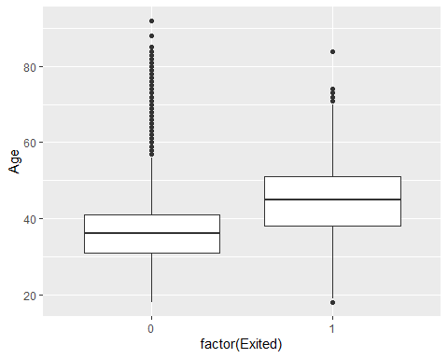
ggplot(churn_df, aes(x = factor(Exited), y = Balance)) +
geom_boxplot()
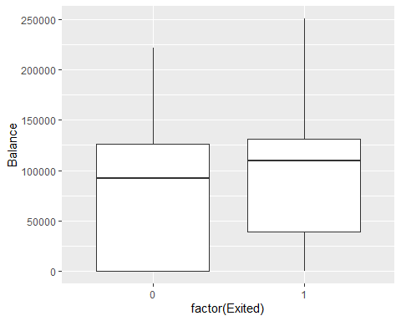
ggplot(churn_df,aes(x=factor(NumOfProducts),fill=factor(Exited)))+
geom_bar(position="dodge")
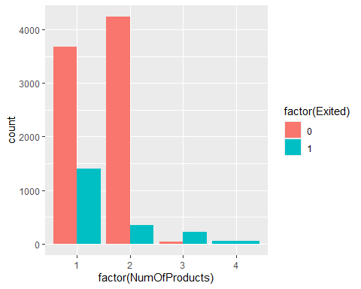
ggplot(churn_df,aes(x=factor(Gender),fill = factor(Exited)))+
geom_bar(position = "dodge")
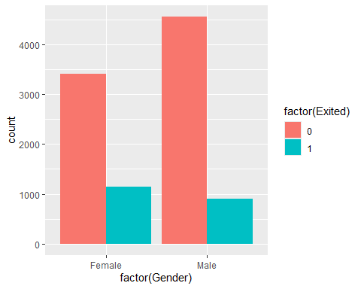
churn_df$Geography <- as.factor(churn_df$Geography)
churn_df$Gender <- as.factor(churn_df$Gender)
churn_df$Card.Type <- as.factor(churn_df$Card.Type)
churn_df$HasCrCard <- as.factor(churn_df$HasCrCard)
churn_df$IsActiveMember <- as.factor(churn_df$IsActiveMember)
churn_df$Exited <- as.factor(churn_df$Exited)
log_model <- glm(Exited ~.,data=churn_df,family="binomial")
summary(log_model)
##
## Call:
## glm(formula = Exited ~ ., family = "binomial", data = churn_df)
##
## Coefficients:
## Estimate Std. Error z value Pr(>|z|)
## (Intercept) -3.269e+00 2.591e-01 -12.614 < 2e-16 ***
## CreditScore -6.551e-04 2.804e-04 -2.337 0.0195 *
## GeographyGermany 7.743e-01 6.769e-02 11.440 < 2e-16 ***
## GeographySpain 3.254e-02 7.064e-02 0.461 0.6451
## GenderMale -5.252e-01 5.452e-02 -9.634 < 2e-16 ***
## Age 7.282e-02 2.578e-03 28.249 < 2e-16 ***
## Tenure -1.549e-02 9.358e-03 -1.656 0.0978 .
## Balance 2.644e-06 5.144e-07 5.141 2.74e-07 ***
## NumOfProducts -9.952e-02 4.713e-02 -2.111 0.0347 *
## HasCrCard1 -4.560e-02 5.937e-02 -0.768 0.4425
## IsActiveMember1 -1.076e+00 5.770e-02 -18.654 < 2e-16 ***
## EstimatedSalary 5.163e-07 4.739e-07 1.089 0.2760
## Card.TypeGOLD -1.417e-01 7.674e-02 -1.847 0.0648 .
## Card.TypePLATINUM -7.393e-02 7.603e-02 -0.972 0.3309
## Card.TypeSILVER -4.472e-02 7.608e-02 -0.588 0.5566
## Point.Earned -1.346e-04 1.206e-04 -1.116 0.2644
## ---
## Signif. codes: 0 '***' 0.001 '**' 0.01 '*' 0.05 '.' 0.1 ' ' 1
##
## (Dispersion parameter for binomial family taken to be 1)
##
## Null deviance: 10112.5 on 9999 degrees of freedom
## Residual deviance: 8559.7 on 9984 degrees of freedom
## AIC: 8591.7
##
## Number of Fisher Scoring iterations: 5
prob<- predict(log_model,type="response")
head(prob)
## 1 2 3 4 5 6
## 0.1326063 0.1649778 0.3596780 0.2242003 0.1492900 0.2620644
class_pred <- ifelse(prob>0.5,1,0)
head(class_pred)
## 1 2 3 4 5 6
## 0 0 0 0 0 0
actual <- as.numeric(as.character(churn_df$Exited))
table(Predicted = class_pred, Actual = actual)
## Actual
## Predicted 0 1
## 0 7673 1598
## 1 289 440
mean(class_pred == actual)
## [1] 0.8113
set.seed(123)
train_index <- createDataPartition(churn_df$Exited,p=0.7,list= FALSE)
train_data <- churn_df[train_index,]
test_data <- churn_df[-train_index,]
tree_model <- rpart(Exited ~.,data= train_data,method= "class")
rpart.plot(tree_model)
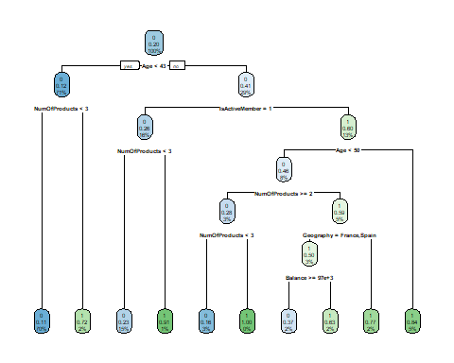
tree_pred <- predict(tree_model,newdata= test_data,type="class")
confusionMatrix(tree_pred,test_data$Exited)
## Confusion Matrix and Statistics
##
## Reference
## Prediction 0 1
## 0 2317 351
## 1 71 260
##
## Accuracy : 0.8593
## 95% CI : (0.8463, 0.8715)
## No Information Rate : 0.7963
## P-Value [Acc > NIR] : < 2.2e-16
##
## Kappa : 0.4772
##
## Mcnemar's Test P-Value : < 2.2e-16
##
## Sensitivity : 0.9703
## Specificity : 0.4255
## Pos Pred Value : 0.8684
## Neg Pred Value : 0.7855
## Prevalence : 0.7963
## Detection Rate : 0.7726
## Detection Prevalence : 0.8896
## Balanced Accuracy : 0.6979
##
## 'Positive' Class : 0
##
rf_model <- randomForest(Exited ~.,data= train_data,ntree=500)
rf_model
##
## Call:
## randomForest(formula = Exited ~ ., data = train_data, ntree = 500)
## Type of random forest: classification
## Number of trees: 500
## No. of variables tried at each split: 3
##
## OOB estimate of error rate: 13.84%
## Confusion matrix:
## 0 1 class.error
## 0 5398 176 0.03157517
## 1 793 634 0.55571128
rf_pred <- predict(rf_model, newdata = test_data)
confusionMatrix(rf_pred, test_data$Exited)
## Confusion Matrix and Statistics
##
## Reference
## Prediction 0 1
## 0 2313 326
## 1 75 285
##
## Accuracy : 0.8663
## 95% CI : (0.8536, 0.8783)
## No Information Rate : 0.7963
## P-Value [Acc > NIR] : < 2.2e-16
##
## Kappa : 0.5135
##
## Mcnemar's Test P-Value : < 2.2e-16
##
## Sensitivity : 0.9686
## Specificity : 0.4664
## Pos Pred Value : 0.8765
## Neg Pred Value : 0.7917
## Prevalence : 0.7963
## Detection Rate : 0.7713
## Detection Prevalence : 0.8800
## Balanced Accuracy : 0.7175
##
## 'Positive' Class : 0
##
importance(rf_model)
## MeanDecreaseGini
## CreditScore 245.26854
## Geography 80.09880
## Gender 34.63682
## Age 481.11150
## Tenure 143.98156
## Balance 259.82705
## NumOfProducts 273.44454
## HasCrCard 31.65541
## IsActiveMember 89.74940
## EstimatedSalary 248.90716
## Card.Type 97.75895
## Point.Earned 243.06981
varImpPlot(rf_model)
