
PROJECT IDEA PROPOSAL
TriSense
A Unified Edge-AI Wearable for Real-Time Assistance to the Visually, Hearing, and Speech Impaired
Course | DSN4091 – Capstone Project, Phase I
Supervisor | Dr. Bubai Manna
Team Members | 23BCE11053 Neelabja Mukhopadhyay · 23BCE11807 Aryan Dev Jha · 23BCE11656 Mohammed Farhan Khan · 23BCE11558 Yash Aman · 23BCE11118 Geet Basantani
Submitted for | Supervisor's review prior to Phase I – Review 1 (19–25 Aug 2026)
1. Motivation
Over 2.2 billion people worldwide live with vision impairment, more than 430 million experience disabling hearing loss, and millions more rely on sign language as their primary means of communication (WHO). Existing assistive solutions largely serve these groups in isolation and remain expensive relative to what most affected individuals in India can afford. A white cane gives no predictive collision warning; hearing aids do not transcribe conversation; and sign-language communication with a non-signer still depends on a human interpreter.
Inexpensive edge-AI hardware has now matured enough to run real-time inference locally, without cloud dependency. This creates an opportunity to build one affordable, offline-capable device that meaningfully helps three different disability groups, instead of three separate specialized products.
2. Problem Statement
Visually, hearing, and speech-impaired individuals each depend on single-purpose assistive devices that address only one need, are often unaffordable in low-resource settings, and frequently rely on internet connectivity that is not always available. There is no existing low-cost device that serves all three groups from a single, shared, fully offline platform.
3. Proposed Solution — TriSense
TriSense is a single belt-worn wearable, built around a Raspberry Pi 4 edge-compute unit, offering three independently selectable modes that share the same core hardware:
- Blind Mode: an ultrasonic sensor array combined with camera-based depth cues predicts time-to-collision with obstacles and delivers directional haptic (vibration) alerts, allowing the user to navigate without needing to interpret raw distance readings.
- Deaf Mode: an on-device microphone streams ambient speech into a fully offline speech-to-text engine, displaying live rolling captions on a compact screen — no cloud dependency, no added latency.
- Mute Mode: a camera captures the user's hand gestures; a lightweight landmark-based classifier recognizes signs and converts them to speech through a small speaker, so a non-signer can understand what the user is communicating.
All three modes run entirely on-device. The project deliberately treats Blind Mode and Deaf Mode as guaranteed deliverables, since both rely on well-established, lower-risk techniques, while Mute Mode — the most technically demanding component — is planned as a staged extension once the first two are stable, protecting the overall project timeline.
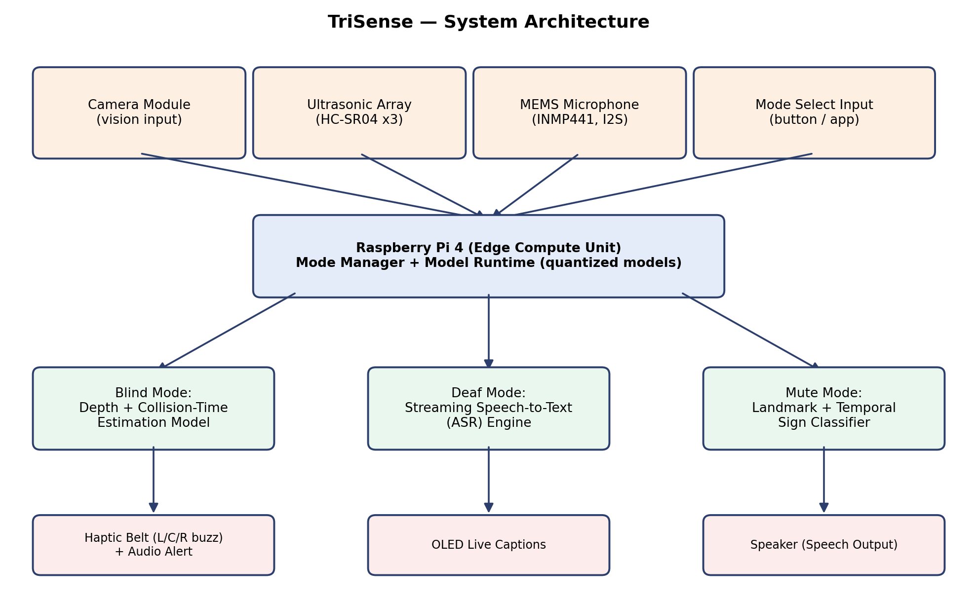
Fig. 1 — TriSense System Architecture: shared edge-compute backbone with three independent inference pipelines.
4. What Makes This Different
Each underlying technique — ultrasonic/depth-based obstacle sensing, on-device speech recognition, and landmark-based sign-language recognition — is individually well established in prior research. However, no reviewed system integrates all three into one affordable, shared, offline-first device serving three separate disability groups. TriSense's contribution is this integration itself: a reusable, edge-optimized multi-modal engine and system architecture, rather than a new individual algorithm — directly relevant to affordable assistive technology in resource-constrained settings such as rural India, and a natural candidate for a conference paper or book chapter given the applied engineering contribution and social-impact angle.
5. Feasibility & Current Progress
- Total hardware cost per prototype: approximately ₹7,000–9,500, using a Raspberry Pi 4 (4GB), ultrasonic sensors, a camera module, microphone, small display, speaker, and haptic motors — all sourced from Indian retailers.
- Literature review completed across all three domains, confirming feasibility of each component technique on edge/embedded hardware.
- System architecture and a phased, review-aligned project timeline finalized (see Fig. 2).
- Blind Mode: core software logic (distance sensing, collision-time prediction, haptic alert triggering) built and validated through unit tests and simulation; physical hardware validation is pending procurement of the Raspberry Pi.
- Deaf Mode and Mute Mode development are planned next, following the same incremental, testable build approach.
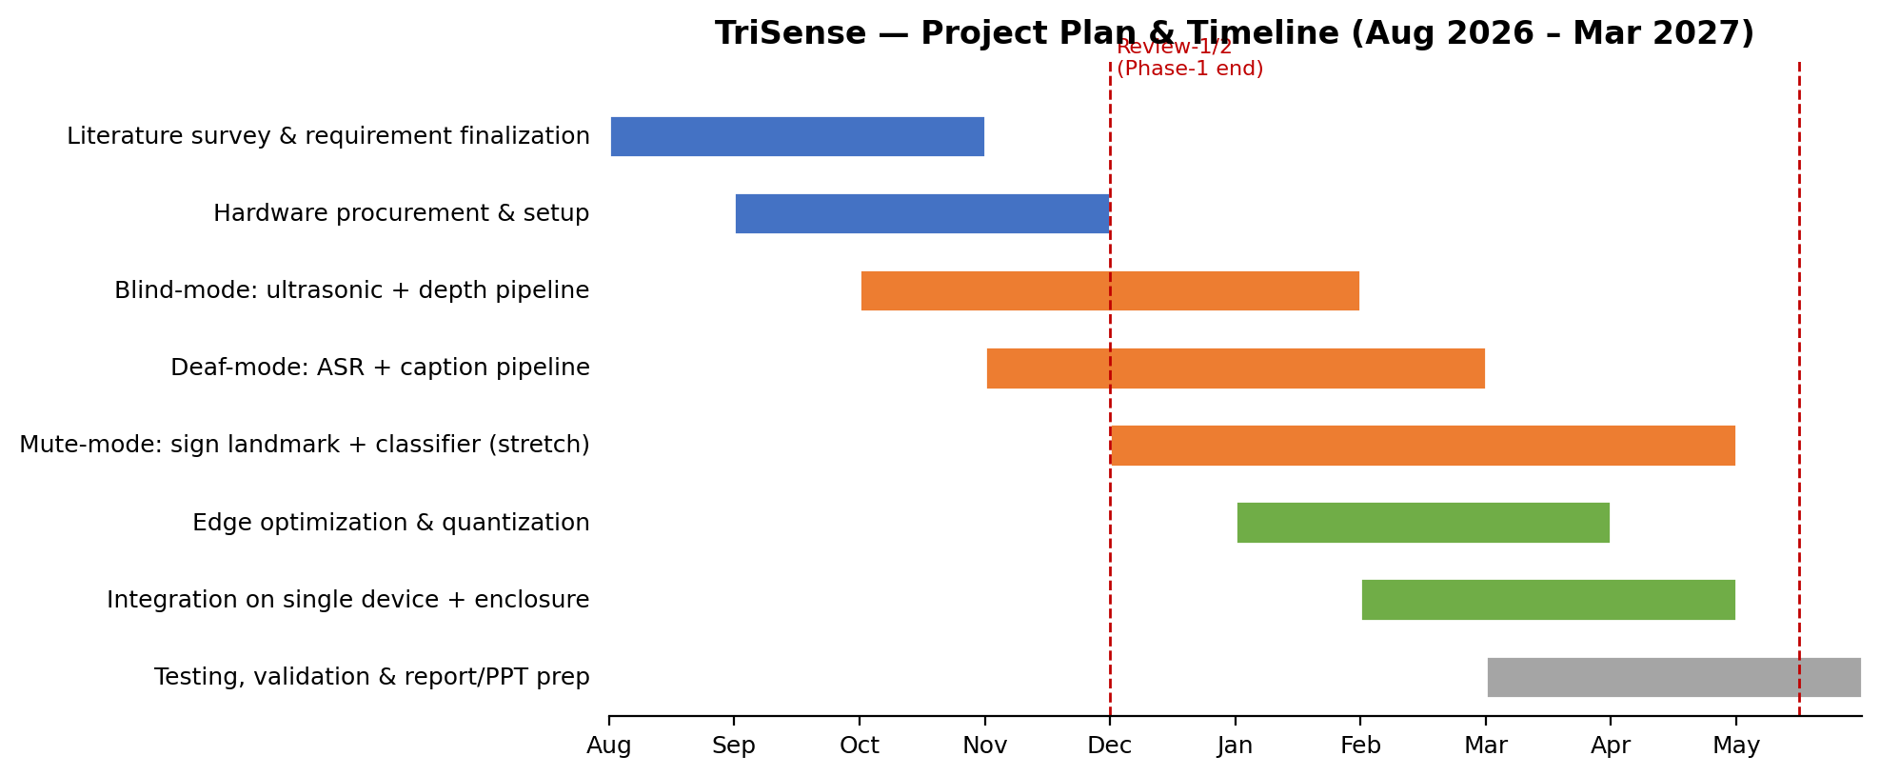
Fig. 2 — Project timeline aligned to Phase I / Phase II review milestones.
6. Question for Supervisor's Review
We would be grateful for your assessment of whether this project idea and its current scope meet the standard expected for this capstone, and whether the scope — particularly the staged treatment of Mute Mode — seems appropriately ambitious for a two-semester, five-member team project. We are open to adjusting the scope based on your guidance, and to shaping the work with an eventual conference paper or book chapter contribution in mind, as discussed.

